Draft

**KYRGYZ REPUBLIC**

**REMIT MPA phase 1**

**Stakeholder Engagement Plan (SEP)**

**2025**

**Bishkek**

# 

# TABLE OF CONTENTS

TABLE OF CONTENTS 2

LIST OF ABBREVIATIONS AND ACRONYMS 3

1.0. INTRODUCTION 4

1.1 Description of the project 4

1.2 Project components 4

2.0. OBJECTIVES OF THE STAKEHOLDER ENGAGEMENT PLAN 5

2.1. Brief description of previous activities in relation to interaction with interested parties 5

2.2. Specific goals SEP include: 5

2.3. Principles and rules stakeholder Engagement: 6

3.0. LEGAL AND REGULATORY FRAMEWORK 7

3.1. Basic provisions established by law KG 7

3.2. World Bank stakeholder engagement requirements 9

4.0. IDENTIFICATION AND ANALYSIS OF STAKEHOLDERS 10

4.1. Project participants 10

4.2. Identification of project stakeholders 10

4.3. Interested parties 11

4.4. Vulnerable individuals or groups 14

4.5. Methodology for interaction with stakeholders 18

4.6. Criteria for stakeholder analysis 19

5.0. STAKEHOLDER ENGAGEMENT PROGRAM 20

5.1. Methods of interaction with stakeholders 20

6.0. ACTIVITIES TO TAKE INTO ACCOUNT THE VIEWS OF INTERESTED GROUPS 22

6.1. Disclosure of information 24

7.0. ESTIMATED BUDGET 27

8. GRIEVANCE REDRESS MECHANISM 27

8.1 GRM Objectives 27

9.0. MONITORING AND REPORTING 31

9.1. Reporting on stakeholder engagement activities 32

9.2. Quarterly and annual reports of PIU 33

9.3. Semi-annual Environmental and Social Compliance Reports for the World Bank 33

Appendix 1. Estimated budget for the stakeholder engagement plan (SEP) 34

Appendix 2. Summary description of consultations held on the REMIT project in Tash-Kumyr and Bishkek 35

Appendix 3. Details of the meeting process with local authorities Tashkumyr 37

Appendix 4. Details of the meeting process Bishkek 40

Appendix 5. Lists of meeting participants 43

# LIST OF ABBREVIATIONS AND ACRONYMS

AA – Aiyl Aimak

AO – Aiyl Okmotu

CC – Complaints [Commission](https://dictionary.cambridge.org/ru/%D1%81%D0%BB%D0%BE%D0%B2%D0%B0%D1%80%D1%8C/%D0%B0%D0%BD%D0%B3%D0%BB%D0%BE-%D1%80%D1%83%D1%81%D1%81%D0%BA%D0%B8%D0%B9/commission)

ESMP – Environmental and social management plan

ESIA – Environmental and social impact assessment

ESF – Environmental and social framework

ESS – Environmental and social standard

FM – Feedback Mechanisms

GRM – Grievance Redress Mechanism

GRS – Grievance Redress Service

IP – Interested Parties

IA – Implementing Agency

JSC – Joint Stock Company

KG – Kyrgyz Republic

LMP – Labor management procedures

MoE – Ministry of Energy of the Kyrgyz Republic

M&E – Monitoring and Evaluation

NEGK – National Electric Grid of Kyrgyzstan

OHS – Occupational Health & Safety

OS – Other Stakeholders

PIU – Project implementation Unit

PL – Power Line

PAP – Project affected Person

RAP – Resettlement Action Plan

RPF – Resettlement policy framework

SEP – Stakeholder Engagement Plan

SH – Sexual harassment

SEA – Sexual exploitation and abuse

VG – Vulnerable groups

WB – World Bank

# 1.0. INTRODUCTION

This Stakeholder Engagement Plan (SEP) designed for project «Regional Electricity Market Interconnectivity and Trade – Central Asia» (hereinafter referred to as REMIT or Project), financed by the World Bank (WB) and in accordance with ESS10 WB to ensure full and open interaction with stakeholders during the implementation of the Project, allowing for the correct identification of various stakeholders and the development of an approach to interaction with each subgroup, establish a meaningful dialogue between them and distribute responsibilities for the implementation of stakeholder interaction activities. Stakeholders are individuals or groups directly or indirectly affected during the implementation of a project, as well as individuals who may be interested in the project and/or may have the opportunity to influence its results, in both positive and negative ways.

SEP describes the ways in which IA will maintain communication with stakeholders and includes a mechanism through which people can report problems, provide feedback or file complaints regarding project contractors and the projects themselves. The involvement of local people is essential to the success of the project - in order to ensure smooth cooperation between project personnel and local communities and to minimize and mitigate the environmental and social risks associated with the proposed project.

SEP Is a flexible living document that can be periodically reviewed during project implementation. It will be updated as necessary to reflect new or modified activities, changes in project documents or the involvement of new stakeholders.

## 1.1 Description of the project

The REMIT project will help facilitate the expansion of electricity trade and support the clean energy transition in Central Asia. The regional market will contribute to increased commercial trade transactions and investment in the energy sector of Central Asian countries. Although the region's existing energy networks are interconnected, electricity exchanges remain well below possible capacity. The main obstacles include insufficient synchronization of power systems, lack of coordination of generation and load distribution obsolete substation equipment, a also insufficient level of management. The REMIT project aims to overcome these barriers.

## 1.2 Project components

The proposed project (MPA) consists of the following three components:   
(i) Component 1: Pilot regional electricity market; (ii) Component 2: Strengthening grid connectivity and sustainability; and (iii) Component 3: Strengthening the enabling environment and institutional capacity.

1. Component 1: Regional electricity market. This component aims to support the implementation of a pilot short-term market platform to promote regional electricity trade in Central Asia. The proposed pilot project aims to have a strong demonstration impact on the way the regional market operates in Central Asia, ensuring that the growing demand for energy in the region is met through the efficient use of cheaper energy, improving security and security of supply, thereby stimulating economic growth and green transition in the region. The project will integrate new market/country entrants over time as well as link them to different markets in the future.

2. Component 2: Strengthening and digitalizing regional connectivity. REMIT MPA will support the development of a regional market with «soft» (intangible) and «hard» (material) infrastructure. Based on country proposals and their priority investment programmes, a potential list of critical investments needed to strengthen regional systems has been identified.

Within Phase 1 of Component 2, three reconstruction/modernization facilities have been identified: two substations «Kristall» and «Torobaeva» and a power transmission line «Kristall-Yulduz». Reconstruction work will be carried out (1) in the city of Tash-Kumyr for the substation «Kristall», (2) in the Suzak district for the substation «Torobaeva» and (3) reconstruction/new construction of the power transmission line «Kristall-Yulduz» in the Uch-Korgon aiyl aimak Aksy district. All facilities are located in Jalal-Abad region.

Component 3: Strengthening the enabling environment and institutional capacity. Since efficient cross-border trade depends on reliable energy sectors at the domestic level, this component will support activities aimed at: (i) strengthening the financial viability and governance of national energy sectors (for example, tariff reform); (ii) strengthening regulatory agencies through training, capacity-building and specific activities. This component will also support the oversight, management and coordination of projects.

# 2.0. OBJECTIVES OF THE STAKEHOLDER ENGAGEMENT PLAN

The SEP is designed to fully and openly involve stakeholders in the implementation of this Project in order to carefully identify different stakeholders and develop an approach to reach each subgroup, establish constructive dialogue between them and share responsibilities for the implementation of stakeholder engagement activities. The SEP aims to ensure broad and active involvement of stakeholders and the timely creation of an atmosphere of constructive dialogue in the process of preparing and implementing the Project. The plan provides for an appropriate approach to consultation and disclosure and sets out methods of interaction with stakeholders. This SEP also aims to inform, improve and facilitate participatory decision-making with Project-affected people and other stakeholders in a comprehensive and timely manner, and to provide these groups with adequate opportunities to share their views on the Project.

The purpose of the present SEP is to determine the procedure for interaction with stakeholders within the framework of the Project and the procedure for maintaining long-term relations between IA (NEGK), Contractor, PIU, by the local community, PAP and other interested parties.

## 2.1. Brief description of previous activities in relation to interaction with interested parties

In accordance with the World Bank procedures and the national legislation of the Kyrgyz Republic, public consultations were organized and held on March 26, 2025 in Tash-Kumyr, Jalal-Abad region, and on April 17, 2025 in Bishkek, which were an important stage in the public participation process aimed at ensuring transparency of the project and taking into account the opinions of all stakeholders. The goal was to inform stakeholders about the social and environmental aspects of the REMIT project, discuss the prepared documents related to social and environmental safety issues. Public consultations were held at two levels: (1) local (Tash-Kumyr, Jalal-Abad region, March 26, 2025); (2) national (Bishkek, April 17, 2025). Summary of the consultations held is in Appendix No. 2-5, with Minutes and lists of participants.

## 2.2. Specific goals SEP include:

* Stakeholder Engagement and Information Disclosure
* Identify, collate and assess affected parties and other stakeholders and how they may be affected or interested in the Project;
* Describe the requirements for interaction with stakeholders provided for by KG legislation and World Bank ESS;
* Analyze stakeholders who may influence the project decision-making process in order to understand project stakeholders and develop appropriate methods and tools to interact with them;
* Describe the different mechanisms for interaction with stakeholders, including effective methods and channels for disseminating information about the project through different platforms accessible to different types of stakeholders, taking into account their needs: effective communication tools for consultation and disclosure;

Provide stakeholders with timely access but also guide engagement and consultations to manage ES risks and impacts.

* to information on the preparation and progress of the Project;
* Ensure that information disclosed to interested parties is accessible and that consultation venues are accessible to all interested parties;
* Ensure also the participation of women, the elderly, people with disabilities, etc. identifying all vulnerable groups and consulting with them and considering their proposals properly;
* Establish/develop an effective complaints mechanism for the project.
* Register formal consultation and disclosure activities, establish a stakeholder tracking and records management system.

## 2.3. Principles and rules stakeholder Engagement:

SEP developed in accordance with the recommendations and requirements of the World Bank environmental and social standard ESS10 and is part of the environmental and social assessment of the project.

Active stakeholder engagement in project activities is a key factor in promoting project accountability and sustainability of project results and providing feedback to improve implementation and results.

In line with best practice approaches, the IA/PIU will be required to apply the following principles in their stakeholder engagement activities:

• Openness: public consultations throughout the life of the project should be conducted openly, without external interference, coercion or intimidation. The consultation sites will be easily accessible and will not require significant travel, entry fees or prior access authorization.

• Cultural acceptability: activities, format, time and location of consultations will be consistent with local customs and norms. Activities will be conducted in a language that participants can understand.

• Informed participation and feedback: information will be provided in advance and disseminated to all stakeholders in an appropriate language and format. Opportunities for feedback will be provided to interested parties and recommendations and comments from interested parties will be reviewed and taken into account.

• Inclusion: consultations will include all categories of people in the local community, including persons with disabilities, older persons and other vulnerable groups. If necessary, IA/PIU will provide logistical support so that participants with disabilities and persons without sufficient financial means or access to transport can attend public meetings organized within the framework of the project.

• Gender sensitivity: consultations will be organized in such a way as to ensure equal access for both women and men. If necessary, IA/PIU organizes separate meetings and focus group discussions for men and women, uses facilitators of the same gender as participants, and provides additional support to facilitate access to information.

NEGK/PIU must ensure that meaningful consultations are organized and conducted in accordance with ESS10, building on the following rules:

* the process begins early in the project planning process to gather initial opinion on the project proposal and inform project development;
* feedback from stakeholders should be encouraged, particularly as a way of informing project development and involving stakeholders in identifying and mitigating environmental and social risks and impacts; the
* continues on an ongoing basis as risks and impacts arise;
* the process is based on the prior disclosure and dissemination of relevant, transparent, objective, meaningful and easily accessible information within a time frame that allows for meaningful consultation with stakeholders in a culturally appropriate format, in the appropriate local language (s) and understood by stakeholders;
* reviews and responds to feedback in an adequate manner and further measures should be taken;
* maintains active and inclusive interaction with the parties affected by the project;
* the process is free from external manipulation, interference, coercion, discrimination and intimidation; and
* the relevant project documentation shall be disclosed to the public.

# 3.0. LEGAL AND REGULATORY FRAMEWORK

Public participation in KG regulated by a number of national laws and international conventions, as well as the principles of international organizations supporting the implementation of projects.

## 3.1. Basic provisions established by law KG

Interaction with interested parties and disclosure of information are regulated by the Constitution of the Kyrgyz Republic and the following regulations:

- Law of the Kyrgyz Republic «On state guarantees of equal rights and equal opportunities for men and women» dated August 4, 2008 № 184 (as amended by the Law of the Kyrgyz Republic dated July 14, 2011 № 97);

- Law of the Kyrgyz Republic «On guarantees and freedom of access to information» dated December 5, 1997 № 89 (as amended by the Law of the Kyrgyz Republic of March 18, 2017 № 47);

- Law of the Kyrgyz Republic «On access to information falling under the jurisdiction of state bodies and local governments of the Kyrgyz Republic» dated December 28, 2006 № 213 (as amended by the Law of the Kyrgyz Republic dated July 20, 2017 № 130);

-Decree of the President of the Kyrgyz Republic «On the implementation of the Law of the Kyrgyz Republic «On access to information falling under the jurisdiction of state bodies and local governments of the Kyrgyz Republic» dated May 8, 2007 № 240;

- Order of the Prime Minister of the Kyrgyz Republic dated April 22, 2008 № 210 (On approval of sample reports on the progress of implementation of the Law of the Kyrgyz Republic «On access to information falling under the jurisdiction of state bodies and local governments of the Kyrgyz Republic» and Instructions for filling out these sample reports);

- Law of the Kyrgyz Republic «On the procedure for considering citizens’ appeals» dated May 4, 2007 № 67 (as amended by the Law of the Kyrgyz Republic dated July 27, 2016 № 151);

- Law of the Kyrgyz Republic «On the accession of the Kyrgyz Republic to the United Nations Economic Commission for Europe Convention on Access to Information, Public Participation in Decision-Making and Access to Justice in Environmental Matters» dated 12 January 2001 № 5;

- Law of the Kyrgyz Republic «On Environmental Protection» dated June 16, 1999 № 53 (as amended by the Law of the Kyrgyz Republic dated March 23, 2020 № 29);

- Law of the Kyrgyz Republic «On local state organizations and local governments» dated October 20, 2021 № 123;

- Law of the Kyrgyz Republic «On Joint Stock Companies» dated March 27, 2003 № 64 (as amended by the Law of the Kyrgyz Republic dated November 29, 2021 № 141);

- Law of the Kyrgyz Republic «On Non-Profit Organizations» dated October 15, 1999 № 111 (as amended by the Law of the Kyrgyz Republic dated June 26, 2021 № 78).

**Constitution KG** guarantees freedom of speech and expression, establishing that every citizen of the country has the right to freely express and disseminate thoughts, ideas and opinions, freedom of literary, artistic, scientific and technical creativity, freedom of the press, communication and dissemination of information. The adoption of laws restricting freedom of speech and the press is not permitted.

No one may be discriminated against on the basis of sex, race, language, disability, nationality, religion, age, political or other opinion, education, origin, property or other status or any other circumstance. In the Kyrgyz Republic, men and women have equal rights and freedoms, as well as equal opportunities for their implementation.

**Law of the Kyrgyz Republic «On state guarantees of equal rights and equal opportunities for men and women»** establishes state guarantees to ensure equal rights and opportunities for persons of different sexes in the political, social, economic, cultural and other spheres of human life, is designed to protect men and women from discrimination on the basis of gender and is aimed at establishing progressive democratic relations between men and women.

**Law of the Kyrgyz Republic «On guarantees and freedom of access to information»** regulates the relations that arise in the process of exercising the right of everyone to freely and unhindered seek, receive, research, produce, report and disseminate information. Everyone is guaranteed the right to access information. The State protects the rights of everyone to seek, receive, research, produce, report and disseminate information. Restrictions on access and dissemination of information can only be established by law. The basic principles of freedom of access to information are the general availability, objectivity, timeliness, openness and reliability of information.

**Law of the Kyrgyz Republic «On the procedure for considering citizens' appeals»** aimed at legal regulation of relations related to the implementation of everyone’s right to appeal to state bodies and local governments, enshrined in the Constitution of the Kyrgyz Republic, as well as the procedure for considering citizens’ appeals by state bodies, local governments and officials.

**Law of the Kyrgyz Republic «On access to information falling under the jurisdiction of state bodies and local governments of the Kyrgyz Republic**» is aimed at ensuring the implementation and protection of the right to access information falling under the jurisdiction of state bodies and local governments, as well as achieving maximum information openness, transparency and transparency of activities.

In 2001, the Kyrgyz Republic joined **Aarhus Convention** on access to information, public participation in decision-making and access to justice in environmental matters of the United Nations Economic Commission for Europe, which also contains provisions to ensure disclosure of the Project's objectives and environmental considerations. In order to promote the protection of the right of every person of present and future generations to live in an environment favorable to his health and well-being, each Party guarantees the rights to access environmental information, public participation in decision-making, access to justice in environmental matters, in accordance with the provisions of this Convention.

One of the principles of environmental protection in accordance with the Law **KR «On environmental protection»** there is a principle of openness: transparency in resolving environmental issues, carrying out economic and other activities that have an impact on the environment, close interaction with government agencies and the population, promotion and stimulation of measures aimed at the protection and rational use of natural resources, a combination of national, regional and international interests in the field of environmental protection. The law also guarantees the right of every citizen and organization to access environmental information at the disposal of government bodies in accordance with the provisions of this Law.

The activities of local government bodies are regulated by the Law **KR «On local self-government».** The law establishes requirements for the organization of local self-government at the level of local administrative units in the Kyrgyz Republic, defines the role of local government bodies in the exercise of state power, establishes the organizational and legal basis for their activities, establishes the competence and principles of relations between local government bodies.

**In the Law of the Kyrgyz Republic «On Non-Profit Organizations»** it is indicated that a non-profit organization — a voluntary self-governing organization created by citizens and (or) legal entities on the basis of their common interests to realize spiritual and other intangible needs in the interests of its members and (or) society as a whole, which does not have profit-making as the main goal of its activities and does not distribute the profits received among members, founders and officials. A non-profit organization has the right to engage in any type of activity not prohibited by law.

## 3.2. World Bank stakeholder engagement requirements

The World Bank's Environmental and Social Framework (ESF) came into force on October 1, 2018. They include the Environmental and Social Standard (ESS) 10 (Stakeholder Engagement and Information Disclosure), which recognizes «the importance of open and transparent communication between the Borrower and project stakeholders as an integral element of international best practice». ESS10 stresses that effective stakeholder engagement can significantly improve the environmental and social sustainability of projects, increase their acceptability and contribute significantly to the successful design and implementation of projects. The ESS 10 applies to all projects supported by the Bank under investment project financing. Implementing Agency (IA) will interact with stakeholders, which is an integral part of the environmental and social assessment of the project, as well as its development and implementation. According to the World Bank's environmental and social guidelines, the requirements set out in ESS 10 are as follows

* The project IA will be required to engage with stakeholders throughout the project life cycle, commencing such engagement as early as possible during the project development process and over a period of time that allows for meaningful consultation with stakeholders regarding project preparation. The nature, scale and frequency of stakeholder engagement will be proportionate to the nature and size of the project and its potential risks and impacts.
* Implementing Agency (IA) will conduct meaningful consultations with all stakeholders, provide timely, relevant, understandable and accessible information and consult with them in an acceptable manner, without manipulation, interference, coercion, discrimination or intimidation.
* The stakeholder engagement process will include the following, as outlined in more detail in the ESS: (i) identifying and analyzing stakeholders; (ii) planning how stakeholder engagement will occur; (iii) disclosure; (iv) stakeholder consultation; (v) reviewing and responding to complaints; and (vi) reporting to stakeholders.
* The contractor will maintain and disclose, as part of the environmental and social assessment, a documented stakeholder engagement report, including a description of the stakeholders consulted, a summary of the comments received and a brief explanation of how those comments were taken into account or the reasons why the above was not implemented.

IA will implement SEP evenly throughout the project cycle. It shall be disclosed as early as possible before the Project begins, and EA shall seek the views of interested parties on SEP, including identification of stakeholders and proposals for future engagement. If in SEP significant changes are being made PIU must reveal the updated version SEP. According to ESS10, NEGK is also to implement a complaints mechanism to promptly receive and facilitate resolution of concerns and complaints from project affected parties related to the Project's environmental and social performance. For more information on the World Bank's environmental and social standards, follow the link below:

[www.worldbank.org/en/projects-operations/environmental-and-social-framework/brief/environmental-and-social-standards](http://www.worldbank.org/en/projects-operations/environmental-and-social-framework/brief/environmental-and-social-standards%20)

# 4.0. IDENTIFICATION AND ANALYSIS OF STAKEHOLDERS

## 4.1. Project participants

Project participants - these are «people who play a role in the project or may be affected by the project, or who have an interest in the project». Project participants may be grouped into key stakeholders who are «...individuals, groups or local communities that may be affected positively or negatively by the project and directly or indirectly»... especially... «those directly affected by it, including those who are disadvantaged or vulnerable» and secondary stakeholders who are «...wider stakeholders who may be able to influence the outcome of the project through their participation in the project»... and secondary stakeholders who are «...those who may be able to influence the outcome of the project through their participation in the project...»

ESS 10 recognizes two broad categories of stakeholders: «Project affected parties» and «Other stakeholders»*.* The latter includes «those who may be affected by the project due to actual impacts or potential risks to their physical environment, health, safety, cultural practices, well-being or livelihoods. These stakeholders may include individuals or groups, including local communities». These are the individuals or households most likely to experience change as a result of the environmental and social impacts of the project. The parties affected by the project are described below:

* **Project Affected Persons (PAPs) -** these are individuals, households, groups and other organizations in the project's area of influence that are directly or indirectly, positively or negatively (actually/potentially) affected by the project and/or have been identified as being particularly sensitive to change and relevant to the project's activities. These PAP should be directly involved in determining impacts and their significance and in deciding on mitigation and management measures.
* **Vulnerable groups (VG)** these are individuals who may be disproportionately affected by the project or who may be at a greater disadvantage than any other group because of their vulnerable status and who may require special engagement efforts to ensure their equal representation in consultations and decision-making related to the Project. These may include female-headed households, the elderly population, persons with disabilities, etc.
* Other stakeholders (**OS) -**these are individuals/groups/organizations who believe or expect that their interests are or may be affected by the project and/or who may in any way affect the outcome of the project and its implementation process.

## 4.2. Identification of project stakeholders

Project stakeholders are defined as local authorities, public institutions, local community, formal or informal groups and organizations, civil society, media, as well as persons whose interests or rights will be affected by the Project, directly or indirectly, positively or negatively, who may be interested in the implementation of the Project and who may in any way affect the results of the Project.

**Figure 1. Stakeholder identification and analysis**

For the purposes of this SEP stakeholders who may be directly affected and involved in the implementation of the Project are classified as PAP. These include, but are not limited to, local communities, women, poor and vulnerable individuals or groups.

Specific stakeholders for relevant activities will be considered during the implementation of the Project to ensure that they are all identified and involved, with particular attention to the different vulnerable groups. Community representatives can provide useful information about the local context and act as the main conduits for the dissemination of information related to the Project, as well as the main channel of communication between the Project and the target communities and their established networks. The legitimacy of such representatives may derive either from their formal elected status or from their informal and having great influence community provisions which allow them to act as focal points for Project contacts

## 4.3. Interested parties

One of the priority areas SEP is the identification of stakeholders who may be positively or negatively affected by project activities. The main stakeholders that will be directly or indirectly involved in the implementation of the project are listed below

Key project stakeholders are

*Government level:*

* Ministry of Finance of the Kyrgyz Republic;
* Ministry of Energy of the Kyrgyz Republic;
* Ministry of Labor, Social Security and Migration of the Kyrgyz Republic;
* Ministry of Natural Resources, Environment and Technical Supervision

*Local level:*

* Plenipotentiary representatives of the President of the Kyrgyz Republic at the regional level;
* Local authorities
* *Direct stakeholders of the project*
* Potential contractors and workers;
* Electricity consumers;
* *Other stakeholders within the Project are*
* civil society groups,
* state-owned enterprises;
* private enterprises, entrepreneurs, youth and women's organizations, various NGOs;
* also local and national print and broadcast media, digital/web organizations and their associations.

*Affected party:*

* Persons who will be adversely affected by the project;
* Socially vulnerable segments of the population.

*Project implementers:*

* JSC «National Electricity Grid of Kyrgyzstan» (NEGK)
* Potential contractors and workers

**Segmentation/stakeholder prioritization**

The stakeholders identified by the project were segmented according to their spheres of influence. Stakeholders of high and significant importance are presented in Table 2 below.

**Table 2. Segmentation of stakeholders into segments**

| Interested parties | Level | Description of the description | Sphere influences | Interest | Level of influence |
| --- | --- | --- | --- | --- | --- |
| Key stakeholders | | | | | |
| Ministry of Finance of the Kyrgyz Republic | National | General progress supervision implementations Project by financial issues | Exercise of supervision and control for mastering funds project.  Monitoring and evaluation of financial reporting on project funds from NEGK (PIU) | High | High |
| Ministry of Energy of the Kyrgyz Republic | National | Maintaining general supervision and management for implementation of the Project | Overall coordination and control of project and subproject implementation for NEGK (PIU), monitoring and evaluation of project activities | High | High |
| Ministry of Labor, Social security and migration of Kyrgyz Republic | National | Implementation of public policy, including issues of labor protection and promotion of employment; social protection of the population, including support for socially vulnerable categories of citizens, children in difficult life situations, people with disabilities and elderly citizens; social security and gender equality; migration | Carries out state supervision and control over compliance in organizations with labor legislation and other regulatory legal acts containing labor law norms, through inspections, surveys, issuing mandatory orders to eliminate violations, and bringing perpetrators to justice in accordance with the legislation of the Kyrgyz Republic | High | High |
| Ministry of Natural Resources, ecology and technical supervision of the Kyrgyz Republic | National | General supervision of the Project on environmental issues | Will exercise general control over compliance with environmental and environmental measures implementations subprojects; | Average | high |
| Other government departments | National | Beneficiaries | They will receive it benefits from implementation of the project in part electrification of territories. | High | High |
| Small and medium-sized enterprises | National | Beneficiaries | The reconstruction and upgrading of substations and the reconstruction/construction of the new line will ensure a reliable, stable power supply for production work | High | Low |
| Electricity consumers | National | Beneficiaries | They will receive it benefit from reliable and stable consumption electricity in the everyday life. | High | Low |
| Electricity consumers exposed to negative  impact | Regional | Beneficiaries | The project will develop mitigation measures and minimizing negative impacts and will turn it on in the tools ESMF, and will also provide execution developed mer. | High | High |
| Other interested parties | | | | | |
| (NGOs, media, public)  May influence perception of the project and transparency of implementation | Regional | Information, participation in discussions, monitoring | May influence perception of the project and transparency of implementation | Medium | Medium |
| Implementing party | | | | | |
| JSC «National Electricity Grid of Kyrgyzstan» (NEGK) | National | Direct beneficiary | Will benefit from reconstruction and modernization of project facilities: from reconstruction of Kristall and Torobaeva substations and reconstruction/construction power line Kristall-Yulduz  Procurement process/financial management) and social/environmental protective measures.  Raising employee potential | High | High |
| Potential contractors and workers | Regional | Workers Project | Execution design events.  Possibilities employment. Source of income. | High | High |
| Affected parties | | | | | |
| Affected parties (local residents, vulnerable groups) | Regional | Identified during the census and inventory of property; have rights under ESS5 depending on legal status (owner, tenant, informal user). | Most vulnerable, exposed to risks during project implementation, deterioration of environmental or social conditions.  Protection of rights, compensation, security, access to resources | High | High |
| Affected parties (those displaced, losing land, income, property) | Regional | In the event of physical relocation, the right to housing or land of equal or better quality, with access to services and legal rights of tenure, where possible. | Most vulnerable, deterioration of environmental or social conditions.  Compensation for loss of land, property, income-generating activities (crops, trees, etc.), restoration of living conditions, restoration of business or employment. | High | High |

## 4.4. Vulnerable individuals or groups

It is important to understand whether the impact of a project may disproportionately affect socially vulnerable populations, who are often unable to communicate their concerns or understand gist provided a project impacts. Vulnerable status can be due to origin, gender, age, health status, economic hardship, financial insecurity, socially disadvantaged position in the community (such as unemployed youth), dependence on others (dependency) or on natural resources, etc.

SEP also defines vulnerable groups as special categories of stakeholders, that is, individuals or groups that may require special treatment interaction with them because of their vulnerable status, the [1]to ensure their equal representation in the consultation and decision-making processes related to the Project. In the context of this Project, these may be groups that, for various reasons (such as disability), find it particularly difficult to access information and express their views on the Project and its implications. Engagement with vulnerable groups and individuals often requires special measures and assistance to support their participation in project decisions to ensure that their awareness and contribution to the overall process is comparable to that of other stakeholders.

The following categories of persons may be classified as vulnerable groups:

The categories listed below include «those who may be affected by the Project due to actual impacts or potential risks to their physical environment, health, safety, cultural practices, well-being or livelihood. These are people or households likely to experience changes related to the Project's environmental and social impacts: the

* People with disabilities/people with special needs
* Unemployed youth
* Migrant workers
* Elderly people
* Residents of mountainous and border areas
* Unskilled women (secondary education only)
* Women engaged in seasonal agriculture
* Women with secondary vocational education
* Single mothers/female-headed households

**Table 3: Description of vulnerable groups ,possible impacts, and expectations**

| Name of stakeholders | Description of the description | Expectations | Interest |
| --- | --- | --- | --- |
| Women, including female-headed households | Women farmers;  Women engaged in seasonal agriculture;  Women after maternity leave;  Women with secondary vocational education;  Single mothers/Female-headed households. | Women who wish to work but they either do not have sufficient skills or have no one to leave their children with while they are at work.  Lack of full-time/official work in rural areas.  Lack of knowledge about rights and available social protection and employment programmes.  Possible restrictions on access to water, pastures, and land use may **worsen their economic situation and food security.** Project activities may result in increased noise levels, air pollution, dust, and chemicals. Restricted or impaired access to medical facilities. Increased accident rates due to machinery, power lines, or changes in traffic patterns. Project activities may affect health. | High |
| Unemployed youth | Youth without skills (school education only);  Unemployed young people engaged in seasonal farming or construction;  Unemployed young people with secondary vocational education;  Young people with economic disabilities to continue their education;  Graduates with no professional skills; | Those wishing to get a well-paid job and in need of training.  It is expected that there will be temporary work with official employment.  Lack of work in rural areas.  No skills, insufficient knowledge, the only option is labor migration. | High |
| ~~P~~eople with special needs | Individuals and households with disabilities, education and skills as part of their population | The project will take into account their safety, including minimizing risks associated with the construction and operation of energy facilities, as well as protection against discrimination and infringement of rights. Limited access to medical facilities during the project may increase vulnerability. | High |
| Vulnerable households, including landless households | Rural households below the official extreme poverty/poverty line | Landless and other vulnerable households often live in remote or poorly developed areas where infrastructure is weak or non-existent.  Vulnerable households often have limited access to information about available programs and services and are not sufficiently involved in decision-making processes.  They expect to find formal employment and a steady income. | High |
| Residents of mountainous and border areas | Rural households living in mountainous and border areas | Mountainous and border areas are often characterized by poor accessibility and limited access to information.  Access project services: information about the project, its benefits, social assistance measures | High |
| Elderly people | Households consisting of elderly people. The main area of activity of an elderly person after retirement is domestic work. Domestic work is the only activity for 31% of older people, for another 30.5% this activity is the main one, and 38.4% do this if necessary. The largest percentage of elderly people employed only in households is observed in the Jalal-Abad region (47.3%). | As mobility becomes increasingly difficult for many older citizens as they age, it is important for them to have comfortable and affordable living conditions in their homes, where they spend most of their time. Reliable power supply is one of these basic conditions.  Construction work is noisy, which can cause irritability, sleep disturbances, and high blood pressure. Limited access to medical facilities during the project may increase vulnerability. | High |
| Migrant workers | A migrant worker — is a person who migrates within his country in search of work | They live temporarily in their places of work, which affects their access to social services and rights. They may not be registered at their place of residence, which makes it difficult to obtain medical care, education for their children, and other benefits. They often work in the informal sector with low protection and risk of exploitation.  It is expected that there will be temporary work with official employment. | High |

A more detailed assessment will be carried out before the renovation/construction of Kristall-Yulduz begins, as it is a site that is expected to be subject to significant impacts. At the same time, there is the possibility of resettlement, loss of land, real estate, crops and income-generating assets, which will have a particularly negative impact on vulnerable groups of the population.

With the option of replacing wires with increased power, the impact can be assessed as moderate or insignificant, since people may experience inconvenience associated with the movement of special equipment near their places of residence and temporary power outages. But even then, vulnerable groups must be protected by measures to minimize absence access to public transport, hospitals, educational institutions, other public infrastructure.

Stakeholder engagement activities will be tailored to the needs of social groups that may be excluded because of their beliefs, ethnicity, gender, social status or any other reasons. Discussions with disadvantaged/disadvantaged groups affected by the project should aim to provide opportunities for on-site research into the potential social impacts of the project. Focus group discussions should be organized for vulnerable groups, taking into account their special needs (if any) and the suggestions received during the initial public consultation. To ensure that consultations with local communities include vulnerable groups, presentations will need to be made in Kyrgyz and other languages (as required) to make them more user-friendly for members of the local community. Transport services (if possible and included in the costs) for vulnerable groups involved in the PIU.

Project website and other social media channels in KG will be used as feedback mechanisms (FMs) for the disclosure of project documents, including SEP, project updates and details, GRM project in Russian/Kyrgyz/Uzbek languages. In cases where the Internet is not available, traditional communication methods will be used to inform and involve vulnerable groups, such as face-to-face meetings, focus group discussions, information stands/boards, booklet/leaflet distribution. Further consultations to determine the final list of vulnerable groups to be assessed for social impact will be organized during the implementation of the project.

The following mechanisms will be used to disclose information to vulnerable groups:

1. Social and traditional media for any announcements related to the project. These include official websites of ministries, accounts on social networks (Facebook, Instagram, Telegram) and official newspapers.
2. Publication of all information about the project, including GRM, in Russian/Kyrgyz/Uzbek languages.
3. Hold public meetings, including seminars and workshops, at a time and place convenient for women, taking into account the needs of persons with disabilities (if any) and the barriers faced by socially vulnerable groups. Often such meetings are conveniently held in public places or women's public organizations (if any).

## 4.5. Methodology for interaction with stakeholders

**Basic principles**

In order to comply with best practice, the following principles should be applied prior to the project implementation phase to stakeholders: the

- Openness and life-cycle approach: public consultation on the project will be organized for a fixed period of time to develop environmental and social documents conducted openly, without external manipulation, interference, coercion or intimidation;

- Conscious participation and feedback: information will be provided and widely disseminated to all stakeholders in an appropriate format; opportunities are provided for the transmission of feedback from stakeholders, analysis and consideration of comments and concerns;

- Involvement and sensitivity: Stakeholders are identified to better support communication and build effective relationships. The participatory process is inclusive. All stakeholders are always invited to participate in the consultation process. All interested parties are given equal access to information. Sensitivity to the needs of stakeholders is a key principle underlying the choice of engagement methods. Particular attention is paid to vulnerable groups, in particular women, youth, older people, including various groups.

- Flexibility: the methodology should be adapted to other forms of interaction, depending on the cultural context and area of the project, including various forms of communication via the Internet or by telephone and discussions in the focus groups.

## 4.6. Criteria for stakeholder analysis

The stakeholder engagement process will begin with identification, mapping and analysis. It is expected that the Stakeholder Engagement Plan (SEP) will help to clarify to IA on identification procedure for upcoming phases project. To identify stakeholders, it is proposed to use the following criteria, adjusted to take into account local specifics:

• Impact: the social group may be able to significantly influence project implementation or ongoing activities;

• Partnerships: there are opportunities to build partnerships between the project developer and this one/by other social groups within the framework of project implementation or ongoing activities;

• Dependence: the implementation of a project can significantly affect these social groups, in particular, it can influence the vital interests of their representatives if they depend on the ongoing activities of the project economically or financially;

• Representation: ta or another social group may have the right to representation in relation to a project or ongoing operations, and this right is legalized by law, custom and/or cultural specificity;

• Interest expressed: a social group and/or an individual may express an interest in a project or ongoing operations, and this group is not necessarily directly affected by planned or ongoing actions.

# 5.0. STAKEHOLDER ENGAGEMENT PROGRAM

IA of the project will be required to consult with the public and all relevant stakeholders on key project-related activities, to provide information on project design, technical, environmental and social assessments, and seek feedback from stakeholders and the public on project activities. The results of such consultations will be agreed upon with participants and documented. Due consideration will be given to feedback, views and suggestions received from interested parties.

## 5.1. Methods of interaction with stakeholders

**Public consultation/hearing:** Environmental and Social Affairs Group of PIU will assist in the organization of public meetings as required throughout the life cycle of the project.

**Media and social networks.** Specialist of PIU will be responsible for posting information about the project on the Contractor's website and for communicating with the local community through social media campaigns throughout the project cycle. Social media channels can also be used to spread information, as social media usage rates are high among users of all ages and backgrounds.

**Сommunications.** Written information will be disclosed to the public through various information materials, including brochures, leaflets, etc. PIU will also be required to regularly update its website with key project updates and reports on the environmental and social effectiveness of the project in English, Russian and Kyrgyz. The website will also provide information on the project's grievance mechanism.

**Trainings and seminars.** Training sessions on various environmental and social issues, including environmental and social management tools, design and implementation, awareness raising on inclusion/exclusion, labor issues, risks, may be provided to stakeholders SEA/SH, LMP, GRM, SEP, GDF.

**5.2. Stakeholder Engagement Roles and Responsibilities**

PIU (environment and social affairs officers, monitoring and evaluation officers and will be responsible for and lead all aspects of stakeholder engagement. To implement the various activities and achieve the effective results provided for in SEP the Engagement Group will need to closely coordinate its activities with other key stakeholders, such as local public and private organizations, contractors and subcontractors, affected communities and affected individuals. The roles and responsibilities of these actors/stakeholders are described in table no. 4 below.

**Table 4. Stakeholder Engagement Roles and Responsibilities**

| Interested party | Responsibility of stakeholders |
| --- | --- |
| Local authorities | • Implementation assistance SEP, particularly with regard to the components of the activity;  • Institutional support for the implementation of activities under SEP;  • Facilitation PIU in carrying out activities involving the local population as part of the implementation of the SEP |
| PIU | •Planning and implementation SEP;  • Key stakeholder engagement activities;  • Development of a grievance mechanism, management and resolution of grievances;  • Coordination/monitoring of contractors' ESMP-related activities and SEP;  • Monitoring and reporting on social and environmental indicators to the World Bank. |
| Contractors, subcontractors | Inform PIU about any issues related to interaction with stakeholders;  • Consider and resolve complaints arising during construction work, in close cooperation and as directed PIU;  • Disclose and implement various plans (e.g. ESMP, workforce management plan, etc.);  • Inform local governments about any environmental monitoring, for example, control of noise, vibration, dust, etc.  • Announce important construction work, the timing of construction and possible restrictions on access to public infrastructure |
| Government agencies:  - Ministry of Natural Resources, Environment and Technical Supervision;  - State Land Agency;  Other organizations (if necessary) | Participate in the implementation of individual activities within the framework ESMP and SEP;  • Monitoring the compliance of the Project with legislation KG;  •Provide state environmental assessment for construction work.  • Provide the public with access to and interaction with analytical and EIA reports.  The State institution «Cadastre» registers rights to land and other immovable property and provides information on registered rights. Provide information on land and other real property rights for the project. Provide assistance to local authorities IA and PIU in conducting public consultations on land issues of the project. |
| Local authorities and local communities affected by the project. | Send complaints to a social specialist PIU and participate in the local grievance process;  • Provide assistance PIU in carrying out activities involving the local community as part of the implementation SEP;  • Provide access to disclosed documents ESIA (copies may be kept in AO) |
| Parties affected by the project | Participate in public consultations on the project and in discussions with the monitoring and oversight group PIU, where their interests are affected.  • File complaints using the complaint mechanism (section on the complaint mechanism);  • Assistance in identifying mitigation measures (environmental and social) through interaction with local governments and PIU |

# 6.0. ACTIVITIES TO TAKE INTO ACCOUNT THE VIEWS OF INTERESTED GROUPS

The project will take steps to ensure the project interest groups, including disadvantaged and vulnerable groups had equal opportunities to participate in project activities, access project information and benefits, provide feedback or lodge complaints. Project representatives will help ensure full coverage of all project-affected groups by holding training and information sessions to ensure greater participation of target groups. All of the above stakeholder engagement methods, in particular those targeting vulnerable groups, will be used PIU as required.

PIU staff shall ensure timely, accessible, and culturally sensitive information and participation of all stakeholders, taking into account the different levels of project impact on various groups. Distinguish between interaction with:

* Affected parties
* Other interested parties
* Implementing agencies and relevant authorities

**Table 5. Stakeholder categorization and level of influence**

|  |  |  |  |
| --- | --- | --- | --- |
| Stakeholder Category | Interest in the Project | Level of Influence | Key Aspects |
| Project Implementers (PIU, contractors) | Project implementation, compliance with WB deadlines, budget, and standards | High | Responsible for project implementation, compliance with WB social and environmental standards, work quality and labor protection |
| Government authorities (relevant ministries, state inspections, local administrations, etc.) | Project coordination and oversight, permitting, compliance with national legislation | High | Ensure compliance with legislation, liaison with communities |
| Affected parties (local residents, vulnerable groups) | Protection of rights, compensation, safety, access to resources | Medium – High | Most vulnerable, exposed to risks during project implementation |
| Adversely affected parties (resettled persons, those losing land, property, income) | Compensation, restoration of living standards to pre-project level, relocation support, income restoration | High | Require compensation and support during resettlement |
| Other interested parties (NGOs, media, local businesses) | Awareness, participation, transparency of project initiatives | Medium | Important for ensuring public support and project transparency |

**Table 6. Stakeholder engagement plan**

|  |  |  |  |  |  |  |
| --- | --- | --- | --- | --- | --- | --- |
| Interested Party | Interacts With | Interaction Channels | Meeting Location | Frequency | Methods of Interaction | Objective |
| PIU | All other stakeholders | Operational meetings, trainings, social media, NEGK website, GRM | PIU office, local communities | Monthly / as needed | Public consultations, direct communication | Ensure coordination, resolve issues |
| Contractors | Workers, PIU | Announcements, safety briefings, grievance redress mechanism (GRM) | Construction site | Weekly | Toolbox talks, awareness sessions | Occupational safety, grievance handling |
| Local communities | PIU, contractors | Meetings, brochures, radio | Regional IA offices, community centers | Before / during construction | Information dissemination, consultations | Inform communities and reduce impacts / risks |
| Vulnerable groups | PIU, social specialists | Individual outreach, targeted communication | Home visits | As needed | Targeted consultations | Prevent exclusion, ensure access to information, protect rights, provide support and compensation |

**Table 7: Special Measures for Vulnerable Groups under the Stakeholder Engagement Plan**

|  |  |  |  |
| --- | --- | --- | --- |
| Vulnerable Group | Needs / Constraints | Potential Negative Impacts of the Project | Proposed Special Engagement Measures |
| Women, especially female-headed households | Limited mobility, lower access to information and participation | Loss of livelihoods, lack of access to compensation | Separate meetings with women, women’s participation in consultations, gender-disaggregated data collection, participation in GRM |
| Elderly persons | Limited physical capacity, no digital access | Loss of housing, lack of support in recovery | Home visits, adapted information (oral, large print), support via social workers |
| Persons with special needs | Physical, informational, communication barriers | Limited access to services or consultations | Accessible venues for consultations, sign language interpretation, support persons |
| Poor and landless households | Low education level, no formal property ownership | Exclusion from compensation, deterioration in living conditions | Expanded vulnerability criteria, assistance with documentation, targeted consultations |
| Youth, especially unemployed | Lack of experience and access to information, social isolation | Missed opportunities for employment and participation | Youth engagement programs, participation in consultations, priority in hiring/training |
| Informal land users | Lack of legal status | Exclusion from compensation and resettlement | Inclusion in RAP as vulnerable, support and access to alternative housing |
| Seasonal workers | Mobile lifestyle, difficulties with registration | Exclusion from consultations and compensation | Flexible participation (mobile consultations), inclusion in PAP registries |

## 6.1. Disclosure of information

In addition to the publications on the website of EA, the Contractor's website shall also contain the disclosure of project documents, including environmental and social indicators, in Russian, Kyrgyz and English. All future environmental and social monitoring reports listed in the sections above will be published on this website. Project information (including building updates and related environmental and social data) will also be posted on the Contractor's website. The site will also provide clear guidance on terminology used in environmental and social reports or documents. All information brochures/leaflets will be posted on the website. An online complaint form will also be available on the Contractor's website, together with the contact details of the team and all environmental and social safeguards officials. PIU will be required to regularly update and maintain the website (monthly). Details of project disclosures are given in Table no. 6.

**Table 8. Disclosure of information**

| Disclosure of information | Responsibility | Target group | Frequency | Communication channel/location |
| --- | --- | --- | --- | --- |
| General information about the project, including components, planned activities, all ESMF tools | PIU | All interested parties | During project preparation and before the start of project implementation  Any updates throughout the project | website of IA, local radio, brochures, meetings with the public, public consultations  contractor's website,  Information stands/offices of relevant public authorities |
| Complaints Mechanism (GRM), GRM Channels and GRM Data | Local authorities/municipalities involved | All interested parties | For the duration of the project | IA website, local radio, brochures, meetings with the public, public consultations, information stands/offices of relevant public authorities  Contractor's website |
| Project progress reports | PIU | All interested parties | Quarterly | IA website  Contractor's website |
| Semi-annual reports on monitoring compliance with environmental and social standards | PIU | All interested parties | Every six months | IA website  Contractor's website |
| Environmental and social management plans | PIU  Local authorities/municipalities involved | All stakeholders, including local communities/project beneficiaries in the relevant subproject area | ESMF project: public consultation prior to the start of the project. Final ESMF: after approval by IA/WB before construction work begins. | IA website  Contractor's website  Website of participating local authorities/municipalities, if applicable  Information stands/offices of the respective JSCs |
| Resettlement action plans (RAP) if any | PIU Local authorities/municipalities involved | All stakeholders, including local communities/project beneficiaries in the relevant subproject area | RAP project: during the impact assessment prior to the public consultation. Final RAP: after approval by the IA/WB before the implementation of the RAP begins. | website IA  Contractor's website  Website of participating local authorities/municipalities, if applicable  Information stands/offices of the respective JSCs |
| Implementation reports | PIU | All stakeholders, including local communities | After approval by the IA/WB | Project website  Website of participating local authorities/municipalities, if applicable  Information stands/offices of relevant public authorities |

# 7.0. ESTIMATED BUDGET

Estimated budget SEP will be prepared PIU after determining the specific parameters of the project (technical/economic) at specific sites.

# GRIEVANCE REDRESS MECHANISM

As required by the World Bank's Environmental and Social Standard (ESS) № 10, PIU will implement and use its (GRM) for relevant activities during the operation of this Project. GRM streamlines the process of receiving, addressing and resolving complaints that may arise from activities under this Project.

GRM it is necessary that direct and indirect beneficiaries of the Project have the opportunity to submit their appeals in the form of complaints, proposals for improving the activities of the Project, proposals for eliminating problems without any costs and with a guarantee of their timely resolution at all stages of the Project implementation. Appeals directly related to the implementation of the Project are considered. Appeals or complaints can be either individual or collective. This mechanism will also allow anonymous complaints to be filed and considered. In accordance with the Law of the Kyrgyz Republic «On the procedure for citizens' appeals», citizens can send any appeals on issues related to the implementation of the Project at all stages of its implementation. This GRM will apply to the entire Project, but the emphasis will be on residents/populations living in certain areas in the Project's impact area, where social, environmental and other problems may arise during the rehabilitation or construction of energy facilities.

## 8.1 GRM Objectives

* Register, verify, consider, monitor and respond to complaints or requests received related to social, environmental and any other issues related to the activities of the Project;
* Achieving mutually acceptable solutions that satisfy both the Project and the affected persons, and resolving any complaints at the local level by agreement with the affected party;
* Promote the development process at the local level, while maintaining transparency and establishing a degree of accountability to the people affected by the project; the
* Establish feedback;
* Allow vulnerable individuals and/or groups to express their views.

**8.2. Complaint Review and Resolution Process** **and communication channels**

Special communication materials (brochures, posters) will be created to help local residents learn about the channels and procedures for filing complaints. Social media channels will be used to the maximum extent possible to disseminate information, as social media usage (particularly Facebook, Instagram, and Telegram) appears to be high among users of different ages and backgrounds in the communities affected by the project. Information stands will provide local residents with information on stakeholder engagement activities, construction updates (status and types of work), contact details of the local Project representative, etc. Information boards will be placed in the offices of the JSC, where they will be easily accessible to persons affected by the project and where a complaint handling mechanism will be presented. Brochures and leaflets on various social and environmental issues related to the (sub)projects will be available at these information stands.

Table 7 provides details of the levels, timing and responsibilities for handling requests and complaints.

**Table 7. Matrix for managing complaints and complaints**

| To whom the complaint is filed | Form of submission | Grievance procedure | Complaint resolution time |
| --- | --- | --- | --- |
| FIRST /LOCAL LEVEL  Territorial division of NEGK  Address:  Tel:  Email address:  Representative responsible for maintaining the grievance journal (GJ)  Required to be indicated in all information materials/messages | Orally, in writing, in electronic format | 1. Registration in the complaint register with date, time, Applicant's full name;  2. Territorial NEGK representative registers a complaint;  3. The complaint is being considered and feedback is provided to the applicant within 5 days;  4. If the complaint is not upheld, the complaint is forwarded to second central level. | 5 days |
| SECOND /CENTRAL LEVEL  Project implementation unit (PIU) to the complaints commission (CC)  Address:  Tel:  Email address:  Social specialist responsible for the journal GRM: | Orally  In writing  In electronic format | 1. Social specialist PIU registers complaints/suggestions in the Complaints log;  2. Maintains and monitors the complaints process and responses to them;  3. Complaints Commission (CC) consists of: a representative of the NEGK, PIU one local community leader;  4. The complaint is being considered by the CC within 14 days;  5. Consideration of a complaint may require additional verification of the issue, including the collection of additional documents.;  6. Monthly social specialist PIU reports on the status of work with complaints in management of NEGK and the World Bank.  6. Complaint at this level maximum must be allowed.  7. If the applicant is dissatisfied, he can contact the WB GRS or to the judicial system of the Kyrgyz Republic | 14 days  Then, according to the legislation of the Kyrgyz Republic, it is considered within 30 days |
| Service for consideration of complaints WB (GRS ) or the judicial system of the Kyrgyz Republic | In writing  In electronic format | 1. The WB GRS reviews in accordance with WB procedures;  2. If the applicant is not satisfied with the decision GRS, he can go to court according to the legislation of the Kyrgyz Republic. | as soon as possible |
| NOTES | In writing | The applicant has the right to immediately appeal to the Court of the Kyrgyz Republic directly, where the stated complaints are resolved in accordance with the legislation of the Kyrgyz Republic |  |

**First / Local Level**: The first step in the process of resolving complaints is an oral or written, electronic (by telephone, mail, etc.) complaint filed by the grieved party to the local complaints commission, which also includes representatives of the project and local authorities. The written complaint received will be registered in the register by a commission specialist. The period for consideration of a complaint by the local council is 5 working days. If the complaint is not resolved at the first level, it will be transferred to the central level for consideration.

**Second / Central level**: if the complainant is not satisfied with the decision of the responsible person of the NEGK territorial subdivision, the representative will submit the complaint or appeal in writing to the complaints commission (CC) in the PIU with the conclusion and supporting documents prepared at the local level. The received documentation will be registered in the grievance and appeal log by the PIU Social Specialist. At this level, the Project Social Specialist will be in direct contact with the complainant. The PIU will determine the validity of the grievance, notify the complainant that assistance will be provided. A response will be provided within 14 working days, during which time meetings and discussions will be held with the claimant. The project will assist the complainant at all stages to resolve the complaint and ensure that it is dealt with in the best way possible. If resolution of the complaint requires special verification (review), additional materials or other measures, the timeframe for resolution may be extended, but not more than 30 calendar days, in accordance with the Law of the Kyrgyz Republic "On the Procedure for Consideration of Citizens' Appeals" No. 67 of May 4, 2007. Anonymous complaints will also be considered by the Project and appropriate measures will be taken.

In case of an objection to the decision of the central level committee of the CC, the complainant may appeal to the WB Grievance Redressal Service (GRS), which handles grievances according to the WB procedures. If the complainant is not satisfied with the decision of the WB GRS. The Project's GRM does not preclude recourse to the courts in accordance with Kyrgyz law at any stage of GRM. The grievance process is described in the Grievance Matrix.

**Figure 1. Complaints handling scheme**

The complaint closed

problem solved / complaint resolved?

The final resolution shall be based on outcome of Court order/GRS resolution

Third level: WB Grievance Redressal Service (GRS)

or the Court of the Kyrgyz Republic

**Statements and complaints**

Local level

Territorial division of NEGK

(5 days)

The complaint closed

problem solved / complaint resolved?

Central level

Complaints commission (CC) PIU

(14 days)

**Complaint Registration Log**

All incoming complaints, requests and suggestions are subject to registration in the Complaints Registration Log. Information from the log is copied and included in the electronic database. The electronic database should contain, at a minimum, up-to-date information on the date of submission, registration number, nature of the issue, responsible person, period for resolution of the complaint and feedback (positive or negative). The specialist will track the progress of the complaint by its registration number. Provisions for unhindered access and confidentiality on sensitive issues, especially those related to **SEA/SH**, have also been included in the GRM to avoid fear and retribution for filing a complaint. The Contractor will be responsible for developing personnel procedures, health and safety plans and **SEA/SH** protocols that will apply to its own employees and the employees of subcontractors working on the Project. These procedures and plans will be submitted to the PIU for review and approval before contractors are allowed to mobilize to the construction site.

In addition to seeking resolution of their grievances through the local and central GRMs in the country, communities and individuals affected by a World Bank (WB)-supported project such as this operation can also file complaints with the Grievance Redress System (GRS) established by the World Bank. The GRS ensures that complaints received are promptly reviewed in order to address project-related concerns. Project affected communities and individuals may submit their complaint to the Bank’s independent Accountability Mechanism (AM). The AM houses the Inspection Panel, which determines whether harm occurred, or could occur, as a result of Bank non-compliance with its policies and procedures, and the Dispute Resolution Service, which provides communities and borrowers with the opportunity to address complaints through dispute resolution. Complaints may be submitted to the AM at any time after concerns have been brought directly to the attention of Bank Management and after Management has been given an opportunity to respond. For information on how to submit complaints to the Bank’s Grievance Redress Service (GRS), please visit <http://www.worldbank.org/GRS>. For information on how to submit complaints to the Bank’s Accountability Mechanism, please visit <https://accountability.worldbank.org>.

**Documentation/reporting of complaints**

The PIU will be responsible for:

* Analysis of qualitative data on the number, content and status of complaints, and inclusion of complaints in the project database;
* Monitoring unresolved issues and proposing measures to solve them;
* Prepare GRM reports as part of the project progress reports submitted to the World Bank. Regular reports (quarterly, semi-annually, annually) submitted to the World Bank should include a GRM section that provides updated information on the following:
* Status of GRM implementation (procedures, training, public awareness campaigns, budgeting, etc.);
* Qualitative data on the number of complaints received (applications, proposals, complaints, requests, positive responses) indicating the number of complaints resolved;
* Quantitative data on the types of complaints and responses provided, issues and queries that remained unresolved;
* Level of satisfaction with the measures taken (reaction);
* Checking whether any corrective actions have been taken.

# 9.0. MONITORING AND REPORTING

The monitoring and evaluation of the stakeholder process is considered vital in order to allow the PIU to respond to the issues identified and to modify the timing and nature of the engagement activities to make them more effective. Compliance with the following characteristics/responsibilities/activities will help achieve successful interaction:

• Sufficient resources to perform the task;

• Inclusiveness (inclusion of key groups) of stakeholder engagement;

• Grievance settlements

• Facilitating stakeholder involvement;

• Clearly defined approaches; and

• Transparency in all actions.

Monitoring the stakeholder engagement process allows you to evaluate the effectiveness of this process. In particular, by identifying key performance indicators reflecting the SEP objectives and specific actions and timelines, the completed process can be both monitored and evaluated.

In terms of time, two distinct but interrelated monitoring activities will be implemented: the

* + - * During task execution: short-term monitoring that allows adjustments/improvements to be made during task execution; and
      * After completion of all project activities: review of results at the end of the project to assess effectiveness SEP as it is implemented.

## 9.1. Reporting on stakeholder engagement activities

Stakeholder engagement will be in line with policy WB and the requirement of the law KG on the need to inform all interested parties about the progress of the Project before the start of the Project. In the future, public consultations will be held with PIU for all selected Projects and (sub)projects involving all interested parties. If necessary, additional meetings/consultations with local stakeholders will be held during the implementation of the Project. In addition, the liaison group, together with environmental and social experts, will have the opportunity to review and evaluate the effectiveness of liaison activities depending on the level of feedback received from stakeholders during these periods.

Effectiveness will be assessed by the extent to which the actions and outcomes of the interactions are consistent with those specified in this SEP. The following will be taken into account in the performance evaluation:

* + - * Materials distributed: types, frequency and location of distribution;
      * Place and time of formal engagement events and level of participation, including specific stakeholder groups;
      * Number of people attending public or official meetings;
      * Number of comments received on specific issues, type of stakeholders and details of feedback provided;
      * The number and type of stakeholders who meet with the project team by mail, telephone or any other means of communication;
      * Minutes of meetings, attendance registers and photographic evidence;
      * Comments received from government agencies, community leaders and others and sent to the Project;
      * The number and types of feedback and/or complaints and the nature and timing of their resolution, and the extent to which feedback and comments have been taken into account and have led to corrective action.

Reporting on environmental and social activities undertaken by the PIU at the Project implementation stage, it will be carried out in accordance with the requirements ESIA and ESMP.

ESIA Is the national environmental impact assessment procedure, the process by which a project promoter identifies adverse environmental impacts, ensures public participation, assesses the effects of such impacts and proposes measures to reduce them. Conducted for types of activities subject to mandatory environmental impact assessment in accordance with the Law of the Kyrgyz Republic «On the general technical regulations for ensuring environmental safety in the Kyrgyz Republic».

ESMP aimed at ensuring compliance of the Project with the principles and practices of environmental and social management, and therefore with the requirements of environmental policy and Government laws KG, as well as standards WB according to security measures. ESMP acts as a management tool to ensure proper implementation of measures to prevent and mitigate environmental impacts, as well as monitoring and institutional strengthening of recommended activities during project implementation.

## 9.2. Quarterly and annual reports of PIU

During the development and construction phase of the Project, specialists in environmental and social guarantees PIU will prepare brief monthly reports on the effectiveness of environmental and social safeguards for Project management, which will include updates on the implementation of the stakeholder engagement plan. The monthly reports will be used to produce quarterly accounts and the annual accounts will be reviewed by the Contractor's management. Quarterly and annual reports will be published on the Project Executor's website.

## 9.3. Semi-annual Environmental and Social Compliance Reports for the World Bank

Semi-annual reports on environmental and social standards will be prepared and submitted to the World Bank during the project period. These reports will include a Stakeholder Engagement Section, which will provide updates on the implementation of the Stakeholder Engagement Plan.

## Appendix 1. Estimated budget for the stakeholder engagement plan (SEP)

**Project:** Rehabilitation of two substations «Kristall» and «Torobaeva» and a power transmission line «Kristall-Yulduz»- (Tash-Kumyr and surrounding villages)  
**Country:** Kyrgyz Republic  
**Implementation period:** 2025-2028

|  |  |  |
| --- | --- | --- |
| ****Budget Item**** | ****Description**** | ****Estimated Cost (USD)**** |
| Staff | Coordinator, field assistants, translators | 20,000-22,000 |
| Consultations & Meetings | Public hearings and meetings in Tash-Kumyr and villages | 4,000 -5,000 |
| Communication & Information | Leaflets, posters, press releases, radio | 2,000- 3,000 |
| Surveys & Feedback | Household surveys, focus groups, fieldwork | 3,000 - 4,000 |
| Grievance Redress Mechanism (GRM) | Hotline, grievance boxes, administration | 1,000 -2,000 |
| Training | Workshops for staff and contractors | 3,000 - 4,000 |
| Transport & Logistics | Trips to villages, vehicle rental, fuel | 5,000 - 6,000 |
| Contingencies (10%) | Reserve for unforeseen community requests | 2,000 -3,000 |

**Estimated Total SEP Budget (2025–2028): 40000-49000 (USD)**

## Appendix 2. Summary description of consultations held on the REMIT project in Tash-Kumyr and Bishkek

On March 26, 2025, in Tash-Kumyr, Jalal-Abad region, public consultations were held on the planned project “Regional Electricity Market Interconnectivity and Trade” (REMIT) and the work done on the development of documents on social and environmental aspects within the framework of this project in the Jalal-Abad region.

The public hearings were attended by 98 people, including representatives of the Jalal-Abad branch of NEGK and the Tash-Kumyr City Hall, representatives of the aiyl okmotu (local council), the aksakal council/council of elders, civil activists, women activists, young people from Tash-Kumyr, and local residents.

An overview of the planned REMIT project was presented to those present. The project includes the modernization/reconstruction of the Kristall and Torobaeva transformer substations, as well as the replacement of wires with increased capacity on the existing supports of the 220 kV Kristall-Yulduz power line in the Jalal-Abad region. The project aims to improve the reliability of electricity supply to consumers in Kyrgyzstan, including the population, taking into account the growth in prospective demand (loads), the development of social facilities, industry, new production facilities, as well as ensuring the accelerated development of trunk electricity networks. The project also takes into account environmental and social aspects aimed at preventing, minimizing, and mitigating environmental and social risks and impacts in the region during its planning and implementation.

The social benefits of the project were also presented to those present, such as improving the accessibility and reliability of energy supplies for the region's population, developing local infrastructure, improving the quality of energy supplies, attracting investment to the region, generating additional tax and social contributions, and creating new jobs during the project's implementation. Information was provided on the possible social impacts of the project and measures to minimize them.

Questions asked during the discussion and of most interest to those present:

1. Which company will be responsible for implementing the project?

2. When is the project expected to be completed?

3. Will there be power outages during the implementation of the project?

4. Will jobs be provided to the local population?

5. What work is planned at the substations during the project implementation?

6. Why are electricity tariffs being increased, especially for cities and villages such as Tash-Kumyr, which are located between two hydroelectric power plants and do not provide electricity payment benefits?

7. What is the water level in the Toktogul Reservoir?

8. With such a low water level and insufficient inflow, there is a high risk of the Toktogul HPP being shut down.

The Consultant provided comprehensive answers to all questions asked by the participants.

The participants in the public consultations were asked if they had any objections to the planned project, to which they replied that they had no objections.

In conclusion, a representative of the Aksakals Association thanked the speakers for the timely and accessible information presented. The participants in the public consultations assessed the work done as sufficient in scope and of a high standard.

All participants were informed about the possibility of providing feedback by email and telephone.

On April 17, 2025, public consultations on the REMIT project were held in Bishkek, organized by the National Electric Grid of Kyrgyzstan (NEGK).

The public consultations were attended by 25 people: employees of the REMIT project PIU, representatives of various services of NEGK, employees of Jalal-Abad branch of NEGK, representatives of three public organizations - Public Fund ADT, Public Fund GDS, Public Fund AIP and an expert of the legal company “Consult Expert Group”. Minutes and lists of participants are attached.

Presentations were presented informing participants about the social and environmental impacts of the REMIT project and measures to minimize them, within the framework of the developed ESMF document, as well as presentations on the developed documents: RPF, LMP and SEP.

The consultant's lawyer provided explanations on the legal aspects of the project related to land issues and involuntary resettlement.

Questions asked during the discussion:

Participants had questions about the technical parameters of the project - what equipment will be replaced, how, etc.

These questions were answered by the director - specific technical issues will be resolved by the NEGK Technical Council. The consultant developed the framework documents without taking into account the technical details of the project.

1. Comment: The EIA should be based on the requirements of Kyrgyzstan's legislation, not on the requirements of the World Bank.

2. Comment: There is no need to develop an RPF and RAP, as Kyrgyzstan's legislation does not require this, and there is no need to follow the World Bank's SES principles.

3. The consultant should not only develop the documents, but also be responsible for all PAPs during the project implementation process. In other words, if the consultant provides estimates, he is responsible for all payments.

Comprehensive answers were given to all questions and comments, including those concerning the fact that if the legislation of the country where the project is being implemented does not provide for protective measures for persons affected by the project, the ESS and World Bank requirements take precedence. This applies to all projects financed by the World Bank. Also, only licensed independent appraisers can conduct real estate appraisals in accordance with Kyrgyz law.

The minutes of the public consultations and lists of participants are attached.

## 

## Appendix 3. Details of the meeting process with local authorities Tashkumyr

/machine translation/

**MINUTES**

of public consultations on informing the public about the social and environmental aspects of the Regional Electricity Market Interconnectivity and Trade (REMIT) project in the Jalal-Abad region

**Place, date, and time of public consultations:**

Tash-Kumyr, Jalal-Abad region, **March 26, 2025**

**Method of informing the public:**

Public consultations on the planned Regional Electricity Market Interconnectivity and Trade (REMIT) project and the work done to develop documents on the social and environmental aspects of this project in the Jalal-Abad region by the contractor, Energy Consult.KG LLC.

**Chair of the public consultations:** Representative of NESK Bostanov B.Ch.,

Co-chair - Deputy Mayor Myrzabekov T.

**Speakers:** Sultankulova Aigul, Director of Energy Consult.KG

Ruslan Ryabikin, ecologist, head of the Energy Consult KG monitoring group

Chinara Biyalieva, sociologist, Energy Consult KG

**Secretary of the public consultations:** Zhanna Imankulova, expert, Energy Consult KG

**Participants in the public hearings:**

__98____ people took part in the public hearings.

**Subject of public consultations:** The planned REMIT project, which includes the modernization/reconstruction of the Kristall and Torobaeva, as well as the replacement of wires with increased capacity on the existing supports of the 220 kV Kristall-Yulduz power line, and discussion of the social and environmental aspects of the project in the Jalal-Abad region.

**Reason for the public hearings:**

The purpose of the public consultations was to inform the public about the planned REMIT project, which includes the modernization/reconstruction of the Kristall and Torobaeva, as well as the replacement of wires with increased capacity on existing 220 kV Kristall-Yulduz power line towers, and the socio-environmental aspects of the above-mentioned project in the Jalal-Abad region, with the aim of taking into account the opinions of the local population and specialists.

The public hearings were attended by representatives of the Tash-Kumyr City Hall, the aiyl okmotu, the aksakal council/council of veterans, civil activists, women activists, young people from Tash-Kumyr, and local residents.

**The public hearings were conducted as follows:**

- Welcome speech by a representative of NESK. General information about the topic of the public hearings and their purpose.

- An overview of the planned REMIT project and the project consultant company was presented by the director of Energy Consult.KG, Aigul Sultankulova, who also briefly described the documents developed for the executive agency to comply with national legislation and the World Bank's Social and Environmental Standards, the protective measures provided for workers, the principles of interaction with stakeholders, and the support and protection measures provided in the event of forced resettlement.

- A presentation on informing about social aspects within the framework of the REMIT project in the Jalal-Abad region was given by Chinara Biyalieva, sociologist at Energy Consult. KG.

- A presentation on the environmental aspects of the REMIT project in the Jalal-Abad region was given by Ruslan Ryabikin, an environmental expert at Energy Consult. KG.

- **Consideration of questions and suggestions from participants in the public consultations.**

No comments or suggestions were received from participants regarding the proposed procedure for conducting public hearings.

During the meeting, the participants discussed the expected impact on the environmental and social life of the region, in particular the nearby villages, as a result of the implementation of the above-mentioned project.

The REMIT project involves the creation of a pilot regional electricity market between the countries of Central Asia. It aims to meet the growing demand for energy in the region through the efficient use of available and cheaper energy sources. The direct positive effects will be seen in meeting the growing demand for electricity in the region by increasing the capacity of transformer substations and the throughput capacity of 220 kV power lines. The regional electricity market will facilitate commercial trading and attract investment in the energy sectors of Central Asian countries, provided that the region's power system has sufficient capacity to support the growth in trade.

The project includes the modernization/reconstruction of the Kristall and Torobaeva transformer substations, as well as the replacement of wires with increased capacity on the existing supports of the 220 kV Kristall-Yulduz power line in the Jalal-Abad region. The project aims to improve the reliability of electricity supply to consumers in Kyrgyzstan, including the population, taking into account the growth in prospective demand (loads), the development of social facilities, industry, new production facilities, and the accelerated development of trunk electricity networks. The project also takes into account environmental and social aspects aimed at preventing, minimizing, and mitigating environmental and social risks and impacts in the region during its planning and implementation.

The social benefits of the project were also presented to those present, such as improving the accessibility and reliability of energy supplies for the region's population, developing local infrastructure, improving the quality of energy supplies, attracting investment to the region, generating additional tax and social contributions, and creating new jobs during the project's implementation. Factors such as infrastructure development and job creation will improve the quality of life of the local population and contribute to social stability. Information was provided on possible risks and measures to minimize them. Information was provided on the possible social impacts of the project and measures to minimize them. Risks such as labor risks associated with the influx of temporary workers, possible disputes with local communities, community health and safety issues during reconstruction work, temporary restrictions on access to public places, possibly homes, social infrastructure, impact on land use (Kristall-Yulduz), impact on agriculture (Kristall -Yulduz), temporary impact on traditional lifestyles of local communities due to land use, grazing, and temporary negative effects from work (noise, dust, pollution, etc.), temporary inconveniences with power supply due to construction work, Households within a 20 m radius of the facilities may be affected.

Mitigation measures:

Ensure the involvement of local residents in decision-making processes related to the use and redevelopment of land for energy projects.

Conduct open consultations and discussions with representatives of local communities to identify their concerns and suggestions.

Conclude agreements and contracts between energy companies and local communities regarding the possible use of land and compensation.

Carrying out construction work during the off-season, if possible after the harvest, to minimize the impact on agricultural land.

Using rural roads and embankments between fields to move equipment and workers where possible, reducing the risk of damage to crops.

Compensation for damage – if crop damage cannot be avoided, farmers will receive full compensation, the amount of which will be assessed by the relevant authorities in accordance with established procedures.

In terms of the environment, the project may have the following negative impacts:

Air pollution and greenhouse gas emissions (construction work, transport, SF6 emissions)

Water pollution (oil spills, construction waste runoff)

Soil disturbance (earthworks, laying of new lines)

Potential impact on biodiversity (changes in the habitat of birds and animals)

Impact of hazardous and other waste and associated soil and water pollution, leakage of toxic substances (oil, elegas, PCBs), danger to human health and ecosystems, disruption of ecosystems due to improper waste disposal, etc.

To reduce the negative impact, the following measures are planned:

Control of construction work (pollution control, protection of water bodies)

Minimization of pollutant emissions

Waste disposal and control of chemicals

Protection of biodiversity (habitat conservation measures)

The implementation of these measures will ensure the sustainability of the project and reduce its environmental impact.

**ESMF** is a key tool for controlling and reducing risks, including:

Analysis of possible environmental and social impacts

Development of an impact management plan

Institutional mechanisms for implementing protective measures

Monitoring and regular assessment of the effectiveness of the solutions implemented

Key aspects of interaction:

Conducting public consultations

Informing the public through the media, social networks, and the Internet

Taking into account the opinions of the local population during project implementation

Developing compensation mechanisms for impacts on land plots and infrastructure

The beneficiaries of the project are not only recipients of benefits, but also active participants in the process.

Following the presentations, time was allocated and all participants in the public consultations were given the opportunity to ask questions.

**Questions asked during the discussion**:

**Question:** Which company will be responsible for implementing the project?

**Answer:** Ryabikin R. – After the tender, a winner will be selected – a company (contractor) that will subsequently be responsible for implementing the project.

**Question:** When will the project be completed?

**Answer:** Sultankulova A.U. – The project is scheduled to be completed in approximately 2026.

**Question:** Will there be power outages during the implementation of the project?

**Answer:** Sultankulova A.U. – Yes, power outages may be planned during the implementation of the project. Power outages will be carried out in stages in compliance with all safety regulations, normative acts, and standards, as well as taking into account the minimization of inconvenience to local residents. The work will be carried out during off-peak hours, or a power outage schedule will be drawn up to notify the population in advance of the temporary absence of electricity, allowing them to prepare and take the necessary measures for their daily needs.

**Question:** Will jobs be provided to the local population?

**Answer:** Sultankulova A.U. – Any job requires certain qualifications, especially when it comes to tasks such as the reconstruction of transformer substations and the replacement of power line wires. The qualification requirements for specialists are set by the project contractors, and recruitment and employment will be carried out in accordance with these requirements.

At the same time, local residents who do not have the necessary qualifications can apply for other types of unskilled work.

**Question:** What work is planned to be carried out at the substations during the implementation of the project?

**Answer:** Sultankulova A.U. – More detailed information on this issue will be provided after the completion of the design and estimate documentation.

Question: Why are electricity tariffs being increased, especially for towns and villages such as Tash-Kumyr, which are located between two hydroelectric power plants and do not provide electricity payment benefits?

Answer: Sultankulova A.U. - Tariff setting is the responsibility of the Cabinet of Ministers of the Kyrgyz Republic and is developed by the State Department for Energy Regulation under the Ministry of Energy of the Kyrgyz Republic.

Question: What is the water level in the Toktogul reservoir?

Answer: As of March 26, the water level in the Toktogul reservoir is approximately 8.5 billion cubic meters.

Question: With such a low water level and insufficient inflow, there is a high risk of the Toktogul hydroelectric power plant shutting down.

Answer: Sultankulova A.U. One of the goals of the REMIT project is to integrate the energy generated from renewable sources into the grid to supply consumers, which will allow water to be saved in the Toktogul Reservoir.

The participants in the public consultations were asked if they had any objections to the planned project, to which they replied that they had no objections.

In conclusion, a representative of the aksakals took the floor and thanked the speakers for the timely information. The participants in the public consultations assessed the work done as sufficient and of a high standard.

All participants were informed about the possibility of providing feedback by email and telephone.

Photographs from the event are attached to the Public Consultation Protocol.

Director of Energy Consult.KG

Sultankulova A.U. 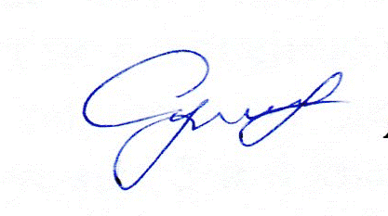

Appendix: Photos

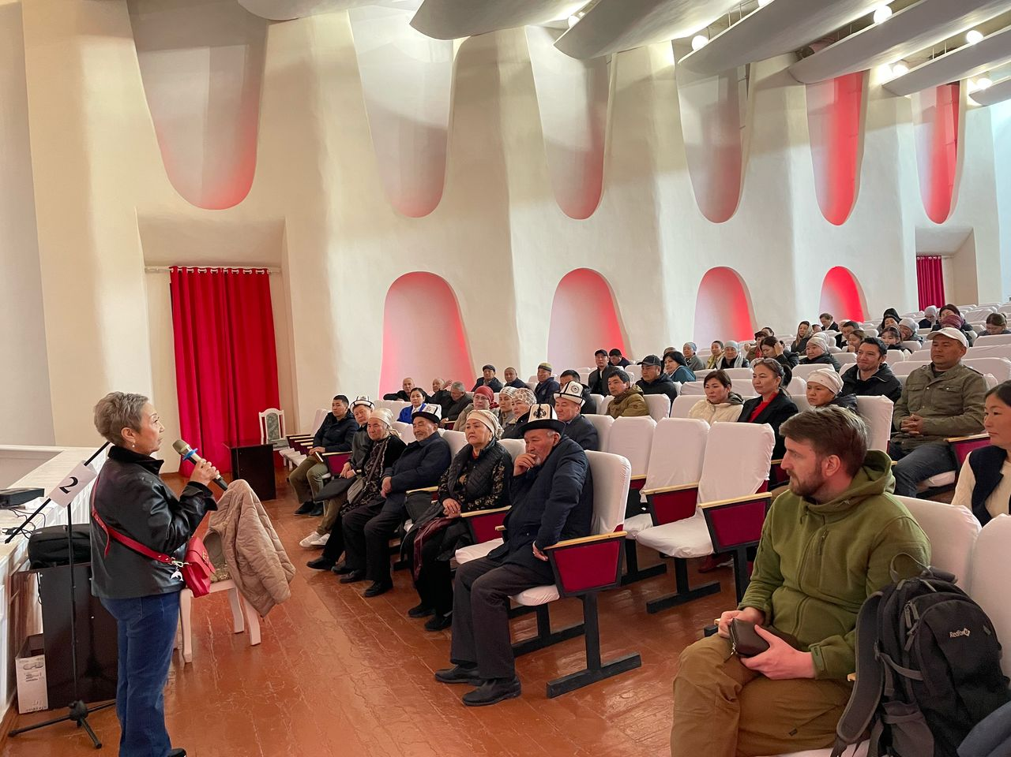

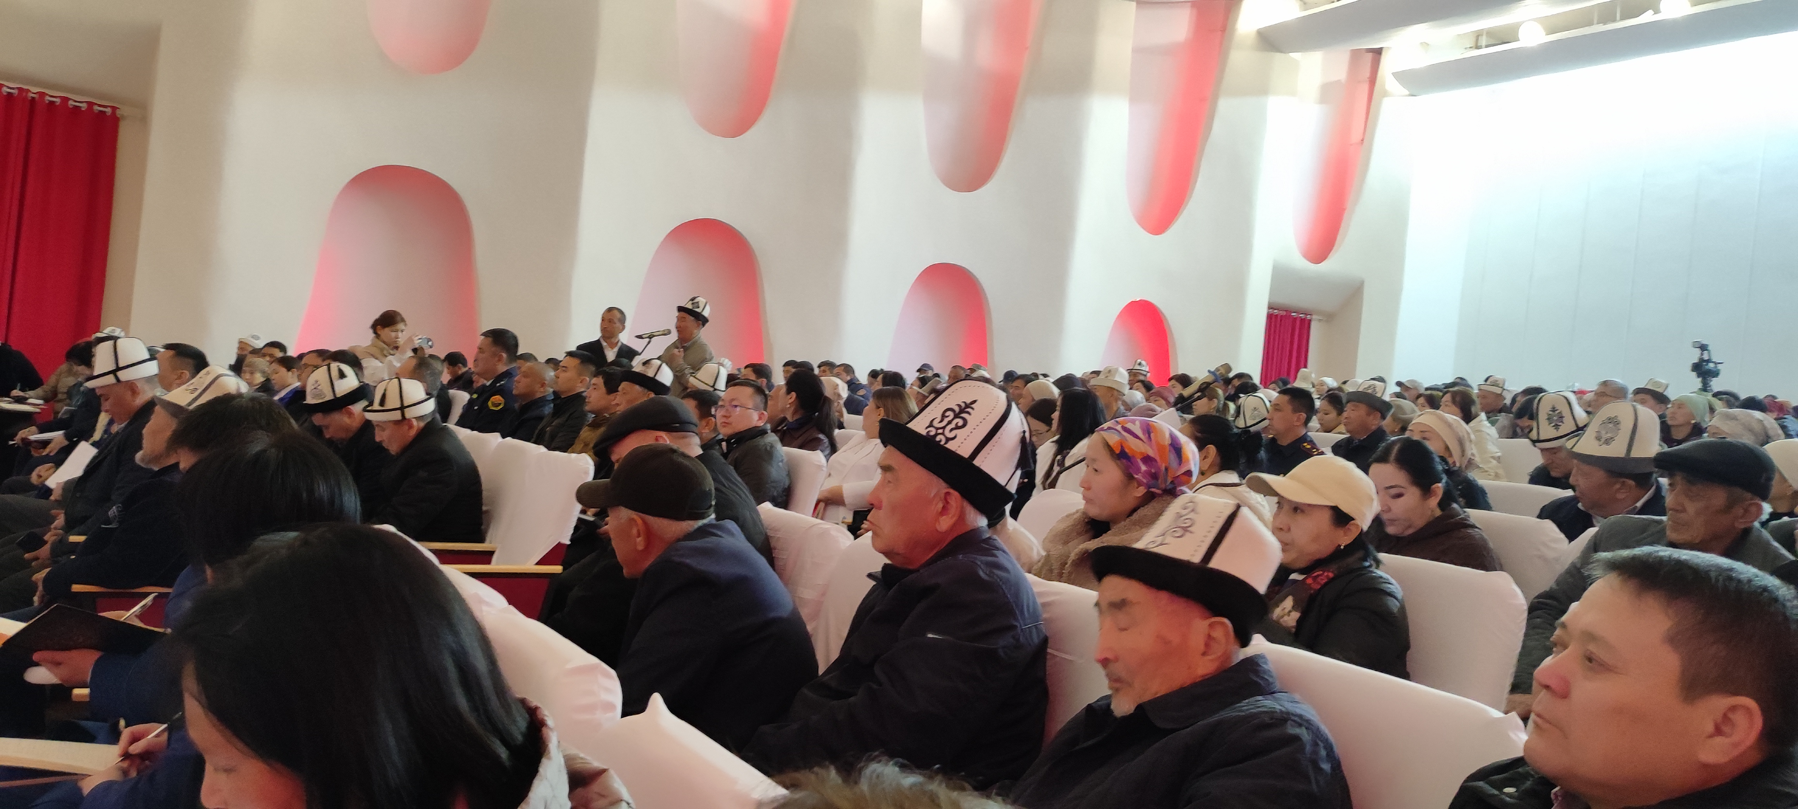

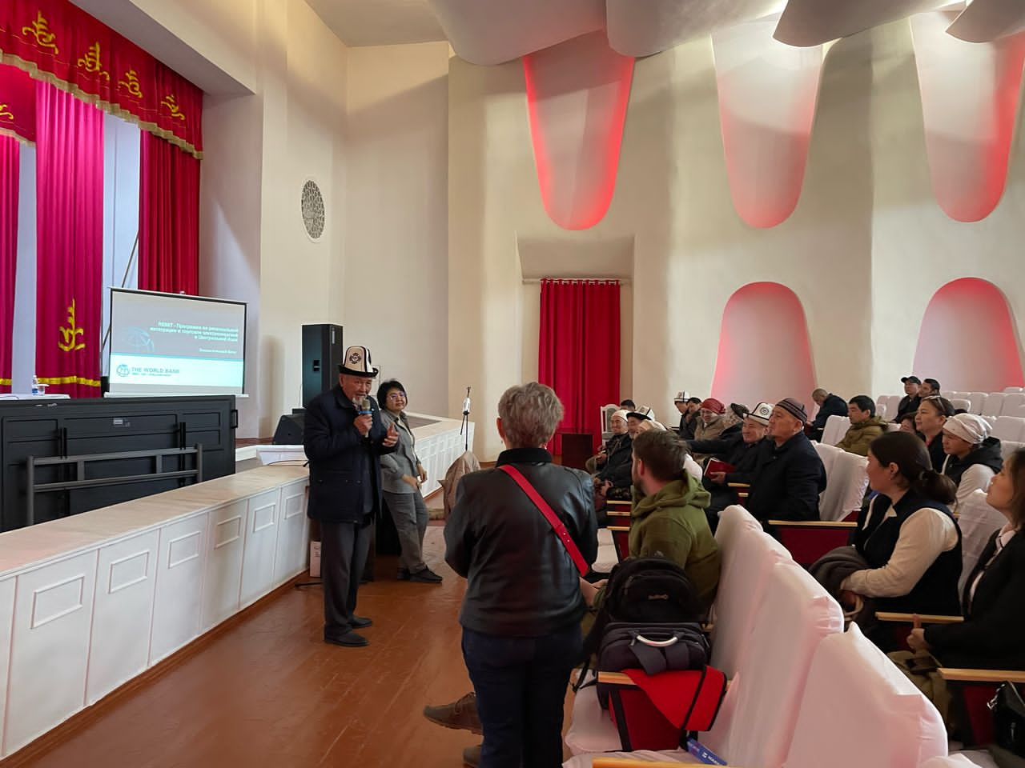

## Appendix 4. Details of the meeting process Bishkek

/machine translation/

**MINUTES**

of public consultations on informing the public about the social and environmental aspects of the Regional Electricity Market Interconnectivity and Trade (REMIT) project in Bishkek, at the NESK building

**Place, date, and time of public consultations:**

Bishkek, April 17, 2025

**Method of informing the public:**

Public consultations on the planned Regional Electricity Market Interconnectivity and Trade (REMIT) project and the work done to develop documents on the social and environmental aspects of this project in the Jalal-Abad region by the contractor, Energy Consult.KG LLC.

**Chair of the public consultations:** Representative of NESK, Director of the REMIT Project GRP, A.R. Tyumenbaev

**Speakers:** Aigul Sultankulova, Director of Energy Consult.KG

Ruslan Ryabikin, ecologist, head of the Energy Consult KG monitoring group

Chinara Biyalieva, Sociologist, Energy Consult KG

Elena Gavrilova, Lawyer, Energy Consult KG

**Secretary of public consultations:** Zhanna Imankulova, Expert, Energy Consult KG

**Participants in public consultations:**

Twenty-five people took part in the public hearings.

**Subject of public consultations:** The planned REMIT project, which includes the modernization/reconstruction of the Kristall and Torobaeva, as well as the replacement of wires with increased capacity on existing 220 kV Kristall-Yulduz power line supports, and discussion of the social and environmental aspects of the project in the Jalal-Abad region.

**Basis for public consultations:**

The purpose of the public consultations was to inform NEGK and PIU employees about the planned REMIT project, which includes the modernization/reconstruction of the Kristall and Torobaeva transformer substations, as well as the replacement of wires with increased capacity on the existing supports of the 220 kV Kristall-Yulduz power line, and the socio-environmental aspects of the above-mentioned project in the Jalal-Abad region, with the aim of taking into account the opinions of NEGK specialists, PIU employees, and public organizations.

The public consultations were attended by employees of the REMIT project PIU, representatives of the NEGK services, and employees of the Jalal-Abad branch of NEGK and representatives of three public organizations participated via videoconference. A list of participants with signatures is attached.

**Procedure for conducting public consultations:**

- Welcome speech by the representative of the National Energy Regulatory Commission - Director of the REMIT project PIU, Akylbek Rabayevich Tyumenbayev.

General information on the topic of public consultations and their objectives.

- Overview information on the planned REMIT project and the project consultant company was presented by the director of Energy Consult.KG Aigul Sultankulova, who also briefly described the documents developed for the executive agency to comply with national legislation and the World Bank's ESS, the protective measures provided for employees, the principles of interaction with stakeholders, and the support and protection measures provided in the event of forced resettlement.

- A presentation on informing about social aspects within the framework of the REMIT project in the Jalal-Abad region was given by Chinar Biyalieva, a sociologist at Energy Consult. KG.

- A presentation on environmental aspects within the REMIT project in the Jalal-Abad region was given by Ruslan Ryabikin, an environmental expert at Energy Consult. KG.

Both presentations were based on the ESMF document.

- A presentation on the documents developed for the project - “Resettlement Policy Framework,” “Labor Management Procedures,” and “Stakeholder Engagement Plan” - was given by Aigul Sultankulova, director of Energy Consult. KG.

- Elena Gavrilova, lawyer at Energy Consult. KG, spoke on the legal aspects of the project related to land issues and forced resettlement.

- **Consideration of questions and suggestions from participants in the public consultations.**

No comments or suggestions were received from participants regarding the proposed procedure for conducting public hearings.

During the meeting, the participants discussed the expected impact on the environmental and social life of the region, in particular the nearby villages, as a result of the implementation of the above-mentioned project.

The REMIT project involves the creation of a pilot regional electricity market between the countries of Central Asia. It aims to meet the growing demand for energy in the region through the efficient use of available and cheaper energy sources. The direct positive effects will be seen in meeting the growing demand for electricity in the region by increasing the capacity of transformer substations and the throughput capacity of 220 kV power lines. The regional electricity market will facilitate commercial trading and attract investment in the energy sectors of Central Asian countries, provided that the region's power system has sufficient capacity to support the growth in trade.

The project includes the modernization/reconstruction of the Kristall and Torobaeva transformer substations, as well as the replacement of wires with increased capacity on the existing supports of the 220 kV Kristall-Yulduz power line in the Jalal-Abad region. The project aims to improve the reliability of electricity supply to consumers in Kyrgyzstan, including the population, taking into account the growth in prospective demand (loads), the development of social facilities, industry, new production facilities, and the accelerated development of trunk electricity networks. The project also takes into account environmental and social aspects aimed at preventing, minimizing, and mitigating environmental and social risks and impacts in the region during its planning and implementation.

The social benefits of the project were also presented to those present, such as improving the accessibility and reliability of energy supplies for the region's population, developing local infrastructure, improving the quality of energy supplies, attracting investment to the region, generating additional tax and social contributions, and creating new jobs during the project's implementation. Factors such as infrastructure development and job creation will improve the quality of life of the local population and contribute to social stability. Information was provided on possible risks and measures to minimize them. Information was provided on the possible social impacts of the project and measures to minimize them. Risks such as labor risks associated with the influx of temporary workers, possible disputes with local communities, community health and safety issues during reconstruction work, temporary restrictions on access to public places, possibly homes, social infrastructure, impact on land use (Kristall-Yulduz), impact on agriculture (Kristall-Yulduz), temporary impact on traditional lifestyles of local communities due to land use, grazing, and temporary negative effects from work (noise, dust, pollution, etc.), temporary inconveniences with power supply due to construction work, Households within a 20 m radius of the facilities may be affected.

Mitigation measures:

Ensure the involvement of local residents in decision-making processes related to the use and redevelopment of land for energy projects.

Conduct open consultations and discussions with representatives of local communities to identify their concerns and suggestions.

Conclude agreements and contracts between energy companies and local communities regarding the possible use of land and compensation.

Carrying out construction work during the off-season, if possible after the harvest, to minimize the impact on agricultural land.

Using rural roads and embankments between fields to move equipment and workers where possible, reducing the risk of damage to crops.

Compensation for damage – if crop damage cannot be avoided, farmers will receive full compensation, the amount of which will be assessed by the relevant authorities in accordance with established procedures.

In terms of the environment, the project may have the following negative impacts:

Air pollution and greenhouse gas emissions (construction work, transport, SF6 emissions)

Water pollution (oil spills, construction waste runoff)

Soil disturbance (earthworks, laying of new lines)

Potential impact on biodiversity (changes in the habitat of birds and animals)

Impact of hazardous and other waste and associated soil and water pollution, leakage of toxic substances (oil, elegas, PCBs), danger to human health and ecosystems, disruption of ecosystems due to improper waste disposal, etc.

To reduce the negative impact, the following measures are planned:

Control of construction work (pollution control, protection of water bodies)

Minimization of pollutant emissions

Waste disposal and control of chemicals

Protection of biodiversity (habitat conservation measures)

The implementation of these measures will ensure the sustainability of the project and reduce its environmental impact.

**ESMF** is a key tool for controlling and reducing risks, including:

Analysis of possible environmental and social impacts

Development of an impact management plan

Institutional mechanisms for implementing protective measures

Monitoring and regular assessment of the effectiveness of the solutions implemented

Key aspects of interaction:

Conducting public consultations

Informing the public through the media, social networks, and the Internet

Taking into account the opinions of the local population during project implementation

Developing compensation mechanisms for impacts on land plots and infrastructure

The beneficiaries of the project are not only recipients of benefits, but also active participants in the process.

Following the presentations, time was set aside and all participants in the public consultations were given the opportunity to ask questions.

**Questions asked during the discussion**:

Participants had questions about the technical parameters of the project – what equipment would be replaced, how, etc.

These questions were answered by the PIU director – specific technical issues will be decided by the NEGK Technical Council until they are finalized. The consultant developed framework documents without considering the technical details of the project.

Extensive comments were made by NEGK employee Raimkulov R.

1. Comment: The EIA should be carried out in accordance with the requirements of Kyrgyz legislation, not the requirements of the World Bank.

Response: The EIA is carried out in accordance with the requirements of Kyrgyz legislation, pursuant to Kyrgyz Republic Decree No. 60 of February 13, 2015, “On the Approval of the Regulations on the Procedure for Conducting Environmental Impact Assessments in the Kyrgyz Republic,” as the conclusion of the environmental review is issued by the authorized state body of the Kyrgyz Republic.

2. The following comment regarding compensation: according to Raimkulov, there is no need to develop a PDP, as Kyrgyz legislation does not require this and there is no need to follow the principles of the World Bank's ESS.

Response: If the legislation of the country where the project is implemented does not provide for protective measures for those affected by the project, the ESS and World Bank requirements prevail. This applies to all projects financed by the World Bank.

3. Comment by Raimkulov R. The consultant must not only develop the documents, but also be responsible for all legal and regulatory compliance during the project implementation process. In other words, if the consultant provides estimated figures, he is responsible for all payments.

Answer: The consultant cannot be responsible for the project implementation process, as this is the competence of the NEGK and the PIU. Moreover, the consultant is not involved in real estate appraisal, as this can only be done by licensed independent appraisers (companies).

Elena Gavrilova, a lawyer at Energy Consult KG, also provided clarification on this issue. The other participants had no questions for the consultant.

All participants were informed about the possibility of providing feedback by email and telephone.

Photos from the event are attached to the Public Consultation Protocol.

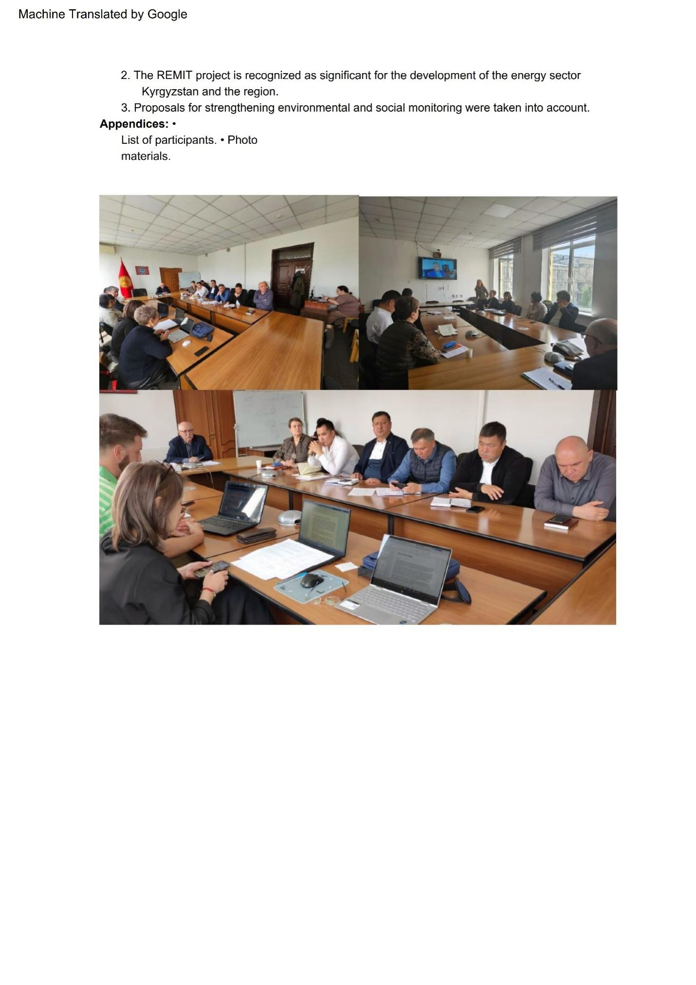

## Appendix 5. Lists of meeting participants

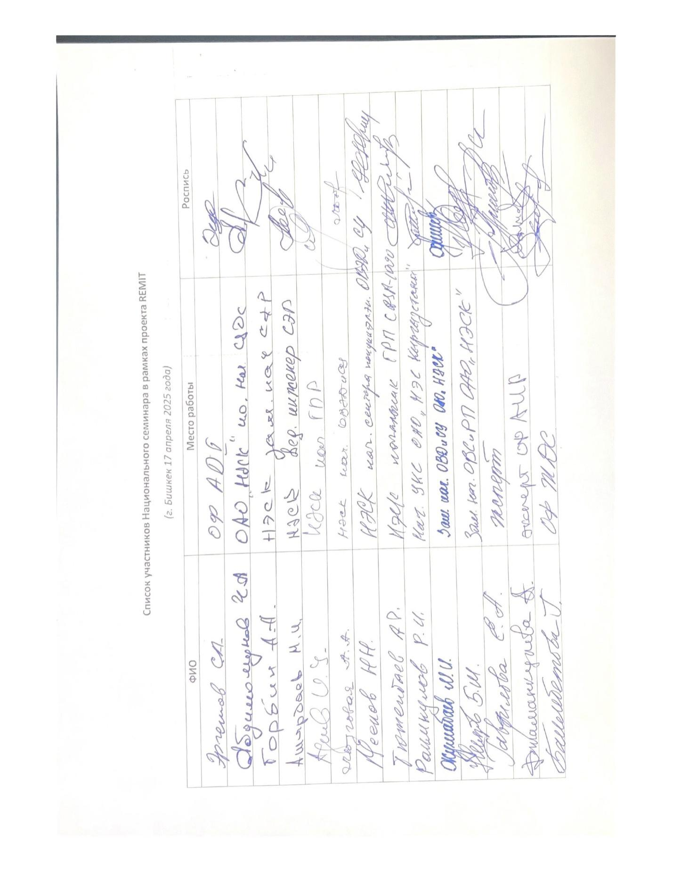

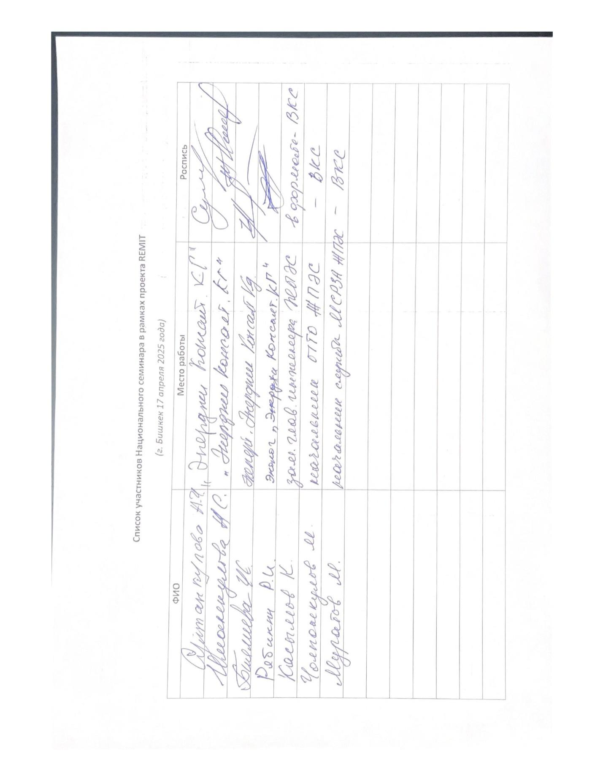

1. Vulnerable status may be based on a person's race, national, ethnic or social origin , skin color, gender, language, religion, political or other views. or groups.