Environmental Protection Chapter (Environmental and Social
Impact Assessment)
Correctionon the bypass route of the power transmission line between the towers 280L[284] - 302L[306]
CASA 1000Project

TABLE OF CONTENTS
TABLE OF CONTENTS 3
LISTOFABBREVIATIONS 9
LISTOFTERMINOLOGY 10
EXECUTIVE SUMMARY 15
1. INTRODUCTION 22
1.1. Project Background 22
1.2. Project Overview 23
2. ENVIRONMENTAL IMPACT ASSESSMENT IN THE KYRGYZ REPUBLIC 24
2.1. Environmental and Social Impact Assessment Methodology 24
3. LEGAL, REGULATORY AND ADMINISTRATIVE FRAMEWORK 26
3.1. Current Regulatory Legal Acts of the Kyrgyz Republic applied in the preparation of the EIA Project 26
3.2. Required licenses, permits and approvals for the implementation of the CASA 1000 project 34
4. PROJECT DESCRIPTION 37
4.1. Power line route 37
4.2. The need for works 37
4.3. Design and layout of power lines 42
4.4. Power line requirements 43
4.5. Materials and equipment 44
4.6. Access roads 45
4.7. Construction camps 45
5. ANALYSIS ADVANTAGES OF THE PROJECT 46
5.1. Technological and engineering solutions (basic variant) 47
6. ENVIRONMENTAL AND SOCIAL ENVIRONMENT 49
6.1. Climatic and meteorological conditions 49
6.2. Environmental quality 50
6.3. Air quality 50
6.4. Noise level 52
6.5. Vibration level 52
6.1. Surface waters 54
6.2. Hazard zones and forecasts of possible activation of hazardous processesand phenomena 54
6.3. Engineering and geological surveys 54
6.4. Geological and lithological structure 55
6.10. Soil-forming rocks 56
6.11. Soil fertility and quality 57
6.11.1. Soil on the platforms under the supports 58
6.12. Vegetable kingdom 63
6.13. Animal kingdom 69
6.14. Examination of the territory to identify objects of historical and cultural heritage (archaeology) 78
6.15. Human environment 81
7. ASSESSMENT OF POTENTIALLY SIGNIFICANT IMPACTS 84
7.1. Air impact assessment 84
7.1.1. Construction phase 84
7.1.2. Operational phase 86
7.1.3. Conclusions 86
7.2. Impact assessment on surface and groundwater 87
7.2.1. Construction phase 87
7.2.2. Operational phase 88
7.2.3.Conclusions 88
7.3. Impact on landscape, soils and land resources assessment 88
7.3.1. Construction phase 89
7.3.2. Operational phase 90
7.3.3. Conclusions 91
7.4. Flora and fauna impact assessment 92
7.4.1. Construction phase 92
7.4.2. Operational phase 93
7.4.3. Conclusions 93
7.5. Impact on terrestrial animals 93
7.5.1. Construction phase 93
7.5.2. Operational phase 94
7.5.3. Conclusions 95
7.6. Physical Impact Assessment 96
7.6.1. Construction phase 96
7.6.2. Operation phase 98
7.6.3. Conclusions 100
7.2. Environmental impact of waste 100
7.2.1. Generation and types of waste 100
7.2.2. The impact of waste on the environment 101
7.2.3. Mitigation measures 102
7.2.4. Conclusions 102
7.3. Assessment of impact on objects of historical and cultural heritage 103
7.3.1. Construction phase 103
7.3.2. Operational phase 103
7.3.3. Conclusions 104
7.4. Assessment of the socio-economic impact of the project 104
7.4.1. Positive impact on socio-economic factors and population 105
7.4.2. Adverse risks and impacts on human health and socio-economic factors 105
7.4.3. Potential labor risks 109
7.4.4. Responsible staff 111
7.9.5. Conclusions 115
8. LABOR PROTECTION 117
8.1. Principles of Safe Work Performance 118
8.2. Emergencies Risk Assessment 119
8.3. Accident Elimination Plan during Construction Works 120
8.4. Response to the COVID 19 pandemic 121
9. ENVIRONMENTAL AND SOCIAL MANAGEMENT PLAN 122
Basic ESMP 125
10. STAKEHOLDER ENGAGEMENT / PUBLIC CONSULTATION PLAN 148
11. THE GRIEVANCE REDRESS MECHANISM 150
BIBLIOGRAPHY 152
ANNEXES 157
Appendix 1. Bypass route map 158
Appendix2. List of equipment and vehicles for construction 159
Appendix3. List of Structures required for changes in the bypass section 160
Appendix 4. Plan for the location of access roads 162
Appendix5. Summary of the number of supports and components 163
Appendix 6. Characteristics of climatic conditions of the main affected areas 165
Appendix 7. The results of measuring the concentration of pollutants in the air 166
Appendix 8. Protocols of the Kadamzhai Centre for Disease Prevention and State Sanitary and Epidemiological Surveillance - the results of the study of atmospheric air 167
Appendix 9. Results of noise level measurements 169
Appendix 10. Noise standards in the Kyrgyz Republic 170
Appendix 11. Protocols of the Kadamzhai Centre for Disease Prevention and State Sanitary and Epidemiological Surveillance” – noise study results 171
Appendix 12. Vibration measurement results 173
Appendix 13. Sanitary standards "Industrial vibration, vibration in the premises of residential and public buildings" SN 2.2.4 / 2.1.8.566-96 174
Appendix 14. Protocols of the Kadamzhai Centre for Disease Prevention and State Sanitary and Epidemiological Surveillance –soil pollution study results 176
Appendix 15. Protocols of the Kadamzhai Centre for Disease Prevention and State Sanitary and Epidemiological Surveillance – soil pollution study results 186
Appendix 16.The results of the analysis of the fertility of soil samples 188
Appendix 17. The results of the obtained data on the mechanical and microaggregate composition 189
Appendix 18. Calculation of waste generation volumes 190
Appendix 19. Conclusion of the archaeological survey of the territory 199
Appendix 20. Explication of land plots 202
Appendix 21. List of participants in the public discussion 206
Appendix 22. Coronavirus (COVID-19) Readiness Report Form 207

LIST OF FIGURES
Figure 1.1.1. Schematic layout of the line connectiong four countries 22
Figure 4.2.2. Map of the general location of the OHTL 40
Figure 4.2.3. Map of bypassing route of OHTL 41
Figure 4.3.1. Plan for the assembling metal structures of OHTL 42
Figure 6.3.1. General map of air sampling points 51
Figure 6.5.1. Map of the area surveyed for noise and vibration levels 53
Figure 6.11.1.1. General map of soil sampling points 62

LIST OF TABLE
Table 2.1.1. Identification of the indicators of spatial scale of impact 25
Table 2.1.2. Identification of indicators of time scale of impact 25
Table 2.1.3. Determination of indicators of significance of changes in the natural environment (outside the
site under technical facilities) 25
Table 3.2.1. List of licenses, permits and aprovals during the implementation of the project 34
Table 4.4.1. International norms and standatrts 43
Table 4.4.2. The shortest vertical distance from the wires overhead line to the ground surface, industrialbuildings and structures in populated areas 44
Table 6.11.1. Quantitative parameters to assess soil status on humus content (According to Grishina, Orlov,
1978) 58
Table 6.11.1.1. The results of chemical analysis of soil samples at the sites for towers 60
Table 7.1.1.1. Normative data on pollutants emitted into the atmosphere during the work 85
Table 7.1.3.1.Comprehensive assessment and significance of the impact on theatmospheric air 86
Table 7.2.3.1. Comprehensive assessment and significance of the impact on the surface and ground water88
Table 7.3.4.1. Comprehensive assessment and significance of impacts on land resources and landscape 91
Table 7.4.3.1. Comprehensive assessment and significance of the impact on the flora 93
Table 7.5.3.1. Comprehensive assessment and significance of the impact on the fauna 96
Table 7.6.2.1.1. Maximum permissible levels of electric and magnetic fields 99
Table 7.6.3.1. Comprehensive assessment and significance of physical impact 100
Table7.7.6.1. Assessment of significance of the impact from the waste generation 102
Table 7.8.3.1. Comprehensive assessment and significance of the impact on the HCH objects subject to safety regulations in the course of construction work 104
Table 7.9.1. Comprehensive assessment and significanceof the impact on the social and economic environmenton the territory of the Project 115

LISTOFABBREVIATIONS
АА | Aiyl Aimak
a.a.m. | Absolute altitude in meters
APC | Approximate Permissible Concentration
CSC | Construction Supervision Consultant
dBA | Acoustic decibel
E | Environment
ES | Emergency situation
ESIA | Environmental and Social Impact Assessment
ESMP | Environmental and Social Management Plan
FS | Feasibility Study
HCH | The historical and cultural heritage
Hz | Hertz (unit of measurement )
IEMC | Independent Environmental Monitoring Consultant
IFI | International Financial Institutions
KR | Kyrgyz Republic
m.a.s.l. | meters above sea level
mg/kg | milligrams per kilogram
mg\l | milligrams per liter
MPC | Maximum Permissible Concentration
MPD | Maximum Permissible Discharges
MPE | Maximum Permissible Emissions
MPL | Maximum Permissible Level
NAS KR | The National Academy of Science of KR
NESK/ JSC "NEGK" | National Electric Grid of Kyrgyzstan
NLA | Normative legal acts
OHTL | overhead transmission lines
OJSC | Open Joint Stock Company
OP  PAP | Operational policies  Project Affected Person
PIU | Project Implementation Unit
PTL | power transmission line
RAP | Resettlement Action Plan
SAEP&F | State Agency for Environmental Protection and Forestry under the Government of Kyrgyzstan
SER | Sanitary and epidemiological requirements
SPZ / SG | Sanitary Protection Zone / Sanitary Gap
SFF | State Forest Fund
WB | The World Bank
OP 4.01/4.12 | World Bank Policies

LISTOFTERMINOLOGY
Aiyl Aimak (АА) – an administrative-territorial unit that consists of one or several villages, inwhich local community performs local self-government in accordance with the procedureestablished by the Constitution and Laws of the Kyrgyz Republic.
Biota - a set of plant, animal and microorganism species united by a common area of ​​distribution. Unlike biocenosis, it may be characterized by the absence of ecological links between species¹.
animal species, or for formation of certain biological community.
Water Protection Zone- in order to protect water facilities and prevent emergency situations in the territory of the Kyrgyz Republic, water protection zones (strips) are established around water intakes, reservoirs, pumping stations, canals, treatment facilities and technical devices. The territories of water protection zones (strips) in accordance with the land legislation of the Kyrgyz Republic belong to the lands of the water fund and are transferred to the management of specially authorized bodies. The provision of water fund lands allocated for water protection zones (strips) for other purposes and needs without the consent of specially authorized state bodies is not allowed.
Overhead Transmission Line (OTL) – a structure for transmitting electricity through wires locatedintheopenairandattachedbyinsulatorsandfittingstotowersorbracketsandracks.
Pollutant Emission - the release of pollutants into the atmospheric air from a source of pollution.
Household -a group of two or more people living together in a same dwelling and providing themselves with everything necessary for life through a common household, wholly or partly pooling and spending their funds. These persons may be relatives, or a married couple, or persons without family ties.Ahouseholdmayconsistofonepersonlivinginahousingunitandprovidinghimself/herselfwitheverythingnecessary for life.
Pollutants – are substances that, when released into the environment at a certain concentration, pose a threat to human health, the state of flora and fauna, material and cultural values.
Land plot - the area of land within certain borders.
Forest Fund lands – lands that are covered with forest, as well as those that are not covered with forest, but provided for forestryneeds.
Publicly Protected Land(PPL) - lands of state reserves, natural national parks, wildlife sanctuaries (except for hunting ones), natural monuments, botanical gardens, dendrological and zoological parks, natural areas for health purposes.
Landsofindustry, transport, communications, andenergysupply- thelands granted in accordance with the established procedure for the placement and operation of basic structures, facilities, processing and recycling industrial enterprises, thermal and other power plants, power structures and installations and occupied by subsidiary structures, in-house access roads, administrative buildings, as well as land plots intended or used for the needs of industry, and located outside of cities, towns, urban and rural settlements.
The Red Book - a collection of information about the biology, state of populations and habitats of rare, endangered or vulnerable species of fauna and flora and fungi, existing and recommended measures for their conservation, restoration and sustainable use.
Hazardclassoftheobject- thecategoryoftheobject, whichisestablisheddependingonthecapacity, operatingconditions, natureandquantityofthepollutantsreleasedtotheenvironment, noise, vibration, non-ionizingradiation, whichhaveanadverseeffectontheenvironmentandhumanhealth.
Burial mound (Kurgan) - a grave mound of soil and stones, usually of hemispherical or conical shape.
Landscape– anareaofearthsurface, withinlimitsofwhichall-naturalconstituents (surfacelayeroftheatmosphere, terrain, vegetation, soilsandsubsurfacepartofsoilwithcontainedinitsubsurfacewaters) areresidingwithinterdependentandmutuallyconditionedunity.
Power Transmission Line (PTL) - one of the components of the electrical network, a system of power equipment designed to transmit electricity through electric current. The wires of a working power line create electric and magnetic fields of industrial frequency in the adjacent space.
Project Affected Persons – persons who may be directly affected by the “CASA 1000” Project due to the construction of the transmission line, namely the acquisition of land or other real estate, which may adversely affect their assets, including economic livelihoods.
Migration - the movement, redistribution of someone or something (animals from one area to another; chemical elements in the earth’s crust and on the surface; population within a country or from one country to another. etc.).
Magnetic field (MF) of a high-voltage line of industrial frequency- an integral part of EMF created in the immediate vicinity of the overhead line wires under voltage of 400 kV and higher. The MPL of the magnetic field of overhead lines for the population is not standardized.
Maximumone-timemaximumpermissibleconcentration (MPCOT) - a maximum of 20-30 minutes concentration, under the influence of which a person does not have reflex reactions(delay in breathing, changes in the bio potentials of the cerebral cortex, sensation of smell, irritation of mucous membranes, etc.), and at a regulated frequency of repeated exposures (at least 99% of the samples) subacute effects of a nonspecific and specific nature do not appear (an increase in the number of requests for medical assistance for exacerbation of diseases of the lungs, heart, etc.).
Environmentalmonitoring (ecologicmonitoring) -asystemofobservations, evaluationandforecastofnaturalenvironmentcondition, sourcesofman-madeimpactandearlyrecognitionofecosystemtrendsfordecisionmakingpurposesinthesphereofenvironmentprotectionanduseofnaturalresources.
Historical and cultural heritage objects-a place, a structure (creation), a complex (assembly), parts thereof, territories or water bodies that are associated with them, other natural, naturally anthropogenic or human-generated sites irrespective of integrity state, those that havevaluein present days from anthropologic, archaeological, aesthetic, ethnographic, historical, scientific or artistic perspective and preserved their authenticity.
Objects affected by the project –objects (residential and outbuildings, garden facilities, agricultural lands and other real estate objects, affected by the CASA1000 power transmission line, located on the territory with a special mode of use (within the sanitary gap).
Provision of environmental safety – a system of measures and events aimed at elimination of risk of causing harm to the environment, health and property of people.
LocalSelf-Government (LSG) - representative and executive bodies providing solution of issues of local significance.
Daily Safe Reference Levels of Impact (SRLI) -temporary (temporarily introduced) indicative hygienic standard (HS) for the content of harmful substances in the air of the working area, the atmospheric air of populated areas, in water bodies, food products and other objects. It is determined by calculation according to the parameters of toxicometry and according to the physicochemical properties. Approved for a limited period (2-3 years), after which the MPC must be replaced, re-approved for a new period or canceled depending on the prospect of using the substance and the available information on its toxic properties.
Orography of the area - adescriptionofvariouselementsofterrain (ridges, elevatedplains, basins, etc.) andtheirclassificationbasedonexternalcharacteristicsirrespectiveoforigin.
Land acquisition - a transfer by the owner or land user of the right to a land plot to another person or its transfer to a temporary use by another person by means of civil transactions.
Production waste - residues of materials, raw materials, semi-finished products formed during the production of products or work and have lost their consumer properties in whole or in part, as well as related substances formed in the production process and not used in this production.
Сonsumer waste - products, materials and substances that have lost their consumer qualities due to their physical or moral wear and tear. Consumer waste also includes municipal solid waste that occurs in the process of human life.
Occupational safety - a system of measures to preserve the life and health of workers in the course of labor activity, including legal, socio-economic, organizational and technical, sanitary and hygienic, medical and preventive, rehabilitation and other measures.
Environmental and Social Impact Assessment (ESIA) - identification, analysis, assessment and accounting in project solutions of the expected impact of the planned economic and other activities, the changes caused by it in the environment.
Personnel (employees) - persons professionally associated with the construction and / or maintenance of power lines.
Environmental and Social Management Plan(ESMP) - a document that lists: (a) the measures to be taken during the implementation and operation of the project in order to eliminate or neutralize adverse effects on the environment and social environment or reduce them to an acceptable level; and (b) the actions required to implement those measures. The ESMP is an integral part of the environmental assessment of a category-A project (irrespectiveofotherapplicablemechanism).
Maximum permissible concentration of a pollutant (MPC) - environmentalstandards, maximumconcentrationofcontaminatingchemicalcompoundcontainedinlandscapecomponents, theonethatuponday-to-dayimpactandduringlongstagedoesnotcausenegativeeffectonhumanbodyoranotherreceptor.
Project documentation- a set of graphic, design and text documents that determine the architectural, functional, technological, structural and engineering solutions required to support the construction, reconstruction or other changes in construction and / or their parts.
Sanitary Gap (SG)- the minimum distance from the source of harmful effects to the border of residential construction, landscape and recreational zone, recreation area, resort. The sanitary gap has a SPZ regime, but does not require the development of a project for its organization. The size of the gap is set in each specific case on the basis of calculations of dispersion of atmospheric air pollution and physical factors (noise, EMF, etc.)
The average daily maximum permissible concentration (ADMPC) - theconcentrationofpollutants, whichdoesnotaffectdirectlyorindirectlyapersonforindefinitelylong (years) inhalation.
Developer of the ESIA (the executor of theESIA work, the Consultant) - a legal entitythat prepares and develops the ESIA, to which the initiator of the project has granted the right to carry out this work.
Land Reclamation - a complex of engineering and technical, land-reclamation, agrotechnical and other measures aimed at restoring the biological productivity and economical value of disturbed lands, as well as improving environmental conditions.
Emergency situation - a state in which, as a result of the occurrence of a source of emergency situations at an object, in a certain territory, the normal conditions of life and activity of people are violated, a threat is caused to their life and health, damage is caused to the property of the population, the national economy and the natural environment.
Ecosystem– An ecosystem can be defined as a biological system that consists of all the living organisms (plants and animals) in an area as well as the nonliving things with which the organisms interact. In an ecosystem, all the components are interdependent on each other..
Operational Policies of the World Bank (OP4.01/4.12) -These policies are considered as the Bank's overarching policy strategies in the areas of: Environmental Assessment OP/BP 4.01, Involuntary Resettlement OP/BP 4.12
Electric field of the high-voltage line of the industrial frequency (EF) -a component of the EMF generated by HVL, which is under voltage of 400 kV and higher, in the sanitary protection zones adjacent to the transmission line of the HVL. EF also is a physical normalized factor of harmful effect on biological species with systematic influence on them by levels of tension electric field exceeding the MPL.
Electricalnetwork (EN) - asetofsubstations, switchgearandpowerlinesconnectingthem: designedfortransmissionanddistributionofelectricalenergy.
Erosionofsoils- a removal of loose material, including soil from the surface of plowed areas under the influence of water or wind. It leads to depletion or destruction of the soil; and could be planar, or area, carried out by planar (stratified, streamlet or stream) flushing and linear, carried out by ravines.Erosion of the soil is caused by the technical and economic activities of man and has appeared since the beginning of cultivation of the land. Itcausesgreatdamagetoagricalture.

EXECUTIVE SUMMARY

The World Bank is financing the Central Asia-South Asia Electricity Transmission and Trade Project (CASA-1000) (hereinafter referred to as the Project or CASA-1000 Project), which will facilitate the trade of 1,300 megawatts (MW) of electricity, i.e., existing summer surplus electricity between the two regions, including the Kyrgyz Republic and the Republic of Tajikistan in Central Asia and the Islamic Republic of Afghanistan and the Islamic Republic of Pakistan in South Asia. The project preparation activities are guided by a 4-country Government-level Intergovernmental Council (IGC) and secretariat, which was established in 2011 in consultation with the 10-member Central Asia Regional Economic Cooperation (CAREC) program. The project mainly finances the construction and operation of the power transmission infrastructure in four countries, appropriate technical support during implementation, and benefit sharing arrangements with communities along the power transmission lines.

The project consists of a 500 kV power transmission line starting from Datka station in the Kyrgyz Republic and terminating at Sugd substation in the Republic of Tajikistan, and the construction of a corresponding 500 kV cell at Datka substation. The total length of the power transmission line across the country is 456 km and it passes through the south-western part of the Kyrgyz Republic.

The power transmission line (PTL) will pass through three administrative regions of the Kyrgyz Republic (Jalal-Abad, Osh and Batken) and nine districts (Leilek, Batken, Kadamjai, Nookat, Kara-Suu, Aravan, Uzgen, Suzak and Bazar-Korgon).

The PTL in the Kyrgyz Republic is conditionally divided into two sections: site TW05 (from the border between the Kyrgyz Republic and the Republic of Tajikistan to the beginning of Site TW06), which is about 126 km long, and site TW06 (from the end tower of TW05 to the Datka substation), which is about 330 km long.

The total length of the PTL is about 456 km, which requires the construction of 1,243 towers. In Batken oblast, 760 towers will be constructed. The sizes of the PTL power support sites are different and will range from 324 (18x18) to 784 (28x28) square meters. The height of towers will be from 30 to 63 meters (depending on the landscape of the area). The width of the PTL right-of-way for 1,209 towers will make 25.7 meters, and for 34 towers - 29.23 meters. In accordance with the Kyrgyz Republic legislation, the sanitary protection zone (for the PTL - sanitary gap (SG)) of the CASA 1000 project PTL on both sides of the external wires will be 30 meters. Thus, the preliminary SG corridor for 1,209 PTL towers will be 85.7 meters, and for 34 PTL towers - 89.23 meters.

Project Environmental Category. In accordance with World Bank safeguard policies and procedures, Operational Policy OP/BP 4.01 Environmental Assessment, and based on the proposed investments and baseline analysis, the project has been assigned Category A.
Expected project beneficiaries. These include communities along the power transmission line corridor thatcould potentially gain employment during the line construction phase, populations in Pakistan and Afghanistan due to reduced energy supply shortages, the Kyrgyz Republic and Tajikistan due to increased income and economic prospects. In Kyrgyzstan, all villages near the PTL will receive some form of support depending on the proximity to the power transmission line, and the village size and needs:
- villages located within 1.5 km of the power transmission line will receive small grants to improve electricity supply and village infrastructure;
- all aiyl aimaks along the PTL impact corridor willenjoy support to organize income generating facilities, especially for youth. Funding is planned for up to 30 facilities, which will be selected through a competitive process with community engagement. The KR residents will not experience any power shortage. Domestic consumer demand will remain at the top of the list.It is also the first commercially profitable project in the energy sector in the history of the country's independence. It will provide Kyrgyzstan with good opportunity to upgrade the energy sector infrastructure.
In addition, local communities along the PTL, in Kyrgyzstan and other Project countries, will receive 0.1 cents per kilowatt hour exported.

The proposed bypass route is the transfer of the location of 26 towers, with a total length of about 9,200 meters; the site is located on the territory of Batken region, Leilek district near the Suluktu city and Vostochny settlement.The development of a bypass route was required after ground movements were discovered in the old section, which could lead to an emergency in the future.
The construction period of the power transmission line is 6 months, taking into account the preparatory work, the deadline for the completion of all work under the Project is scheduled for the end of 2023.
The construction of each tower requires about 40 days, taking into account the preparatory work. According to the work schedule, the Contractor plans to carry out the work and install by three teams at the same time.
In accordance with the legislation of the Kyrgyz Republic, the developed document is an amendment of the Environmental and Social Impact Assessment (ESIA) for the planned bypass route with a length of about 9200 meters, and accompanies the project documentation, which corresponds to the third stage of the ESIA. The document is drawn up in the form of a section of the technical project “Environmental Protection”.
Purpose of project Environmental and Social Impact Assessment.The ESIA has been conducted to avoid, prevent or minimize possible environmental degradation caused by the construction of the PTL, to supplement the originally approved ESIA, to ensure environmental sustainability of the planned activity territory, and to contribute to better living conditions for the population’s life.
For this purpose, the following processes have been included and documented in the ESIA:
• description of Project activities along the planned 9,200 m bypass route;
• implementation of the detailed baseline environmental and social analysis;
• identification and assessment of potential environmental and social impacts and
problems, both negative and positive, associated with the Project;
• development of measures to prevent, minimize or eliminateadverse environmental and social impacts that may becaused by the Project along the explored section of the PTLroute.

The current ESIA is based on the main ESIA (for the entire route) which summarized the potential impacts from the construction and operation of transmission line underthe route change. The environmental and social management plans (ESMP) for the project implementation phase.and the program for the environmental and social supervision and monitoring have been developed and presented in the main ESIA for the entire PTL route.
The ESIA includes a comprehensive impact assessment of the selected technical option of the updated route; contains detailed description of technical solutions and measures to avoid, prevent, and mitigateidentified environmental and social impacts of the proposed activities; specifies Operational Health and Safety requirements for reducing potential impacts on the environment, staff, and health of the population.
ESIA legal framework. The ESIA has been conducted taking into account both, National Regulations and WB Operational Policies, the safety standards and industry recommendations.
National requirements in the field of environmental protection and natural resource management, as well as environmental impact assessment during the construction of industrial and linear facilities are regulated by the legislation of the Kyrgyz Republic “On environmental protection” (No. 53 dated June 16, 1999) and “the Regulation on the procedure for conducting an environmental impact assessment in the Kyrgyz Republic”, approved by the Decree of the Government of the Kyrgyz Republic No. 60 dated February 13, 2015.The major WB OPs applied while conducting the ESIA are OP 4.01 on Environmental Assessment and OP 4.12 – On Involuntary Resettlement. In addition, OP/BP 4.04 “Natural habitats”, OP/BP 4.11 “Tangible cultural heritage” and OP/BP 4.12 “Involuntary resettlement”.Besides, the WB Labor Management Procedures (LMP), and the WB Guidelines and Sector (Energy) Environmental, Health and Safety Guidelines, as well as the WB Civil Engineering Guidelines have been considered.Responding to the COVID 19 pandemic, the ESIA included documents adopted by the WB to combat the virus.
Potential impacts on birds.The most dangerous for birds are the PTL sections crossing floodplains of rivers or on the approach to reservoirs and feeding places, and those crossings the currently existing and planned PTL. The combination of night time, bad weather with precipitation or fog exacerbates the situation and is a serious factor in increasing bird mortality from collisions with the PTL wires. It is difficult to foresee such combination of factors and even more difficult to exclude, but at the operation stage, measures are provided to avoid the death of migratory birds through equipping the towers with the bird protection facilities.
Potential environmental and social impacts. PTL construction related impacts are likely to be short term and local, may vary depending on the specific PTL site, and can be mitigated by applying internationally recognized best construction practices.
Overall the project will generate the following impacts: (i) dust and noise and emission of pollutants during construction activities; (ii) solid and hazardous wastes; (iii) degradation of soil and grass vegetation; (iv)oil spills and leaks from the equipment and machinery which may contaminate soil and water resources; (v) risks of exposure to unconfirmed health effects from electric and magnetic fields; (vi) occupational health and safety risks; etc.
Potential environmental impacts associated with the construction and operation of the PTL. The environmental impacts associated with the construction of transmission lines are likely to be short-term and can be mitigated by applying internationally recognized best construction practices. As a rule, the impacts are associated with the following aspects, such as: (a) construction of 26 transmission towers required for the construction and support of the transmission lines which required throughout the Project; (b) construction of temporary access roads to the tower sites required during the construction of the project.
The impacts associated with the PTL can be summarized as follows:
- full loss of vegetation, but only at the location of towers’ construction sites;
- withdrawal of land from agriculturaluse, but only in theconstruction sites of power transmission towers;
- moderate or low fragmentation of habitat;
- low risk for fauna species at the site of installation of power transmission towers and areas adjacent to them;
- low increase of soil erosion;
- low and local impact of dust during the construction process;
- low potential noise effects during the construction of PTL;
- low and local level of disruption of local traffic;
- low and local impact on existing water and mineral resources and known deposits;
- low risk of impactbyunconfirmed health effects from electric and magnetic fields (after commissioning of the transmission line);
- low risk of occupational health and safety problems.

The project for the construction of a bypass route for the power transmission line does not provide for any impact on surface water sources.
Additional installation of temporary construction camps is not envisaged - existing base camps will be used.
The total area required for permanent withdrawal for the placement of towers will be 9.564 m² or 0.9564 ha, of which 0,3011 ha for cultivated agricultural land affecting 5 persons, and 0,6553 for pastures. The area of temporary withdrawal for construction sites and access roads to them will be 11.505 m² or 1,1505 hectares, of which 0,2511 hectares are cultivated agricultural lands.
During the PTL operation and maintenance phase, it is necessary to pay attentionto the health and safety of workers, and the polation’s health and safety aspects. The implementation of proven, internationally accepted, and environmentally sound designs, appropriate management and construction practices during PTL construction and operation will be enough to avoid, minimize, mitigate and compensate virtually all potentially specified adverse environmental and social impacts.
The impact of EMF has already been considered during the feasibility study and the main ESIA in the design of the transmission line route and the Corridor of Impact in order to ensure compliance with internationally recognized standards and requirements of the KR legislation. Therefore, no additional mitigation measures are proposed.
Potential Positive impacts. The potential benefits of the proposed Project relate more to social and economic aspects, including creation of new jobs and respectively, more employment and increasedincome; contribution to poverty reduction and improvement of country’s socio-economic conditions;increased capacity of national transmission company and of other stakeholders.
Potential impact during the PTL operation. The impacts during the PTLoperation phase will be of low and moderate significance. In order to protect the population from the impact of the electric field, created by PTL, sanitation-protective zones are set along the route of the high-voltage line, beyond which the electric field intensity does not exceed 1 kV/m. Electromagnetic fields will be regularly monitored during the O&M phase to ensure compliance with standards and requirements, and additional mitigation measures will be proposed as needed during the O&M phase. The frequency of control is determined based on the change in the technical parameters of the transmitted power for the project. Particular attention should be paid to the places of the shortest distance from residential buildings.
For the construction of the power line, it will be necessary to carry out land transformation. Land for permanent withdrawal must be transferred from the category (agricultural land, land of settlements, etc.) into the category of industrial, transport, communications, energy, defense and other land. When transferring agricultural land, the amounts of compensation for losses of agricultural production and lost profits must be paid, in accordance with the resolution of the GKR No. 1 of 05.01.2016 "On approval of the standards for the cost of compensation for losses of agricultural production and the use of funds received in the order of their compensation" Land explication plan presented in Appendix 20.
The bypass route does not affect permanent buildings (households) and does not imply resettlement. Implementation of the RAP will eliminate all risks associated with compensation payments. Theimpactisexpectedtobeinsignificant. To mitigate negative impacts, a Resettlement Action Plan will be developed and implemented prior to the commencement of preparation and construction works at the bypass section. The identified PAP will be informed of the purpose, timing and procedure of land withdrawal from land turnover or temporary use of land resources.
If land is permanently withdrawn, compensation will be paid for damage to the PAP at replacement cost. All such Compensation shall be paid prior to commencement of construction works on the bypass section as part of the RAP implementation. In case of land withdrawal on a temporary basis, losses caused to landowners and land users, including lessees, shall be compensated to them in full (including lost profit).
Additional pressure on local resources and infrastructure: Resources such as water and electricity will be required for construction activities and operation of the temporary camp. Obtaining these supplies from local sources will not put additional pressure on these sources as the temporary camp is already operational.
When carrying out construction and repair (at the operational stage) work, in some cases, the contractor will be forced, as part of the technological process, to block local roads and driveways (transport corridors), since the power transmission line is a linear Project. This can negatively impact local communities, especially in areas where access to social facilities is already a problem.
To address impacts associated with the closure of local roads and access routes will be addressed through the measures for minimization affect.
Grievance Redress Mechanisms (GRMs) have been developed to comply with national legislation as well as international standards, and tend to address both environmental and social issues. Grievances and claims can be considered through the following steps and actions in accordance with the existing GRM established by the PIU, both at the PTL construction and operation phase.
Complaints shall be considered by a specially constituted project Grievance Redress Committee (GRC) for the respective district administration and shall be resolved within 14 days of filing. If the district level GRC is unable to resolve the grievance within the 14-day period, grievances should be submitted through the GRC representative to the central PIU. The PIU leader will make the final decision after evaluating the case and carefully preparing the decision by the PIU resettlement representative. Grievances must be reviewed and resolved within 7 days of the grievance being filed. If within 14 days a decision is not reached at the PIU level, PAPs can additionally refer their case to the appropriate court.The grievance logs along with grievance handling forms are kept on site, all complaints are recorded in logs and tear sheets, which are given to the complaining PAPs to ensure an adequate and transparent grievance handling process. Using the grievance mechanism, PAPs can seek support from the PIU resettlement representative, who can be assisted by national and international consultants.
The project as a whole provides for all the necessary mechanisms and methods of labor protection and safety. The construction Contractor implements the presented mechanisms and reports to the representatives of the PIU.

In order to minimize / eliminate the impacts and risks on the environment, measures have been developed to preserve the environment. These activities will be included in the contract and instructions to the Construction Contractor (ESMP).
Environmental and Social Management Plan (ESMP). The ESMP was developed as part of the original ESIA to avoid, prevent, mitigate and monitor each potential impact identified in the assessment and is applicable for this section of the PTL. The ESMP includes a well-resourced program of for production control and monitoring of environmental components during the construction and operation of the proposed activity's sites.
The ESMP outlines the monitoring parameters, location and methodology of observations and, responsibilities of all parties at different stages of the Project implementation.
It should be noted that construction work on the main route of the transmission line is ongoing and the ESMP developed by the Contractor in line with the ESIA guidelines already contains sufficient measures to identify and minimize potential environmental impacts, which are confirmed by reports prepared by an independent environmental supervision consultant.
An additional budget for the implementation of the ESMP is not provided, because the original route will be replaced by a bypass route and does not have significant increases.
Institutional responsibilities and capacity to implement environmental safeguards.OJSC “NEG of Kyrgyzstan” will own, build and operate its part of the CASA 1000 Project using internationally recognized technical, environmental and other practices and standards for the transmission of electricity in the territory of the Kyrgyz Republic in accordance with the Agreement between the Government of the Kyrgyz Republic, OJSC “Electric Power Plants” and OJSC “NEG of Kyrgyzstan” in relation to the CASA 1000 power transmission line project.
OJSC “NEG of Kyrgyzstan”, through its local branches, Enterprises ofHigh Voltage Electrical Networks(EHVEN), will ultimately be responsible for environmental and social management and implementation of the ESIA and ESMP.
In addition, the PIU has hired, on a competitive basis, an Independent Environmental Monitoring Consultant (IEMC) who provides support to the PIU in the establishment and operation of environmental management systems, makes proposals for capacity building and its adjustment during the project implementation period, and monitors the implementation of the Contractor's plan for the implementation of the ESMP at the construction and operation stages. IEMC will carry out external monitoring and evaluation of compliance with the requirements of the ESMP.A Social Development Specialist has also been appointed in PIU to monitor implementation of social safeguard management including RAP.
ESIA disclosure and consultation. To identify and consider public preferences as well as to inform the stakeholders about the planned activities within the framework of the CASA 1000 project and its possible environmental and social impact, public hearings were conducted in the administration building of Kulunda aiyl aimak of Batken oblast. Public hearings were held on 19 August 2022 and 12 October 2022.
Prior to the planned activities (from 26.02.2020 to 31.03.2020), the ESIA draft was posted on the website of JSC “NESK”: www.nesk.kg for informing the public.
For public hearings logging companies, local people and administration of the settlements, located along the planned line of PTL route, representatives of state agencies of environmental protection, and other interested stakeholders were invited.
The public hearings with stakeholders allowed to effectively getting valuable feedback on the the ESIA draftfrom local communities, local self-government bodies, NGOs and local state bodies.

INTRODUCTION

Project Background
The Kyrgyz Republic and the Republic of Tajikistan are two countries in Central Asia, which account for one of the world largest reserves of environmentally friendly hydropower in the form of water that flows from mountain ranges every summer and forms river runoff. Both countries have electricity surplus in summer period. Afghanistan and Pakistan located in South Asia nearby suffer from shortage of electricity and at the same time try to meet rapidly growing power demand. Pakistan is not able to meet the electricity demand of its citizens, especially during the hot summer, which causes frequent blackouts that undermine industrial production, sometimes entail closure of small enterprises and lead to job slashing. At the same time, millions of people continue to live with no electricity completely.
The new system of power transmission lines, which will connect four countries and called CASA-1000, will allow the most efficient use of environmentally friendly hydropower resources in Central Asian countries enabling them to transmit and sell summer surplus electricity to energy-deficient countries in South Asia. In addition, the CASA 1000 Project will support the efforts of the countries aimed at improvement of access to electricity, integration and increasing market opportunities, and help find sustainable solutions for water resources management. The route of the line connecting the four countries is shown schematically in Figure 1.1.1.
The proposed bypass route is the transfer of the location of 26towers, with a total length of about 9,200 meters; the site is located on the territory of Batken region, Leilek district near the Suluktu city and Vostochny settlement.
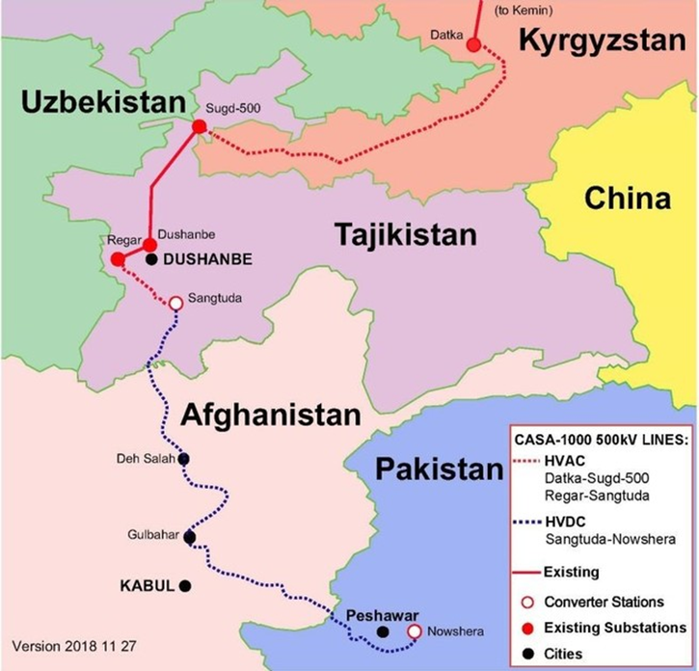

Figure 1.1.1. Schematic layout of the line connecting four countries

Project Overview
OJSC “NEG of Kyrgyzstan” implements the Project CASA 1000 “The Central Asia - South Asia Electricity Transmission and TradeProject” (hereinafter referred to as the Project or the CASA 1000 project). As part of the proposed bypass route, it is planned to construct a power line with a capacity of 500 kV. The total length of the transmission line is about 9200 meters;for a total of 26 towers will change its location. The location change has no additional technical changes in construction or in construction methods. The changes will affect only the height of the tower structures, which is changed according to the terrain.

Mitas Energy, the Contractor for the construction, using the services of a consulting company, conducted an environmental impact assessment of the planned activities within the framework of the bypass route of the CASA 1000 Project on the environment in accordance with the norms and requirements of national legislation.

- ENVIRONMENTAL IMPACT ASSESSMENT IN THE KYRGYZ REPUBLIC
This environmental impact assessment (EIA) presents the environmental and socio-economic baseline conditions of the project area, identifies the potential environmental and community impacts of CASA 1000, proposes appropriate mitigation measures to address the identified impacts, and includes details of public consultations.
The purpose of the EIA is to prevent and/or mitigate the impact of the proposed activity on the environment and related consequences; consideration and evaluation of alternatives, development of appropriate mitigation, management and monitoring measures.
This study was carried out in accordance with the requirements established by the legislation of the Kyrgyz Republic.
The study area is the territory of a bypass route of about 9200 meters length along the previously approved route of the CASA 1000 power line in the territory of Batken region, Leilek district near the city of Suluktu and the Vostochny settlement.
  - Environmental and Social Impact Assessment Methodology
This section describes the methodological framework for assessing the impact on various components of the natural environment. The analysis of identifying the possible impacts of the project is based on the identification of the types of activities that can be provided during the construction and operation of the facilities and the environmental aspects associated with this. In order to identify the impacts, the sources of their occurrence have been studied and described.
After determining all the possible consequences of the project implementation for social and environmental components, the significance of the proposed changes in such components is assessed. Environmental aspects are assessed based on the current social and environmental context, and its changes during the implementation of the Project.
The methodological approach settled in the Decree of the Government of the Kyrgyz Republic, using impact significance assessment, is applied at this stage.
The approach used to assess the environmental impact of a project determines the social and environmental significance of the components, as well as the intensity, duration and spatial extent of the expected negative impact.
These qualities are grouped when converting qualitative characteristics and quantitative indicators into points according to tables 2.1.1-2.1.3 to one common indicator, namly the degree of impact. This indicator provides an overall assessment of the significance of the expected impact on certain social and environmental components. The suitable measures are proposed to mitigate the most dramatic impacts based on significance.

Table 2.1.1. Determining indicators of the spatial scale of the impact
Impact gradation | Assessment point
Local: impact on the environment within the site of the proposed activity | 1
Limited: impact on the environment within a radius of up to 0.5 km from the site of the proposed activity | 2
Local: impact on the environment within a radius of 0.5 to 5 km from the site of the proposed activity | 3
Regional: impact on the environment within a radius of more than 5 km from the site of the proposed activity | 4

Table 2.1.2. Determining impact time scale indicators
Impact gradation | Assessment point
Short-term: impact observed for a limited period of time up to 3 months | 1
Medium duration: impact that occurs within 3 months to 1 year | 2
Long-term: impact observed for a long period of time - from 1 year to 3 years | 3
Long-term (permanent): impact observed for more than 3 years | 4

Table 2.1.3. Determination of indicators of the significance of changes in the natural environment (outside the territories under technical structures)
Impact gradation | Assessment point
Minor: changes in the environment do not exceed the existing limits of natural variability | 1
Weak: changes in the natural environment exceed the limits of natural variability. The natural environment is completely self-regenerated after the cessation of exposure | 2
Moderate: changes in the natural environment that exceed the limits of natural variability lead to the disruption of its individual components. The natural environment retains the ability to self-regenration | 3
Strong: changes in the natural environment lead to significant disturbances of the components of the natural environment. Separate components of the natural environment lose their ability to self-regeneration | 4

The overall assessment of significance is made by multiplying the point for each of the three indicators. Additionally, weight coefficients of the significance of each indicator in the overall assessment can be introduced.
The total number of points (within 1-8 points) characterizes the impact as an impact of low significance, 9-21 - an impact of medium significance, 28-64 - an impact of high significance.

- LEGAL, REGULATORY AND ADMINISTRATIVE FRAMEWORK
EIA was prepared with consideration of the norms and requirements of the national legislation of the Kyrgyz Republic.
National requirements in the field of environmental protection and natural resource management, as well as environmental and social impact assessment during the construction of industrial and linear facilities are regulated by the legislation of the Kyrgyz Republic on environmental protection (No. 53 as of June 16, 1999) and the Regulations on the procedure for conducting an impact assessment on the environment in the Kyrgyz Republic”, approved by the Decree of the Government of the Kyrgyz Republic No. 60 a of February 13, 2015
  - Current Regulatory Legal Acts of the Kyrgyz Republic applied in the preparation of the EIA Project
- Law of the Kyrgyz Republic as of June 16, 1999 No. 53 “On Environmental Protection” (as amended and supplemented as of July 25, 2016).
Environmental quality standards, maximum permissible harmful effects, as well as methods for their determination are approved by the republican state authorities for environmental protection and health care of the Kyrgyz Republic in coordinatin with other specially authorized state bodies in accordance with their competence.
Regulation of environmental quality is a system of norms and standards of environmental quality developed on the basis of international conventions and agreements, taking into account the latest achievements of science.
In order to establish maximum permissible environmental impact standards, environmental quality is standardized.
- Law of the Kyrgyz Republic dated May 8, 2009 No. 151 “General technical regulations for ensuring environmental safety in the Kyrgyz Republic” (as amended and supplemented as of March 01, 2012).
Technical regulation in the field of environmental safety is the established requirements for environmental safety in this technical regulation and in special technical regulations.
Ensuring environmental safety in the design, construction and operation of high-voltage power lines is carried out a follows:
1) the use of machinery and equipment with design characteristics, as well as the use of technological processes that ensure the reduction of the negative impact on the environment, the safety of personnel and the prevention of emergency situations;
2) the use of effective methods and technologies for cleaning up emissions, discharges of pollutants, technologies for the disposal of generated waste, allowing minimization of the levels of negative impact on the environment;
3) conducting an environmental impact assessment of the object of the planned economic and other activities before making a decision on the implementation of the specified activity, taking into account the environmental safety requirements established by this technical regulation. (Article 7).

In accordance with Article 12, in order to preserve flora and fauna in the course of design, construction and operation of high-voltage power lines:
1. It is prohibited to clear cross-cuts of trees and shrubs during the breeding season for the construction of facilities.
2. Measures to protect objects of the animal world should be provided, including the restriction of works during periods of mass migration, in places of reproduction and molting, rearing of young animals, spawning, fattening and migration of juvenile fish.
3. Measures should be provided to prevent and reduce the risk of death of birds in case of contact with current-carrying wires in the areas of their attachment to the support structures. Power lines, supports and insulators should be equipped with special bird protection devices, including those preventing birds from nesting in places that allow birds to touch current-carrying wires. It is forbidden to use uninsulated metal structures as special bird protection devices.
4. Sanitary protection strips are installed to prevent the death of wildlife from the impact of the electromagnetic field of power lines along these lines

Article 13 imposes environmental safety requirements that ensure the protection of soils and natural landscapes as follows:
1. When carrying out work related to the disturbance of the topsoil, the fertile soil layer is subject to removal(where available), storage and subsequent use for reclamation.
2. The laying of routes for temporary access roads is carried out with the maximum use of the existing road network, taking into account local natural conditions.
3. The movement of vehicles and special equipment is carried out only along specially constructed roads that ensure safe movement that does not cause disturbance of vegetation and soil cover.
Environmental safety requirements in the field of production and consumption waste management in the cour of design, construction, operation, reconstruction, conservation and liquidation of economic and other activities, sites for the collection and/or accumulation of waste, equipped in accordance with the requirements established by special technical regulations, should be provided.
- Law of the Kyrgyz Republic dated June 16, 1999 No. 54 “On Environmental Expert Examination” (as amended and supplemented as of May 04, 2015).
The Kyrgyz Republic has the state and public environmental expert examinations. Implementation of the planned activity without a positive conclusion of the state environmental expertise is not allowed. Environmental expertise should as well cover "... project documentation for assessing the impact of the proposed activity on the environment of the feasibility study of the proposed activity."
- Land Code of the Kyrgyz Republic dated June 2, 1999 No. 45 (with amendments and additions as of July 30, 2016.)

It is allowed to withdraw (purchase) a land plot in accordance with the Land Code of the Kyrgyz Republic for state and public needs. Withdrawal (purchase) of a land plot for state and public needs may be carried out on the basis of an agreement between the authorized body and the owner of the land plot or land user. If the owner of the land plot or the land user disagrees with the withdrawal (purchase) or its terms, the authorized body is entitled to apply to the court within two months with a claim for a paid withdrawal (purchase) of the land plot from the moment the refusal is received. Before the court makes a decision on the withdrawal (purchase) of the land plot, the owner of the land plot or the land user is entitled to exercise their rights to the land plot and incur the necessary costs to ensure the use of the land plot in accordance with its intended purpose. The owner of the land plot or the land user bears the risk of attributing to him the costs and losses associated with new construction, expansion or reconstruction of buildings and structures in the specified period.
When determining the redemption price of a land plot, it shall include the market value of the right to the land plot and the buildings and structures located there, as well as losses caused to the owner or land user in connection with the termination of the right to the land plot, including losses associated with the early termination of obligations to the third parties.
If a land plot is withdrawn for state or public needs, with the consent of the owner of the land plot or land user, the latter may be provided with another land plot with the value of the right to it offset in the redemption price.
According to the norms of the Code, a compulsory servitude may be established to ensure the following:
1) access to the land plot, if other access is impossible, extremely difficult or requires disproportionate expenses;
2) laying and operation of power lines, communications, water supply, heat supply, land reclamation and other needs that cannot be provided without the establishment of a compulsory servitude.
The servitude may be established by an agreement of the parties (voluntary servitude) or, if necessary, on the basis of a decision of an authorized body (compulsory servitude).
The encumbrance of a land plot with a servitude does not deprive the owner of the land plot or the land user of the use and disposal of his right to the land plot.
Compensation for losses caused to the owner of a land plot or land user by the establishment of a compulsory servitude shall be subject to compensation by the person in whose interests the servitude is established. The amount of losses is determined by the authorized body, or by the court in case of disagreement of the owner of the land plot or land user. The owner of a land plot or a land user whose land plot is encumbered with a compulsory servitude has the right, to demand from the person in whose interests the servitude is established, a proportionate payment instead of compensation for losses.
- Forest Code of the Kyrgyz Republic dated July 8, 1999 No. 66 (as amended and supplemented as of July 30, 2019).

The forest legislation of the Kyrgyz Republic is aimed at the protection, secrity, reproduction of forests, ensuring rational and non-exhaustive use, based on the national objectives of effective forest management, conservation of the biological diversity of forest ecosystems, increasing the ecological and economic potential of forests, meeting the needs of society in forest resources on the basis of evidence-based, multipurpose forest management.
All forests and lands that are in state, communal and private ownership, provided for the needs of forestry, form a single forest fund of the Kyrgyz Republic. All forests and lands provided for the needs of forestry, except for forests that are in communal and private ownership, form the state forest fund.
The lands covered with forest, as well as not covered with forest, but intended for the needs of forestry, are recognized as the lands of the forest fund.

The forest fund lands include the following:
- Forest lands, including forests (lands covered with forest vegetation) and lands not covered with forest vegetation (non-closed forest cultures, plantations, nurseries, cuttings, burnt areas, sparse areas, clearings, wastelands);
- Non-forest lands that form a single natural complex with forests (agricultural and other land, as well as lands where the forest was reduced during the construction of facilities related to economic activities, roads, fire breaks, power lines routes, pipelines)
The boundaries of the lands of the forest fund separating them from the lands of other categories are determined in the manner established by the legislation of the Kyrgyz Republic.
The State Forest Fund is in the exclusive ownership of the Kyrgyz Republic
The forest fund does not include the following:
- individual trees and groups of trees, shrub vegetation and agroforestry plantations in agricultural lands;
- protective plantings on the offtake of railways and highways, canals and other linear structures;
- individual trees and groups of trees and shrubs, landscaping in cities and other settlements (except for urban forests) in home gardens, summer cottages and garden plots.
Creation of plantations not included in the forest fund, care for them, their use and protection are carried out in the manner determined by the local self-governments and local state administrations, unless otherwise established by the legislation of the Kyrgyz Republic.
In accordance with the constitutional provision on the right of private ownership of land in the Kyrgyz Republic, private forest lands are allowed on the terms of granting land plots to private ownership for artificial forest cultivation.
If the land plots occupied by forests are withdrawn for state or public needs, the issue of preserving or cutting down forest plantations and the procedure for using the wood obtained in this case is simultaneously decided on the basis of proposals from the republican state forestry management authority.

When researching, designing, building and commissioning new and reconstructed enterprises, structures and other facilities, as well as when introducing new technological processes that affect the status and reproduction of forests, the definite measures are involved and implemented to ensure the protection of forests from the negative impact of wastewater, chemicals, industrial and municipal emissions, waste and other harmful effects.
The determination of construction sites for enterprises, structures and other objects that affect the status and reproduction of forests is carried out in accordance with the current legislation on the basis of positive conclusions of the state environmental expertise and the republican state forestry management authority, other specially authorized state bodies.
- Law of the Kyrgyz Republic dated June 20, 2001 No. 53 "On the protection and use of flora" (with amendments and additions as of July 25, 2016).
The law is binding for individuals and legal entities on the following:
- comply with the requirements established by law and other regulatory legal acts for the protection and use of flora objects;
- prevent the deterioration of the habitat of flora objects, observe environmental technologies when collecting and harvesting wild-growing plant materials;
- do not violate the integrity of natural plant communities, contribute to the conservation of their species diversity, increase the productivity of herbage (tree stand), seeds, fruits, and other products;
- provide all possible assistance to state bodies that maintain the state cadastre and monitor flora objects, control the protection and use of flora objects;
- prevent deterioration of other natural resources;
- to oberve the rights of tenants, other temporary users, as well as adjacent users of flora objects;
- fulfill other requirements for the protection and rational use of flora objects, provided for by the legislation of the Kyrgyz Republic
- Law of the Kyrgyz Republic dated June 17, 1999 No. 59 "On the Fauna" (as amended and supplemented as of March 22, 2016).
When conducting a state environmental expert review of projects for the construction and reconstruction (expansion, technical re-equipment) of enterprises, structures and other facilities, introduction of new equipment, technology, materials and substances, their impact on the status of thewildlife objects, migration routes and conditions for reproduction of animals is considered on the mandatory basis.
The locations of enterprises, structures and other facilities, as well as the introduction of new equipment, technology, materials and substances that affect the state of wildlife objects, are agreed with the republican state body for environmental protection of the Kyrgyz Republic
• Law of the Kyrgyz Republic "On production and consumption waste" as of November 13, 2001 No. 89.

Determines the state policy in the field of production and consumption waste management and is designed to facilitate the prevention of the negative impact of production and consumption waste on the environment and human health when handling waste, as well as to maximize their involvement in economic circulation as an additional source of raw materials
- Law of the Kyrgyz Republic On the transfer (transformation) of land plots, as ofJuly 15, 2013 No.145 (As amended by the Laws of the Kyrgyz Republic dated March 19, 2016 No.21, June 1, 2017 No.95)
Legal regulation of relations arising in connection with the transfer (transformation) of land is carried out in accordance with the norms of the Land Code of the Kyrgyz Republic, this Law and other regulatory legal acts of the Kyrgyz Republic, adopted in accordance with them.
The transfer (transformation) of land from one category to another is a state function, carried out in case of a change in their main intended purpose.
When transferring (transforming) agricultural land from the categories of agricultural land, forestry, water resources and reserves to other categories of land or types of land not related to agricultural and forestry production, the amounts of the cost of compensation for losses and lost profits by the new land users and owners are paid, with the exception of cases provided for by this law.
The definition of a specially authorized state body and the procedure for using the incoming funds from compensation for agricultural and forestry losses is established by the Government of the Kyrgyz Republic
If it is necessary to change the purpose of a land plot in connection with its withdrawal, including by way of redemption, for individual housing construction, state or municipal needs, the transfer of this land plot from one category of land to another is carried out after its withdrawal or redemption.
The procedure for preparing documents and considering applications for the transfer of land includes a commission four-level approval of materials.
- Law of the Kyrgyz Republic dated January 11, 2001 No. 4 "On the management of agricultural land" (as amended and supplemented as of July 30, 2016).
State-owned and leased agricultural lands are alienated for state purposes after payment of estimated costs and lost profits at the time of alienation.
- Regulations on water protection zones and strips of water bodies in the KR” GD of the KR as of 07.07.1995 No. 271
The width of the water protection zone for rivers is set on both banks and makes 50 m, the width of the coastal water protection zone is 30 m.
The following is prohibited within water protection zones and coastal strips:
- installation of containers with fuels and lubricants;
- parking and washing of vehicles and equipment;
- storage of production waste and other garbage;

- discharge of untreated sewage, as well as the performance of other types of work that have a harmful impact on the state of water bodies.
- Sanitary-Epidemiological Rules and Regulations. "Sanitary protection zones and sanitary classification of enterprises, structures and other objects", GDKR as of April 11, 2016 No. 201
Sanitary and epidemiological rules and regulations apply to the location, design, construction and operation of the newly built, reconstructed and existing industrial facilities, and production facilities, transport facilities, communications, agriculture, energy, experimental production facilities, public utilities, sports, trade, public catering, etc., which are sources of impact on the environment and human health.
In order to ensure the safety of the population nearby the facilities and industries that are sources of impact on the environment and human health, a sanitary protection zone (SPZ) is established as a special area with a special mode of use, the area of which ensures a reduction in the impact of pollution on the atmospheric air.
According to its functional purpose, the sanitary gap (SG) is a protective barrier that ensures the level of safety of the population during the operation of the facility.
The criterion for determining the area of the SG is not exceeding the maximum permissible concentrations of pollutants for the atmospheric air of populated areas and the maximum permissible levels of physical impact on atmospheric air at its outer border and beyond
- The Law of the Kyrgyz Republic “On the Procedure for Considering Citizens' Appeals” (March 4, 2007, No. 67, last amended on July 27, 2016, No. 151).
Every citizen in the Kyrgyz Republic has the right to apply personally or through his representative to state authorities, local self-government bodies and their officials, who are obliged to provide a reasoned answer within the time period established by the law.
State bodies and their officials are not entitled either to deprive citizens of the right to apply with proposals, statements and complaints, or restrict them in such a right.

Applications and complaints in the interests of minors or incapacitated persons may be submitted by their legal representatives, as well as guardianship authorities.
Foreign citizens and stateless persons enjoy the right to apply in accordance with this Law, unless otherwise provided by the current legislation of the Kyrgyz Republic or international treaties.
Citizens exercise the right to appeal freely and voluntarily. The exercise by citizens of the right to appeal should not violate the rights and freedoms of other persons.
Consideration of citizens' appeals is free of charge.
A written (electronic) appeal is subject to mandatory registration within one working day from the date of receipt by the state authority. A written (electronic) appeal is considered within 14 working days from the date of registration of a written (electronic) appeal.

In cases where it is necessary to conduct a special check (expert examination), the case require additional materials or other measures to resolve a citizen’s appeal, the deadlines for resolving complaints may be extended as an exception, but not more than 30 calendar days.
If the solution of the issues raised in a written (electronic) appeal falls within the competence of several state bodies, local self-governments or officials, a copy of the appeal is sent to the relevant state bodies, local self-governments or relevant officials within five working days from the date of registration
- Labor Code (August 4, 2004 No. 106, as last amended on December 31, 2019 No. 150).
The Labor Code is the fundamental legislative act aimed at regulating all labor issues in the Kyrgyz Republic. This Code regulates labor relations and other relations directly associated with the protection of the rights and freedoms of the parties to labor relations, the establishment of minimum guarantees of rights and freedoms in the sphere of labor. The Code prohibits discrimination and ensures that all citizens have equal rights to work. It is forbidden to refuse employment, regardless of nationality, race, gender, language, religion, political beliefs, social status, education and property. Everyone has equal opportunities to exercise their labor rights and freedoms.
The use of child labor in the worst forms is prohibited. Forced labor, that is, compulsion to perform work under the threat of any violent influence, is prohibited.
- Law on Local Self-Government (July 15, 2011 No. 101, as last amended on August 8, 2019 No. 118)
This Law establishes the principles of organizing local self-government at the level of administrative-territorial units, determines the role of local self-government in the exercise of state power, establishes the organizational and legal foundations for their activities, establishes the competence and principles of the relationship between local self-government bodies and state authorities, state guarantees of local legal communities for self-government
Local self-government is an independent activity of the local community in its own interests and under its own responsibility, aimed at resolving issues of local importance.
Local self-government is carried out by local communities through the representative and executive bodies of the aiyl aimak and the city, as well as through the direct participation of citizens.
Local self-government is carried out, among other things, on the following principles:
- openness and responsibility of local self-government bodies to the local community and the performance of their functions in the interests of the local community;
- the will of citizens through the local self-government system, as well as through meetings of citizens and kurultai;
- protection of the rights and legally protected interests of local communities;
- publicity and consideration of public opinion

Local self-government bodies work in close cooperation with state authorities in order to create conditions for the implementation of the constitutional rights of citizens of the Kyrgyz Republic for participation in resolving issues of state and local importance.

  - Required licenses, permits and approvals for the implementation of the CASA 1000 project
Table 3.2.1.
List of licenses, permits and approvals for the implementation of the Project
Type of document | Authorized body | Regulatory legal acts | Note
The third stage of the EIA is an assessment of the impact of the proposed activity on the environment.* | Ministry of Natural Resources, Ecology and Technical Supervision of the Kyrgyz Republic | Regulations on the procedure for conducting an environmental impact assessment in the Kyrgyz Republic,  GD of the KR as of February 13, 2015 No. 60 | In accordance with section 4 of the Regulations on the procedure for conducting an environmental impact assessment in the Kyrgyz Republic, an assessment of the impact of the proposed activity on the environment should be carried out when developing project documentation (project, working (detailed) project).  The results of the impact assessment are executed in the form of the "Environmental Protection", project section (working draft) which is submitted to the state environmental expertise to obtain an opinion before commencement of the Project.
The fourth stage of the EIA is the post-project analysis. | 1. The organization of the post-project analysis and control over this work are provided by the project initiator;  2. Post-project analysis is carried out by a specialized organization (research, design or other organization, firm); | Regulations on the procedure for conducting environmental impact assessment in the Kyrgyz Republic, GD KR as of February 13, 2015 No. 60 | In accordance with Section 4 of the Regulations on the procedure for conducting an environmental impact assessment in the Kyrgyz Republic, a post-project analysis should be carried out in a year after the commencement of activities, in order to confirm the safety of the facility for the environment and adjust environmental measures.
Permission to place waste in the environment | Ministry of Natural Resources, Ecology and Technical Supervision of the Kyrgyz Republic | Law of the Kyrgyz Republic as of June 16, 1999 No. 53 "On Environmental Protection"  Law of the Kyrgyz Republic as of May 8, 2009 No. 151 "General technical regulations for ensuring environmental safety in the Kyrgyz Republic"  Law of the Kyrgyz Republic as of October 19, 2013 No. 195 “On the licensing and permit system in the Kyrgyz Republic” | Article 14 of the Law of the Kyrgyz Republic as of May 8, 2009 No. 151 "General technical regulations for ensuring environmental safety in the Kyrgyz Republic". Objects of economic and other activities, in accordance with the degree of negative impact, undertakes as follows:  1) in the prescribed manner develop and approve draft standards for waste generation, taking into account the composition of the raw materials and materials used;  2) keep records of generated, used, neutralized, transferred to other persons or received from other persons, as well as placed waste;  3) conduct an inventory of waste and their disposal facilities;  4) monitor the state of the environment in the territories of waste disposal facilities;  5) carry out work to restore disturbed lands to a state corresponding to the intended purpose of the lands;  6) ensure compliance with established limits on waste disposal and implementation of planned measures to reduce them.
Emissions of pollutants into the atmosphere from stationary sources |  |  | Article 10 of the Law of the Kyrgyz Republic as of May 8, 2009 No. 151 “General technical regulations for ensuring environmental safety in the Kyrgyz Republic” “Entities of economic and other activities that have stationary and mobile sources of pollutants and greenhouse gases emissions into the atmospheric air at the facility:  1) ensure compliance with the established standards for permissible emissions of pollutants into the atmospheric air and the implementation of planned measures to reduce the established limits on emissions of pollutants;  2) conduct an inventory and accounting of emissions of pollutants, greenhouse gases and ozone-depleting substances for each source based on the data of industrial environmental control;  3) comply with the rules and modes of operation of equipment and facilities designed to clean up and control emissions of pollutants, greenhouse gases and ozone-depleting substances into the atmospheric air.
Water use permit (when using underground and surface water sources) | - The use of groundwater is subject to licensing;  - Water use carried out without the use of structures or technical devices, that do not affect the state of water, does not require legal entities and individuals to obtain a license for the right to use water, subject to compliance with the requirements established by specially authorized bodies. | - Law of the Kyrgyz Republic "On the licensing and permit system in the Kyrgyz Republic" as of October 19, 2013 No. 195  - Law of the Kyrgyz Republic "On Water" as of January 14, 1994 No. 1422-XII | - Art. 16 clause 5 “The following types of activities are subject to licensing: ... activities related to the right to use subsoil (... including the selection and use of groundwater, the construction and operation of underground structures);  - Art. 15 “Water use carried out without the use of structures or technical devices that do not affect the state of water does not require legal entities and individuals to obtain a license for the right to use water, subject to the requirements established by the specially authorized bodies.
Temporary connection to utility water supply networks | Issuance of technical conditions for temporary connection to networks for the period of construction and installation works is carried out at the request of a construction organization | GD KR No. 100 as of February 10, 2009  RULES for the provision of technical conditions and the procedure for connecting to engineering networks in the Kyrgyz Republic | Section 1. General provisions: "technical conditions" is a document defining the point of connection to engineering networks, the load (power) allowed for connection, the source of supply, the parameters of the carrier or receiver, the method and schedule of regulation, the main parameters and requirements that should be performed to connect the construction site to the engineering and technical support networks, and guaranteeing the applicant the connection to the engineering and technical support networks during the validity period of the technical secifications"
Agreement on land use (land allotment - temporary use) or transformation (permanent use) of land into land for industry, transport, communications, energy and other purposes. | Local administration, State Registration Service or Government of the Kyrgyz Republic.  The choice of land plots provided for ownership or use in settlements and the preparation of relevant documents is carried out by the bodies of architecture and construction. | Land Code of the Kyrgyz Republic as of June 2, 1999 No. 45 | According to Chapter 14 of the Land Code of the Kyrgyz Republic, energy lands include land plots allocated for:  2) placement of overhead power lines, ground structures of cable power lines, substations, distribution points, other structures and energy facilities.
Expert approval of the project on the availability of forest fund lands | State Agency for Environmental Protection and Forestry | Forest Code as of June 29, 1999 | When developing project documentation (working (detailed) project), after determining the final route of the power line
Expert coordination of actions to preserve historical and cultural heritage (HCH) | Ministry of Culture, Information and Tourism of the Kyrgyz Republic | Law of the Kyrgyz Republic of July 26, 1999 No. 91 “On the protection and use of historical and cultural heritage” | At the stage of engineering and survey work and during the transfer (transformation) of land, Organizations conducting construction, road works or a significant change in the landscape are required to conduct an archaeological survey for the presence or absence of objects of historical and cultural heritage in the alienated territory. (Article 32 of the Law “On the Protection and Use of Historical and Cultural Heritage”).
Discussion of the Project EIA with the public.  Minutes of public hearings |  | Law of the Kyrgyz Republic as of June 16, 1999 No. 54 "On Environmental Expertise" | Minutes of public hearings, lists of participants in public hearings.

* To carry out construction work when changing the route of the power transmission line, it is necessary to obtain a conclusion from the state environmental expertise and an updated draft ESIA in accordance with - The third stage of the ESIA is an assessment of the impact of the proposed activity on the environment. All permits obtained during the performance of work on the sites under the main ESIA will be considered valid and do not require additional approvals of volumes (because the replaced site does not imply additional volumes of waste generation).
- PROJECT DESCRIPTION
  - Power line route
The proposed bypass route is the transfer of the location of 26 towers, with a total length of about 9,200 meters, the site is located шn the territory of the Batken region, Leilek district near the city of Suluktu and the Vostochny settlement.
A bypass power line is planned to bypass the area with loose soil under the power line. The site is located in the foothills of the northern macroslope of the Turkestan Range near the Vostochny settlement. According to the "Atlas of the Kyrgyz SSR" with the geobotanical zoning (Golovkova et al., 1987), the region belongs to the Asian desert region, the Turkestan-Alai province, the Turkestan district and is located in the Turkestan region, a desert-steppe subregion, with a belt of subtropical steppes (plusavann) at the altitude of 1200-1800 meters, dominated by Artemisia namanganica, A. prolixa, Eurotia ceratoides and others
As part of the ongoing analysis of the bypass section territory, the exlorations were carried out in the following areas (presented in the relevant sections):
- Ecological (background analysis of the territory);
- Biological (assessment of flora and fauna).
  - The need for works
During an inspection of the completed supports foundations under the Contract TW05 for the "Project CASA-1000", horizontal displacements were detcted in the area between the supports 280[284] and 302L[306]. The fact that the displacements are horizontal rather than vertical is indicative of the stability of the foundation design, and it has been found that the main cause of horizontal displacements is a landslide problem in this region.
Since the foundations in other parts of the project, where the slopes are relatively higher, are in good condition and have not been subject to any displaement, horizontal movements in the area between supports 284 and 306, indicate landslide problems despite the relatively lower slope.
In addition, since very specific and long-term tests must be carried out to identify a landslide problem, and the contract term does not cover such a long period, the geological survey report for the relevant part of the project does not provide a prospect for landslides.
As explained above, a new bypass has been prepared to address the issue, for which this environmental impact assessment is provided.
Comparison of the approved and alternative line routes was made in terms of supply, transportation and installation work.
The list of Structures required for bypass modifications is provided in Appendix 3, and a summary of quantities is provided in Appendix 5.
The construction of supports on the bypass route implies an increase in the total length of the line by three supports.
The installation of supports does not provide for additional deployment of camps; existing camps in the Batken region will be used.
The existing base that was provided by the main EIA will be used, the workers involved in the bypass section will live in the Suluktu camp.
The Suluktu camp is rented, and is located in the industrial zone 5-6 km from the city of Sulukta, in the territory of an old brick factory. The subcontractor's existing asphalt plant is located not far from the camp. The land is in private ownership.
The camp is bordered by a mudflow channel and the Isfana-Sulukta highway.
The following infrastructure facilities are located im the camp:
• "Residential premises" Building - 15 rooms
• Laundry - 1
• Showers (containers) - 10 cabins
• Toilet (containers) - 6 cabins
• Container with water tanks - 1.

The order of work on the construction of power lines:
- Preparation of a pit for the foundations of supports;
- Carrying out concrete work in accordance with the recommendations of international standards and project specifications;
- Installation of supports by assembly method in accordance with the requirements of the technical specifications of the project;
- Stretching of wires is carried out in accordance with the requirements of the technical specification of the project.

All works will be carried out within the framework of the requirements of the national legislation of the Kyrgyz Republic, the approved technical project and with the recommendations of international standards.
The special care must be taken when carrying out construction works, so as not to affect the environment and not affect the interests of all stakeholders in the CASA 1000 Project area.

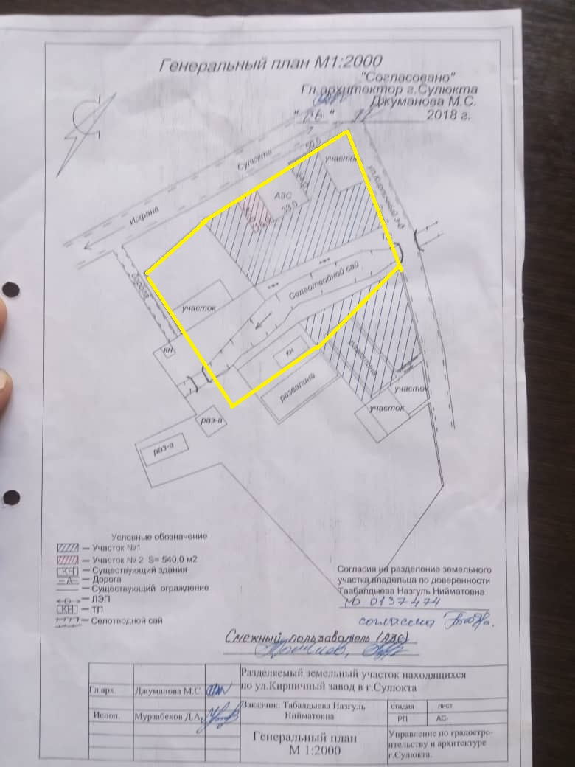
Figure 4.2.1. The general plan of the base near the city of Sulukta

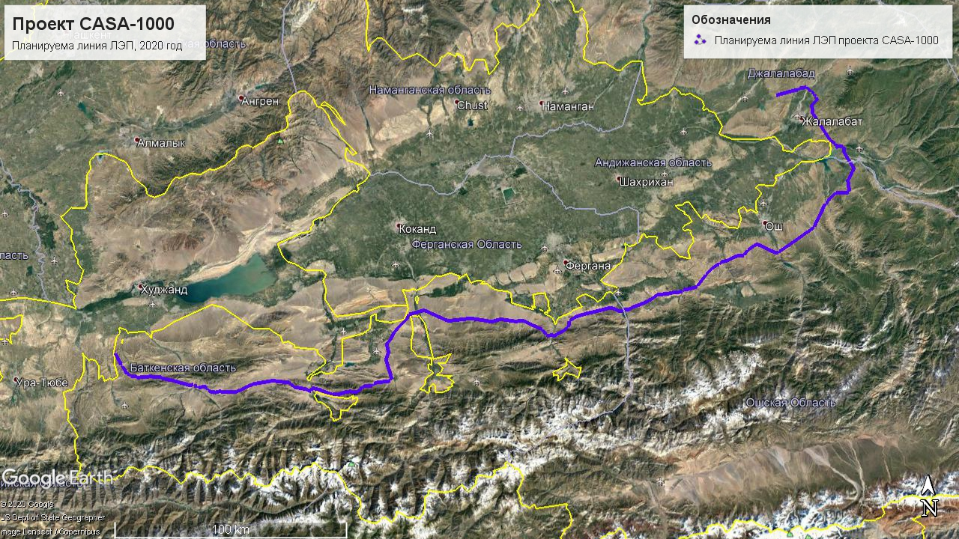
Figure 4.2.2. Map of the general location of the power line route
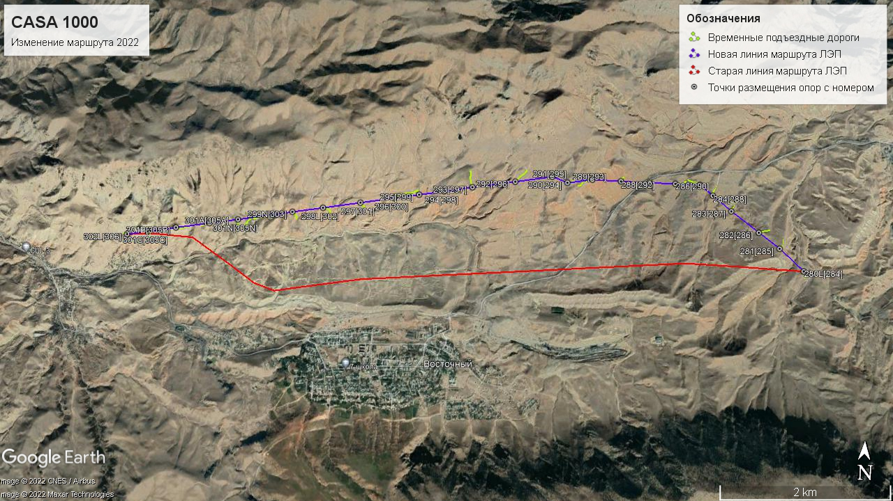
Figure 4.2.3. Power line bypass route map
  - Design and layout of power lines
Mounting of supports by assembly method is carried out in accordance with the requirements of the technical specifications of the Project. The main stages of work on the installation of supports are as follows::
- Sorting of support materials;
- Unloading and sorting on site;
- Installation of racks;
- Installation of the support frame;
- Installation of cross-beams;
- Tightening;
- Installation of number, phase and warning plates;
- Installation of an anti-access device;
- Cleaning of the site upon completion of construction works.

The support can be assembled using cranes or a derrick, depending on site capabilities. The site Head manager will decide on the installation methods during the site visit prior to foundation work and will take all necessary measures to allocate resources.
Installation using a crane is carried out in the following order:
- Assembly of supports in sections on the ground in a horizontal position and tightening of connections;
- Starting with a rack section, each section is lifted by a crane and connected to the previous section;
- Alternatively, the construction team may mount the support in a row if one section is too heavy to lift;
- Tightening of connections

The site for the installation of cranes and the installation of parts of the supports must be even and sufficiently stable.
Figure 4.3.1 shows a plan for the assembly of metal structures of power lines.

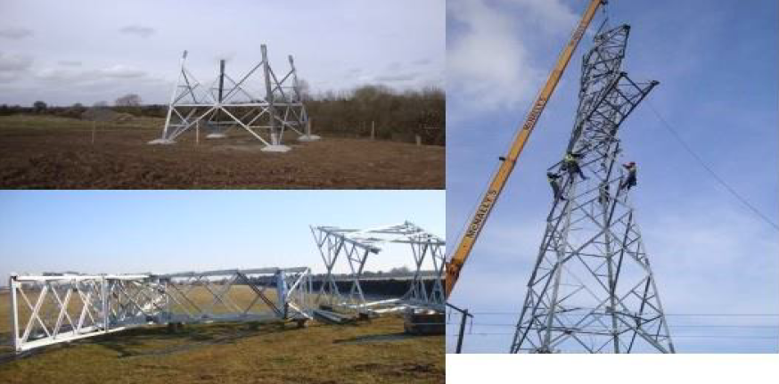
Figure 4.3.1. Plan for the assembly of metal structures of power lines
  - Power line requirements
The design of the supports was carried out in accordance with the requirements of the Specification, KR-SNIP and PUE (Electrical Installation Code). Structural design in accordance with ASCE 10-15.
The static calculation of the 500 kV overhead transmission line supports was performed in the OPORA program by POWERLINE. The following calculations were performed for all supports:
- Calculation of sag and tension;
- Load calculation;
- Plan of support;
- Support design;
- Foundation design;
- Line-loop design.
The design of foundations for power transmission line supports of 500 kV overhead lines is based on the requirements of the 7th edition of the Specification and the Electrical Installation Rules (PUE).
International norms and standards used in the design of power lines are presented in the table 4.4.1.
Table 4.4.1. International norms and standards
ASTM A36M | Standard Technical Specification for carbon steel structure
ASTMA123M | Standard Technical Specifications for zinc (hot dip galvanized) coatings on iron or steel products
ASTM A153M | Standard Technical Specifications for zinc (hot dip galvanized) coatings on iron or steel hardware
ASTM A363 | Standard Technical Specifications for zinc coated steel ground wires (galvanized)
ASTM A394 | Standard Technical Specifications for steel, galvanized and simple bolts of power lines’ supports
ASTM В232 | Standard Technical Specifications for concentric multicore coated steel reinforced aluminum conductors (ACSR)
ASTM-B429 | Standard Technical Specifications for aluminum alloy extruded structural tubes
ASTM D1171 | Standard test method for rubber damage - outdoor or chamber ozone cracking (triangular samples)
IEC 60060-1 | High voltage test methods
IEC 61325 | The standard specifies: characteristics of insulators: the conditions under which the specified values of these characteristics must be verified; acceptance criteria
IEC 61854 IEC 61284 BS 3436-1986 | Overhead lines - requirements and tests for spacers. Overhead lines - requirements and tests for fittings. Technical specifications for zinc.
IEC 1089-1991 BS 215-1970 | Technical specifications for aluminum conductors for overhead transmission purposes
IEC 1089-1991 BS 215-1970 | Aluminum conductor, galvanized steel, reinforced.
IEC 1089-1991 BS 215-1970 BS 1559-1949 ISO 6892-1984 | Galvanized steel aluminum conductor - reinforced for extra high voltage (400 kV) and above. Coils and reels for bare wires. Steel wire tensile test method
IEC 888-1987 BS 443-1969 | Galvanized coating on round steel wires
ISO 1460 – 1973 BS 433-1969 | Methods for determining the mass of zinc coating of products made of galvanized iron and steel
IEC 437-1973 | Test method for radio interference on high-voltage insulators
IEC 888-1987 | Galvanized steel wire for multicore wires
IEC 889-1987 | Rigid aluminum wire for overhead power lines
BS:3288 (Part-1) | Insulator and conductor fittings for overhead power lines. Performance and general requirements

Table 4.4.2. The smallest vertical distance from the wires of the overhead line to the surface of the earth, industrial buildings and structures in populated areas
High voltage power line working conditions | The smallest distance, m, at voltage of the high voltage power line, kW
To the surface of the earth | 15,5
To industrial buildings and structures | 8

4.5. Materials and equipment
Dry-type reinforced concrete foundations will be used for all types of supports. Dry foundation is used in places where normal dry stable or unstable soil occurs and groundwater occurs 3.0 meters below ground level. According to the planned route of the power transmission line, places with stable soil were selected for the construction of supports.
The organization of logistics for the construction of a 500 kV power transmission line using materials, structures and equipment is carried out as follows:
Key materials supplied from abroad, such as steel structures, conductors, ground wires, insulators, etc., must be cleared by customs service in the city of Osh and then transported to approved temporary construction camps, which will be located near the settlement of Vostochny
Storage of all equipment and structures of supports will take place in the warehouses of temporary camps. The Contractor shall transport all necessary equipment and materials from temporary storage sites (temporary construction camps) directly to the construction site, according to the power line construction schedule.
The concrete mixture will be purchased from suppliers with delivery to the installation site.
All warehouses are equipped with special lifting devices and mechanisms. The list of equipment and machinery required for the construction of power lines in one camp is presented in Appendix 2.
  - Access roads
The plan of access roads was prepared for each suport of the bypass route During the detailed design. To carry out works under the Project, it is planned to make maximum use of the existing network of roads and access roads used by the local population. But, in a number of cases, it was not possible to develop a power line route taking into account the available roads, and therefore, in such cases, access roads to construction sites for the installation of supports will be built.
In accordance with the terms of the technical project, the access roads under construction to the construction site are temporary, and after the need for them passes, the site used as an access road will be reclaimed / brought to its original state, regardless of the purpose of the land plot.
In order to have a positive socio-economic impact of the Project, some roads connecting different parts of the settlements may be left as improved, in coordination with the authorities and local self-government.
In the construction of new access roads, priority will be given to areas with thin stony soil and sparse vegetation. Appendix 4 presents a plan of the layout of access roads to the locations of the supports
  - Construction camps
It is planned to use already existing construction camps and lodges.
Support structures and other materials necessary for construction will be delivered to the support construction site from storage areas of temporary construction camps.
Estimated workforce required for operation is about 200 people, of which 85% will be skilled labor and 15% will be a support workforce.

- ANALYSIS ADVANTAGES OF THE PROJECT
The Regional Market Development Initiative is based on a forward-looking assessment of the existence of significant electricity surpluses in the countries of Central Asia, creating significant potential for trade. These countries have already invested heavily in energy projects. After the completion of these projects, the volume of electricity produced will exceed the energy needs in the Kyrgyz Republic and the Republic of Tajikistan.
In case of refusal to implement the planned activity (“Zero Option”), the Kyrgyz Republic will most likely have to find other markets for selling additional volumes of generated electricity, or face the loss of significance of existing capacities.
The Kyrgyz Republic belongs to the category of poor countries, and it is expected that the possible results and income from the implementation of the CASA 1000 project will have a significant positive impact on the population and on the socio-economic development of the country as a whole.
The following prerequisites contributed to the emergence of the CASAREM initiative to create a regional market:
- Central Asian countries have significant summer surpluses of electricity (Kyrgyz Republic, Republic of Tajikistan). Upstream countries supply water to downstream countries on the basis of bilateral agreements.
- In South Asia, there is a significant need for electricity import (especially in Pakistan) to meet current and projected demand.

The CASA 1000 and CASAREM (Central and South Asia Regional Electricity Market) projects offer opportunities to strengthen regional cooperation with neighboring countries. Failure to implement the Project may lead to limitation of the opportunities that favor said cooperation, as well as to limitation of the additional benefits that it could provide, which will lead to an overall loss for the Central Asian region as a whole.

The CASA 1000 project has several benefits, such as:
- Contribute to the development of the country and improve the efficiency of water resources use by expanding the electricity sales market.
- Improve trade and regional cooperation in the region, support economic growth and serve as a showcase for similar cooperation in other areas of the economy (e.g. development of transport, communications, etc.).
- Indirectly create incentives for the participation of the private sector in the development of the country's energy sector, through the implementation of other projects for the production of electricity

The Zero Option alternative for Pakistan and Afghanistan would mean either developing additional capacity within their own borders or importing electricity from countries other than the Kyrgyz Republic and the Republic of Tajikistan. Afghanistan and Pakistan are currently in the process of maximizing their production capacity, but despite this, if the CASA 1000 project is abandoned, their needs will not be fully satisfied. Importing from countries other than the Kyrgyz Republic and Tajikistan will result in higher financial costs.
Thus, the Zero Option of the CASA 1000 Project for the Kyrgyz Republic will weaken the possibility of developing regional cooperation and obtaining additional benefits, which can significantly affect the development of the country as a whole. This will be a significant loss not only for the Kyrgyz Republic, but also for the regions of Central and South Asia as a whole. In this regard, the choice of Zero option is not expedient.
The power line route had to be adjusted due to the discovery of landslide risks in the previously agreed area, and therefore a proposed bypass route was investigated.
Submission of a Zero Option is not possible. Other alternatives were excluded during the design and development phase of the bypass route project.
The route starts from the Datka substation in the Kyrgyz Republic, and ends at the Khujand substation in Tajikistan. In general, the choice of the construction route of the CASA 1000 power transmission line is based on the already existing infrastructure in the country. Main part of the route in the territory of the Kyrgyz Republic passes through altitudes of less than 2000 meters above sea level (masl). The proposed bypass route is the transfer of the location of 26 supports of the total length of about 9,200 meters, the site is located in the territory of the Batken region, Leilek district near the city of Suluktu and the Vostochny settlement. Аltitudes of more than 950 meters above sea level (masl).
The route is laid as far as possible away from settlements, as well as from the enclaves of Uzbekistan and Tajikistan located within the state border of Kyrgyzstan. To optimize the route, the following criteria were used:
- Minimizing the number of points with sharp angles;
- Avoid places with severely rugged terrain and high altitudes when choosing a power line route;
- Proximity to existing roads to facilitate access during construction and maintenance;
- Reduction of adverse environmental and social impacts.
During the detailed design stage and then during the study before the start of the work, the designers, OJSC "NEGK " (PMU) and the contractor will thoroughly consider the issues related to the laying of the route of central axial line of PTL. This work includes some additional studies, such as hydrogeology, construction technology, security, opportunities to reduce social and environmental impacts, and so on.

  - Technological and engineering solutions (basic variant)
The electricity-generating infrastructure required for the implementation of the CASA 1000 project is already available in the countries- project participants. After the construction, electricity will go through high-voltage power lines from the Kyrgyz Republic to Republic of Tajikistan (477 km), and from Tajikistan - to Afghanistan and Pakistan (750 km).
The voltage of the transmission line is determined by its length and transmitted power: it can be low (up to 1 kV), medium (3-35 kV), high (110-220 kV), super high (330-1000) and ultrahigh (over 1000 kV).
Since the total length of the power line in the CASA 1000 project is near 1,227 km in four countries, and based on its intended use, an ultra-long-range power line with a voltage of 500 kV was selected. This type of super high voltage power lines (330-1000 kV) is used for communication between power systems operating in non-synchronous environment or with different frequencies, as well as for increased stability of the power system operation, which is characteristic for the planned Project.
Based on the above information, there are no other alternatives for the type and purpose of the power line to achieve the objectives stated in the CASA 1000 project, except for the refusal to implement the planned activity (zero option).
It should be noted that this route under study has already been presented as an alternative option designed to avoid the occurrence of landslides in this area. The development of a bypass route was required after soil movements were discovered at the old site, which could lead to an emergency in the future.
In this connection, in next sections of the document, an assessment is conducted for the option that is taken as a basic/primary one.
To optimize costs and ensure constructive engineering solutions, the following criteria were used:
- To link the existing energy infrastructure and reach the "end points" in the target infrastructure, according to the Project plans (from the Datka substation in the Kyrgyz Republic to the Sugd substation in Tajikistan);
- Proximity to existing medium voltage transmission lines to ensure a potential connection at the minimum length of medium voltage lines;
- Rational use of surplus electricity generated by the Toktogul HPP and other HPP of republic in the summer months;
- It is assumed that the design will meet the minimum safety of vertical distances;
- The average distance between the towers will be 420-450 m, and towers will have a height from 30 m to 63, with the size of the base on average 20x20 m.
- It is assumed that the towers will have a lattice structure with a wide base, without braces, the tower material is galvanized steel, with two lightning protection air wires;
- The planned line crosses the mouth of the Kara-Darya River (the width of the river is more than 1600 meters and the width between towers is 450 m), see Fig. 8.2.1.1.1. When carrying out detailed project design, it is necessary to provide options for bypassing this section or the possibility of installing towers without significant impact on the environment;
- In any area and under different circumstances, the requirements of the norms and rules of the Kyrgyz Republic legislation regarding vertical and horizontal safety distances must be observed.

- ENVIRONMENTAL AND SOCIAL ENVIRONMENT
The proposed bypass route is the transfer of the location of 26 supports of the total length of about 9,200 meters, the site is located in the territory of the Batken region, Leilek district near the city of Suluktu and the Vostochny settlement.
The site is located in the foothills of the northern macroslope of the Turkestan Range near the Vostochny settlement. According to floristic zoning (Kamelin, 2002), the study area belongs to the Ancient Mediterranean subkingdom of the Holarctic Kingdom, the Turkestan floristic region of the Central Asian floristic province
  - Climatic and meteorological conditions
The climate of the region is sharply continental, arid, with a pronounced vertical zonality. Significant daily and seasonal temperature fluctuations are noted in the high-mountainous southern part of the area. In the mid-mountain zone, the climate is much milder, temperature fluctuations are not so contrasting, and the snow cover is unstable. The climate of the northern, low-mountainous part of the territory is semi-desert, with long dry summers and short winters with little snow. The latitudinal orientation of the ridges, which coincides with the prevailing direction of the winds that carry the moisture of seasonal cyclones, does not significantly affect the distribution of precipitation.
Winter periods are short and mild.
Summers are hot and dry; occasional short-term rains and thunderstorms, according to the weather forecast, may occur at the beginning of the summer period. Autumn, like summer, is long and mostly dry and sunny. Noticeable changes of the weather may occur from the second half of October, and during this period the cloudiness may increase, and prolonged drizzling rains may occur. Dense and heavy fogs are an integral part of the autumn period.
The climate of the region, depending on the altitude position of the territory, varies from the valley-foothill zone (up to 1200 m) with hot summers and moderately cool winters; to the nival zone (over 3000 m) with a rigorous and very cold climate.
The Leilek region is characterized by a sharply continental climate with long hot summers and short cool winters with little snow.
In Batken and Leilek regions, large temperature fluctuations are observed during the day and seasons.
When comparing the temperature values ​​of the presented regions, it can be seen that the average air temperatures in winter vary from 0 to ... - 4 ° C in the valley part and from ... -6 to ... -15 ° C in the mountainous part.
Significant daily and seasonal temperature fluctuations are observed in Leilek and Batken regions.
The amount of atmospheric precipitation in this area is also regulated by altitudinal zoning and ranges from 500 to 1000 mm/year in the highlands and up to 200-600 mm/year in the zone of low foothills.
There is practically no snow cover in the Leilek region, it is not constant, and its height makes 15 cm on average.

The change of the wind in mountainous areas is insignificant from year to year. The direction of the wind has a natural connection with the terrain. The most typical are mountain-valley winds. Mountain ranges, causing dynamic deceleration of air flows, prevent the development of high wind speeds in mid-mountain regions. The increase in wind speeds in the highlands is associated with the influence of air currents of the free atmosphere and the wind is mainly westward, that is, it coincides with the general westward circulation of the free atmosphere. Wind speeds in the mountainous area are represented mainly by light and weak winds from 2 to 5 m/s. In summer eriod the wind speed increases slightly as compared to winter.
  - Environmental quality
As part of the assessment of the impact of the proposed activities on the environment of the Project, in accordance with the requirements of the legislation of the Kyrgyz Republic, in August-November 2022, an analysis of the background state of the environment was carried out in the territory of the planned route for the construction of the power transmission line of the CASA 1000 Project. The studies included representative sampling of soil, water, air and measurements of noise and vibration. The results of the conducted studies are presented in the relevant sections below.
  - Air quality
To assess the background state of atmospheric air quality, sampling was carried out in the territory of the proposed bypass route of the CASA 1000 power transmission line.
Atmospheric air samples were taken at 3 sites near the future location of power lines and analyzed for the content of: sulfur dioxide (SO2), nitrogen oxides (NO2), carbon monoxide (CO) and dust (suspended matter) (see Apendix 8).
The location of the sampling sites was fixed using the global positioning system GPS and is shown in Figure 6.3.1. To obtain the maximum one-time concentrations of harmful impurities, each sample was taken three times at each of the sites, after which the values ​​were averaged.
Sampling sites were selected depending on the orography of the area, in accordance with the requirements of the methods and the location of settlements.
The Kyrgyz Republic has hygienic standards “Maximum permissible concentrations of pollutants in the atmospheric air of populated areas”, being the starting point for assessing the baseline state of air quality before the start of the Project.
Studies have shown no concentrations of pollutants in the air (NO2, CO, SO2, Dust) exceeding the maximum permissible single concentration of a substance (PDKmr) is in the three sampling sites.

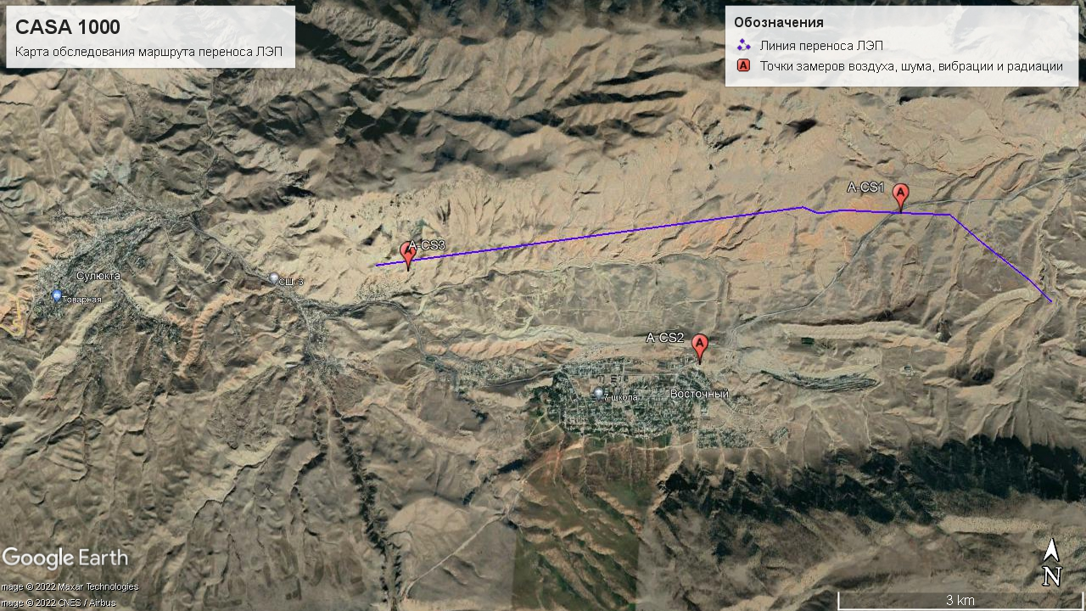
Figure 6.3.1. General map of air sampling points

  - Noise level
Noise level measurements were carried out to assess the background noise level in the area of ​​the proposed bypass route of the CASA 1000 Project.
The main purpose of this study was to further monitor possible changes as a result of anthropogenic impact during construction work. The results of noise level measurements are presented in Appendix 11 (Protocols of the Kadamzhai “Project to improve the technical capacity of the Batken District Centre for Disease Prevention and State Sanitary and Epidemiological Surveillance” - results of the noise study).
The noise standards used in Kyrgyzstan are presented in Appendix 10. “Noise standards in the Kyrgyz Republic” serve to assess the background state in the study area.
Noise measurements were carried out at 3 points, the measurements did not show an excess of the maximum permissible level (MPL) for populated areas (MPL -75 dBA). The main source of noise for these study points were the sounds reproduced by the wind and the movement of cars, not exceeding the limit levels.
  - Vibration level
Vibration level measurements were carried out to assess the background state of the vibration level in the territory of the proposed bypass route of the CASA 1000 Project; the measurement points are shown in Figure 6.5.1.
The main purpose of this study was to further monitor possible changes as a result of anthropogenic impact during construction work. Vibration level measurements were carried out in accordance with GOST 12.1.049-86 “Vibration. Measurement methods at workplaces of self-moving wheeled road construction vehicles”, SanPiN 2.1.2.1002-00 “Sanitary and epidemiological requirements for residential buildings and premises”.
The measurement results are regulated by the Sanitary Norms (SN 2.2.4/2.1.8.566-96) "Industrial vibration, vibration in the premises of residential and public buildings" (see Appendices 13 and 14), serve to assess the background state in the study area. The results of measurements of the vibration level are presented in Appendix 15 (Protocols of the Kadamzhai “Project to improve the technical capacity of the Batken District Centre for Disease Prevention and State Sanitary and Epidemiological Surveillance” - the results of the vibration study).
The analysis of vibration level measurements carried out at 3 points in the territory of the proposed bypass route of the power transmission line showed that weak vibration (less than 19.3 dBA) is recorded from vehicles moving along country/central roads. At all points of vibration measurements, there is no excess of the maximum allowable level of MPL (from 72-101 dBA).
Figure 6.5.1. Map of the noise and vibration study area

  - Surface waters
The bypass section of the CASA1000 power transmission line does not cross any surface water source, and therefore no water samples were taken.
Based on previous hydrogeological surveys of the Project area, the route passes through areas where the depth of groundwater is below 3 meters from the surface of the earth. Flooding is not expected in the areas of location of the power transmission line supports.
  - Hazard zones and forecasts of possible activation of hazardous processesand phenomena
There is a possibility of activation of hazardous processes and phenomena along the route of the Project power lines, according to the data of the Ministry of Emergency Situations of the Kyrgyz Republic:
• in Batken district of Batken region in the form of landslide processes.
Based on the above conditions, the Contractor took the necessary measures when designing the route of the transmission line and the technical features of the supports for the construction of the CASA 1000 transmission line, so that these hazardous processes do not affect the performance of the transmission line.
  - Engineering and geological surveys
Additional work was carried out to clarify the geological and lithological structure of the areas where the supports are located, and to clarify the technogenic conditions developed within their location.
For this purpose, the employees of Mitash Energy ve Mademi Inshaat Ishleri ​​Turk carried out the excavation of 25 pits at the site in a mechanized way with a depth of exploration of up to 5.0 meters. R.K. Mirzakhakimov, the chief geologist of RusMir LLC, has carried out a reconnaissance survey of the area where the supports were located with a description of the geological and lithological structure of the areas where the new supports were located based on the results of the drilling of pits, as well as the relief; information is given on the presence of landslide phenomena, planar washout and other geodynamic processes developed according to the new location of the supports.
Based on the geological and lithological structure of the areas of location of the transferred supports and on the selected engineering-geological elements (EGE), when compiling an additional technical report for the modified part of the route of the 500 kV overhead line 125 km long, indicators of the physical-mechanical and corrosion properties of soils, seismicity of the area and climatic information without changing the numbering of engineering-geological elements and all tables adopted in the main technical report of RusMir LLC for 2019 for the facility: “Transmission of electricity from Central Asia to South Asia CASA-100”, “Construction agreement 500 kV AC overhead line with a length of 125 km from an intermediate point to the Kyrgyz-Tajik border”, which passed the State Expertise in 2020, were applied.
  - Geological and lithological structure
According to the results of mining by mechanized method, in the geological and lithological structure in the areas, the changed location of supports No. 280L[284]-300N[304]; 301N[305N]-301C[305C]; 302L[306], of the projected route of the 500 kV overhead line,
125 kilometers long, alluvial-proluvial and deluvial-proluvial soils of the Upper Quaternary-modern age (apQIII-IV; dpQIII-IV), represented by silty-argillaceous soils-loess-like, macroporous, as a rule, solid and semi-solid in consistency, subsidence, with a thickness from a few meters to 5.0 meters or more (supports No. 284; 287; 288; 290; 291; 293; filler up to 20%, poorly cemented with carbonate-argillaceous cement (supports No. 297; 298; 299; 300; 301; 303). At the locations of supports No. 285; 286; 289; 292; 294; 295; 297; 302; 303; 304; 305N; 305A; 305B; 305C; 306, Paleogene - Neogene rocks occur, represented by sandstones, siltstones, and limestones. The soils listed above are everywhere covered by a soil-vegetative layer, up to 0.2 meters thick.
A detailed geological and lithological structure, along a partially modified route of a 500 kV overhead line, is given in the geological and lithological columns of workings and on engineering and geological sections for each support on the plan-profile of a 500 kV overhead line.
- Hydrogeological conditions
In hydrogeological terms, the location of the planned construction of a 500 kV overhead line, 125 kilometers long, from support No. 280L (284) to support No. 302L (306) is quite simple and based on materials from previously completed hydrogeological works ^{[2]}, is represented by one aquifer developed in Paleozoic rocks. The aquifer lies at a depth of about 50 meters or more and does not affect the projected overhead line route. According to paragraph 2.97 of the "Guidelines for the design of the foundations of buildings and structures" (to SNiP 2.02.01-83), the entire territory of the 500 kV overhead line, from support No. 280L (284) to support No. 302L (306), is classified as potentially flood-free groundwater.

- Geological processes and phenomena
The widespread manifestation of planar washout should be noted as one of the negative geodynamic processes in the territory of the projected construction. Almost along the entire altered route, starting from support No. 284 and up to support No. 305С, the trough-shaped erosion incisions are noted, with an incision depth of up to 20 meters or more, of a width of up to 50-100 meters along the top, where during intense precipitation and snowmelt in the spring-summer season, the passage of flood waters of a mudflow character is possible. There were no drops and landslide phenomena in the areas where the supports and the territories adjacent to them were located.
Support No. 299N (303) is located at the foot of a slope with an inclintion of the earth's surface up to 25°, on the surface of which there are fragments of rocks formed due to the destruction by weathering of bedrock – limestone. It is recommended to provide measures to protect the support from rockfall.
Plots composed of loess-like loamy clay-loamy soils, from solid to semi-solid consistency, which are subsiding when soaked, with type II soil conditions for subsidence. When designing, it is recommended to provide for measures to eliminate the subsiding properties of loam with the removal of rain and melt water from falling under the base of the support foundations.
Areas composed of siltstones, moderately weathered, softened in water, of medium strength, collapsible, strongly fractured; cracks are filled with parent rock.
It is recommended to provide for measures to drain rain and melt water from the location of the supports, as well as to provide measures to reinforce the base under the supports.

- Conclusion
- Due to the presence in the geological and lithological section along the modified route of the designed route of the 500 kV overhead line of soils with type II soil conditions for subsidence (supports No. 284; 287; 288; 290; 291; 293; 296), the design should be carried out with consideration of SNiP 2.02.01-83 p.p. 3.1-3.14. and it is necessary to provide for the drainage of rain and melt water from the location of the supports
In case of exclusion of water ingress into the base of the foundations of the supports, the design resistance R₀ to subsiding loams of natural composition, with a density in the dry state Rd = 1.35t/m, is recommended to be acceptd, according to table No. 4 SNiP 2.02.01-83 "Foundations of buildings and structures", equal to: R₀=350kPa (3.5kgf/cm²).
- No slopуs and landslide phenomena were noted in the areas of the supports and adjacent territories.
Support No. 299N(303) is located at the foot of a slope with an inclination of the earth's surface up to 25°, on the surface of which there are fragments of rocks formed due to the destruction of bedrock - limestone by weathering. It is recommended to provide measures to protect the support from the rockfall.
Areas composed of siltstones, moderately weathered, softened in water, medium strength, collapsible, strongly fractured; cracks are filled with parent rock. It is recommended to provide for measures to drain rain and melt water from the location of the supports, as well as to provide measures to reinfoce the base under the supports.
- In the event of a significant change in the surface of the site by vertical planning, a change in the location of supports or technical characteristics, the engineering and geological conclusion should be clarified in accordance with the changed conditions;
If soils that do not comply with this conclusion are found at the foundation laying marks, the pit should be inspected in kind by a geological engineer of RusMir LLC, with the drawing up of an act.

6.10. Soil-forming rocks
The project provides for earthworks, this section presents the characteristics of soil-forming rocks in the territory of the planned power transmission line route. When implementing the technical solutions of the project, this information will make it possible to make decisions on the removal of the fertile layer(in the places of its presence), based on the thickness of the soil layer and the characteristic features of the soils in the areas where supports and access roads are located.
In the modern period, in the zone of medium and high mountains, characterized by a less hot and more humid climate, the chemical decomposition of rocks is more intense with the removal of alkalis and alkaline earths, chlorides, sulfates and carbonates into the deep strata of loose sediments and down the slopes - into the plains and water basins . In the areas rich in precipitation, this process is even more pronounced, up to the destruction of aluminosilicates, the removal of silicic acid, and the accumulation of sesquioxides; therefore, more clayey soils are formed there, such as dark brown and brown.
Outcrops of stony rocks are widespread in high-mountain and partly mid-mountain zones. It is represented by various, but mostly calcareous rocks, less by shales and sandstones, and very rarely by igneous rocks (granites, etc.).
In the zone of middle mountains and foothills, deluvial deposits are widespread, represented by rubble-cartilaginous or skeletal-fine-grained sediments.
Loams are widespread in the study area of ​​the proposed bypass route. In the zone of medium mountains, they are found in small patches on slopes that are gentler and slightly prone to washout and leveled watershed areas. Most of the soils are heavy silty loams. In the area of ​​low foothills, loesses occupy large areas and form a continuous cover. Due to the weak resistance against erosion, the foothill zones can be strongly eroded and redeposited down the slopes. According to their mechanical composition, they belong to silty loams.

6.11. Soil fertility and quality
A baseline environmental analysis was carried out for supports 280L[284] to 302L[306] along the proposed bypass section of the project's transmission line route.
As part of additional studies, soil samples were taken at the bypass section to analyze and predict changes in their quality. At the same time, soil samples were taken in such a way as to cover a large area of ​​the study area, the selection was carried out on every 6th support in two layers to determine soil fertility and separately to determine the chemical elements of pollutants. Orography of the valley and short sections of access roads necessary for the construction of power lines allow arrangement of the results of laboratory analyzes of the soil under the supports and access roads. .
Soil surveys were carried out under the sites for the placement of power transmission supports; previously prepared ground excavations by an excavator near the centers of placement of supports were found.
It should be noted that the study area of ​​the bypass route has outcrops and a wide distribution of stony rocks in the middle mountain zone. In the zone of middle mountains and foothills, deluvial deposits are widespread, represented by rubble-cartilaginous or skeletal-fine-grained sediments. In the plains of intermountain depressions, thick alluvial-proluvial deposits of pebbles, sandy loams, and less often loams, are predominantly developed. In this connection, the soil in the territory of the proposed route and the bypass section is unproductive and poor. Due to the poverty of soils and in the areas planned for the construction of supports, the fertile layer is very small (in a layer of 0-20 cm), or it is very thin (less than 10 cm). When carrying out works on the removal and storage of the fertile layer(if any), when cleaning the site for the construction of power transmission supports, it is necessary to be very vigilant to prevent mixing of the fertile layer with bedrock. It should also be noted that a fertile layer suitable for removal, according to a number of methodological sources, must meet a certain quality indicator, i.e., the humus content in the lower layer to be removed should be at least 1,0- 1,5 % .
When determining soil fertility the experts were guided by the Methodological Guidelines for the Assessment of Soils in the Kyrgyz Republic (Mamytov, Voronov et al., 1994), which made it possible to assess the background state of soil quality in the territory of the planned construction of the Project.
The results of the obtained data on the mechanical and microaggregate composition, according to the classification of N.A. Kachinsky is presented in Appendix 17.
Soil quality assessment was carried out according to the Quantitative parameters of humus content (according to Grishina, Orlov, 1978) and is presented in Table 6.11.1.

Table 6.11.1. Quantitative parameters for assessing the state of soils in terms of humus content (according to Grishina, Orlov, 1978)
Attribute | Level, characteristic | Limits
Humus content in the minimum soil profile, % (0-20cm) | Very high | >10
 | High | 6-10
 | Medium | 4-6
 | Low | 2-4
 | Very low | <2

6.11.1. Soil on the platforms under the supports
As part of the preparation of the EIA, in accordance with the requirements of the legislation of the Kyrgyz Republic, studies were carried out on the fertility and quality of the soil in the study area of the proposed transfer of power lines. Soil samples were analyzed for indicators: mechanical composition, pH, humus, total nitrogen, gross and mobile forms of phosphorus and potassium, absorption capacity and absorbed sodium. The results of the study of the sites planned for the construction of supports are presented in Appendix 16.
When conducting a study of the bypass route, 9 soil samples were taken from the sites identified for the construction of supports and temporary access roads. Soil samples were analyzed in the laboratory of the Republican Soil and Agrochemical Station of the State Institution "Kyrgyzgiprozem" at the Ministry of Agriculture and Irrigation Engineering of the Kyrgyz Republic; the results are presented in Table 3.2.3.2.
Humus is the main organic matter of the soil, containing the nutrients necessary for higher plants. Humus makes up 85-90% of soil organic matter and is an important criterion in assessing soil fertility. It is a composite dynamic complex of organic compounds formed during the decomposition and humification of organic residues. The composition of humus includes specific humic substances, intermediate decay and humification products, and nonspecific organic compounds.
According to the results of laboratory studies, a high content of humus (from 6 to 10%) on the site under the support is observed only in one sample: S-CS 2.1 (6.55% - in a layer of 0-10 cm, and in a layer of 10-20 cm (S -CS 2.2), its almost two-fold decrease to 3.74%) is already observed; the rest of the samples showed a lower humus content, the average humus content (from 4 to 6%) is observed in one sample from the sites: S-CS 1.1 (4.58% - in the 0-10 cm layer, and in the 10-20 cm layer (S-CS 1.2), and almost twofold decrease to 3.64% is already observed.
A low content of humus (from 2 to 4%) is observed in two samples on the sites under the supports: S-CS 3.1 (4.58% - in a layer of 0-10 cm, and in a layer of 10-20 cm (S-CS 3.2) already there is an almost two-fold decrease to 3.64%) and S-CS 4.1 (4.58% - in the 0-10 cm layer, and in the 10-20 cm layer (S-CS 4.2), and there is already an almost two-fold decrease to 3 .64%).
A very low humus content (less than 2%) is observed in one sample of S-CS 5 in a layer of 0-10 cm, 1.56% is observed (layer 10-20 was not taken due to high stoniness and visual determination of the absence of a fertile layer).
Table 6.11.1.1 presents the results of the chemical analysis of soil samples on the sites determined for the placement of supports (every 6th support). Graphic placement of sampling points is shown in Figure 6.11.1.1.

Table 6.11.1.1. The Results of chemical analysis of soil samples at the sites for supports
Element | Support No. | Dense residue | Humus | СО2 | рН | Absorption capacity | Absorbed sodium | Gross |  | Nitrogen total | Mobile
 |  |  |  |  |  |  |  | Phosphorus | Potassium |  | Phosphorus | Potassium
Measurement unit |  | % | % | % |  | mg-eq. per 100g of soil |  | % | % | % | mg/kg | mg/kg
S-CS 1.1 |  | 0,083 | 4,58 | 1,1 | 7,75 | 22 | 0,2 | 0,196 | 1,65 | 0,205 | 26 | 440
S-CS 1.2 |  | 0,063 | 3,64 | 1,2 | 7,9 | 17 | 0,18 | 0,185 | 1,71 | 0,18 | 14 | 360
S-CS 2.1 |  | 0,068 | 6,55 | 2,1 | 7,8 | 21 | 0,12 | 0,17 | 1,8 | 0,3 | 31 | 568
S-CS 2.2 |  | 0,064 | 3,74 | 2,2 | 7,8 | 18 | 0,12 | 0,17 | 1,92 | 0,17 | 15 | 400
S-CS 3.1 |  | 0,086 | 3,48 | 3,1 | 7,9 | 17 | 0,12 | 0,107 | 1,65 | 0,17 | 38 | 600
S-CS 3.2 |  | 0,057 | 3,38 | 3,2 | 7,8 | 16,8 | 0,18 | 0,112 | 1,86 | 0,16 | 15 | 280
S-CS 4.1 |  | 0,13 | 2,23 | 4,1 | 7,75 | 14 | 0,18 | 0,108 | 1,41 | 0,11 | 25 | 336
S-CS 4.2 |  | 0,12 | 1,66 | 4,2 | 7,95 | 13,4 | 0,18 | 0,53 | 1,23 | 0,075 | 7 | 160
S-CS 5 |  | 0,063 | 1,56 | 3,1 | 7,95 | 18 | 0,12 | 0,53 | 0,66 | 0,07 | 32 | 300

The concentration of nitrogen in all selected samples is at the level of <0.3%, which indicates the fulvation of soils, the highest nitrogen content is observed in the layer 0-10 cm for two samples S-CS 1.1 and S-CS 2.1. The combination of a small amount of nitrogen and a low content of humus in soils indicates their erosion (washout).
It should also be noted that the fertile layer suitable for removal must meet a certain quality indicator, i.e. the humus content in the lower layer to be removed should be at least 1.0-1.5% (A.P. Klopotovsky, 1984).In accordance with this, the removed layer should be 12-20 cm, in the places of its presence and exclude displacement with unproductive, infertile layers.
Hydrogen index (pH) in soil samples will vary from 7.75 to 7.95, with an average value of 8.85.
The gross content of phosphorus on the platforms under the supports varies from 0.017 to 0.53%, with an average value of 0.23%.
The concentration of the gross content of potassium in soils varies from 0.36 to 1.92%, the average value is 1.5%.
The content of mobile phosphorus in soil samples varies from 7 mg/kg to 38 mg/kg, with an average value of 22.5 mg/kg.
The content of mobile potassium in soil samples varies from 160 mg/kg to 600 mg/kg, with an average value of 382.67 mg/kg.
In almost all samples, an increase in the concentration of arsenic from 2.2 mg/kg to 6.0 mg/kg, with a MPC of 2.0 mg/kg, is observed, with the exception of the S-CA3 sample, with a content of 1.6 mg/kg.
There is also an excess of Heptachlor pesticides in all mail samples from 0.068 mg/kg to 0.115 mg/kg, with MPC equal to 0.05 mg/kg.
The protocols of the Kadamzhay Centers for Disease Prevention and State Sanitary and Epidemiological Surveillance - the results of the study of soil pollution are presented in Appendix 14.
Land use along the transmission line route in the Project area is mainly represented by pastures with herbaceous-shrub vegetation and non-irrigated cultivated land in some places.

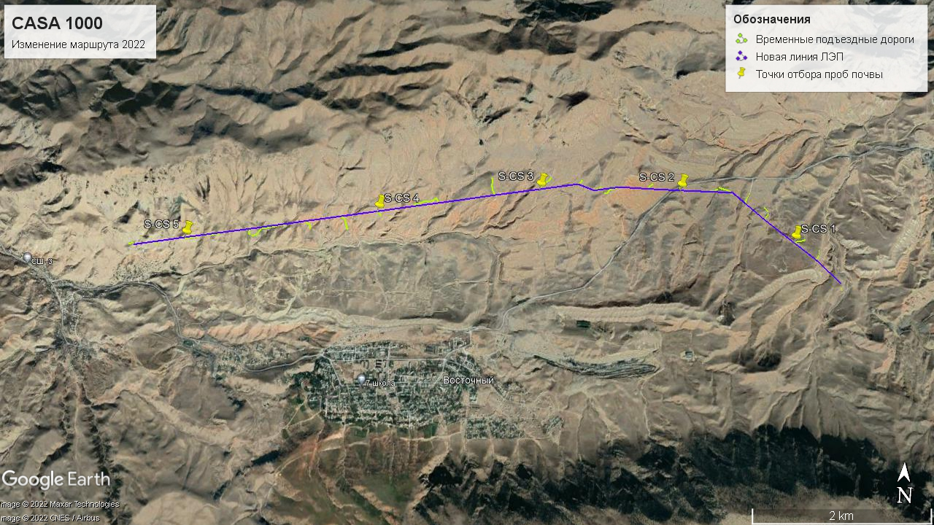
Figure 6.11.1.1. General map of soil sampling points

6.12. Vegetable kingdom
The flora of the region has been studied, but no lists of it have been published. Separate data on the flora of the region can be obtained from the "Flora of the Kirghiz SSR" (1952-1965), "Guide to the Plants of Central Asia" (1968-1993). According to floristic zoning (Kamelin, 2002), the study area belongs to the Ancient Mediterranean subkingdom of the Holarctic Kingdom, the Turkestan floristic region of the Central Asian floristic province.
Taking into account the experience of counting flora species in areas similar in terms of conditions, based on the field studies, it can be estimated as 250 species.

A field expedition was organized to study the vegetation cover.
The study was conducted by G.A.Lazkov, Doctor of Biological Sciences

❖ Research methodology
The relocation site included 26 planned support sites and access lines to the newsupports with a total length of about 9,200 meters. The description of the vegetation cover was carried out along the entire line of the bypass route with the survey corridor of 100 m.
Plants located within the same community outside the planned areas for supports were also taken into account.
The abundance of species was determined by the Drude scale.
- Soc – Sociales – plants are met in mass, individuals close to each other, forming a background.
- Cop – Copiosae – copiously
- Сор₃ – very copiously (70–90 % herbage volume)
- Сор₂ – copiously (50–70 %)
- Сор₁ – many (30–50 %)
- Sp – Sparsae rare (5–30 %)
- Sol – Solitaria single (1-5 %)
- Un – no plant found in the area
The productivity of the community was taken into account only in herbaceous species, by mowing the aboveground mass per 1 sq. m in 5-fold repetition and recalculation of mass per hectare.
The life form is given as follows:
- Дер. – tree
- Куст. – bush
- Трав. – herbaceous
If it is impossible to determine the species on the site, the plants are collected in a herbarium. Their determination is carried out in office conditions, with the help of the "Key to Plants of Central Asia" (1968-1993), "Flora of the Kirghiz SSR" (1952-1965) and by comparison with other, already identified material.
- Vegetation description of bypass route
Vegetation type. Large-grass mountain semisavanna
Vegetation with a predominance of xerophytic subshrubs, rarely suffruticose or shrubs
Couch grass formation (Agropyron trichophorum)
Couch grass-mixed association (Agropyron trichophorum + Artemisia prolixa + Carex turkestanica).
Floristic composition of the wormwood-grass mixed association
Item No. | Name of plants |  | Life form | Abundance
 | Latin | Russian
1 | Artemisia prolixa Krasch. ex Poljak. | Полыньширокая | Herb. | Сор₁
2 | Artemisia namanganica Poljakov | Полынь наманганская | Herb. | Sp
3 | Carex turkestanica Regel | Осока туркестанская | Herb. | Sol
4 | Festuca valesiaca Gaudin | Овсяница валлисская | Herb. | Sol
5 | Agropyron trichophorum (Link) K.Richt. | Пырей волосоносный | Herb. | Сор₂
6 | Handelia trichophylla (Schrenk) Heimerl | Ганделия волосистолистная | Herb. | Un
7 | Stipa capillata L. | Ковыль волосатик | Herb. | Sol
8 | Taeniatherum crinitum (Schreb.) Nevski | Лентоостник длинноволосый | Herb. | Sol
9 | Cousinia microcarpa Boiss. | Кузиниямелкоплодная | Herb. | Un
10 | Cousinia horridula Juz. | Кузиния страшненькая | Herb. | Un
11 | Cousinia radians Bunge | Кузиниялучевая | Herb. | Un
12 | Eryngium macrocalyx Schrenk | Синеголовник крупночашечковый | Herb. | Un
13 | Scabiosa songarica Schrenk | Скабиоза джунгарская | Herb. | Sol
14 | Alyssum turkestanicum Regel et Schmalh. | Бурачоктуркестанский | Herb. | Un
15 | Verbascum songaricum Schrenk | Коровякджунгарский | Herb. | Un
16 | Bothriochloa ischaemum (L.) Keng (Andropogon ischaemum L.) | Бородач кровоостанавливающий | Herb. | Sol
17 | Perovskia scrophulariifolia Bunge | Перовския норичниковолистная | Herb. | Un
18 | Peganum harmala L. | Гармала обыкновенная | Herb. | Un
19 | Phlomis salicifolia Regel | Зопник иволистный | Herb. | Un
20 | Achillea asiatica Serg. | Тысячелистниказиатский | Herb. | Un
21 | A. filipendulina Lam. | Тысячелистник таволговый | Herb. | Un
22 | CarduusnutansL. | Чертополох поникающий | Herb. | Un
23 | Chondrilla sp. | Хондрилла | Herb. | Un
24 | Hyalolaena bupleuroides (Schrenk) Pimenov et Kljuykov | Гиалоленаволодушковидная | Herb. | Un
25 | Convolvulus pseudocantabrica Schrenk | Вьюнокложнокантабрийский | Herb. | Un
26 | Linum corymbulosum Reichenb. | Лёнщиточковый | Herb. | Sol
27 | Phlomoides nuda (Regel) Adylov et al. (Eremostachys nuda Regel) | Фломоидесобнаженный | Herb. | Un
28 | PoabulbosaL. | Мятлик луковичный | Herb. | Сор₁
- The abundance of plants in the lists is given according to the Drude scale adopted in geobotanical studies:
Сор₃– very copiously (70–90 % herbage volume)
Сор₂ – copiously (50–70 %)
Сор₁ – many (30–50 %)
Sp – moderate (5–30 %)
Sol – little, rare (1-5 %)
Un – as a single unit or less than 1%

Coverage - 90%
It is used as a summer-spring pasture.
Productivity 5 c/ha.
A number of plants are ornamental: Species Phlomis salicifolia, Convolvulus pseudocantabrica, etc.
There are no Red Book species.
There are no species endemic to Kyrgyzstan.

Vegetation type. Irano-Turanian friganoids
Vegetation with a predominance of xerophytic subshrubs, rarely suffruticose or shrubs
Artemisia broad formation (Artemisia prolixa)
2. Wormwood-grass-mixed association (Artemisia prolixa + Artemisia namanganica + Agropyron trichophorum).
List of species of the wormwood- grass mixed association
Item No. | Name of plants |  | Life form | Abundance
 | Latin | Russian
1 | Artemisia prolixa Krasch. ex Poljak. | Полыньширокая | Herb. | Сор₁
2 | Artemisia namanganica Poljakov | Полынь наманганская | Herb. | Сор₁
3 | Carex turkestanica Regel | Осока туркестанская | Herb. | Sol
4 | Festuca valesiaca Gaudin | Овсяница валлисская | Herb. | Sol
5 | Agropyron trichophorum (Link) K.Richt. | Пырей волосоносный | Herb. | Сор₁.
6 | Stipa capillata L. | Ковыль волосатик | Herb. | Sol
7 | Taeniatherum crinitum (Schreb.) Nevski | Лентоостник длинноволосый | Herb. | Sol
8 | Cousinia microcarpa Boiss. | Кузиниямелкоплодная | Herb. | Un
9 | Alyssum turkestanicum Regel et Schmalh. | Бурачоктуркестанский | Herb. | Un
10 | Bothriochloa ischaemum (L.) Keng (Andropogon ischaemum L.) | Бородач кровоостанавливающий | Herb. | Sol
11 | Perovskia scrophulariifolia Bunge | Перовския норичниковолистная | Herb. | Un
12 | Peganum harmala L. | Гармала обыкновенная | Herb. | Un
13 | Phlomis salicifolia Regel | Зопник иволистный | Herb. | Un
14 | Achillea asiatica Serg. | Тысячелистниказиатский | Herb. | Un
15 | Convolvulus pseudocantabrica Schrenk | Вьюнокложнокантабрийский | Herb. | Un
16 | Linum corymbulosum Reichenb. | Лёнщиточковый | Herb. | Sol
17 | Phlomoides nuda (Regel) Adylov et al. (Eremostachys nuda Regel) | Фломоидесобнаженный | Herb. | Un
18 | PoabulbosaL. | Мятлик луковичный | Herb. | Сор₁
- The abundance of plants in the lists is given according to the Drude scale adopted in geobotanical studies:
Сор₃– very copiously (70–90 % herbage volume)
Сор₂ – copiously (50–70 %)
Сор₁ – many (30–50 %)
Sp – moderate (5–30 %)
Sol – little, rare (1-5 %)
Un – as a single unit or less than 1%

Coverage - 90%
It is used as a summer-spring pasture.
Productivity 5 c/ha.
A number of plants are ornamental: Species Phlomis salicifolia, Phlomoides nuda, etc.
There are no Red Book species.
There are no species endemic to Kyrgyzstan.

Vegetation type. Irano-Turanian friganoids
Vegetation with a predominance of xerophytic subshrubs, rarely suffruticose or shrubs
Formation of wormwood Namangan (Artemisia namanganica )
3. Wormwood-grass-mixed association (Artemisia namanganica + Eremurus olgae + Peganum harmala).

Item No. | Name of plants |  | Life form | Abundance
 | Latin | Russian
1 | Artemisia prolixa Krasch. ex Poljak. | Полыньширокая | Herb. | Сор₁
2 | Artemisia namanganica Poljakov | Полынь наманганская | Herb. | Un
3 | Carex turkestanica Regel | Осока туркестанская | Herb. | Un
4 | Agropyron trichophorum (Link) K.Richt. | Пырей волосоносный | Herb. | Un
5 | Stipa capillata L. | Ковыль волосатик | Herb. | Un
6 | Taeniatherum crinitum (Schreb.) Nevski | Лентоостник длинноволосый | Herb. | Sol
7 | Cousinia microcarpa Boiss. | Кузиниямелкоплодная | Herb. | Un
8 | Alyssum turkestanicum Regel et Schmalh. | Бурачоктуркестанский | Herb. | Un
9 | Bothriochloa ischaemum (L.) Keng (Andropogon ischaemum L.) | Бородач кровоостанавливающий | Herb. | Un
10 | Perovskia scrophulariifolia Bunge | Перовския норичниковолистная | Herb. | Sol
11 | Peganum harmala L. | Гармала обыкновенная | Herb. | Sp
12 | Phlomis salicifolia Regel | Зопник иволистный | Herb. | Un
13 | Achillea asiatica Serg. | Тысячелистниказиатский | Herb. | Un
14 | Convolvulus pseudocantabrica Schrenk | Вьюнокложнокантабрийский | Herb. | Un
15 | Linum corymbulosum Reichenb. | Лёнщиточковый | Herb. | Un
16 | Phlomoides nuda (Regel) Adylov et al. | Фломоидесобнаженный | Herb. | Un
17 | PoabulbosaL. | Мятлик луковичный | Herb. | Sol
18 | Eremurus olgae Regel | Эремурус Ольги | Herb. | Sp
19 | Acanthophyllum pungens (Bunge) Boiss. | Колючелистник колючий | Herb. | Un
20 | Cynodon dactylon (L.) Pers. | Свинорой пальчатый | Herb. | Un
21 | Krascheninnikovia. ceratoides (L.) Gueldenst. | Терескен кустарниковый | Herb. | Un
22 | Cousinia horridula Juz. | Кузиния страшненькая | Herb. | Sp
- The abundance of plants in the lists is given according to the Drude scale adopted in geobotanical studies:
Сор₃– very copiously (70–90 % herbage volume)
Сор₂ – copiously (50–70 %)
Сор₁ – many (30–50 %)
Sp – moderate (5–30 %)
Sol – little, rare (1-5 %)
Un – as a single unit or less than 1%

Coverage - 60%
It is used as a summer-spring pasture.
Productivity 3 c/ha.
A number of plants are ornamental: Species Eremurus olgae, Phlomis salicifolia, Acanthophyllum pungens
There are no Red Book species.
There are no species endemic to Kyrgyzstan.

Vegetation type. Anthropogenically modified communities
Represented by fields of wheat and barley and fallows with a predominance of weeds.
The vegetation is not described, as it is represented by weeds and cultivated plants, which change depending on the crop rotation.
.

Vegetation map
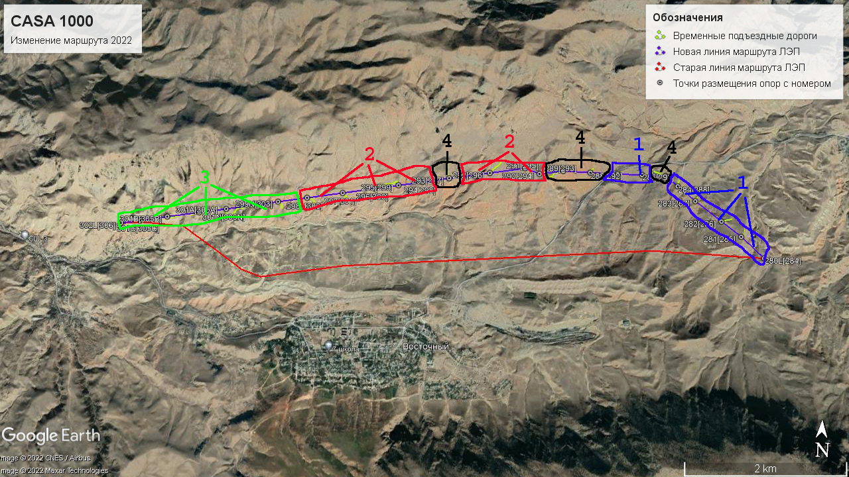
1. Wormwood-grass-mixed association (Agropyron trichophorum + Artemisia prolixa + Carex turkestanica);
2. Wormwood-grass-mixed association (Artemisia prolixa + Artemisia namanganica + Agropyron trichophorum)
3. Wormwood-grass-mixed association (Artemisia namanganica + Eremurus olgae + Peganum harmala);
4. Anthropogenically modified communities.

Summary:
As a result of studying the flora (vegetation cover) in the territory of the bypass section, the following conclusions can be drawn:
- Vegetation in the zone of the proposed bypass power line is represented by 2 main types: Large-grass mountain smisavannas, represented by the formation of couch grass (Agropyron trichophorum) with a couch grass-mixed association (Agropyron trichophorum + Artemisia prolixa + Carex turkestanica); Iranian Turanian friganoidswith the wormwood formation (Artemisia prolixa) with sagebrush-forb association (Artemisia prolixa + Artemisia namanganica + Agropyron trichophorum)), the Namangan wormwood formation (Artemisia namanganica) with wormwood-mixd grass association (Artemisia namanganica + Eremurus olgae + Peganum harmala); anthropogenically modified communities represented by fields of wheat, barley and fallows.
2. There are no plant communities unique for the study area in the territory of the site.
3. There are no species endemic to Kyrgyzstan in the area of the bypass route of the power transmission line.
4. There is no tree vegetation in the study area.
5. Some economically valuable plants are found in the study area, but their reserves are insignificant.

- Protected plant species

During the examination of species listed in the "Red Book of the Kyrgyz Republic" and endemic species were not found at the site.
The survey was carried out in autumn.

6.13. Animal kingdom
The purpose of our research was to collect factual material on the population of vertebrates (reptiles, birds, mammals) in the site of the bypass power line CASA-1000, located at the foothills of the northern macroslope of the Turkestan Range (Almaly mountains) near the Vostochny settlement; the total length was more than 12 km, which is slightly more than the bypass route (which is necessary for a full assessment of the territory).
The study area is geographically represented by steppe zones, the predominant type of plant community is xerophytic subshrubs, rarely small shrubs.

- Zoogeographic characteristics of the study area
The study area is located in the Palearctic region, the South Palearctic podo, the Nagorno-Asian province of the Pamir-Alai subprovince, the Alai district of Turkestan-Alai mid-mountain region, the Turkestan site. It presents all the species characteristic of this part of the zoogeographical area.
According to its faunistic composition, the site is transitional between the Turkestan and Alai ranges.
Species of the Southern Palearctic and the Western part of the Southern Palearctic of the faunistic complexes among birds and mammals prevail here, with a significant participation of Central Asian species. A significant proportion is also represented by species from the northern and temperate Palearctic. The complex composition of the fauna confirms the importance of the territory of the Turkestan Range for the conservation of the biodiversity of the mountainous country.
Mountain, desert-steppe and shrub-meadow species take almost an equal part of the ecological groups. The most sensitive to anthropogenic impact among them are mountain and shrub-meadow groups (Atlas of the Kirghiz SSR, 1978).

- Material and method
In the process of work, we used a variety of methods applid in zoological research (Novikov, 1953), which can be divided into visual and experimental. Determination of the number of animals is of great importance for studying the ecological situation of the bypass route of the power transmission line, making it possible to give an objective assessment of the study area. To clarify the wildlife in the summer season (reptiles, birds and mammals), an expeditionary trip was carried out on August 18-19, 2022. The direct bypass route of the power transmission line and the adjacent territory along the foothill steppe area were examined. The total area of ​​the study area made 6 km² .
The number and species composition of animals (reptiles, birds and mammals) was observed from a walking route. Ten binoculars were used to determine the species affiliation and quantitative enumeration of animals. The enumeration took place during the period of the greatest activity of birds, when there is the least chance of missing individual zooids. This time fell on the morning hours, immediately after sunrise, from 6 to 10-11 o'clock and in the evening from 17-19 o'clock. The birds were counted along a pre-selected route, passing through all the main biotopes at a speed convenient for observation, and all the birds met in the counting strip were enmerated, identified by voice and appearance, regardless of the distance to them. When birds were found, they were determined to the species; the species and quantitative composition of the birds were entered into the registration card.
It was taken into account that most mammals are very cautious, lead a hidden, often nocturnal lifestyle and catch the eye only for a short moment. The presence of many mammals was taken into account by the traces of their activity. When traces of an animal were found, attention was paid to the following signs:
1) the size of the footprint of the hind and front legs; 2) the number of fingers on them, the size and shape of the pads on the fingers and the sole, the presence or absence of hair on its lower surface; 3) the presence or absence of claw marks, their number, length and shape, the difference between the fore and hind limbs, the size and shape of the hooves, the features of their structure; 4) the ability of the fingers to move apart more or less when moving from dense to loose soil; 5) mutual arrangement of footprints during different runs of the animal. When excrement and other traces of vital activity were found, their species affiliation was established. In places where animals were supposed to be resent, the area was examined most carefully. Reptiles were counted in a strip up to 20 m throughout the route
The total length of the accounting route was 12 km. The distribution of animals by the sites was carried out according to the following gradations: dominant, the number of which prevails over other species. Subdominants are species that are inferior in number to dominant ones. Common - those species that are most often found. Small in number - inferior in number to other species located in this territory. Rare - single individuals found in the area
All encountered animals were marked with conventional icons on the route map. The route scheme was plotted on a map of the study area (1:5 000).
Transect points according to GPSmap 60Cx CASA 1000 power line survey navigator (reptiles, birds and mammals).
Birds were counted throughout the day from 8 a.m. to 8 p.m. 12 km were covered for the entire accounting period of the study. During this time, 23 bird species from 5 orders, 13 families and 21 genera have been recorded along the CASA 100 transmission line. (Ivanov, 1976).

- Factual material on reptiles
The count of reptiles was carried out in the foothill part of the Almalmy mount, the species composition of reptiles was limited to 1 species.
Support 280L [284] to 301B [305B] and surrounding area
One species was recorded throughout the entire site:
Eremias (s. str.) nikolskii Bedriaga – Kirghiz racerunner – A total of 17 zooids were recorded.
In total, the presence of 1 species was recorded on the studied section of the CASA 1000 bypass route; it is possible that during the examination of the spring aspect, 2 species were additionally met.
There are no reptiles listed in the Red Book of Kyrgyzstan in the study area.

- Systematic list of reptiles registered on the CASA 1000 bypass route (Vostochny settlement) and their geographical distribution

class REPTILIA (SAUROPSIDA part.) – ПРЕСМЫКАЮЩИЕСЯ, илиРЕПТИЛИИ – СОЙЛОПЖҮРҮҮЧҮЛӨР – REPTILES
fam. Lacertidae – НАСТОЯЩИЕЯЩЕРИЦЫ – НАКТАКЕСКЕЛДИРИКТЕР – TRUE [WALL] LIZARDS
genus Eremias Fitzinger in Wiegmann sensu [44] (=Dimorphea Jeriomtschenko [45]) – Ящурки, степныеящерицы – Кескектер – Racerunners, Sandlizards, Desert lacertas
1. Eremias (s. str.) nikolskii Bedriaga – ящуркакиргизская, илиНикольского – Николскийкескеги – Kirghiz racerunner– ?ЗТ(с), ЗТ(юз), ЗТ(юв), ВТ, ПФ; сэ.

- Factual material on bird record
We surveyed the bypass route by one route due to the short length of the route from support 280L [284] to 301B [305B], which runs along the southern slope of the Almaly mount, the site is characterized as an anthropogenically modified plant community, represented by fields of wheat and barley and fallows with a predominance of weeds . 23 species of birds out of 272 zooids were noted on the site.
The distribution of birds by ecological groups is as follows: shrub-forest - 4, steppe - 6, clay cliffs - 2, rocks and screes - 10, synanthropic - 1.
Survey data by species in the area of support 280L [284] to 301B [305B]
No. | Species | Nature of stay | Species occurrence | Birds counted on the route
1 | Milvusmigrans (Bodd.) – коршунчёрный | ВК, шр. | об. | 5
2 | Buteorufinus (Cretzschm.) – курганник | ВК, шр. | об. | 2
3 | Aquilachrysaetos (L.) – беркут | ВК, шр. | ред.. | 2
4 | Gypshimalayensis Hume – грифгималайский | ВК, шр. | ред.. | 23
5 | Aegypius monachus (L.) – грифчёрный | ВК, шр. | ред.. | 4
6 | Gypaetusbarbatus (L.) – бородач | ВК, шр. | ред.. | 6
7 | Falco (C.) tinnunculusL. – пустельга обыкновенная | ВК, шр. | об. | 4
8 | Alectoris chukar (J.E.Gray) – кеклик | ВК, шр. | об. | 12
9 | Columbalivia Gm. – голубьсизый | ВК, шр. | об. | 20
10 | Streptopeliaorientalis (Lath.) – горлицабольшая | ВК, шр. | об. | 2
11 | Coraciasgarrulus (L.) – сизоворонка | ВК, шр. | об. | 3
12 | Meropsapiaster L. – щурказолотистая | ВК, шр. | об. | 30
13 | Pyrrhocoraxpyrrhocorax (L.) – клушица | ВК, шр. | об. | 15
14 | Corvus (s. str.) corax L. – ворон | ВК, шр. | об. | 4
15 | Galeridacristata (L.) – жаворонокхохлатый | ВК, шр. | об. | 37
16 | Alaudaarvensis (L.) – жаворонок полевой | ВК, шр. | об. | 16
17 | Hirundo (s. str.) rusticaL. – ласточка деревенская | ВК, шр. | об. | 40
17 | Sylviaalthaea Hume (?=S. affinis Blyth) – славкагорная | ВК, шр. | об. | 2
19 | Oenantheisabellina (Temm.) – каменка-плясунья | ВК, шр. | об. | 5
20 | Oenantheoenanthe (L.) – каменка обыкновенная | ВК, шр. | об. | 7
21 | Oenanthepleschanka (Lepechin) – каменка-плешанка | ВК, шр. | об. | 12
22 | Anthusspinoletta (L.) – конёк горный | ВК, шр. | об. | 12
23 | Motacilla (s. str.) personataGould – трясогузка маскированная | ВК, шр. | об. | 9
Total |  |  |  | 272
Note: ос. – settled, гн. – nesting, мг. – met only during migration, пер. – migratory, дм. - dominant, сд. – subdominant (species inferior in number to dominants), об. – ordinary, мл. – few, р. – rare, к. – feeding, п. - navigating.
As can be seen from Table 1, in summer, the dominant species are the European bee-eater, the crested lark and the common swallow, in this area the golden bee-eater and the common swallow are found during feeding. The subdominant are the Himalayan vulture and the gray dove. It should be noted that a large number of the Himalayan vulture is due to the fact that in the area 280L [284] there was a corpse of a calf, on which vultures flight from all around. The gray dove nests in nearby settlements. Common species are black kite (found during feeding), long-legged buzzard (found during feeding), chukar (nests in adjacent territories), chough (found during feeding), such species as: crested lark, field lark, isabelline wheatear , common wheatear, pleshanka wheatear, mountain pipit and masked wagtail (nests in this area). Few species are golden eagle, black vulture, bearded vulture, common kestrel and oriental turtleneck. It should be noted that all of the listed species do not nest in this area, and are found during feeding or during flight.

List of birds registered in the Red Book of the Kyrgyz Republic, encountered on the route of the power line "CASA 1000" (Vostochny settlement)
No. | Specis | Registered in the Red Book of the Kyrgyz Republic | Listed by the IUCN
1 | Aquilachrysaetos (L.) – беркут – бүркүт – golden eagle | + | –
2 | Aegypius monachus (L.) – грифчёрный – тазкара – Cinereous vulture | + | +
3 | GypshimalayensisHume – гриф гималайский (снежный) – кумай – Himalayangriffon | + | +
4 | Gypaetus barbatus (L.) – бородач – көкжору – lammergeyer | + | +
Note: IUCN – International Union for Conservation of Nature.

List of birds of economic importance (hunting species)
Alectoris chukar (J.E.Gray) – кеклик – кекилик – chukar partridge
Columbalivia Gm. – голубьсизый – көккөгүчкөнү – rock pigeon
Streptopeliaorientalis (Lath.) – горлицабольшая – чоңбактек – Oriental turtle dove

- List of birds of aesthetic importance (songbirds)

Pyrrhocoraxpyrrhocorax (L.) – клушица – кызылтумшукчөкөтаан – red-billed choughGaleridacristata (L.) – жаворонокхохлатый – молдоторгой – crested lark
Alaudaarvensis (L.) – жаворонокполевой – талааторгою – Eurasian skylark
Sylviaalthaea Hume (?=S. affinis Blyth) – славкагорная – тоошалкысы – Hume’s whitethroad
Oenantheisabellina (Temm.) – каменка-плясунья – чакчыгай – isabelline wheatear
Oenantheoenanthe (L.) – каменкаобыкновенная – көкчакчыгай – Northern wheatearOenanthepleschanka (Lepechin) – каменка-плешанка – караалачакчыгай – pied wheatear

- Systematic list of birds registered on the CASA 1000 bypass route (Vostochny settlement) and their geographical distribution)
class AVES – ПТИЦЫ – КУШТАР – BIRDS
order FALCONIFORMES – СОКОЛООБРАЗНЫЕ – ШУМКАРСЫМАЛДУУЛАР – FALCONIFORMES
family Accipitridae – ЯСТРЕБИНЫЕ – КАРЧЫГАСЫМАЛДАР
genus Milvus Lacépède – Коршуны – Айрыкуйруктар – Kites
1. Milvusmigrans (Bodd.) (=Milvus korschun S.G.Gmelin) – коршунчёрный – айрыкуйрук – black-eared kite – ВК; шр.
genus Buteo Lacépède – Сарычи – Сырылар – Buzzards
2. Buteorufinus (Cretzschm.) – курганник - жамансары - long- legged buzzard – ВК; шр.
genus Aquila Brisson – Орлы – Бүркүттөр – True eagles
3. Aquilachrysaetos (L.) – беркут – бүркүт – golden eagle – ВК; шр.
genus Gyps Savigny – Сипы – Кажырлар – Griffons, Vultures
4. Gypshimalayensis Hume – грифгималайский (снежный) – кумай – Himalayan griffon – ВК; шр.
fam. Gypaetidae – КӨКЖОРУЛАР – LAMMERGEIERS
genus Aegypius Savigny – Чёрныегрифы – Тазкаралар
5. Aegypius monachus (L.) – грифчёрный – тазкара – Cinereous vulture ВК; шр.
genus Gypaetus Storr – Бородачи – Көкжорулар – Bearded vultures
6. Gypaetusbarbatus (L.) – бородач – көкжору – lammergeyer – ВК; шр.
fam. Falconidae – СОКОЛИНЫЕ – ШУМКАРЛАР – FALCONS
genus Falco Linnaeus – Соколы – Шумкарлар – Falcons
7. Falco (C.) tinnunculus L. – пустельгаобыкновенная – кадимкикүйкө – common kestrel – ВК; шр.
order GALLIFORMES – КУРООБРАЗНЫЕ – ТООКСЫМАЛДУУ – ALLIFORMES
fam. Phasianidae – ФАЗАНОВЫЕ – КЫРГООЛДОР
genus Alectoris Kaup – Кеклики – Кекиликтер – Chukar partridges
8. Alectoris chukar (J.E.Gray) – кеклик – кекилик – chukar partridge – ВК; шр.
order COLUMBIFORMES – ГОЛУБЕОБРАЗНЫЕ – КӨГҮЧКӨНСЫМАЛДУУЛАР – DOVES and PIGEONS
fam. Columbidae – ГОЛУБИНЫЕ – КӨГҮЧКӨНДӨР – DOVES and PIGEONS
genus Columba Linnaeus – Голуби – Көгүчкөндөр – Old Word pigeons
9. Columbalivia Gm. – голубьсизый – көккөгүчкөнү – rock pigeon – ВК; шр.
родStreptopelia Bonaparte – Горлицы – Бактектер – Turtle doves
10. Streptopeliaorientalis (Lath.) – горлицабольшая – чоңбактек – Oriental turtle dove -– ВК; шр.
order CORACIIFORMES – РАКШЕОБРАЗНЫЕ – КӨККАРГАЛАРСЫМАЛДУУЛАР
fam. Coraciidae – СИЗОВОРОНКОВЫЕ – КӨККАРГАЛАР – ROLLERS
genus Coracias Linnaeus – Сизоворонки – Көккаргалар – Rollers
11. Coraciasgarrulus (L.) – сизоворонка – көккарга – European roller – ЗТ, СК, ПИ, ВТ(з,ц), ПФ, А(з); шр.
fam. Meropidae – ЩУРКОВЫЕ – СООРУЛАР – BEE-EATERS
genus Merops Linnaeus – Щурки – Соорулар – Bee-Eaters
12. Meropsapiaster L. – щурказолотистая – көксоору – European bee-eater – ЗТ, СК, ПИ, ВТ(з,с,ц), ПФ, (M)А; шр.
order PASSERIFORMES – ВОРОБЬИНООБРАЗНЫЕ – ТАРАНЧЫСЫМАЛДУУЛАР – PASSERINES
fam. Corvidae – ВРАНОВЫЕ – КАРГАЛАР – CORVIDS
genus Pyrrhocorax Tunst. – Клушицы – Кызылтумшукчөкөтаандар – Choughs
13. Pyrrhocoraxpyrrhocorax (L.) – клушица – кызылтумшукчөкөтаан – red-billed chough – ВК; шр.
genus Corvus Linnaeus – Вороны – Каргалар – Crows
14. Corvus (s. str.) corax L. – ворон – кузгун – common raven – ВК; шр.
fam. Alaudidae – ЖАВОРОНКОВЫЕ – ТОРГОЙЛОР – LARKS
genus Galerida Boie – Хохлатыежаворонки – Молдоторгойлор – Crested larks
15. Galeridacristata (L.) – жаворонокхохлатый – молдоторгой – crested lark – ЗТ(с), СК, ПИ, ВТ(с,ц), ПФ, К; шр.
genusAlauda Linnaeus – Полевыежаворонки – Талааторгойлор – Skylarks
16. Alaudaarvensis (L.) – жаворонокполевой – талааторгою – Eurasian skylark – ВК; шр.
fam. Hirundinidae – ЛАСТОЧКОВЫЕ – ЧАБАЛЕЛКЕЙЛЕР – SWALOWS end MARTIS
genus Hirundo Linnaeus – Касатки – Үйчабалекейлер – True swallows
17. Hirundo (s. str.) rustica L. – ласточкадеревенская, касатка – кыштакчабалекей – barn swallow – ЗТ(с), СК, ПИ, ВТ, ПФ, (M)А; шр.
fam. Sylviidae – СЛАВКОВЫЕ – КОРООЛУСЫМАЛДАР – OLD WORLD WABLERS
genus Sylvia Scopoli – Славки – Шалкылар
18. Sylviaalthaea Hume (?=S. affinis Blyth) – славкагорная – тоошалкысы – Hume’s whitethroad – ЗТ, СК, ПИ(в), ПФ(с,ю); шр.
fam. Muscicapidae – МУХОЛОВКОВЫЕ – ЧЫМЫНЧЫЛАР – OLD WORLD FLYCATCHERS
genus Oenanthe Vieillot – Каменки – Чакчыгайлар – Wheatears
19. Oenantheisabellina (Temm.) – каменка-плясунья – чакчыгай – isabelline wheatear – ВК; шр. 3.
20. Oenantheoenanthe (L.) – каменкаобыкновенная – көкчакчыгай – Northern wheatear – ВК; шр.
21. Oenanthepleschanka (Lepechin) – каменка-плешанка – караала чакчыгай – pied wheatear – ЗТ(с,юз), СК, ПИ, ВТ(з,ц), ПФ(с,в,ю); шр.
fam. Motacillidae – ТРЯСОГУЗКОВЫЕ – ЖЫЛКЫЧЫЧЫМЧЫКСЫМАЛДАР – PIPITS END WAGTAILS
genus Anthus Bechstein – Коньки – Тооэлсанарлар – Pipits
22. Anthusspinoletta (L.) – конёк горный – тоо элсанары – water pipit – ВК; шр.
genus Motacilla Linnaeus – Трясогузки – Жылкычычымчыктар – Wagtails
23. Motacilla (s. str.) personata Gould – трясогузкамаскированная – жылкычычымчык – masked wagtail – ВК; шр.

- Conclusions
1. The biodiversity of birds on the bypass CASA 1000 power line (Vostochny settlement) in summer is represented by 23 species, 272 zooids, including 5 orders, 13 families and 21 genera.
2. The bypass line of the CASA 1000 power transmission line (Vostochny settlement) mainly runs through anthropogenically modified land and is considered an unfavorable ecosystem for birds, which was confirmed by our study: the species and quantitative composition of birds is small.
3. It should be noted that the main and bypass route "CASA 1000" runs on the "Turkestan-Alai" migration corridor, which in turn will be one of the obstacles, where a certain number of birds will die in a collision with a power line, mainly night migrants.The original planned route also passed through the “Turkestan-Alai” migration corridor, changes within the migration corridor are not significant.

- Factual material on mammals
The count was carried out along the southern slope of the Almaly mount, an area depleted in plant communities and unsuitable for mammals. The following species have been recorded throughout the site:
Record data by species in the area of supports 132L [133] to 159N [166]

No. | Species | Nature of stay | Species occurrence | Registered on the route
1 | Canis aureus L. – шакал обыкновенный | а. | об. | опрос. сле.
2 | Vulpesvulpes (L.) – лисица обыкновенная | а. | об. | сле.
3 | MelesleucurusHodgs. – барсук азиатский | а., зм. | мл. | жд. нор.
4 | Ellobius (s. str.) tancreiBlasius – слепушонка восточная | зм. | об. | нор.
5 | Cricetulusmigratorius (Pall.) – хомячоксерый | зм. | об. | нор.
6 | Meriones (Pallasiomys) libycus Licht. – песчанкакраснохвостая | зм. | об. | 3
7 | Lepus (Proeulagus) tolai Pall. (L. capensis auct. part.) – заяц-песчанник-толай | а. | об. | опрос.
Total
Note: об. – ordinary, р. – rare, мл. – few, а. – active all year round, зм. – lie down in a winter sleep, кл. – colonial animals, со. – social animals, сле. – registration by trace, жд. – vital activity, нор. – residential burrows are marked, пом. – the presence of a litter is registered, опрос. – according to survey data.
As can be seen from Table. 3, in summer, the dominant species are the eastern mole vole (found throughout the entire bypass route) and the red-tailed gerbil. Common species are the common jackal, common fox and tolai sandstone hare (their presence was confirmed according to the survey data of local shepherds), gray hamster (single burrows were noted in several places in the adjacent territory).
- Systematic list of mammals recorded on the CASA 1000 bypass route (Vostochny settlement) and their geographical distribution
class MAMMALIA – МЛЕКОПИТАЮЩИЕ – CҮТЭМҮҮЧҮЛƟР – MAMMALS
order CARNIVORA – ХИЩНЫЕ – ЖЫРТКЫЧТАР – CARNIVORES
fam. Canidae – ПСОВЫЕ – ИТТЕР – CANIDES
genus Canis Linnaeus – Волкиисобаки – Карышкырларжанаиттер – Dogs and wolves
1. Canis aureus L. – шакалобыкновенный – golden jackal – ЗТ, СК, ПИ, ВТ, ПФ; шр.
Genus Vulpes Frisch – Лисицы – Түлкүлɵр – Foxes
2. Vulpesvulpes (L.) – лисицаобыкновенная – кадимкитүлкү – red fox – ВК; шр.
fam. Mustelidae – КУНЬИ – КУНДУСТАР
genus Meles Boddaert – Барсуки – Кашкулактар – Eurasian badgers
3. Melesleucurus Hodgs. – барсуказиатский – кашкулак – Asian badger – ВК; шр.
order RODENTIA – ГРЫЗУНЫ – КЕМИРҮҮЧҮЛӨР – RODENTS
fam. Cricetidae – ХОМЯКОВЫЕ – АЛАМАНДАР – CRICETIDS
genus Ellobius Fischer von Waldheim – Слепушонки – Сокурчычкандар – Mole–voles
4. Ellobius (s. str.) tancrei Blasius – слепушонкавосточная (зайсанская) – сокурчычкан – Eastern (Zaisan) mole–vole – ПИ(в), ЦТ, ЗТ, СК, ПИ, ВТ, ПФ, (?)А(з,в); сэ.
genus Cricetulus Milne-Edwards – Хомячкисерые – Бозаламандар – Eurasian hamsters
5. Cricetulusmigratorius (Pall.) (=Hypudaeus cinerascens Wagner, =Cricetus fulvus Blanford, =Cricetus murinus Sev., =Arvicola coerulescens Sev., =C. m. caesius Kashkarov) – хомячоксерый [Палласов] – кескекжекөкчычкан – grey [migratory] dwarf hamster – ВК; шр.
fam. Muridae – МЫШОВЫЕ – КИЧИЧЫЧКАНДАР – TRUE MICE
genus Meriones Illiger – Малыепесчанки – Кичикумчычкандары – Sand rats
6. Meriones (Pallasiomys) libycus Licht. (=Gerbillus erythrourus J.E.Gray) – песчанкакраснохвостая – кызылкуйруккумчычкан – Lybian jird – СК, ЗТ, ПИ, ВТ, ПФ; сэ.
order LAGOMORPHA – ЗАЙЦЕОБРАЗНЫЕ – КОЁНСЫМАЛДАР
fam. Leporidae – ЗАЙЦЕВЫЕ – КОЁНДОР – RABBITS and HARES
genus Lepus Linnaeus – Зайцы – Коёндор – Hares
7. Lepus (Proeulagus) tolai Pall. (L. capensis auct. part.) – заяц-песчанник-толай – коён – Turkestan tolai hare – ВК; шр.
- Conclusons
1. In total, 7 species were registered visually and by traces of vital activity on the studied section of the CASA 1000 bypass route (Vostochny settlement). It should be noted that not all murine species have been noted, due to the limited time for research.
2. Mammals listed in the Red Book of Kyrgyzstan do not inhabit the study area.
3. The most common species are the red-tailed gerbil and the eastern mole vole.
4. The faunistic composition of mammals in the study area is poor compared to other areas of the Batken region.

6.14. Examination of the territory to identify objects of historical and cultural heritage (archaeology)
On October 6-9, 2022, field archaeological surveys were carried out near the city of Syuluktu, Kulunda ayil aimak, Batken region, in order to determine the presence or absence of archeological objects and monuments of historical and cultural heritage in the construction zone of the CASA-1000 power line route with a total length of 9808m. The work was carried out according to the customer's specifications (see Appendix).
The studied plot of land for transformation (Transfer of agricultural land into the category "Lands for industry, transport, communications, defense and other purposes.") is located to the north and northeast of the city of Sulukta on the territory of Kulunda aiyl aimak. The power transmission line and supports are designed 3-4 km to the north of the above-mentioned settlements, which runs along the slopes of adyrs. This site is located in the border zone of Leilek district, Batken region of the Kyrgyz Republic and Khojent region, Republic of Tajikistan
At the time of inspection, the projected area of the CASA-1000 power line has been used for many years as a pasture and tillage arable land. The terrain is uneven, the plateau of the mountain slope, the mass of the earth is rocky (See Appendix, space image 1,2,3,4)
When studying the route of the power transmission line, a total of 26 support sites were inspected and a territory of support sites between them in accordance with the submitted technical specifications of the customer in order to identify the presence or absence of HCH objects forimpact mitigation during the construction of the power transmission line and access roads to them. It should be noted that earlier the pits were laid in place of the supports to study the soil of the earth and geological structure.The area occupied by the place of installation of power transmission suports is 15x15m. Average distance between supports makes 350-370m.
The study was started from the east towards western direction from the line of constructed tower-283, and then takes place in the Republic of Tajikistan.The study was carried out according to the methodology of archaeological exploration at a distance of 50 m from the axis (to the right and left sides of the power line). The updated coordinates of the places for installation of power transmission line supports were presented by the Employer after redesigning, taking into account the preservation of the HCH monuments.
- Support-280L [284] coordinates (39°56'9.79"K 69°42'45.06"D)
- Support-281 [285] is located on the slope of the mountain (39°56'18.57"K 69°42'31.47"D)
- Support-282 [286[around the installation site of the supporting platform is plowed (39°56'24.93"K 69°42'20.92"D)
- Support-283 [287]located on the hillside (39°56'33.53"K 69°42'6.65"D)
- Support-284 [288] is located on the adyr hill (39°56'39.74"K 69°41'56.33"D)
- Support-285 [289] is located on the slope of a plateau (39°56'44.02"K 69°41’49.23"D)
- Support-286[290] is located next to the highway (39°56'43.91"K 69°41'35.75"D)
- Support-287[291] is located on the side of the Sulukta road (39°56'43.80"K 69°41'21.63"D)
- Support-288[292] is located on the slope of the adyr (39°56'43.67"K 69°41'5.83"D)
- Support-289[293] is located on a high plateau (39°56'43.54"K 69°40'49.90"D)
- Support-290[294] is located on a high plateau (39°56'41.71"K 69°40'36.52"D). In this area, the power line crosses the earlier existing power line in the northwest direction.
- Support-291[295] is located on a high plateau (39°56'43.98"K 69°40'28.29"D). In this area, to the north of the installation site of the power line, 5 early excavated mounds were recorded with a funnel in the center. It should be noted that during the studies of the installation site of the above-mentioned power transmission support, where preliminary studies of the soil (pits) of the earth were carried out, no traces of cultural heritage were recorded.
- Support-292[296] is located on the left side of the dry sai (39°56'41.22"K 69°40'8.51"D). The north and western part is plough up.
- Support-293[297] is located on a hill between the sais (39°56'38.01"K 69°39'45.51"D)
- Support-294[298] is located on the adyr hill (39°56'35.90"K 69°39'30.37"D)
- Support-295[299] is located on the adyr hill (39°56'34.02"K 69°39'16.89"D)
- Support-296[300] is located on the adyr hill (39°56'32.14"K 69°39'3.42"D)
- Support-297[301] is located on the adyr hill (39°56'29.59"K 69°38'45.18"D). Plough area around.
- Support-298L [302] is located in the foothill plain (39°56'26.75"K 69°38'24.86"D). Near 45m there are burial grounds of different times; there are funnels in the center. The entire site is plough up.
- Support-299N[303] is located in the foothill plain (39°56'24.43"K 69°38'8.28"D)
- Support-300N [304] is located on a rocky mountain (39°56'22.93"K 69°37'57.57"D). At a distance of 240 m from supportr 300N[304] and 220 m fromsupport 301N[305N] there is a kurgan (tepe) on a hemispherical hill, d-14m, h-80-1m. (photo 49) [coordinates of the kurgan 39°56'21.11"C; 69°37'48.44"B]. During the installation of the power line support, the monument is not threatened with destruction.
- Suppot-301N [305N] is located on the left dry sai (39°56'20.25"K 69°37'38.43"D)
- Support 301A[305A] is located on the adyr hill (39°56'18.11"K 69°37'23.09"D).
- Support-301B[305B] is located on the adyr hill (39°56'15.55"K 69°37'4.85"D)
- Support-301C [305C] (39°56'13.38"K69°36'49.31"D).
- Support-302L [306] is located on the adyr hill (39°56'11.77"K 69°36'37.87"D)

Conclusion:
During the inspection in the construction zone of the power transmission line and the installation site of the power transmission tower from 280L[284] to 302L[306] located on the territory of Kulunda ayil aimak, Leilek district, Batken region, objects of historical and cultural heritage were not identified and are subject to development.
In connection with the redesign of the power line support, the monuments of the IKN are not in danger of destruction, since the monuments are located 240 m from support300N[304] and 220 m from support301N[305N].
Also, as a result of the study of the line and the installation site of the power transmission tower, excavated mounds were noted near support295 (4-5 excavated mounds), to the north-west of support-302 at a distance of 50-52 m, excavated and destroyed mounds were also noted as a result of the development of plowing. But, these objects were partially explored or destroyed, which are not included in the installation area of the power line support.
Recommendations:
1. In the event of a change in the territory of the site or the development of new sites, it is necessary to conduct additional archaeological research.
2. When carrying out construction, installation work of supports, exercise vigilance and caution. In the event of the discovery of the remains of ancient structures, archaeological finds, it is necessary to stop construction work on that site and inform the competent authorities of the protection of the HCH and archaeologists of the KNU.
3. When changing the location of power transmission towers, inform the relevant state authorities. authorities (Ministries of Culture) or other supervisory authorities.

6.15. Human environment
The proposed bypass route is the transfer of the location of 26 supports, with a total length of about 9,200 meters, the site is located on the territory of the Batken region, Leilek district near the city of Suluktu and the Vostochny settlement.
The bypass route does not affect permanent buildings (households) and does not imply resettlement. Implementation of the RAP will eliminate all risks associated with compensation payments. The impact is expected to be insignificant.
PAPs included landowners/landusers of land plots subject to withdrawal on a permanent basis or temporary use. In total, there are five (5) families of PAPs (individuals) in Kulunda Aiyl Aimak of Batken oblast. Along the route of the power transmission line in the section between supports 280L [284] and 302L [284] of Kulunda ayil aimak, Batken oblast, no assets or land plots affected by the Project, owned by legal entities, have been identified.
In total, the total area of land (of all categories) in the area between pylons 280L [284] and 302L [284] of Kulunda aiyl aimak of Batken oblast, necessary for permanent acquisition for placement of pylons, will be 9,564 sq.m. or 0.9564 ha, of which:
0.0765 ha of rainfed arable land in private ownership;
0.1885 ha of privately owned hayfields;
0.0361 ha of state-owned hayfields;
0.6553 ha of pastures owned by the state and under the operational management of LSGs.

The total area required for permanent withdrawal for the placement of supports will be 9564 m² or 0.9564 ha, of which 0.3011 ha for cultivated agricultural land, and 0.6553 for pastures. There are no irrigated agricultural lands. The area of temporary withdrawal for construction sites for supports and access roads to them will be 11,505 m² or 1.1505 hectares, of which 0.2511 hectares are cultivated agricultural lands. The land explication plan is presented in Appendix 20.
The Grievance Redress Mechanism (GRM) is presented in section 11 and will also consider complaints from local communities related to land withdrawal and compensation payments to PAPs, both at the PTL construction and operation stage.
In general, the project provides all necessary mechanisms and occupational health and safety practices . The Construction Contractor implements the presented mechanisms and reports to the representatives of the PIU. The impact on the health and safety of personnel (labor protection) from the implementation of the measures and norms presented in section 8 will be of low significance.

Air transmission lines as an element of the electric power system have direct contact and interaction with the environment. The most characteristic environmental problems encountered in the design and construction of power lines are the following: alienation and seizure of land, deforestation of forests, restriction of economic activity in the zone of alienation of land for power lines, the influence of electric and magnetic fields on the biosphere, deterioration of visual appearance of landscape in the places of passage of air lines.
Part of these environmental impacts can be quantified and can be expressed in economic indicators that are considered in the design. Most of the impact on the biosphere and social systems is difficult and sometimes impossible to assess.
In areas with high population density, simultaneously with economic and technical problems arising during the construction of the power transmission line, problems of aesthetic influence of these lines on the environment also appear. This impact is related to the size (height) of the towers, their architectural forms, with the coloring of all line elements. For better visual and aesthetic perception, it is recommended to choose towers that meet the requirements of industrial aesthetics and the correct architectural forms, with natural cover (screening) in the form of wood, hills, etc., masking (coloring) the elements of the lines to reduce their gloss, and to use of two-circuit tower/towers or towers of different height.
Withdrawal of land from land use. According to the project, the land for construction towers is a subject to permanent withdrawal. The size of these construction sites are on average equal to 20 x 20 m, depending on the size of the foundation plus 2 meters on each side. Along with the persistent the provision of land for the construction sites, land is temporarily withdrawn for the construction of temporary access roads.
In addition to permanent allocation of land, temporary land acquisition for the period of construction of power lines for the construction of access roads.
In general, power transmission lines do not pose a significant threat to the environment, since they do not pollute air, water and land.
Based on the above information, there are no alternative options for the type and purpose of the power line in the CASA1000 project for the reasonable use of natural resources, except for the refusal to implement the planned activity (zero option). In this connection, in next sections of the document, an assessment is conducted for the option that is taken as a basic/primary one.
To ensure population’s safety, its welfare and environmental protection, the following criteria were used in the CASA1000 project:
- To ensure the safety of the population, a sanitary break is established for the power transmission line, which is installed along the high-voltage line, beyond which the electric field does not exceed one kV/m. The sanitary break acts as a guard zone of the high-voltage line, within the boundaries of which the restrictions are imposed on the access of persons during the construction and operation of power lines. For the operational organization, the requirements for permanent monitoring of vegetation and any work inside of the break are established, to ensure operating conditions and repair of transmission lines, as well as to exclude the possibility of damage to the electric network;
- Obligatory observance of environmental protection standards, regulated by the legislation of the Kyrgyz Republic and the World Bank requirements for this Project;
- Exported surpluses are set using restrictions on the coordination of the operation of water reservoirs (Toktogul, Nurek) in the summer months, which increases flexibility by taking advantage of a larger volume of the Toktogul reservoir;
- The implementation of the Project will not lead to problems of electricity supply(deficit) in the territory of the Kyrgyz Republic;
- Mandatory development and implementation of the Resettlement Action Plan (RAP) in compliance with the World Bank's requirements and RPF for physical and economic displacement and resettlement with payment of compensation to persons affected by the Project.

- ASSESSMENT OF POTENTIALLY SIGNIFICANT IMPACTS
  - Air impact assessment

7.1.1. Construction phase
At the stage of work during the construction period, transport and construction equipment is used that meets the requirements for this type of work.
The main sources of atmospheric air pollution during the construction of power transmission lines are as follows:
- movement of vehicles on earth roads;
- earthworks to remove the fertile-vegetative layer (FVL), prepare construction sites, temporary roads and pits for the foundation of the support;
- temporary warehousing of FVL from construction sites and temporary roads;
- storage of excavated soil during the preparation of foundations;
- emissions from cars and special equipment (internal combustion engines).

Vehicle traffic on dirt roads can cause dusting, to reduce the impact, the project provides for hydrological irrigation of access roads and construction sites, if necessary.
When removing FVL, excavating soils for foundations, loading, unloading and transporting bulk materials, suspended solids (dust) are released into the atmosphere.
Storage of FVL and excavated material can also cause dusting during storage with the onset of adverse weather conditions (high winds).
During operation, vehicle engines emit the following into the atmosphere: nitrogen dioxide, nitrogen oxide, carbon oxide, hydrocarbons (for gasoline), hydrocarbons (for diesel fuel), sulfur dioxide and soot.
The list of the main harmful substances that can enter the atmosphere during the construction phase in the territory of the designed power transmission line is presented in the table 7.1.1.1.
For substances emitted into the atmosphere by various sources, there are maximum one-time and average daily maximum allowable concentrations (MPC and MPCd) approved by the Ministry of Health of the Kyrgyz Republic and approximately daily safe exposure levels (ADSEL).
Storage of fuel and lubricants in the territory of the camp is not provided, refueling will be carried out directly by a tanker which will bring fuel from the nearest settlements.
In general, the project is planned to consume about 100 tons of diesel fuel and 20 tons of gasoline.
The number of machinery involved in the construction is about 25 pieces of machinery (a detailed list of machinery is presented in Appendix 2).

Table 7.1.1.1. Regulatory data on pollutants emitted into the atmosphere during works
Item No. | Substance name | Code | MPC, mg/m³ | MPCd, mg/m³ | ADSEL,  mg/m³ | Hazard Class
Gaseous substances
1 | Nitrogen dioxide | 0301 | 0,085 | 0,04 | - | 4
2 | Nitrogen oxide | 0304 | 0,4 | 0,06 | - | 3
3 | Sulfur dioxide |  | 0,5 | 0,05 | - | 3
4 | Hydrogen sulfide | 3230 | 0,008 | - | - | 2
5 | Carbon oxide | 3894 | 5,0 | 3,0 | - | 4
6 | Vapors of gasoline | 494 | 5 | 1,5 | - | 4
7 | Kerosene | 2732 |  |  | 1,2 | -
8 | Limit hydrocarbons | 5001 | - | 1,5 | - | 4
Solid substances
1 | Inorganic dust containing silicon (Si) 20-70% |  | 0,3 | 0,1 | - | 3
2 | Metal and abrasive dust | 2062 | 0,5 | 0,15 | - | 3
3 | Benz(a)pyrene | 479 | - | 0,000001 | - | 1
4 | Soot | 3186 | 0,15 | 0,05 | - | 3
5 | Iron oxide welding aerosol | 1353 | - | 0,4 | - | 3

The summing effect of exposure is possessed by:
- all types of dust (solid components of welding aerosol, soot, inorganic dust);
- sulfur dioxide;
- nitrogen dioxide.

7.1.1.1. Mitigation measures
In order to protect the atmospheric air, the following is prohibited:
- operation of vehicles that do not meet the requirements of special technical regulations in terms of the composition and volume of emissions of pollutants into the atmospheric air and noise level;
- burial, neutralization and incineration of production and consumption wastes that pollute the environment in the territory of economic entities and settlements.

When carrying out preparatory and construction work, it is necessary:
- carry out dust suppression measures by implementing a set of methods and means to prevent dust pollution of the atmosphere, which occurs as a result of earthworks and heavy traffic on earth roads;
- cover the soil and loose building materials when transporting over long distances;
- the use of the minimum possible and necessary amount of equipment, which will reduce the amount of emissions of pollutants into the air;
- during long breaks in work, it is forbidden to leave mechanisms and vehicles with engines running;
- limit the speed of vehicles to the minimum when driving on earth roads to avoid dusting.

7.1,.1 .2. Residual impact
By implementing the above air mitigation measures in the Project area, the impact can be fully mitigated. Therefore, the significance of the residual impacts will be low, as shown in Table 7.1.3.1. Periodic air quality monitoring will be required to ensure effective and strict compliance with mitigation measures.

7.1.2. Operational phase
Impacts on the atmospheric air during the operation of the power transmission line are not accompanied by significant emissions of pollutants. The example of the inventory of sources of atmospheric emissions during the operation of similar facilities, shows a small number of sources of pollution. For example, the equipment used during repair and maintenance work. Moreover, none of them is able to cause changes of the background indicators.

7.1.3. Conclusions
A comprehensive assessment and significance of the impact on the atmospheric air is presented in Table 7.1.3.1. The total number of points (within 1-8 points) is characterized as the impact of low significance on the atmospheric air at the stage of construction and operation of power transmission lines

Table 7.1.3.1. Comprehensive assessment and significance of impact on atmospheric air
Impact / risk | Spatial scale | Duration | Significance | Total score
Construction period
Vehicle traffic on earth roads | 2 | 1 | 1 | 2
Earthworks for the preparation of construction sites, temporary roads and pits for the foundation of the support | 2 | 1 | 2 | 4
Temporary storage of FVL from construction sites and temporary roads | 1 | 1 | 2 | 2
Storage of excavated soil during the preparation of foundations | 2 | 1 | 2 | 4
Emissions from cars and special equipment (internal combustion engines) | 1 | 1 | 3 | 3
Operation period
Vehicle traffic on earth roads | 1 | 1 | 1 | 1

  - Impact assessment on surface and groundwater

7.2.1. Construction phase
The project for the construction of a bypass route for the power transmission line does not provide for any impact on surface water sources.
Additional installation of temporary construction camps is not provided; the existing base camps will be used. No negative impact on surface and underground water sources is planned. Temporary camps, for the period of their work, are connected to the existing water supply networks that provide drinking and technical needs of the construction contractor. If it is not possible to use the water supply network to provide drinking water, drinking water will be purchased from specialized organizations in bottled form in containers of 19 liters.
Waste water is discharged from the territory of temporary camps into septic tanks, the contents of which, as necessary, are removed by a specialized organization under a contract. In this connection, runoff does not have a negative impact on surface and groundwater.
Water for technological needs is planned to be taken from water supply networks (if possible) or from surface water sources in agreement with the authorized state bodies and local governments.
When immersing hoses in surface water sources and pumping water, temporary clouding of the water flow is possible due to the rise of bottom sediments during water intake by water carriers.
The project does not provide for the installation/drilling of new wells for the use of groundwater. During the construction of the power transmission line, no impact on groundwater is envisaged.
According to research, in all areas of the placement of supports, a deep occurrence of groundwater, more than three meters, was determined, this is due to the passage of the route through high-mountainous areas. The proposed bypass route of the power line will stretch along the middle mountainous terrain at altitudes from 1340 to 1550 m above sea level.

7.2.1.1. Mitigation measures
In order to protect water bodies, the following is prohibited:
- discharge and burial of industrial, household and other wastes into water bodies, including littering of water bodies and their banks with waste;
- discharge of sewage sludge to unauthorized places of placement or storage;
- discharge of industrial untreated sewage, as well as disposal of untreated storm sewage to areas of low terrain;
- passage of vehicles outside driveways, roads and bridges (directly in the water flow of streams and rivers);
- washing and refueling of machines and mechanisms outside specially equipped places.

The contractor undertakes as follows:
- comply with the boundaries of the areas allotted for the construction of supports and access roads;
- equip places of rest and work with inventory containers for household and construction waste;
- keep records of the amount of water withdrawn from surface and underground sources;
- keep records of transferred wastewater for treatment to other organizations;
- carry out production, departmental environmental control in accordance with the regulations approved by the management of the organization.

7.2.1.2. Residual impact
The impact is not expected with the implementation of the above measures.

7.2.2. Operational phase
The operation of high-voltage power lines does not have any impact on surface or groundwater.

7.2.3.Conclusions
A comprehensive assessment and significance of the impact on water quality is presented in Table 7.2.3.1. The total number of points (within 1-8 points) is characterized as an impact of low significance at the stage of construction and operation of the power transmission line.
Table 7.2.3.1. Comprehensive assessment and significance of impacts on surface and groundwater
Impact / risk | Spatial scale | Duration | Significance | Total score
Construction period
Pollution with fuels and lubricants | 3 | 1 | 2 | 6
Rise of bottom sediments and increase in turbidity in the river during surface water intake | 2 | 1 | 2 | 4

  - Impact on landscape, soils and land resources assessment
In the territory of construction of the bypass route of the power transmission line, in a layer of 0-20 cm, the humus content is higher than 1.5% in all samples according to the results of laboratory studies.

7.3.1. Construction phase
The main sources of impact on the soil and landscape of the territory during the construction of power transmission lines can be:
- clearing the territory from vegetation;
- removal and storage of fertile-vegetative layer (FVL) from construction sites and temporary roads(if available) and its storage;
- excavation during the preparation of foundation pits;
- installation and installation of supports.

The main impact on the soil and landscape will be caused by mechanical disturbance of the soil surface as a result of clearing areas for the construction of supports from vegetation, as well as during subsequent land works.
Removal of topsoil (where it exists) can lead to minor degradation, but its proper storage and use for recultivation can minimize the risks.
The ongoing construction work can lead to a change in the properties of soils due to loosening and destruction as a result of the movement of equipment and pressure from power transmission line components.
It is important to note that temporary losses of humus and nutrients are possible on high-humus soils (dark gray soils, mountain brown dark and mountain soils of fescue steppes) at the construction sites of supports. However, this will not lead to a significant imbalance in the natural system of the territory during the reclamation of these areas.
During earthworks during the installation of power transmission towers, it is possible to bury the modern humus layer and bring rubble-pebble material to the surface, the so-called bottom rocks, which can affect the stability of slopes, especially in areas prone to landslides. Results for humus and other nutrient content to determine FVL are presented in Section 6.11.
When excavating during the preparation of pits for the foundation, the excess excavated soil will be used to fill existing roads or build new ones, in coordination with local self-government bodies and territorial environmental authorities.
Taking into account that the route of the project transmission line passes through the territories transformed by anthropogenic impact, as well as the short duration and spatial limitation of the planned activities during the construction of the transmission line, the described impacts are acceptable and will not have a significant impact on the soil cover of the Project area.
Maximum compliance with the norms and measures for soil protection at the construction sites of power transmission supports and in places prone to landslide processes must be performed.
Due to the installation of power transmission supports, the landscape of the territory of the bypass route will not undergo major changes, because there is already an existing power line near the route.

7.3.1.1. Mitigation measures
- When carrying out work related to soil disturbance, the fertile soil layer is subject to removal(in the places of its presence), storage and subsequent use for reclamation;
- Rational use of land when storing the excavated soil: it is possible to use soil for backfilling access roads (in coordination with local authorities and local self-government);
- Laying of routes of temporary access roads is carried out with the maximum use of the existing road network, taking into account local natural conditions;
- The movement of vehicles and special equipment is carried out only on specially constructed roads that ensure safe movement that does not cause disturbance of vegetation and soil cover;
- Any types of waste should be stored only in specially designated areas and, as it accumulates, removed from storage sites at construction sites or temporary camps by a specialized organization.

The contractor undertakes as follows:
- Carry out activities that prevent or prohibit the development of water and wind erosion of soils, salinization, waterlogging or other types of land fertility reduction;
- Excavated soil from the pit for towers is returned to its place, after concrete work, backfilling of the pit is carried out. Each meter of backfill is rammed and doused with water. A small amount of excess soil is formed, but at each site it is used when planning the earth’s surface of the site (technical recultivation), which does not need to be removed and it is not advisable to develop a plan for the disposal of excess soil. Thus, when planning, all the irregularities of the terrain are filled, the site is brought into proper condition.
- Carry out rational use of land when storing structures during construction work;
- Carry out work on dismantling equipment, restoring waterproofing coatings of sites, concrete foundations, cleaning the area from scrap metal, construction debris, removing the contaminated soil layer at the work site and the adjacent territory upon completion of work;
- Carry out technical reclamation (surface leveling, transportation and application of the fertile layer, if it has been removed), as well as biological reclamation, the methods of which are determined by natural and climatic conditions and the intended use of land;
- Comply with the necessary norms and rules for environmental and technical safety in the production of engineering and construction works.

7.3.1.2. Residual impact
By implementing the above mitigation measures in the area of the bypass route, the impact cannot be fully mitigated. Impacts will be of low significance, as shown in Table 7.3.4.1. Periodic monitoring of the implementation of mitigation measures will be required to ensure effective and rigorous implementation of mitigation measures.

7.3.2. Operational phase
Expected impact during operation:
- from service vehicles during scheduled maintenance and preventive maintenance;

The land plot under the wires is not subject to seizure from landowners, land users who can use it for agricultural purposes. Agricultural land located in the sanitary protection breaks of power lines is recommended to be used for growing crops that do not require manual processing.

7.3.2.1. Mitigation measures
- Agricultural lands included in the SPZ, without changing the category of land, continue to be used within the intended purpose, subject to the restrictions established by the legislation of the Kyrgyz Republic for such areas;
- Vehicles during repair and preventive maintenance should move only along the available access roads, avoiding as much as possible the negative impact on agricultural land located in the SPZ of the power transmission line. If this is not possible, then scheduled maintenance work should be carried out after harvest.
- In order to create prerequisites for reducing the negative impact on the landscape, the contractor undertakes to provide technical and biological (if necessary) reclamation after completion of work at all construction sites of power transmission lines and constructed access roads along the entire route of the Project. All equipment, tools, damaged or unused items, bolts and nuts must be removed from construction sites and temporary camp areas.
- Power transmission line supports must comply with all requirements of technical documentation. Small defects in structural elements must be corrected/painted. Anti-climb devices should be installed after completion of work on tensioning, installation of wires and testing of power lines

7.3.2.2. Residual impact
When implementing the above measures to mitigate the impact on the landscape of the Project area, the impact cannot be excluded, but it is necessary to consider that the Project will create prerequisites for the socio-economic development of the country.

7.3.3. Conclusions
The total number of points (within 4-8 points) is characterized as an impact of low significance, and is presented in the table 7.3.4.1.
Table 7.3.4.1. Comprehensive assessment and significance of impacts on land resources and landscape
Impact / risk | Spatial scale | Duration | Significance | Total score
Construction period
Landscape change | 1 | 2 | 3 | 6
Removing the topsoil | 1 | 4 | 2 | 8
Reducing the fertility of the removed FVL | 1 | 2 | 3 | 6
Reduced slope stability | 1 | 2 | 3 | 6
Local activation of erosion processes | 1 | 2 | 3 | 6
Land use change | 1 | 2 | 2 | 4
Withdrawal of land from circulation | 1 | 4 | 2 | 8
Operation period
Aesthetic impact on the landscape | 1 | 4 | 2 | 8

  - Flora and fauna impact assessment
The impact on the flora and fauna can be direct (mechanical damage, destruction, exposure to exhaust gases of vehicles, road construction equipment, noise, dust, etc.) or indirect (due to changes in the habitat).
Protected areas do not fall within the bypass zone.

7.4.1. Construction phase
The main sources of impact in the preparation and production of the planned work will be the following:
- clearing construction sites;
- construction of access roads;
- work on construction sites;
- movement of transport and road construction equipment.

7.4.1.1. Impact on the plant kingdom
Main anticipated impacts:
- destruction of vegetation;
- temporary disturbance of the soil and vegetation cover with subsequent restoration (reclamation) at construction and installation sites;
- impact of emissions from transport and construction equipment on plants and animals.

The construction of the facilities of the planned transmission line will take place after clearing the sites for the construction of supports from all types of vegetation.
During the construction of a power transmission line along the bypass route, the soil and vegetation cover (in the places of its presence)will be removed at the construction sites of the supports. Upon completion of work on construction sites, the removed fertile-vegetative layer of earth will be laid around the installed support, and with it the soil seed bank will be returned, which will lead to the restoration of plant reproduction.
Specially protected, endemic and Red Book plants were not identified during the field research.

7.4.1.2. Mitigation measures
To ensure the conservation of flora, it is necessary to provide and carry out the following activities:
- It is necessary to carry out dust suppression measures during earthworks to preserve the vegetation cover from dust (contractor);
- Ensuring properly organized technical care and maintenance of equipment, construction machinery and vehicles (refueling at specially planned places, use of pallets, etc.); preventing the spill of oil products and fuels and lubricants (contractor);
- When carrying out the removal of the fertile soil layer(in the places of its presence), it is necessary to prevent its erosion, pollution and mixing with the underlying mineral deposits (contractor);
- In order to prevent the ignition of existing shrubs or wild herbs, it is necessary to comply with the safety and fire safety rules determined by the Rules for the production of earthworks (contractor);
- Minimizing the movement of vehicles; the movement of vehicles only along the roads specially designed for this purpose (contractor).

7.4.1.3. Residual impact

After the implementation of the above measures to mitigate the impact of the Project, the impact on the flora will be fully mitigated. The significance of the residual impacts will be of low significance as shown in Table 7.4.3.1.

7.4.2. Operational phase
During the Operational Phase, impacts are foreseen only for the entire Project; and impacts will be negligible for the bypass section (overall significance score of 1).

7.4.3. Conclusions
The total number of points (1-4) characterizes the impact on the flora from the Project during the construction and operation phases as an impact of low significance.
Table 7.4.3.1. Comprehensive assessment and significance of the impact on the flora
Impact / risk | Spatial scale | Duration | Significance | Total score
Contruction period
Vehicle traffic along earth roads (dusting) | 1 | 1 | 1 | 1
Impact of emissions from transport and construction equipment on plants | 1 | 1 | 1 | 1
Earthworks for the preparation of construction sites, temporary roads | 1 | 1 | 4 | 4
Operation period
Impact of emissions from transport and construction equipment on plants during scheduled maintenance | 1 | 1 | 1 | 1

  - Impact on terrestrial animals
Key expected impacts:
• disturbance (noise, vibrations, artificial lighting, presence of people and equipment);
• partial change in the quantitative composition of invertebrates, for the period of construction, in the places of preparation of foundation pits for supports;
• impacts on birds and their migratory flows (collision with wires, electrocution, additional nesting sites during exploitation).

7.5.1. Construction phase
In connection with the local destruction of herbaceous plants, the number of invertebrates, ecologically associated with weeds and cultivated plants, will slightly decrease, while the species composition of the population of invertebrates will practically not change, only the ratio of the number of representatives of different ecological groups will occur.
In relation to vertebrates, the change will be expressed in the departure of some species from these territories due to the operation of technological equipment and the presence of humans on the sites. This impact will be terminated after construction works are completed, and the animals can return to their usual habitats.
Animals rather quickly get used to technogenic noise and in case of accident-free construction work, the negative impact on animals will have a narrow local character, and only in the areas of work and in their immediate vicinity.
It should be noted that the line of the planned route of the power line passes through the territories transformed by anthropogenic impact, the fauna of the surveyed area was formed with the participation of anthropogenic environmental factors and continues to be affected, the local fauna is adapted to human impact, including various types of disturbance factors.
The studied area is not located on the routes of mass movements of terrestrial vertebrates. No negative impact on the ecological corridor of movement and migration of large terrestrial animals is also expected.
In general, the impact on the species composition and abundance of animals will be local in nature, within the passage of the bypass route and the installation sites of supports, therefore, there will be no significant changes in the composition and abundance of biodiversity species in the territory where the power transmission line passes.

7.5.1.1. Measures to reduce the impact on wildlife
To reduce the impact on wildlife in the territory of the bypass route at the construction sites, the contractor is recommended to:
1. exclude/minimize the performance of work during the reproduction period;
2. use the minimum possible and necessary amount of equipment, which will reduce the level of emissions of pollutants into the air and noise impact on the animal world;
3. carry out explanatory work among the workers employed within the framework of the Project about the prohibition of trapping and shooting animals, destroying nests, burrows, etc.;
4. ban the free-range dogs.

7.5.1.2. Residual impact
After the implementation of the above measures to mitigate the impact of the Project, the impact on wildlife will not be fully mitigated. Residual impacts will be of low significance as shown in the table 7.5.3.1.

7.5.2. Operational phase

7.5.2.1. Impact on birds in the Project area
The route of the planned CASA 1000 transmission line and its adjacent areas does not cover Important Bird Areas (IBA). The nearest similar territory (western Chon-Alai district of Osh region) is located at a distance of more than 70 km from the planned power transmission line.
Bad weather with precipitation or fog is a significant factor in the increased death of birds from wire strikes. The power line running across the gorge can also be a source of danger for small and medium-sized birds (swallows, starlings, ducks) during the migration period.
It should be noted that the existing migratory flows of birds will run parallel to the planned line of the power line route, with the exception of certain sections.
The combination of night time, bad weather with precipitation or fog exacerbates the situation and is a serious factor in the increase of bird’ deaths from collision with power lines. But such a combination of factors is difficult to predict and even more so, to exclude.
Dangerous areas for birds are places where power lines of different voltages and heights are combined.

7.5.2.2. Measures to reduce the impact on the avifauna
At the stage of operation, it is necessary to provide for measures to prevent the death of birds, for this it is necessary to provide for equipping the supports with BPD structures (Bird protection devices). Monitoring the number of bird deaths.
In areas where large birds are settled, it is recommended to use the following types of structures as special BPDs:
• Devices (“hedgehogs”) that make it difficult for birds to land on the traverses of power transmission line supports with suspension insulation at the locations of the attachment points of insulating suspensions (devices of anti-laanding type);

In addition, to reduce the negative impact of high-voltage power lines on wildlife, primarily on birds, the following is recommended:
• Timely reclamation of construction sites after excavation and other works, restoration of natural grass, which reduces the attractiveness of the power line route for most species of day and night birds of prey and terrestrial animals as a feeding statio;
• Eliminate the formation of attractive local food resources for various animal species (dumps of household and food waste, etc.).).

7.5.2.3. Residual impact
Even after the implementation of the above mitigation measures, the impacts cannot be fully mitigated. Residual impacts will be of low significance as shown in the table 7.5.3.1.

7.5.3. Conclusions
Thus, intense long-term local impact on the biological diversity of the territory will take place during the construction of the planned transmission line. With accident-free construction work, a negative impact on the conditions for the reproduction of biota elements will have a narrow local character, only in the territory of the power transmission line protection zone. The impact on the wildlife during the construction period will be temporary, limited by the construction period, the impact during the operation phase will take place during the entire period of operation of the CASA 1000 transmission line.
Irreversible negative impacts on vegetation and wildlife that can cause irreparable damage to the population as a result of construction and operation are not expected.
The total number of points (within 9-21 points) is characterized as an impact of medium significance at the construction phase and medium significance at the phase of operation of the power transmission line.
Table 7.5.3.1. Comprehensive assessment and significance of the impact on wildlife
Impact / risk | Spatial scale | Duration | Significance | Total score
Construction period
Temporary change in abundance and species diversity at work sites | 1 | 2 | 2 | 4
Habitat loss/Disturbance of natural habitats of animals and plants and increased pressure on habitats | 1 | 2 | 2 | 4
Anxiety (noise, vibrations, artificial lighting, the presence of people and equipment) | 1 | 1 | 2 | 2
Operation period
Risk of death of birds from electric shock | 1 | 4 | 3 | 12
Possible bird strike with power lines | 1 | 4 | 4 | 16
  - Physical Impact Assessment

7.6.1. Construction phase

7.6.1.1 Evaluation of the impact of electric and magnetic fields
During the construction of the transmission line of the CASA 1000 project, the impact of electromagnetic radiation is not expected.

7.6.1.2. Noise impact
The main sources of noise during the construction period are vehicles and construction equipment (the list of machinery and equipment is presented in Appendix 2).
The saturation of the surrounding space with noise of increased intensity can lead to distortion of sound information and disruption of the auditory activity of humans and animals. Therefore, it is necessary to comply with the standards for the possible impact of noise sources on the environment during works.
The main sources of noise during construction can be as follows:
• compressor unit;
• dump trucks;
• backhoe loader;
• vehicles for transportation of workers.
The noise impact planned during the construction of the power transmission line will be of a short-term nature and will be at significant distance from settlements.

7.6.1.3. Vibration impact
The main source of vibration impact at the facility are machines and mechanisms that create noise during operation (a list of machinery and equipment is presented in Appendix 2). Vibrations generated by working mechanisms are formed as a result of a complex summation of the impact of various local sources of different power.
Sanitary standards establish the following permissible values for vibration of workplaces of category 2 - transport (excavators, bulldozers, etc.)

Maximum permissable values
Vibration acceleration |  | Vibration velocity
m/s | dB | m/s | dB
Z_{O}X_{O}Y_{O} | Z_{O}X_{O}Y_{O} | Z_{O}X_{O}Y_{O} | Z_{O}X_{O}Y_{O}
0,56 | 109 | 0,56 | 101

The vibration impact planned during the construction of the power transmission line will be of a short-term nature and will have a significant distance from settlements, with the exception of two supports 301С[305C] and 301B[305B] - 180 meters and 230 meters, respectively. The construction of two supports will be carried out in stages and in time coordinated with intended course.

7.6.1.4. Mitigation measures
To mitigate noise and vibration impacts expected during the construction period, the following measures should be applied:
- The mode of operation of construction equipment must be agreed with local authorities (subject to work in the evening and at night);
- The movement of vehicles must be organized along certain routes and access roads, the speed limit must be observed when crossing settlements to 40 km/h;
- Use only serviceable construction machinery and equipment.

7.6.1.5. Residual impact
After the implementation of the above measures to mitigate the impact on the local population, the impact can be fully mitigated. Therefore, the significance of residual impacts will be low, as shown in Table 7.6.3.1. Periodic monitoring of noise and vibration levels at sensitive points during operation is recommended to ensure effective and rigorous compliance with mitigation measures..

7.6.2. Operation phase

7.6.2.1. Evaluation of the impact of electric and magnetic field
Power lines generate electric and magnetic fields that are considered hazardous to health, although this has not been scientifically proven. Electric field refers to the difference in electrical potential, measured as the voltage between two points one meter apart. The electric field is generated by line voltage across the conductors. The electric field of power lines depends on the voltage, on the number of circuits, on the design of the circuits, and on the design of the wire itself. The voltage of an electric current decreases rapidly with distance. Typically, the electric field is strongest in the middle of the line segment, where the phase conductors have the most sag. The electric field strength is expressed in volts per meter, and in power lines it is usually in kW/m. Strong electric fields with a frequency of 50 Hz occur mainly in high-voltage installations, i.e. inside switchgear and under power lines. Electric fields are shielded by grounded objects such as trees and buildings.
The magnetic field around power lines is formed by electric current in conductors. Because the current is proportional to the load on the line, the magnetic field often changes both within 24 hours and from one season to the next. The magnetic field under a power line is strongest in roughly the same areas as the electric field. The magnetic field is expressed in units of Tesla [T] (1T = 1V * sec/m²), which is a measure of the magnetic field density. In the context of power lines, the unit used is the microtesla (µT). Magnetic fields are not shielded by walls and roofs. Around power lines, magnetic fields are often weaker than those seen in daily life and work, such as cell phones that use frequencies in the GigaHertz (GHz) range.
The electric and magnetic fields are believed to cause cancer and affect the nervous system. At present, there is still a significant difference of opinion among scientists regarding the degree of possible harmful health effects caused by these fields. There are several studies and publications that report severe exposure to electromagnetic fields, but discussion of biological and medical effects continues. The International Council on Large High Voltage High Voltage Electrical Systems (CIGRE), a permanent non-governmental and non-profit international association based in France, publishes summaries of recent research on the biological and health effects of electrical and magnetic fields from time to time.
Exposure limits for EMF (Electromagnetic Fields) developed by the International Commission on Non-Ionizing Radiological Protection (ICNIPRP), a non-governmental organization officially recognized in accordance with the guidelines of the World Bank Group (WBG), World Health Organization (WHO), are given in Table 7.6.2.1.1 . WHO has also concluded that EMF exposure below the limits recommended in the ICNIPR international guidelines does not appear to have any known health effects. The electromagnetic fields of CASA-1000 are within the ICNIPR standards, which will be confirmed by measurements after the commissioning of the transmission line.
Table 7.6.2.1.1. Maximum permissible levels of electric and magnetic fields
 | Electric field (kV/m) | Magnetic field (µT)
ICNIPR standards | Population impact: 5;  Occupational exposure: 10 | Population impact: 200;  Occupational exposure: 1000
Legislative requirements of the Kyrgyz Republic | Impact on the population: 1.0 (on the border of the sanitary gap);  Occupational exposure: 5 (no more than 8 hours business day) | Not standardized

7.6.2.2. Measures to minimize the harmful impact
The impact of EMF has already been considered during the feasibility study and main ESIA for the design of the transmission line route and the Corridor of Impact in order to ensure compliance with internationally recognized standards and requirements of the legislation of the KR. Therefore, no additional mitigation measures are proposed.
Electromagnetic fields will be regularly monitored during the O&M phase to ensure compliance with standards and requirements, and additional mitigation measures will be proposed as needed during the O&M phase.The frequency of control is determined based on the change in the technical parameters of the transmitted power for the project. Particular attention should be paid to the places of the shortest distance from residential buildings.

7.6.2.3. Residual impact
The impact of EMF on the local population is excluded, the nearest location of residential buildings is located near the support 301С[305C] and is more than 180 meters.
Workers involved in the construction and maintenance of power lines may be exposed to occupational hazards from contact with energized power lines during construction, maintenance and operation. It is assumed that only trained and certified workers should be involved in hazardous activities such as maintenance or repair work, and all necessary protective measures, including grounding, etc.; therefore, such risks are regarded as minimal or insignificant. The contractor's health and safety plan should include all necessary controls.

7.6.2.4. Noise exposure
At the stage of operation, during the operation of overhead power lines, there are acoustic noises in the form of crackling and hissing (humming). The greatest noise occurs in bad weather, when water droplets on the surface of the wires become the source of a large number of corona discharges, which, in turn, become sources of noise. Strong hissing occurs with ice and frost.
At the same time, measurements of noise levels on existing overhead power lines showed that at voltages of 500 kV, the actual noise levels under the lines do not exceed the limit values ​​established by the standards. No additional measures are provoded.

7.6.2.5. Impact of vibration
Vibration impact is not foreseen at the operation phase.

7.6.3. Conclusions
The total score (between 2-8) is characterized as an impact of low significance.
Table 7.6.3.1. Comprehensive assessment and significance of physical impact
Impact / risk | Spatial scale | Duration | Significance | Total score
Construction period
Noise generation from working construction equipment and machines | 2 | 1 | 1 | 2
Vibration during operation of construction equipment and machinery | 2 | 1 | 1 | 2
Operation period
Electromagnetic radiation | 2 | 4 | 1 | 8
Acoustic noise, TV & radio interference | 2 | 4 | 1 | 8

  - Environmental impact of waste
    - Generation and types of waste
Basic waste generation processes:
Construction phase:
- Assembly of power transmission towers and tension of wires;
- Construction of temporary structures (warehouses, camps);
- Cleaning of territories, buildings and structures;
- Functioning of household and industrial drains;
- Work of canteens and kitchens.
Operation stage:
- Repair work / replacement of structural parts;

Waste types:
Production processes:
- Waste from construction and repair works;
- Paint containers;
- Vegetation after area clearing;
- Destroyed and damaged insulators;
- Pieces of wires;
- Packing materials from auxiliary materials;
- Concrete mixture containing dust;
- Remains of scrap, rags, etc.;
- Tires for automobiles and road construction equipment;
- Waste batteries of cars and road construction equipment.
Waste products from vital activity:
- Waste storage tanks (sumps for sewerage);
- Sols waste from office and household premises, unsorted (excluding bulky waste);
- Food waste from kitchens and public catering organizations, unsorted.

The calculation of the volumes of waste generation and their hazard classification were carried out on the basis of methodological recommendations and Decrees of the Government of the Kyrgyz Republic: No. 9 as of January 15, 2010 “On approval of the hazardous waste classifier and guidelines for determining the hazard class of waste”, No. 559 as of September 19, 2011 "On Approval of the Methodology for Determining Payments for Environmental Pollution in the Kyrgyz Republic". For non-hazardous waste, calculations and classification were given in accordance with the Federal Classification Catalog of Waste (FCCW) approved by the Order of Rosprirodnadzor as of May 22, 2017, because Kyrgyzstan does not have such a classifier for non-hazardous waste. The calculation is presented in Appendix 18.

Existing camps will be used to implement the construction of the bypass route, no additional impact is expected.
    - The impact of waste on the environment
Industrial and domestic waste generated during the construction of power transmission lines are potential sources of impact on all components of the environment: soil and vegetation cover, atmospheric air, surface and underground water bodies, flora and fauna.
The degree of danger of environmental pollution during waste management depends on the amount, composition and hazard class of waste, as well as the frequency of their formation and the nature of their placement.
- The concrete mixturefor the foundations of the supports will be purchased ready-made, the impact from this technological process will be minimized and will not have a significant negative impact on environmental components.
- In the course of construction and installation works (earthworks, foundation pouring, assembly and installation of towers, stringing of wires) waste of various hazard classes will be generated; it is expected that they will not have a strong negative impact on the environment, provided that the general and environmental requirements for collection and waste storage, as well as with their timely removal to the places of their disposal and burial.

During the preparation of construction sites, during the grass stand, the grass is mowed before removing the FVL (in the places of its availability) and placed in a specially designated place. It is forbidden to make fires, burn grass, shrubs and other vegetation residues on the territory.
The operation of power transmission lines consists in carrying out maintenance and overhaul aimed at ensuring their reliable operation. During the operation of the power transmission line, industrial and domestic waste will not be generated. During maintenance, inspections, checks, measurements, and other types of work should be performed. When carrying out repair work on power lines, in the event of waste generation, all packaging materials and other industrial waste will be removed from the work site by the repair team.
Subject to the necessary norms and rules for the collection and storage of waste, the possibility of pollution of environmental components is minimal.
    - Mitigation measures
In order to comply with the requirements of environmental safety in the field of production and consumption waste management, the following is prohibited:
- unauthorized disposal of waste in the environment;
- unauthorized burning of waste;
- unauthorized extraction of buried waste.
    - Conclusions
The main volumes of waste generation occur during the construction of power transmission lines.
Given the relative short duration of the construction period and the short duration of waste accumulation in one place, the environmental impact is assessed as insignificant.
After passing the need for each construction site, the territory of the site must be cleaned and cleared of construction and household waste before carrying out reclamation works.
It is planned that during the construction of the power transmission line the impact on the environment will be minimal.
During operation, waste generation will be extremely low and occur only during scheduled maintenance. Repair teams after carrying out planned and/or unscheduled work on the repair of power lines must clear the area of industrial and domestic waste at the end of the work, and remove the waste to specially designated areas in agreement with local self-government bodies.
Table 7.7.4.1. Assessing the significance of impacts from waste generation
Impact / risk | Spatial scale | Duration | Significance | Total score
Construction phase
Waste generation during construction and installation works | 1 | 2 | 1 | 2
Soilid waste generation | 1 | 2 | 1 | 2
Fire hazard when harvesting dry vegetation | 1 | 2 | 1 | 2
Operation phase
Waste generation during right-of-way maintenance (tree pruning) | 1 | 1 | 1 | 1
The total number of points (within 1-8 points) is characterized as an impact of low significance at the stage of operation of the transmission line.
  - Assessment of impact on objects of historical and cultural heritage
    - Construction phase
During the preparation of the EIA, a survey of the area was carried out to identify objects of historical and cultural heritage (HCH), such as graves, old settlements and shrines, located in the vicinity of the power line route. Based on the studies, the route of the power line was changed, the protection zones for the preservation of archaeological sites were observed, as far as it was technically possible (taking into account the slope of the relief, geological and geodetic parameters, etc.). That is, all measures were taken to maximize the removal of power transmission towers from the identified archaeological sites in the Project area. For all objects located in the SPZ power lines, a security zone has been observed
It should be noted that the height of the supports is from 30 to 63 meters above the ground, which also reduces the possibility of negative impact on the land resources where the archaeological sites are located.
During construction work, it is planned to minimize the likelihood of unintentional damage to archaeological sites, since the remoteness of construction work, on a bypass route, from the nearest HCH is more than 220 m. Any such impact could be detrimental to the project as it could potentially cause tension between the project and local communities and even lead to the cessation of construction activities.
In case of compliance with the safety regulations and established buffer zones for historical and archaeological monuments, during construction work, no impact is expected that violates the integrity of the HCH objects.
      - Measures to prevent impact
- Measures to prevent impact on HCH facilities are as follows:
- If objects similar to objects of historical and cultural heritage (old dishes, tools, burial places, etc.) are found during the construction work, the contractor will immediately stop all works on this site and report the discovery to the representatives of the Customer and the Ministry of Culture and Technology of the Kyrgyz Republic. Representatives of the Ministry of Culture and Technology of the Kyrgyz Republic will assess the discovered objects and draw up a further action plan that will need to be completed before the resumption of works at the construction site.
- The contractor is obliged as folows:
- When carrying out work, install tape fences for objects of the HCH, as well as in places of religious or cultural significance, based on the obtained data on the location of objects presented in the EIA, as well as in consultation with local communities and local self-government bodies (LSG).

    - Operational phase
During the operation phase, scheduled inspections and repairs of power transmission lines (if necessary) will be carried out by territorial enterprises of high-voltage electrical networks (EHEN) of NES Kyrgyzstan OJSC. During the operation of the power transmission line, no impact on the HCH objects is planned.
    - Conclusions
A comprehensive assessment of the impact on HCH objects, subject to safety regulations during construction work, is presented in Table 7.8.3.1. The total number of points (within 1-8 points) characterizes the impact of the Project on HCH objects as an impact of low significance.
Table 7.8.3.1. Comprehensive assessment and significance of the impact on HCH objects subject to safety regulations in the course of construction work
Impact / risk | Spatial scale | Duration | Significance | Total score
Construction period
Construction of access roads | 1 | 1 | 1 | 1
Traffic and road construction equipment | 1 | 1 | 1 | 1
Works on construction sites (earthworks, foundation pouring, installation of supports, wire tension) | 1 | 1 | 1 | 1
Operation period
Repair works | 1 | 1 | 1 | 1

  - Assessment of the socio-economic impact of the project
The proposed bypass route is the transfer of the location of 26 supports, with a total length of about 9,200 meters, the site is located on the territory of the Batken region, Leilek district near the city of Suluktu and the Vostochny settlement.
PAPs included landowners/landusers of land plots subject to withdrawal on a permanent basis or temporary use. In total, there are five (5) families of PAPs (individuals) in Kulunda Aiyl Aimak of Batken oblast. Along the route of the power transmission line in the section between supports 280L [284] and 302L [284] of Kulunda ayil aimak, Batken oblast, no assets or land plots affected by the Project, owned by legal entities, have been identified.
In total, the total area of land (of all categories) in the area between pylons 280L [284] and 302L [284] of Kulunda aiyl aimak of Batken oblast, necessary for permanent acquisition for placement of pylons, will be 9,564 sq.m. or 0.9564 ha, of which:
0.0765 ha of rainfed arable land in private ownership;
0.1885 ha of privately owned hayfields;
0.0361 ha of state-owned hayfields;
0.6553 ha of pastures owned by the state and under the operational management of LSGs.
The Grievance Redress Mechanism (GRM) is presented in section 11 and will also consider complaints from local communities related to land withdrawal and compensation payments to PAPs, both at the PTL construction and operation stage.
In general, the project provides all necessary mechanisms and occupational health and safety practices . The Construction Contractor implements the presented mechanisms and reports to the representatives of the PIU. The impact on the health and safety of personnel (labor protection) from the implementation of the measures and norms presented in section 8 will be of low significance.

    - Positive impact on socio-economic factors and population
The proposed project is a part of the Risk Reduction Mode (RRM) included in the forthcoming World Bank Country Partnership Framework (CPF) for the Kyrgyz Republic to finance strategic reforms and preventive measures aimed at eliminating the risks of vulnerability, conflict and violence that inhibit progress in the development of the KR. The proposed project will help to achieve the objectives of the RRM by increasing resilience at the level of individuals, communities and local administration in order to reduce vulnerability risks.
Community Employment Opportunities: A construction contractor will employ around 500 workers. Most of the skilled workers (85%) will be foreign employees, and 15% will be semi-skilled workers, including drivers, locksmiths, welders, cooks and others who will be recruited from the local communities of the nearby settlements.
In the process of consultations with stakeholders, local communities have shown strong interest in employment opportunities under the Project implementation. In accordance with the wishes of local communities, contractors are obliged to employ local population as much as possible. In addition to maintaining good relationships with local communities, maximizing local employability can also be cost-effective, as attracting labor from other parts of the country can be more expensive.

Impact mitigation measures
This is the beneficial effect of the Project and, therefore, does not need to be mitigated as such. The contracting organization has to develop an employment policy, in consultation with the LSGs, in order to ensure equitable access and employment opportunities for all communities in the project area, especially persons affected by the Project (PAP).
Interaction with stakeholders is an inclusive process throughout the project implementation cycle. If such interaction is properly planned and implemented, it contributes to the formation of strong, constructive and open relationships that are important for the successful management of the socio-environmental risks of the project. Interaction with stakeholders is the most effective when it begins on the early stage of the project development process, and is an integral part of the initial project solutions, as well as the assessment, management and monitoring of environmental and social risks and project impacts.

    - Adverse risks and impacts on human health and socio-economic factors
The proposed project activities may result in environmental impacts related to noise, dust, air and water pollution, solid waste management, biodiversity degradation, health hazards and occupational health and safety issues, etc. Environmental risks are expected to be typical of construction/rehabilitation activities or various energy supply or energy efficiency activities. Project activities will be temporary in nature and limited to the site area. All impacts can be appropriately mitigated through the application of best construction and/or energy supply or energy efficiency practices and appropriate mitigation measures.

Hazardous production factors in the result of construction works: A direct impact on labor protection and human health during construction works can be caused by various factors, e.g. high-altitude work, the operation of cranes and bulldozers, welding, electric shock, etc. Potential impacts on workers’ safety and health are also associated with occupational injuries during construction (falling objects, etc.) or contaminated drinking water or food.
PTL sanitary-protection zone (Corridor of impact): According to the requirements of the KR legislation, for newly designed HV lines it is allowed to take boundaries of sanitary-protection zone along the route of HV line with a horizontal arrangement of conductors and without means of reducing the electric field intensity on its both sides at the following distances from the land projection of the outer phase conductors in the direction perpendicular to the HV line - 30 m - for 500 kV HV lines. The width of the electrical transmission line (the distance between outer phase conductors) will be for 1207 towers – 25,7 m, 37 towers – 29,23 m. Consequently, the width of the sanitary-protection zone of PTL will be a maximum not more than 90 m.
Within the sanitary-protection zone boundaries, location of residential buildings is not allowed. In this regard, all PAP, living within the 30 meters’ zone on both sides of the outer phase conductors must be resettled. Other activities, except permanent residence, within the boundaries of the PTL sanitary-protection zones, are allowed and designated purpose of the land will not be changed. Consequently, within the boundaries of the PTL sanitary-protection zones agricultural land will be withdrawn from agriculture only for PTL construction sites. Remaining land, located under electrical transmission lines within the boundaries of the PTL sanitary-protection zones, will be available for the use by PAP.
Cultural heritageprovides a link between past, present and future in material and immaterial forms. People perceive cultural heritage as a combination and reflection of their ever-changing values, beliefs, knowledge and traditions. Cultural heritage in many forms of its manifestations is an important source of valuable scientific and historical information, a mean of socio-economic development and an integral part of the cultural identity, cultural norms and cultural continuity of the nation. “OP 4.11. Cultural Heritage”foresee measures developed for protection of the cultural heritage objects throughout the project cycle.
Procedure of handling with findings of cultural and historical value is a procedure that has to be followed during project implementation if previously unknown object of cultural heritage is discovered. It has to be foreseen in all contracts related to construction in the framework of the project.
Procedure of handling with findings of cultural and historical value, reflected in the ESMP of the main ESIA regulates finding handling, related to the project.
The procedure should include a notification requirement of the relevant authorities about retrieved objects or places by cultural heritage experts; fencing of places or sites with retrieved objects in order to avoid further interference; assessing of retrieved items or sites with assistance of cultural heritage experts; determiningand carryingout of activities in accordance with the requirements of “OP 4.11. Cultural Heritage” and the national legislation of the KR;training the personnel and project workers on the operational procedures in case of detection of findings of cultural and historical value.

Impacts from the access roads: The construction activities will require the use of the existing road network and the construction of the new temporary access roads within the Project area for providing an access to the electric power transmission tower installation sites. On average the access roads will be 5 m wide and short distance of 500 m to access the construction sites.

Construction of the new access roads will impact on the agricultural land (cropland, pasture, etc.). Upon completion of the Project, the temporary access roads will be restored to their original condition (remediated) or may be transferred in the account of the local government authorities, in agreement with the land users, without returning them to their original condition.

The area of temporary withdrawal for construction sites and access roads to them will be 11.505 m2 or 1,1505 hectares, of which 0,2511 hectares are cultivated agricultural lands. Land plots of five PAPs (see Appendices 20) for construction of temporary access roads will be withdrawn from owners for temporary use, according to the KR legislation. If necessary, access to the construction site on a part of the land may be handled based on a land easement, subject to the rights of each of the parties.
The existing transport roads to be used by the contractor to access the construction sites will be improved within the framework of the necessary technical requirements of Project, which will contribute to the improvement of logistics processes in the marketing of agricultural products by the local population. At the same time, when passing the construction equipment on the existing road network, there is a risk of destruction of the local infrastructure, which may cause discontent from the local communities.
During the operational phase, routine preventive maintenance and repairs will require the use of the existing road network in the Project area for access to the transmission line towers.
Alienation and transformation of land: Social risks may include aspects related to alienation of land (e.g., land acquisition for the state and public needs based on voluntary alienation with payment of damage at the replacement cost).
In addition, problems related to vulnerable groups of the population (PAP) in the process of decision-making on land alienation and intergenerational conflicts related to land ownership may arise. To minimize such risks, the project must first perform a set of strict procedures, according to the RAP, before the transformation and alienation of land.

Access restrictions:At the implementation stage, some social impact caused by construction will take place. Construction work under the project may result in limited access to houses, land or other private or public property. Appropriate measures will be taken to avoid any safety violations and accidents or disputes with the local population, including and in regard with the use of external labor for construction. Special ESMP developed under the project will include necessary measures for reduction of potential negative impacts and risks. Public consultations have been held at the design stage (the ESIA and ESMP development) before commencement of construction works.

Neighborhood expectations related to benefits sharing:
The bypass route project will cover 3 regions in the south of the Kyrgyz Republic, 53 settlements within 8 administrative districts, but the Project will not be able to provide assistance to all settlements and AAs.High expectations for benefit sharing from local neighboring AAs and/or villages may be another social risk. Such expectations can lead to social tension and discontent when benefit sharing is not materialized. This risk will be mitigated through interactions and related awareness raising activities that clearly inform stakeholders within the project areas about eligibility criteria of the project, as well as the functioning of the Grievance mechanisms (GM), if residents have problems after awareness-raising activities.
Labor. It is necessary to pay attention to child labor, forced labor, wages, and migrant labor.The project emphasizes and adopts the ILO concept of‘decent work’. This impliesfairly paid work, safe, socially protected, not diminishing human dignity, opening equal starting opportunities for all, guaranteeing participation in making management decisions and personal development.These fundamental principles of decent work will be fundamental in implementation of the project. Migrant and child labor are nota serious concern in Kyrgyzstan.As plenty of jobs are available in the rural areas, no problem of labor influx is expected.However, NESK and Contractor will ensure avoiding Child Labor deployment. These requirements are elaborated further in the following sections.

Source of workforce

Most employees have already been hired and available at contractors to construct the bypass section, and additional workers can be hired (where necessary), but the core workforce will be switched from the main transmission line route as needed/occupied.

Type of workers
It is expected that project will engage the following categories of project workers:
Direct workers: Direct workers would likely include project managers and supervisors who are NESK. The estimated number of direct workers dedicated to the project would probably not exceed - staff. It is estimated that the direct workers would include current NESK employees from the Project Management Unit, who will be assigned to work on this Project and that new employees may be hired to supervise performance of the construction contractors, including environmental and social performance.
Direct workers would also include independent consultants, who are specialized in certain disciplines (such as social safeguards and community relations). These consultants will be hired under individual contracts, on a part-time basis, with specific definitions of assigned tasks and responsibilities. At present, the only consultants expected to be needed would be to assist with development of a Resettlement Action Plan.

Contracted Workers: Two broad categories of contracted workers are expected: (i) private organizations (contractors, sub-contractors) who will provide local capacity building, as well as implementation support services; and (ii) those who work under the civil works contractors.Some of the contractors may need to engage one or more subcontractors, in which case the subcontractors’ workforces will also be considered contracted workers.

Migrant workers: It is expected, that the project will require a combination of local workers
from nearby villages, workers from other parts of Kyrgyzstan, and possibly workers from other
countries. The “internal migrants” would be workers who already have experience working on
similar projects in different parts of the country. Foreign “migrant” workers, if any, are likely to
be management and technical staff. The number of migrant workers would depend on decisions
made by the individual contractors. Based on previous experience, the distribution could be
expected to about 10 percent international,25-30 percent from other parts of Kyrgyzstan, and 40-
65 percent from the local area.

Workforce characteristics
Taking into account the nature of the project workforce (mostly unskilled and semiskilled construction labor) and characteristics of the labor force market in Kyrgyzstan, it is likely the workforce, especially the lower-skilled workers, will be predominantly male. It is estimated that women would represent perhaps about10-20 percent of the workforce, and those would likely be technical (e.g., engineering) and/or staff working in the operation offices and camps (maids, cooks, cleaners etc.). All workers will be over 18 and will probably average 25-40 years old.
    - Potential labor risks
Project activities
Construction of the distribution lines will take place in and near villages along the transmission lines and will include the following activities:
- Preparation of storage and preparation areas for construction materials
- Clearing of land along the right-of-way corridor between the grid connection point and the village, then to individual houses and buildings that are to be electrified
- Demolition of buildings and removal of debris (it is expected this will be minimal, if needed at all, as NESK will make every effort to design the distribution line corridors to avoid buildings and houses)
- Excavation of holes for the power towers, which may be concrete, or possibly wooden towers attached to concrete bases. This would be done primarily with hand tools, although some sites may use mechanized tools.
- Transport of towers to storage areas initially, then from storage areas to their point of erection. Initial transport would be by truck, with shorter distances by hand.
- Erection of towers (including assembly where concrete bases support wooden towers) and installation of insulators
- Stringing of conductors
- Reinstatement of disturbed areas, removal of waste, restoration of storage area, and demobilization.

Key labor risks

The key labor risks during construction would be health and safety risks arising from construction of the various project components. Typical risks would include exposure to physical hazards from use of heavy equipment, working at height, trip and fall hazards, exposure to noise and dust, falling objects, exposure to hazardous materials, risks from tools and machinery, and from exposure to electrical hazards. During operation, key risks would be “routine” health and safety risks, including especially risks from working with electricity.
As the construction activities will involve hazardous work, persons under the age of 18 will not be employed on the project. All workers will be exposed to some occupational health and safety hazards, primarily including:
- Working in mountainous terrain
- Carrying heavy loads
- Exposure to chemicals (e.g., paints, fuels, fresh concrete)
- Stringing works
- Traffic accidents
- Altitude sickness (for those from outside high-altitude areas)
- Working near and in water (in some instances)
- Working at heights
- Working around vehicles and machinery
- Exposure to extreme weather.
During operation, workers would be exposed to many of the same risks, but less frequently, many fewer workers, and generally less hazardous physical work. The primary risks would be the risk of electrocution from working with and near electricity during line repairs and maintenance, and traffic accidents.
NESK has a well-developed program for occupational health and safety and is experienced at supervising contractors’ safety programs as well. All contractors will be required to submit details of their Occupational Health and Safety programs as part of their tenders, and the strength of those programs will be among the criteria used by NESK to select the contractors.

GBV/SEA/SH. The Project is assessed as having a relatively low risk of gender-based violence (GBV) risk since a significant number of workers, in many cases most workers, will be local and it is not intended that migrant workers would be housed in the villages. Nonetheless, the contractor will be required in the contract to commit against the use of child and forced labor, introduce mitigation measures against GBV, and NESK/IEMC staff in charge of contractor supervision will monitor and report the absence of forced labor. A strictly enforced Code of Conduct will reduce the risks that arise from labor influx into rural areas (e.g., stress on local services, sex traffic, general disruption, etc.). Project also will sensitize all the staffand workers on protocol for dealing with sexual exploitation and abuse.Throughout construction, NESK, implementation supervisors and contractorswill remain in close communication with community members and leaders in order to identify any issues before they become problems. However, if labor-related risks arise during project implementation, NESK will develop procedures to prevent further impacts. It is noted that previous NESK construction projects have not encountered issues related to labor influx or other labor-related issues.
Child labor
Kyrgyzstan’s labor code prohibits deployment of forced labor and child labor. However, there are some minor variations between this and that of the WB requirements. For the project, Employment is permissible for 14 plus age, but with guardian permission. And that 14-18 years are not permitted to work under difficult and unsafe working conditions Towards enforcing these codes and thence mitigate risks, especially that of the risk of child labor strict protocol will be developed to ensure the minimum age provision in the contract; age verification protocol upon recruitment; maintenance of labor registry. Such risks should be also monitored continuously by PIU and IEMC.
Age of employment
The Kyrgyz Republic law prohibits anyone under 18 from performing “unhealthy or heavy” and there are special requirements for leave, work hours, and other conditions of employment. Employer will ensure that no construction workers under 18 years are employed. Under 18 years old employees are allowed to work in sectors with no health risks with the following reduced working hours: the employees aged 14 to 16 years old - no more than 24 hours a week, from 16 to 18 years old - no more than 36 hours a week. 56. Contractors will be required to verify and identify the age of all workers. This will require workers to provide official documentation, which could include a birth certificate, national identification card, passport, or medical or school record. If a minor under the minimum labour eligible age is discovered working on the project, measures will be taken to immediately terminate the employment or engagement of the minor in a responsible manner, taking into account the best interest of the minor.

Women
Kyrgyz Republic’s Article 217 prohibits overtime, weekend work, and business trips for women (Article 216) For women with children under 14 years of age and for caregivers when there is no mother, overtime and business trips are allowed, but only if the woman (or caregiver) agrees. Other gender-specific provisions are described in relevant subsections.

Working hours
The standard work week is 40 hours, with less allowed for those under 18. The number of hours per day, and days per week, is established in the contract/agreement between the employer and employee (Article 90). Employers must provide women with children up to 18 months with additional thirty-minute breast feeding time every three hours a day, and mothers with two or more children with additional onehour time-off a day. Upon the worker request, additional time offs are summed with lunch and rest break, or summed and used at the beginning or end of the working days (shifts) in accordance with reduced working hours (Article 309). Details of time off are established in contracts/agreements. 8 29. Article 304 prohibits overtime, weekend work, and business trips for women who are pregnant or who have children under three years of age. For women with children between 3 and 14 years of age, overtime and business trips are allowed, but only if the woman agrees.

    - Responsible staff
Overall responsibility for ESMP as well as performance of contractors who design and construct the transmission lines will be supervised by the NESK Project Management Unit (PIU). Overall, NESK with IEMC, will be responsible for:
- Implementing the labor management procedure.
- Ensuring that contractors who are constructing the distribution lines and connections prepare labor management procedures that comply with this labor management procedure, as well as Occupational Health and Safety Plans (as a part of the operational ESMP) for PIU approval before mobilizing to the field. NESK will approve the procedures and plans before issuing notices to proceed with construction works.
- Monitoring to verify that contractors are meeting obligations toward contracted and subcontracted workers as required by law, the General Conditions of Contract, the Special Conditions of Contract, and the relevant World Bank Standard Procurement Documents.
- Monitoring contractors’ implementation of their approved labor management procedures
- Monitoring compliance with occupational health and safety standards at all workplaces in line with the national occupational health and safety legislation and with approved Occupational Health and Safety Plans.
- GBV/SEA/SH protocols.
- Monitoring training of project workers.
- Ensuring that the grievance redress mechanism for project workers is established and implemented and that workers are informed of its purpose and how to use it.
- Monitoring implementation of the Worker Code of Conduct.
- Reporting to the World Bank on performance on at least a quarterly basis.

The Contractors will be responsible for the following:
- Developing labor management procedure as well as an ESMP encompassing occupational health and safety plan as well as GBV/SEA/SH protocols which will apply to their own and subcontractor employees who work on the projects. These procedures and plans will be submitted to NESK/ IEMC for review and approval before the contractors are allowed to mobilize to the field.
- Employ or appoint qualified social, labor (human resources), and occupational safety experts to prepare and implement labor management procedures, Occupational Health and Safety Plans, and to manage subcontractor performance.
- Supervise their subcontractors’ implementation of labor managements procedures and Occupational Health and Safety Plans.
- Maintain records of recruitment and employment of contracted workers.
- Communicate job descriptions and employment conditions to all workers.
- Develop and implement the Worker Grievance Redress Mechanism, including ensuring that grievances received from their own and subcontractor employees are resolved in a timely manager, and reporting the status of grievances and resolutions on a monthly basis
- Have a system for regular review and reporting to PIU/ IEMC on labor and on occupational safety and health performance.
- Provide induction (including social induction) and regular training to employees in labor protection requirements, including training on their rights under Kyrgyz law, on the risks of their jobs, and on measures to reduce risks to acceptable levels.
- Ensure that all contractor and subcontractor workers understand and sign the Code of Conduct prior to the commencement of works, and supervise compliance with the Code.

After the bidding, process is completed and the Contractors are known, this labor management procedure can be updated to include additional details about companies, as necessary.

Forced labor and child labor
Article 8 of the 2016 Labor Code prohibits forced labor. The Code also sets the minimum age at which a child can be employed as well as the conditions under which children can work (Articles 21, 74, and Chapter 15). The minimum employment age is 15, but in certain cases of vocational training, mild work may be allowed for 14-year-olds (Article 21). In addition, there are some restrictions on what type of work can be done by workers under the age of 18, and what hours of work are permissible. Examples of labor restrictions include that those between 14 and 15 cannot work more than 24 hours per week while those under 18 cannot be engaged in “heavy work, underground work, and work with harmful and dangerous working conditions, as well as work which may be detrimental to their health and moral development” and there are restrictions on lifting (Article 208). Those under 18 also may not work more than 35 hours per week; during the academic year, the maximum number of hours is half of this.

Security personnel:It is likely that NESK will deploy security forces to safeguard their facilities. Risk on this count is quite low for the following reasons.

NESK engages only registered security personnel. While at most locations, security personnel are not armed, at some locations armed security personnel are deployed only at a few high risk locations. In pursuit of its continual improvement philosophy, NESK will review and update its security arrangements, if required, as per Security Personnel Requirements to meet the international requirements.
When the NESK directly retains employees or contractors to provide security to safeguard its personnel and property, it will assess risks to those within and outside the project site posed by its security arrangements. In making such arrangements, the client will be guided by the principles of proportionality, good international practices in terms of hiring, rules of conduct, training, equipping and monitoring of such personnel, and applicable law. The client will make reasonable inquiries to satisfy itself that those providing security are not implicated in past abuses, will train them adequately in the use of force (and where applicable, firearms) and appropriate conduct toward workers and the local community, and require them to act within the applicable law. The client will not sanction any use of force except when used for preventive and defensive purposes in proportion to the nature and extent of the threat.
The grievance mechanism developed for the project shall allow the affected community to express concerns about the security arrangements and acts of security personnel. The NESK will investigate any credible allegations of unlawful or abusive acts of security personnel, take action (or urge appropriate parties to take action) to prevent recurrence, and report unlawful and abusive acts to public authorities when appropriate.
Capacity building activities in the framework of the Project will include orientation to prevention of impacts (ESIA) and implementation of activities (ESMP). In addition, the selection, development, contracting, monitoring and evaluation of the Project will be carried out in accordance with the guidelines stated in the ESMP. In order to eliminate the identified impacts PIU and its local representations, the contractor will have to take a number of measures to reduce the impacts that are specified in the ESMPof the main EIA.

Additional pressure on local resources and infrastructure: Resources such as water and electricity will be required for construction activities and operation of the temporary camp. Obtaining these supplies from local sources will not put additional pressure on these sources as the temporary camp is already operational.

When carrying out construction and repair (at the operational stage) work, in some cases, the contractor will be forced, as part of the technological process, to block local roads and driveways (transport corridors), since the power transmission line is a linear Project. This can negatively impact local communities, especially in areas where access to social facilities is already a problem.
To address impacts associated with the closure of local roads and access routes will be addressed through the following measures:

- The local community in the territory of the repair work will be informed in a timely manner about the timing and nature of the work being carried out, about the procedure for blocking transport corridors; organization of alternative routes will be determined with the participation of LSGs. The duration of the closure of transport corridors will be kept to a minimum as far as possible.
- Terms of repair and preventive maintenance will be agreed with LSG bodies.

Impact on agricultural lands: land alienation or restriction of land use due to the projects implementation may cause negative effects on communities and individuals. Land alienation or restriction of land use may cause physical displacement (resettlement to another place, loss of land under residential buildings, loss of shelter), economic squeeze-out (loss of land, property or access to property, which leads to the loss of income sources or other livelihoods), or both. The term “involuntary resettlement” refers to such negative impacts. Resettlement is considered involuntary if persons or communities affected by the project do not have right to refuse land alienation or restriction of land use, which leads to their physical displacement or economic squeeze-out.
PAPs included landowners/landusers of land plots subject to withdrawal on a permanent basis or temporary use. In total, there are five (5) families of PAPs (individuals) in Kulunda Aiyl Aimak of Batken oblast. Along the route of the power transmission line in the section between supports 280L [284] and 302L [284] of Kulunda ayil aimak, Batken oblast, no assets or land plots affected by the Project, owned by legal entities, have been identified.
In total, the total area of land (of all categories) in the area between pylons 280L [284] and 302L [284] of Kulunda aiyl aimak of Batken oblast, necessary for permanent acquisition for placement of pylons, will be 9,564 sq.m. or 0.9564 ha, of which:
0.0765 ha of rainfed arable land in private ownership;
0.1885 ha of privately owned hayfields;
0.0361 ha of state-owned hayfields;
0.6553 ha of pastures owned by the state and under the operational management of LSGs.
When land is withdrawn for the construction of power transmission towers, a four-party agreement will be concluded between the land owner (PAP), the relevant LSG body, the Batken TPP branch of NESK JSC and Mitas Energy and Metal Constructions Inc. The Quadripartite Land Transfer Agreement will be concluded with the aim of transferring land to LSG for the process of transformation and construction of the PTLsection, while respecting all the rights of the land owner (PAP).
According to the KR legislation, it is prohibited to locate residential developments, including individual residential houses, territories of gardening associations and cottage development, collective or individual dacha and gardening plots, as well as other territories with standardized indicators of habitat quality.
Resettlement Action Plan will be developed and implemented before the start of pre-construction and construction works in order to mitigate negative impact. Identified PAP will be informed about the goals, terms and procedure for the land withdrawal from agricultural cycle or temporal use of land resources. When land is acquired on a permanent basis, compensation at the replacement cost will be paid to the PAP for the actual damage. Compensations must be paid before the start of construction works in the framework of the RAP implementation.
When land is acquired on a temporal basis, losses caused to the land owners and land users, including land tenants, is a subject to compensation in a full amount (including lost benefit). When land plot is acquired or occupied temporarily and, as a consequence, functioning of irrigation, drainage, anti-erosion and mudflow protection structures (systems) are partially or completely disrupted, losses are determined onthe basis of estimated cost of building new or reconstruction of existing structures (systems), including the cost of the design and survey works based on the current standards and price rates. In case of untimely return of agricultural (irrigated ploughland and boghara) lands provided to the contractors for temporal use, the latter have to reimburse lost profits and possible losses of agricultural production to the land owners and land users.
Table 7.9.4. List of lands that are subject to withdrawal for the construction of power transmission towers, owned or leased from families of PAPs
No. | Settlement /АА | Type of land | Area withdrawn, m² | Main crop grown
1 | Kulundu A.A. | Rainfed arable land | 441 | Wheat
2 |  | Rainfed arable land | 324 | Wheat
3 |  | Haymaking | 324 | Wheat
4 |  | Haymaking | 400 | Hay
5 |  | Haymaking | 361 | Hay
6 |  | Haymaking | 400 | Hay
7 |  | Haymaking | 400 | Hay
The data was obtained by processing satellite images and the results of field work carried out along the entire route of the bypass section of the CASA 1000 power line. For the construction of the power line, it will be necessary to carry out land transformation. Land for permanent withdrawal must be transferred from the category (agricultural land, land of settlements, etc.) into the category of industrial, transport, communications, energy, defense and other land. When transferring agricultural land, the amounts of compensation for losses of agricultural production and lost profits must be paid, in accordance with the resolution of the GKR No. 1 of 05.01.2016 "On approval of the standards for the cost of compensation for losses of agricultural production and the use of funds received in the order of their compensation" Land explication plan presented in Appendix 20.
    - Conclusions
In most cases, the impact of the Project after the implementation of mitigation measures, the value of the residual impacts will be characterized as an impact of low significance, as shown in the table 7.9.5.
Table 7.9.5. Comprehensive assessment and significance of the impact on the socio-economic environment in the Project area
Impact / risk | Spatial scale | Duration | Significance | Total score
Construction period
Impact from access roads and damage to local infrastructure | 2 | 1 | 1 | 2
Public health and safety impacts during transmission line construction | 2 | 1 | 1 | 2
Impact on the health and safety of personnel (occupational safety) | 1 | 2 | 3 | 6
Blocking of local transport corridors | 1 | 1 | 1 | 1
Social conflicts | 1 | 1 | 2 | 2
Withdrawal from circulation or change of purpose of land resources | 1 | 4 | 2 | 8
Operation period
Impacts on local infrastructure | 1 | 1 | 1 | 1
Exposure to electrical and magnetic radiation | 1 | 4 | 3 | 12

- LABOR PROTECTION
The Labor Code of the Kyrgyz Republic (entered into force on July 1, 2004) obliges employers to ensure occupational safety and establishes national normative requirements for occupational safety and obligations of employees in the field of occupational safety and health. It guarantees the right of workers to occupational safety, training and instruction, health and medical care. This includes the establishment and operation of labor protection services, investigation and recording of occupational accidents and occupational diseases, establishment of benefits and compensations for certain working conditions.
Article 281 of the Kyrgyz Republic Labor Code guarantees healthy and safe working conditions. Employers are obliged to create healthy and safe working conditions for employees, introduce means and technologies that ensure compliance with sanitary and hygienic standards and labor protection norms.
Article 282. The Kyrgyz Republic. Labor Code establishes labor protection requirements for the construction and operation of production buildings, constructions and equipment. Production buildings, facilities, equipment and technological processes shall be organized taking into account the requirements related to occupational health and safety. These requirements include rational use of territory and production facilities, proper use of equipment and organization of technological processes, protection of workers from exposure to harmful working conditions, maintenance of production facilities and workplaces in accordance with sanitary and hygienic standards and rules, arrangement of sanitary and welfare facilities. Industrial buildings and structures should be designed, constructed and operated in such a way as to ensure compliance with occupational health and safety rules and regulations. Machines, tools and other production equipment should be designed with consideration of safety and industrial hygiene requirements.
Key labor risks: key labor risks may include:
- hazardous work requiring heavy machinery for infrastructure construction, installation of electromechanical equipment, etc..;
- exposure of construction site workers to harmful physical factors: dust, noise, vibration, injuries;
- In addition, construction of the PTL will require the use of heavy equipment;
- use of child or forced labor in certain construction works that do not require physical strength or special skills;
- Unclear terms and conditions of employment;
- Denial of the right of workers to form workers' organizations;
- Lack of a grievance redress mechanism through which workers can seek resolution of their grievances/problems;
- labor influx or gender-based violence;
- general understanding and adherence to health and safety requirements are key precautions to prevent or eliminate health hazards to Project workers;
Prevention and protection measures should be carried out in the following order: at the design stage (eliminate hazards by eliminating or replacing certain operations in the technological process); at the contracting stage (supplement contracts with health and safety requirements); at the stage of work commencement and then periodically at the stage of work performance (conduct briefings, establish control and minimize exposure to the hazardous factor, provide personal protective equipment (PPE), monitor the use of PPE).

The project as a whole provides for all the necessary mechanisms and methods of labor protection and safety,the construction contractor implements the presented mechanisms and reports to the representatives of the PIU, both in accordance with the KR norms and WB requirements.

8.1. Principles of Safe Work Performance
Organization of a construction site, work sites and workplaces, passageways for construction machines and vehicles, passageways for people should be establishedwith dangerouszones for people, within which hazardous production factors constantly operate or can potentially operate.
Dangerous zones must be marked with safety signs and inscriptions of the established form.
The zones of permanent hazardous production factors should include the following zones:
• near uninsulated current-carrying parts of electrical installations;
• near unprotected drops in height of 1.3 m or more;
• in places of movement of machines and equipment or their parts and working bodies;
• in places over which cargo is moved by cranes.
The areas of potentially active hazardous production factors include areas of the territory near the tower under construction.
Zones of permanent production factors in order to avoid access by unauthorized persons must be fenced off with protective fences.
The construction site, work sites, workplaces, passages and driveways to them in the dark must be illuminated. Illumination should be uniform, without blinding effect of lighting devices on workers. Work in unlit places is not allowed. At night, the fences must be marked with electric signal lamps with a voltage not exceeding 42 V.
The speed of movement of vehicles near the places of work should not exceed 10 km/h on straight sections and 5 km/h on turns.
In order to reduce the noise load in the daytime, the supply of vehicles and construction equipment with silencers is mandatory.
On the site where installation work is being carried out, other work and the presence of unauthorized persons are not allowed.
Slinging (strapping) of structural elements and equipment should ensure their delivery to the installation site in a position close to the design one.
It is not allowed for people to stay on structural elements and equipment during their lifting or moving. During breaks in work, it is not allowed to leave the raised elements of structures and equipment on weight.
It is not allowed to find people under the mounted elements of structures and equipment until they are installed in the design position and secured.
Work sites must be provided with the necessary means of collective and individual protection of workers, primary fire extinguishing equipment, as well as communication and signaling equipment.
When construction cranes are operating at facilities under construction, the boundary of the danger zone when moving goods is 4 m, the danger zone of flying objects in case they fall from the facility is 3.5 m; hazardous areas when performing hot work and installing welding units within a radius of at least 5 m.
It is prohibited to use in the production of harmful or hazardous substances, materials, products, goods and the provision of services that do not meet the requirements established in the relevant technical regulations.

8.2. Emergencies Risk Assessment
An emergency situation is a state in which, as a result of the occurrence of an emergency source at an object, a certain territory, the normal conditions of life and activity of people are violated, there is a threat to their life and health, damage is caused to the property of the population, the national economy and the natural environment.
This section will mainly consider peacetime emergencies, i.e. man-made emergencies and those resulting from natural disasters or industrial accidents.
Natural disasters include natural phenomena or processes of geophysical, geological, atmospheric, biospheric and other origin of such a scale that cause catastrophic situations characterized by a sudden violation of the safety of the population, the destruction and demolition of material values, the defeat or death of people. Natural disasters can cause accidents and catastrophes. Natural disasters include: earthquakes, floods, storms, hurricanes, snow drifts, icing, mudflows, landslides, fires, prolonged droughts, heavy rains, etc.
An emergency is a change in the normal operation of equipment that poses a threat of an accident. The signs of an accident are determined by the industry normative and technical document.
An accident is an unintentional failure of mechanisms, devices, communications, power lines due to a violation of production technology, operating rules, safety measures, errors made during design, construction, manufacturing, low labor discipline and, as a result, natural disasters.The following accidents can occur on power lines: fires, storm cyclones, power line breaks, lightning strikes into power lines, and accidents include: disconnection of more consumers, disruption of the electrical network, etc.
An important condition for trouble-free operation is the maintenance of calmness by the personnel in case of a change in the regime or the occurrence of malfunctions, the disciplined and conscious implementation of the instructions and orders of senior personnel, the prevention of fuss, confusion, interference in the work of unauthorized persons.
In the event of an emergency, the operating personnel take measures to localize and eliminate the situation that has arisen, ensuring the safety of people and the safety of equipment.
All switching in emergency situations is carried out by operational personnel in accordance with the instructions of the enterprise, with the obligatory use of all protective equipment. The operating personnel registers all the circumstances of the occurrence of the accident in the prescribed manner.
Preventive measures for SWP:
All construction and installation work on the construction of power transmission lines will be carried out strictly in accordance with the project, specially developed for this particular overhead line. The work will be carried out on the basis of state standards and regulations, with mandatory compliance with safety rules during the construction of power lines and electrical installation work.
1. In the production of construction work, a significant proportion of accidents occur in earthworks. The main causes of injury:
• absence or insufficient ground stabilization;
• exceeding the critical height of excavation without fastening;
• violation of the rules for dismantling fasteners;
• rolling down the slope of the soil or stones on the workers in the pit;
• non-observance of safe ways of loading soil into vehicles.
2. The main risks in the production of installation works of overhead lines (installation of towers and foundations of towers) are:
• work at height;
• carrying out electric and gas welding works;
• work in areas dangerous for people. Such zones include - places near non-insulated current-carrying parts of electrical installations; places near unprotected drops at a height of 1.3 m or more; movement zones of machines, equipment or their parts; places over which goods are moved by cranes.
3. During the operation of construction machines, vehicles and hand tools, the following factors can lead to emergency situations:
• work with the use of cranes and other construction machines in the security zones of overhead power lines;
• quality of access roads;
• non-observance of traffic rules;
• work with hand electrified tools.
Preventive measures during operation :
• The operation of overhead lines consists in carrying out maintenance and overhaul aimed at ensuring their reliable operation.
• Maintenance of overhead lines consists of a set of measures aimed at protecting the elements of overhead lines from premature wear.
• During maintenance, inspections, checks, measurements, and certain types of work must be performed.
• Troubleshooting, as well as damage of an unforeseen nature, should be carried out during the next major overhaul, maintenance. Damage that could lead to an accident must be repaired immediately.

8.3. Accident Elimination Plan during Construction Works
The construction contractor has an emergency response plan in place that outlines all necessary measures.

Fundamental decisions to minimize the consequences are mainly related to the timeliness and effectiveness of notification of an imminent or occurred emergency and the ability to minimize the number of risk recipients in the risk zone.
For the period of construction, mobile (cellular) communications or radio stations are used to communicate between construction sites and temporary camps of builders.

8.4. Response to the COVID 19 pandemic
An outbreak of coronavirus disease (COVID-19), caused by the 2019 new coronavirus (SARS-CoV-2), has been spreading rapidly around the world since December 2019 after the first cases were diagnosed in Wuhan, Hubei Province, China. Since the beginning of March 2020, the number of cases outside of China has increased thirteen times, and the number of affected countries has tripled. On March 11, 2020, the World Health Organization (WHO) declared a global pandemic as the coronavirus is rapidly spreading around the world.
The Government of the Kyrgyz Republic has initiated response measures to ensure pandemic preparedness. On January 29, 2020, the Government of the Kyrgyz Republic adopted key legislation regarding COVID-19, including Government Decree No. 30, Order No. 52 of the Minister of Health on preventing the spread of COVID-19 disease, and Protocol No. 1 based on a meeting of the Republican Headquarters for preventing the spread of COVID-19 on the territory of the Kyrgyz Republic. The Ministry of Health, together with WHO and other development partners, the Ministry of Health (MoH), has developed a contingency plan for COVID-19. The plan is designed to provide an effective, timely and coordinated response that will reduce the impact of the COVID-19 outbreak in the Kyrgyz Republic. The plan was approved by the GKR on March 18, 2020.
Since COVID 19 infection may affect the implementation of the CASA 1000 project in the country, measures must be taken in the preparation and conduct of project construction work to ensure that the project (i) takes appropriate precautions to prevent or minimize a COVID-19 outbreak, and (ii) identify and develop an outbreak response plan. This will include the following:
(i) taking measures to minimize the chances of the spread of the virus as a result of the movement of workers; (ii) ensure that their sites are prepared for an outbreak; (iii) develop and implement contingency plans so that staff know what to do in the event of an outbreak and how treatment will be administered; (iv) appointment of a coordinator for COVID-19 issues; (v) requiring the Contractor to contact an occupational safety and health coordinator or specialist and medical personnel (and, if necessary, local medical providers), and coordinating the development and implementation of contingency plans; and (vi) encouraging the use of the project’s existing grievance mechanism to report concerns related to COVID-19, preparations being made by the project to address concerns related to COVID-19, how procedures are being implemented, and health status of their colleagues, workers and other personnel.
With regard to all necessary activities related to COVID 19, the WB has issued Guidance on COVID-19 Considerations in Construction/Construction Contracts. The document is focused on construction / construction works where there are a large number of workers or work camps. The document is intended to advise Bank staff on how to assist Borrowers in addressing key issues related to construction and civil works and COVID-19, and recommends assessing the current situation of the project, understanding the obligations of contractors under existing contracts (Section 3), the requirement for contractors to create appropriate organizational structures (Section 4) and the development of plans and procedures to address various aspects of COVID-19 (Section 5). Accordingly, NESK will ensure that the Contractor complies with these Notes and prepares a contingency plan to be reviewed and approved by NESK. In addition, the Contractor prepares summary reports on the COVID situation using the attached template in Appendix 22.

- ENVIRONMENTAL AND SOCIAL MANAGEMENT PLAN
The Project provides for a baseline Environmental and Social Management Plan (ESMP) for the CASA 1000 Project, which specifies those responsible for the management and control of the environment and social environment.

Before the start of the construction work, the Contractor will develop the Construction ESMP(C-ESMP) of the Project to be approved by the PIU(if it is necessary to finalize the main ESMP made for the whole transmission line route).
The Contractor shall ensure that its environmental and social specialist is recruited prior to mobilization and provided with all resources necessary to carry out the works in accordance with the ESMP requirements and WB principles/policies.
The contractor should ensure that the operational ESMP is activated before the mobilization and is active at all stages of the Project implementation. The operational ESMP should identify resources and personnel needed for the implementation of the environmental and social work. In addition, the Contractor should develop and adopt:
- policy of employment and recruitment of the local population (local workforce recruitment procedure);
- Code of conduct for the personnel (personnel and contracting workers conduct at the construction sites and temporary construction camps);
- A plan of measures related to occupational safety (including COVID-19 and other emergencies);
- services and goods purchase plan (water and energy supply, etc.);
- Environmental and Social Management Plan (ESMP).

The different Management Plans (MP) as defined in original ESIA defines comprehensive Measures on mitigation/elimination of the potential negative impact; establishes requirements to ensure effectiveness and timely implementation of these measures, as well as regulates the methods of fulfillment of these requirements.
The responsible parties for the sectoral MPs implementation are listed in table 9.1.

Table 9.1. List of Management Plans for various components
№ of the management plan | Name | Responsibility | Approval
Work resources, assembly and installation management plan at the construction site
MP – 16 | "Labor protection" management plan | Contractor | ESS
MP– 15 | "Laborconditions"  management plan | Contractor | ESS
MP – 17 | "Technogenicrisks"  managementplan | Contractor | ESS
MP – 01 | "Air quality and greenhouse gas"  managementplan | Contractor | ESS
MP – 07 | "Waste" managementplan | Contractor | ESS
Management, preparation and restorationof the construction site plan

MP – 06 | "Land work"  management plan | Contractor/ PIU | ESS
MP – 03 | "Erosion prevention"  management plan | Contractor | ESS
MP – 07 | "Waste"  management plan | Contractor | ESS
MP – 02 | "Dustcontrol"  managementplan | Contractor | ESS
MP – 01 | "Air quality and greenhouse gas"  managementplan | Contractor | ESS
MP – 10 | "Flora"managementplan | Contractor | ESS
MP – 11 | "Fauna"managementplan | Contractor | ESS
MP– 13 | "Endangered species protection plan (IUCN Red list, endemic species)  managementplan | Contractor/ | ESS
MP – 14 | "Cultural heritage"managementplan | Contractor/ IEMC | ESS
Construction work impact management plan (CWIMP)

MP – 01 | "Air quality and greenhouse gas"  managementplan | Contractor | ESS
MP – 02 | "Dust control"managementplan | Contractor | ESS
MP – 07 | "Waste"managementplan | Contractor | ESS
MP– 09 | "Noise and vibration"management plan | Contractor | ESS
MP – 10 | "Flora"managementplan | Contractor | ESS
MP– 11 | "Fauna"managementplan | Contractor | ESS
MP – 12 | "Birds" management plan | Contractor | ESS
MP –13 | "Endangered species protection plan (IUCN Red list, endemic species)  managementplan | Contractor | ESS
Wastemanagementplan (WMP))

MP – 07 | "Waste"managementplan | Contractor | ESS
MP – 05 | "Wastewater/ sanitary facilities"  management plan | Contractor | ESS
Environmentalpollutionmanagementplan

MP -01 | "Air quality and greenhouse gas"  managementplan | Contractor | ESS
MP -02 | "Dust control" managementplan | Contractor | ESS
MP – 04 | "Surface and underground waters"management plan | Contractor | ESS
MP – 06 | "Land work"managementplan | Contractor/ IEMC | ESS
MP – 07 | "Waste"managementplan | Contractor | ESS
MP – 09 | "Noise and vibration" management plan | Contractor | ESS
MP – 08 | "Electric magnetic field impact" management plan | Contractor | ESS
"Landscape aesthetic and environmental management plan (LAEMP)

MP – 06 | "Land works"managementplan | Contractor/ IEMC | ESS
MP – 03 | "Erosion prevention measures" management plan | Contractor | ESS
Safetymanagementplan (SMP)

MP – 15 | "Labor conditions" managementplan | Contractor/ IEMC | ESS
MP – 16 | "Environmental protection"managementplan | Contractor | ESS
MP – 17 | "Technogenic risks"managementplan | Contractor/ IEMC | ESS
MP – 18 | "Emergency"managementplan | Contractor/ IEMC | ESS
Physical and cultural property management plan – Architectural monuments management plan (PCPMP - AMMP)
MP – 14 | "Cultural Heritage"managementplan | Contractor/ IEMC | ESS
MP– 19 | "Persons affected by the project/ interested parties"management plan | PIU/ JSC "NEGK " | ESS
Public relations and health (PRHMP)

MP – 21 | Regional and local leveldevelopment plan | PIU/ JSC "NEGK" | ESS
MP – 20 | "Grievances review" managementplan | PIU/ JSC "NEGK " | ESS
MP – 19 | "Persons affected by the project/ interested parties"management plan | PIU/ JSC "NEGK " | ESS
Construction work monitoring plan (CWMP)

MP01 - MP21 | Monitoring plans are presented in sections titled "Effectiveness parameters","Control","Report on Detailed MP for various elements of the environment | Contractor/ PIU / JSC "NEK " | ESS

Basic ESMP
This section contains Basic ESMP, developed based on the evaluation of the planned Project CASA activity's impact, presented above. PIU/IEMC/Contractor will be guided by this document to develop the operational ESMP (Table 9.2).

Table 9.2. Environmental and Social Management Plan (ESMP)
Project activities | Description of the potential impact and risks | Proposedmitigationmeasures | Responsibility |  | Key parameters | Duration/frequency | Mitigation Budget
 |  |  | Implementation | Control
Organizational stage
Implementation of the Resettlement Action Plan (RAP) | - Negative impact on PAP assets, including income generating to livelihoods.  - Disruption of normal life for PAP (loss of lands, incomes natural resources, etc.)  - Temporary or permanent land alienation and exploitation.  - Households’ resettlement.  - Grievances and conflicts with the local population.  - GBV / SEA / Health and safetyrisks. | - Development and implementation of RAP.  - During the organizational period (before the start of the construction works) – compensation payments to all PAP (proprietors and users of the objects affected by the Project).  - Construction work on agricultural and household lands, whenever possible, must be planned to take place after harvest.  - Informing the local communities about the mechanisms of grievances and appeals.  - Implementation of "Persons affected by the project/ interested parties" management plan  - Development and implementation of health protection and safety plan (in accordance with section 9 and the inclusion of containment actions COVID 19) | EHVEN, ESS | PIU | Documented approval of the RAP implementation  • Compensation payments  • Income level of PAP  • Number of resettlement and compensation grievances and  Regular training | Before the construction start | The budget will be presented at the RAP
Lease contracts and/or easement for construction of temporary construction camps and temporary access roads | - Disruption of income generating activity  Loss of agriculture, tress, etc.equivalent to loss of income  Temporary loss of access to public and business facilities.  - GBV / SEA / Health and safetyrisks. | - Implementation of RAP  - Compliance with the standards and legal requirements of the KR.  - Consider alternative access roads to construction sites (if needed)  - Development and implementation of health protection and safety plan (in accordance with section 9 and the inclusion of containment actions COVID 19)  - Implementation of "Land work" management plan. | EHVEN, ESS | PIU | Lease documents for all land plots needed  Regular training | Before the construction start | The budget will be presented at the RAP
Land transformation and purchase of land plots for the OTL towersconstruction | - Transfer of land plots needed for tower installations into lands of industry, transport, connection, protection and other purposes.  - GBV / SEA / Health and safetyrisks | - Compliance with the RAP requirements on the procedures of land transformation, land purchase from proprietors, and compensation payments to the state and PAP.  - Implementation of "Persons affected by the project/ interested parties" management plan  - Implementation of "Cultural heritage" management plan and compliance with HCH protection zones | EHVEN, ESS | PIU | Purchase documents for all land plots needed  Regular training | Before the construction start | The budget will be presented at the RAP
Distribution of production picket - installation along the OTL route of signs, indicating the spots of future tower installations. | - Placement of construction sites inpotentially sensitive for flora and fauna zones (potential impact on biodiversity)  - Construction of towers in close proximity to archaeological monuments (potential impact on HCH objects) | - Materials used must be in compliancewith environmental safety standards  - Tower installation sites must not be located at natural habitat of animals and plants, listed in the Red Book of the KR, IUCN, endemic plants of the KR, grow. (The start of the construction works, before their relocation).  - In case populations of plants, listed in the Red Book of the KR, IUCN, endemic plants of the KR, are found on the territory of construction sites, all works must be immediately stopped and MP-13 be implemented.  - Construction in the regions with dense tree vegetation must be avoided to reduce the impact on flora and fauna.  The Project activity must comply with the HCH protection zones.  ·If new, previously unidentified HCH objects are found during the construction works, all works must be immediately stopped and MP-14 be implemented. | Contractor | ESS/ PIU | Completed transplantation Act of plants, listed in the Red Book of the KR, IUCN, endemic plants of the KR.  Forest management project. Compensation for damages and forestry production losses in accordance with the legislature of the KR. | Before the construction start | Included in the total budget of the project
Obtaining necessary licenses and permits | - Lawviolation / projectdisruption  - License to cut down precious wood varieties (juniper) | - Timely receipt of permits and licenses, presented in 3.2.1. «Required licenses, permits and agreements».  - Implementation of management plan "Endangered species protection (the IUCN red list, endemic species)"  Implementation of management plan "Cultural Legacy" | Contractor | ESS / PIU | Availability of licenses and permits:  • License to cut down precious wood varieties (juniper);  • Water supply license (with use of groundwater resources).  Receipt of technical conditions to connect to engineering technical water supply networks (water pipe). | Before the construction start | Included in the total budget of the project (approximate amounts are presented in table 7.4.1.4.1.)
Mobilization period
Providing construction sites with machinery and equipment, and qualified staff | - Gender inequality  - Employment rights (grievances from the local community)  - GBV / SEA / Health and safetyrisks | - Develop policies for employment and recruitment of the local population (procedure of workers recruitment from the local population, including choice criteria for applicants (temporary and permanent positions) with consideration of gender equality. Inform LSG about these policies to avoid conflicts on the Project territory. Recruitment quotas of vulnerable subgroup are recommended.  - Develop programs and training for hired workers to improve their professional skills and introduce the restrictions and obligations in issues of environmental protection, first aid techniques (for key personnel)  - Educate workers on careful treatment of HCH objects, environmental protection and emergency actions.  - Spread awareness among workers about prohibition of animal culling and hunting within the project, destruction of bird nests, etc. within the Project, which must be included in the restrictions and obligations of employment contract.  - Development and implementation of health protection and safety in the workplace plan (in accordance with section 9 and the inclusion of containment actions COVID 19).  - Agreement with local hospitals (conducting initial medical examination of hired workers).  - Purchase of personal protection equipment, first-aid kits (if needed).  - Provisions on SEA / SH and regular training / awareness raising will be provided for project workers | Contractor | IEMC/ PIU | Developed policy for employment and recruitment from the local population  Finished module of training and seminars  Availability of medical personnel  Lack of grievance during hiring  Regular training | - Before the construction start;  - Instructions are performed throughout the Project duration. | Included in the total budget of the project
Identification and clearing of land plots for construction according to coordinates of the OTL towers construction sites and access roads | - Flora and Fauna impact.  - Air pollution.  - Noise.  - Soil pollution.  - Clearing of branches and other obstacles.  - Fires.  - Safety of the workforce and population.  - Local community's grievances | - Project duration planning (total and seasonal) in accordance with harvesting (for agricultural lands) and periods of farm production.  - Construction sites must not be located in habitats of animals and plants, listed in the Red Book of the KR, IUCN, and endemic plants of the KR.  - Work schedule (periods, deadlines) must be approved with local authorities to conform to noise standards during the use of machinery and equipment.  - Temporary storage and placement of vegetation must not limit local population movement or block existing roads. Eliminate the possibility of unexpected fire ignition and environmental pollution.  - Prohibit workers from campfires or burning vegetation. Develop mechanism of transferring vegetation to the local population.  - Ensure environmental protection and safety measures, with mandatory education and training of workers, and control over all workers. Fencing of dangerous sectors.  - Conducting dust-suppressing measures during land works to protect vegetation from dust.  - Eliminate/minimize work during mating seasons  - Use only required quantity of equipment will allow to reduce air pollution, noise impact on animals and population;  - Spread awareness among workers about prohibition of animal culling and hunting within the project, destruction of bird nests, etc. within the Project. Inform all interested parties about availability of grievances review mechanisms. | Contractor | IEMC/ PIU | Approved operational MP developed by the Contractor | - Before the construction start;  - Instructions are performed throughout the Project duration. | Included in the total budget of the project
Preparation and installation of construction camps | - Air pollution.  - Noise.  - Soil pollution.  - Fires.  - Safety of the workforce and population.  - Local community's grievances | - Project duration planning (total and seasonal) in accordance with harvesting (for agricultural lands) and periods of farm production.  - Construction sites must be located on prepared land plots with topsoil removed  - Temporary storage and placement of vegetation must not limit local population movement or block existing roads. Eliminate the possibility of unexpected fire ignition and environmental pollution.  - Prohibit workers from campfires and burning vegetation or waste.  - Ensure environmental protection and safety measures.  - Mandatory education, training, and control of all workers. Fencing of dangerous sectors.  - Use only required quantity of equipment to reduce air pollution and noise impact.  - Spread awareness among workers about prohibition of animal culling and hunting within the project, destruction of bird nests, etc. within the Project. Inform all interested parties about availability of grievances review mechanisms. | Contractor | IEMC/ EHVEN | Implemented MP.  Report on every construction camp | - Before the construction start.  - Instructions are performed throughout the Project duration. | Included in the total budget of the project
Construction of new temporary roads and reconstruction of existing roads(if necessary) along the OTL route (exits; river crossings, channels, access to storage facilities) | - Removaloftopsoil  - Impact on flora and fauna  - Local activation of erosion processes  - Landslides and mudslides  - Noise.  - Air pollution.  - Surface water and soil pollution from POL spill  - Local population grievances | - Approval of locations for temporary and permanent access roads by LSG  - Work schedule must be approved by local authorities to comply with noise standards when working with equipment and machinery  - Removal, storage and preservation of topsoil to be used in recultivation after the Project is finished.  - Avoid storing on sensitive for flora and fauna sectors, near protection zones of water and HCH objects.  - Use only technically serviceable transport, use exhaust pipes, avoid using idle engine innecessarily.  - Special slope protection measures must be implemented on erosion slopes, zones susceptible to landslides and mudslides.  - Implement dust suppressing measures through a range of methods toprevent air pollution, which is caused by land work and transport movement (to reduce the impact on plants and workers)  - Prohibit washing of cars and machinery beyond specially allocated facilities  - Refueling of POL must be done in specially allocated facilities (with pallets) to preserve the environment.  - Immediately remove contaminated soil if POL is spilled.  - Avoid driving on a territory without roads to prevent damaging topsoil;  - Ensure environmental protection and safety measures, mandatory; education, training, and control of all workers. Fencing of dangerous sectors;  - Eliminate/minimize construction work during animal mating seasons;  - Use only required quantity of equipment to reduce air pollution and noise impact on fauna; Inform all interested parties about availability of grievances review mechanisms. | Contractor | IEMC/ EHVEN | Implemented MP.  Report on every construction camp | • Before the construction start;  • Instructions are performed throughout the Project duration. | Included in the total budget of the project
Construction and installation works
Interaction between the contracting firm employees and local population during construction works | - Conflict situations between the contracting firm employees and local population | - Informing and approving the schedule of planned works with local population and LSG.  - Complying with Code of conduct and labor protection of workers, and ensuring safety of local population.  - Management of the contracting firm is responsible for prevention of conflicts between its employees and local population.  - Contracting firm employees must be instructed on legal rights and cultural traditions of the local population on the territory of KR and on responsibilities for violation of rights and cultural traditions of the local population; punishment for violation of the instruction requirements is firing.  - Management of the contracting firm must not allow theft and acts of aggression from their employees toward the local population, special consideration should be given to women in remote households and near population centers. Inform all interested parties about availability of grievances review mechanisms. | Contractor | IEMC / EHVEN | Lack of unresolved grievances | Constantly during the entire construction stage | Included on the total budget
Preparation of foundation pits for towers | - Air pollution.  - Noise and vibrations.  - Disturbance of local population  - Danger for local population and livestock. | - The schedule of planned works must be approved with LSG to comply with noise standards when using machinery and equipment.  - LSG must be informed about locations of foundation pits for the OTL towers.  - Complying with Code of conduct and labor protection of workers, and ensuring safety of local population.  - Use only required quantity of equipment will allow to reduce air pollution and noise impact  - The population and fauna.  - Use only technically serviceable transport, use exhaust pipes and avoid unnecessary idle engine work.  - Mandatory compliance with the border of a construction site.  - Prevention of POL spills by prohibiting use of faulty or unregulated equipment.  - Implement dust-suppressing measures through a range of methods to prevent air pollution, which is caused by land work and transport movement.  - Refueling of POL must be done in specially allocated facilities (with pallets) to preserve the environment.  - Immediately remove contaminated soil if POL is spilled.  - Noise generating equipment must only be used during daytime.  - Fencing of a construction site zone (foundation pits), installation of public information boards, lightning at nighttime. | Contractor | IEMC / EHVEN | Implemented MP.  Report on every construction camp | During construction works and when moving to a new construction site | Included in the total budget
OTL tower foundations installation | - Air pollution.  - Noise  - Disturbance of local population | - The schedule of planned works must be approved with LSG to comply with noise standards when using machinery and equipment  - Complying with Code of conduct and labor protection of workers, and ensuring safety of local population.  - Use only required quantity of equipment would allow reducing air pollution and noise impact on the population and fauna.  - Use only technically serviceable transport, equipment and machinery.  - Implement dust-suppressing measures through a range of methods to prevent air pollution, which is caused by land work and transport movement.  Fencing of a construction site zone (foundation pits), installation of public information boards, lightning at nighttime. | Contractor | IEMC / EHVEN | Implemented MP.  Report on every construction camp | During construction works and when moving to a new construction site | Included in the total budget of the Project
Ground loop installation | - Air pollution.  - Health and safety | - Complying with Code of conduct and labor protection of workers, and ensuring safety of local population.  - Machinery and equipment on pneumatic mode must be grounded when used for work in SR,a metal chain, connected to the frame or bodywork, can be used as a ground wire  - Use only technically serviceable transport, equipment and machinery.  - All metal structure, OTL components, machinery and equipment, which are in affected zones and isolated from the ground, must be grounded during construction and installation operations  - Ensure environmental protection and compliance with safety regulations. Mandatory education, training, and control of all workers. Obtaining access permit (if necessary). | Contractor | IEMC / EHVEN | - Implemented MP.  - Report on every construction camp | During construction works and when moving to a new construction site | Included in the total budget of the Project
Towers transportation | - Traffic disturbance;  - Traffic accidents;  - Air pollution; | Prepare Transport Management Plan (TMP) to be agreed with the local traffic police;  Organizing inspection of the machinery in terms of their status and air emissions;  Drivers and other involved workers training on traffic and works safety;  - Communication to the general public on timing of towers transportation | Contractor | IEMC / ESS | - Transportation management plan;  - Traffic accidents;  - Air pollutant emissions | Before towers transportation (prepare TMP, conducting training and advertising timing of towers transportation);  During transportation, - permanently | Included inthe total budget of the Project
Construction and installation of towers | - Air pollution  - Soil pollution from POL spills.  - Impact on birds  - Health and safety | - Complying with Code of conduct and labor protection of workers, and ensuring safety of local population.  - Rational land use in stockpiling of structures during the construction  - Mandatory compliance with the border of a construction site.  - Installation of bird protection devices  - Immediately remove contaminated soil if POL is spilled.  - Fencing of dangerous zones at a construction site and/or installing information boards  - Include BPD to eliminate death of birds from electric shock on contact with wires, tower components and other parts of electric structures (in low-lying parts of rivers and reservoirs crossing)  - Ensure environmental protection and compliance with safety regulations.  - Mandatory education, training, and control of all workers. Obtaining access permit (if necessary). | Contractor | IEMC / EHVEN | - Implemented MP.  - Report on every construction camp | During construction works and when moving to a new construction site | Included in the total budget of the Project
Suspension and installation of wires andcables | - Soil pollution from POL spills  - Safety and health | - Complying with Code of conduct and labor protection of workers, and ensuring safety of local population.  - All construction and installation work on the OTL objects must be done in strict compliance with the project, developed specifically for this particular PTL. Operations must be conducted based on national standards and documents, with mandatory compliance with safety regulations for construction of OTL and implementation of electric installation operations.  - Installation of anti-climbing devices after completion of final suspension and/or installation of informational boards.  - Fencing of dangerous zones at a construction site and/or installing information boards  - In places, where roads and the PTL cross, road signs must be installed, prohibiting stopping of cars in SR.  - Ensure environmental protection and compliance with safety regulations.  - Mandatory education, training, and control of all workers. Obtaining access permit (if necessary).  - Immediately remove contaminated soil if POL is spilled | Contractor | IEMC / EHVEN | Implemented MP.  Report on every construction camp | During construction works and when moving to a new construction site | Included in the total budget of the Project
Connection, measurement in chain and in SR zone and control of adherence to sanitary and environmental standards according to the legislature of the KR for linear objects. | - Electric magnetic impact  - Air pollution from the equipment.  - Acoustic noise from wires.  - Impact on health and safety of the workers and local population  - Soil pollution from POL spills | - Complying with Code of conduct and labor protection of workers, and ensuring safety of local population.  - Ensure environmental protection and safety measures.  - Mandatory education, training, and control of all workers. Obtaining access permit (if necessary).  - Informing and approving the schedule of planned works with local population and LSG.  - Monitoring of factual electric magnetic fields intensity, building of the fields map for planning and control of duration time for service personnel at this type of objects.  - Electric field intensity beyond the SR must be below 1kV/m.  - Limit time workers spend in zones with various magnetic field intensity, the total duration must not exceed maximum permissible for the zone with the highest intensity.  - At areas of the PTL passing, it is recommended for personnel to wear shielding clothing for protection, if needed using stationary or portable protective shields.  - Ensure environmental protection and compliance with safety regulations.  - Mandatory education, training, and control of all workers. Obtaining access permit (if necessary).  - Reducing potential acoustic noise from the OTL operation, in particular when choosing the phase structure and the distance between phases, considering the maximum noise level must not exceed acceptable standards.  - Electric network enterprise must raise awareness among the population of safety measures in operation or being around PTL.  - Machinery and equipment on pneumatic mode must be grounded when used for work in SR,a metal chain, connected to the frame or bodywork, can be used as a ground wire  - Use only technically serviceable transport, use exhaust pipes and avoid unnecessary idle engine work.  - •Immediately remove contaminated soil if POL is spilled. | Contractor | IEMC / EHVEN | Implemented MP.  Report on every construction camp | During construction works and when moving to a new construction site | Included in the total budget of the Project
Recultivation of lands after the completion of operations(on territories that are not used) | - Negative impact on topsoil  - Air pollution from used machinery  - Soil pollution from POL spills  - Noise from machinery | - Develop a project for recultivation of disrupted lands and territory improvement  - Approving the work schedule and methods of recultivation and improvement with LSG.  - After the completion of installations, shrubs must be planted on places of destabilized slopes in clearings (if any).  Topsoilisrestoredimmediately:  - after dismantling of a camp, after planning of temporary construction camps sites;  - and after completion of tower installation work (after completion of operations requiring use of machinery on a specific construction section).  - Use only required quantity of equipment would allow reducing air pollution and noise impact on the population and fauna.  - Use only technically serviceable transport, use exhaust pipes and avoid unnecessary idle engine work.  - Immediately remove contaminated soil if POL is spilled.  - Complying with Code of conduct and labor protection of workers, and ensuring safety of local population.  - Ensure environmental protection and safety measures.  - Mandatory education, training, and control of all workers. | Contractor | IEMC / EHVEN | Implemented MP.  Report on every construction camp | During construction works and when moving to a new construction site | Included in the total budget of the Project
The OTL operation
The OTL operation | - Electricmagneticimpactonbiosphere  - Health of service personnel.  - Environmental impact (landslides, mudslide, avalanche, etc.)  - Acoustic noise from wires  - Health and safety  - Disruption of local population | - In a timely manner conduct an informational campaign on safety rules around the operational PTL for the local population and LSG  - Mandatory anti-climbing devices on towers  - Numerical, warning and phase signs must be attached to every tower  - Workers must be informed on accountability and responsibility, as well as emergency actions  - Establish action and instructions plan for EHVEN employees in accordance with JSC NEGK documents.  - Monitoring of factual electric magnetic fields intensity, building of the fields map for planning and control of duration time for service personnel at this type of objects.  - Electric field intensity beyond the SR must be below 0.5 kV/m  - Limit time workers spend in zones with various magnetic field intensity, the total duration must not exceed maximum permissible for the zone with the highest intensity  - At areas of the PTL passing, it is recommended for personnel to wear shielding clothing for protection, if needed using stationary or portable protective shields.  - Ensure environmental protection and compliance with safety regulations.  - Mandatory education, training, and control of all workers. Obtaining access permit (if necessary).  - Include BPD to eliminate death of birds from electric shock on contact with wires, tower components and other parts of electric structures (if bird deaths occur at certain sectors).  - To reduce acoustic and electric magnetic impact on the environment, outer-diameter can be increased (if needed).  - Explanation and implementation of grievances review mechanisms | EHVEN / IEMC | PIU | - Compliance with establish limits of EMF.  - Evaluation of compliance with standards of operational procedures and requirements  Data on birds collision and electrocution | After the completion of construction work / annually | Included in the total budget of the Project

A Resettlement Action Plan (RAP) has also been developed - which includes the determination of the amount of compensation and the acquisition of land resources. The RAP has been developed taking into account the requirements of the WB policies (OP 4.12).The bypass route does not affect permanent buildings (households) and does not imply resettlement. Implementation of the RAP will eliminate all risks associated with compensation payments. The impact is expected to be insignificant.
An additional budget for the implementation of the ESMP is not provided, because the original route will be replaced by a bypass route and does not have significant increases.
Institutional responsibilities and capacity to implement environmental safeguards.OJSC “NEG of Kyrgyzstan” will own, construct and operate its part of the CASA 1000 Project using internationally recognized technical, environmental and other practices and standards for the transmission of electricity in the territory of the Kyrgyz Republic in accordance with the Agreement between the Government of the Kyrgyz Republic, JSC “Electric Power Plants” and OJSC “NEG of Kyrgyzstan” in relation to the CASA 1000 power transmission line project.
OJSC “NEGK”, through its local branches, High Voltage Electricity Grid Enterprises (HVEGEs), will ultimately be responsible for environmental and social management and implementation of the ESIA and ESMP.
In addition, the PIU has hired, on a competitive basis, an Independent Environmental Monitoring Consultant (IEMC) who provides support to the PIU in the establishment and operation of environmental management systems, makes proposals for capacity building and its adjustment during the project implementation period, and monitors the implementation of the Contractor’s plan for the implementation of the ESMP at the construction and operation stages. IEMC will carry out external monitoring and evaluation of compliance with the requirements of the ESMP. A Social Development Specialist has also been appointed in PIU to monitor implementation of social safeguard management including RAP.
The Contractor has developed detailed plans for the implementation of the ESMP, taking into account the principles of mitigation of the activities under the Project, prior to the commencement of construction works and is responsible for the implementation of the mitigation and monitoring measures presented in the ESMP.
Institutional capacity of the PIU for the implementation of environmental and social safeguards.
An assessment of the institutional capacity of OJSC “NEG of Kyrgyzstan” showed that although it has the basic capacity to carry out its responsibilities with respect to the CASA 1000 project and ensure compliance with the provisions of the ESIA and ESMP, there is a need for additional capacity building activities. In this regard, the Project will provide additional resources to support the dissemination of information and training to ensure compliance with environmental requirements and provisions of the ESIA/ESMP, if necessary.
The Grievance Redress Mechanism (GRM) will also consider complaints from local communities related to land withdrawal and compensation payments to PAPs.

- STAKEHOLDER ENGAGEMENT / PUBLIC CONSULTATION PLAN
When developing this ESIA for the section between towers 280L [284] and 302L [284] of Kulunda Aiyl Aimak, Batken region, public hearings were held on August 19, 2022 and October 12, 2022 in the administration building of Kulunda Aiyl Aimak. The hearings were attended by about 20 people, including the head of Kulunda aiyl okmotu Tashtalbaev O.K., deputy of Kulunda aiyl kenesh Abduraimov T., land surveyor of Kulunda aiyl okmotu Mupzhazhalov Sh., head of aiyl okmotu B. Razzakov Borukulova (Appendix 21. List of participants in the public discussion).

The purpose of the public hearings was to inform the public about the proposed economic activity and the possible impact of the CASA-1000 project on the environment and social environment of the site between towers 280L [284] and 302L [284] of Kulunda ayil aimak, Batken region, and to take into account public opinion and recommendations of specialists in the preparation of the ESIA.

The objective and expected outcomes of these hearings were participants to understand the environmental impact situation and receive feedback in the form of comments, remarks and suggestions from project-affected people. Many important issues were discussed that are common to all stakeholders in the areas where power lines pass: a) how the issues of passing power lines through private lands will be resolved, b) whether it is possible to graze cattle and cultivate land under the power line, c) envisaged measures to minimize the impact on the environment the environment and people, d) what will be the social package for the residents of the villages where the power line will pass, e) whether compensation will be paid to the persons affected by the project, g) is there a danger of exposure to electromagnetic radiation during the operation of the power line on people and the environment.

All stakeholders were informed during the public hearings on the environmental and social impact assessment of the construction and operation of the CASA-1000 transmission line project. Public consultations with PAPs were held as part of a field trip of the Contractor's experts with the participation of interested parties, representatives of the population of the aiyl aimak, PAPs and local governments, as well as representatives of OJSC “NEGK”. Information about the possible environmental impact of the project was accepted by the participants positively, the participants were more interested in questions regarding possible involuntary resettlement or payment of compensation. The bypass route does not affect permanent buildings (households) and does not imply resettlement. Implementation of the RAP will eliminate all risks associated with compensation payments. The impact is expected to be insignificant.

The following questions were common for all interested persons in the territory of the transmission line:
- How will the issues of passing power lines through private lands be resolved?
- is it possible to graze cattle and cultivate the land under the power transmission line;
- what will be the social package for the residents of the villages where the power transmission line will pass;
- process for compensation of persons affected by the project;
- who in the family can receive compensation;
- gender and vulnerability criteria for compensation.

All participants of the consultations will have the opportunity to familiarize themselves with the location of the power transmission tower on their land plot and its area. Participants were explained their rights and grounds for receiving compensation. They were also explained what documents on property and land plots must be provided in order to receive compensation.

Stakeholders were informed of the mandatory development of the RAP during the public hearings on the environmental and social impact assessment of the construction and operation of the CASA-1000 transmission line project.

Stakeholders were informed about the procedures for calculating and compensating payments, the possibilities of obtaining other assistance for PAPs within the framework of the CASA-1000 project during these hearings.

One of the significant issues that was given special attention was the issue of preserving historical and cultural archaeological values in the territory where the CASA-1000 power line passes. As part of the preparation of the Environmental Impact Assessment, field archaeological studies were carried out, which showed that there are no objects of historical and cultural heritage on this land plot in the construction zone of the CASA -1000 power transmission line and in the installation site of power transmission line supports from 280L (284) to 302 L (306) located on the territory of Kulunda aiyl aimak of Leilek district of Batken region.

11. THE GRIEVANCE REDRESS MECHANISM
To date, the PIUis making significant efforts to prevent and / or address grievances within the framework of the ongoing project. Grievance redress mechanisms (GRMs) have been developed to comply with national legislation as well as international standards and tend to address both environmental and social issues. Grievances and claims can be considered through the following steps and actions in accordance with the existing GRM established by the PIU, both during the construction and operation phases of the transmission line:
• First step: Establishment of a Joint Project Grievance Committee (PGC) for the respective district administration. It is composed of two members of the affected community (including PAPs and non-PAPs), one representative from each interested AA and one representative from each District Committee for Land Management, chaired by one of the PGC representatives (as agreed with PGC members at the district). Grievances must be reviewed and resolved within 14 days of the complaint being filed.
• Second step: If the PGC at the district level fails to resolve the complaint within the 14 day period, the grievances should be submitted through the PGC representative to the PIU at the central level. Elected representatives of the PGC will have the opportunity to act as facilitators by providing their written comments and suggestions to the PIU. The PIU leader will make the final decision after evaluating the case and carefully preparing the decision by the PIU resettlement representative. Grievances must be reviewed and resolved within 7 days of the grievancebeing filed.
• Third step: if within 14 days a decision is not reached at the PIU level, PAPs can additionally refer their case to the appropriate court.

Grievance logs along with grievance handling forms are kept on site, all complaints are recorded in logs and tear sheets, which are given to the complaining PAP to ensure an adequate and transparent grievance handling process. Using the grievance mechanism, PAPs can seek support from the PIU resettlement representative, who can be assisted by national and international consultants.
Leaflets containing information about the Project, as well as contact addresses / phone numbers, are distributed and available at the level of each interested organization and community.
It is recommended to apply the existing and successfully implemented GRM within the framework of the proposed CASA-1000 project at the level of each relevant district along the entire transmission line route, with centralized coordination of the GRM at the level of thePIU. The GRM will help the PIU to set up, monitor and control the grievance redress process.
The GRM log contains information about what actions were taken, what was the main problem, and who was responsible for each action. The status of the GRM describing specific cases will be included in the general reports of the project.
The PGC should deal with anonymous complaints by setting up toll-free telephone numbers, placing additional complaint boxes, e-mail addresses, etc.

Complaint received from citizen
Grievance resolution will be undertaken at the village/town level by a commission consisting of:
1. Two representatives of the locality affected by the Project;
2. One representative from each AA/town hall
3. One representative of the State Committee for Land Management and Geodesy of the Kyrgyz Republic
Processing time: 14 days
Complaint resolved
If the complaint has not been resolvedyet, the complaint can be filed
through local GRM representatives to the SSS of PIU SMBS, which has 7 days to decide on the case
Complaint resolved

If the grievance system fails to satisfy PAPs, they may additionally submit their case to the appropriate court
Reports and statistics
End of GRM

YES NO

YES NO

Figure 11.1. The Grievance Redress Mechanism

BIBLIOGRAPHY
    - National legislation of the KO in the field of environmental protection and technical safety
2) OP 4.01 Environmental Assessment
http://wbln0018.worldbank.org/Institutional/Manuals/OpManual.nsf/toc2/9367A2A9D9DAEED38525672C007D0972?OpenDocument
3) BP 4.01 Environmental Assessment
http://wbln0018.worldbank.org/Institutional/Manuals/OpManual.nsf/toc2/C4241D657823FD818525672C007D096E?OpenDocument
4) OP 4.04 Natural environment
5) http://wbln0018.worldbank.org/Institutional/Manuals/OpManual.nsf/toc2/71432937FA0B753F8525672C007D07AA?OpenDocument
6) PB. 4.04 Natural environment
http://wbln0018.worldbank.org/Institutional/Manuals/OpManual.nsf/toc2/62B0042EF3FBA64D8525672C007D0773?OpenDocument
7) OP 4.09 Pest Control
http://wbln0018.worldbank.org/Institutional/Manuals/OpManual.nsf/toc2/665DA6CA847982168525672C007D07A3?OpenDocument
8) OP 4.11 Cultural property
http://wbln0018.worldbank.org/Institutional/Manuals/OpManual.nsf/toc2/55FA484A98BC2E68852567CC005BCBDB?OpenDocument
9) OP 4.12 Involuntary Resettlement
http://wbln0018.worldbank.org/Institutional/Manuals/OpManual.nsf/toc2/CA2D01A4D1BDF58085256B19008197F6?OpenDocument
10) BP 4.12 Involuntary Resettlement
http://wbln0018.worldbank.org/Institutional/Manuals/OpManual.nsf/toc2/19036F316CAFA52685256B190080B90A?OpenDocument
11) OP 4.20 Indigenous people
http://wbln0018.worldbank.org/Institutional/Manuals/OpManual.nsf/toc2/0F7D6F3F04DD70398525672C007D08ED?OpenDocument
12) OP 4.36 Forests
http://wbln0018.worldbank.org/Institutional/Manuals/OpManual.nsf/toc2/C972D5438F4D1FB78525672C007D077A?OpenDocument
13) PB 4.36 Forests
http://wbln0018.worldbank.org/Institutional/Manuals/OpManual.nsf/toc2/0AE075DC916559D985256C79000BDEF0?OpenDocument
14) OP 4.37 Dam safety
http://wbln0018.worldbank.org/Institutional/Manuals/OpManual.nsf/toc2/C12766B6C9D109548525672C007D07B9?OpenDocument
15) BP 4.37 Dam safety
http://wbln0018.worldbank.org/Institutional/Manuals/OpManual.nsf/toc2/D3448207C94C92628525672C007D0733?OpenDocument44
16) OP 7.50 Projects located on international waterways
http://wbln0018.worldbank.org/Institutional/Manuals/OpManual.nsf/toc2/5F511C57E7F3A3DD8525672C007D07A2?OpenDocument
17) BP 7.50 Projects located on international waterways
http://wbln0018.worldbank.org/Institutional/Manuals/OpManual.nsf/toc2/47D35C1186367F338525672C007D07AE?OpenDocument
18) OP 7.60 Projects located in disputed areas
http://wbln0018.worldbank.org/Institutional/Manuals/OpManual.nsf/toc2/72CC6840FC533D508525672C007D076B?OpenDocument
19) BP 7.60 Projects in disputed areas
http://wbln0018.worldbank.org/Institutional/Manuals/OpManual.nsf/toc2/5DB8B30312AD33108525672 C007D0788?OpenDocument
20) CASA 1000: Power Transmission and Trade Project in Central and South Asia.
21) Abatekov A.K., Golendukhin Yu.N., Works of the Papan detachment // AO., 1978. - P.566.
22) Abatekov A. K., Kanimetov T. A., Sher Ya. A. Research in the zone of the Papan hydroelectric complex // AO., 1979. - P. 588.
23) Aidarkulov K., Zadneprovsky Yu. A., Kozhomberdiev I. K., Tashbaeva K. I. Research in the northern regions of the Osh region. // AO., 1979. – S. 588.
24) Alexandrova L.N., Naydenova O.A., Laboratory-practical studies in soil science// Leningrad.: Kolos, 1967;
25) Arinushkina E.V. Guidelines for the chemical analysis of soils // M.: Nauka, 1975;
26) Atlas of the Kirghiz SSR (vol. 1, Moscow, 1978);
27) Atlas of the Kirghiz SSR. - V. 1. Natural conditions and resources. — M.: GUKK, 1987. — 157 p.
28) Bakanov A.I. The use of zoobenthos for monitoring freshwater reservoirs // Water resources. 1999. vol. 26, no. 1, pp. 68-82.
29) Boehme R.L., Banin D.A. Mountain avifauna of the southern Palearctic. // Publishing House of Moscow. un-ta, 2001, 255 p.
30) Berezovikov N.N., Vinokurov A.A., Belyalov O.V. Birds of the mountain valleys of the Central and Northern Tien Shan // Tethys ornithological research, volume I, Almaty, 2005, 19-130 p.
31) Biological foundations of fisheries in the reservoirs of Central Asia and Kazakhstan, Frunze, Ilim, 1978.
32) Bolshakov M.N. Water resources of the rivers of Kyrgyzstan, their existing and prospective use and protection. //Modern state of natural resources of Kyrgyzstan, their rational use and protection. Frunze. 1977.
33) Borkin L. Ya., I. S. Darevsky. List of amphibians and reptiles of the fauna of the USSR. – Amphibians and reptiles of protected areas. Moscow, 1987: 128-143.
34) Grishina L.S., Orlov D.S. The system of indicators of the humus state of soils, (collection "Problems of soil science" M. 1978);
35) Druzhinina E.V., Zadneprovsky Yu.A. Research in South Kyrgyzstan. // AO., 1975. - S. 553.
36) Duisheev B.A. Works of the Osh-Talas detachment // AO., 1985. - S. 488.
37) Zhadin V.I. Methods for studying the fauna of water bodies and the ecology of benthic invertebrates. 1960. // Life of fresh waters of the USSR. T.4, part 1.
38) Zhadin V.I. Methods of hydrobiological research. M.-L. 1960.
39) Zadneprovsky Yu. A. Works in Kyrgyzstan.// AO., 1966. - S. 187.
40) Ivanov A. I. Catalog of birds of the USSR. - L. Publishing house "Science". 1976. - 275 p.
41) Imankulov D. Uzgen minaret // AO., 1982. - P.499.
42) Ichthyological and hydrobiol ogical research in Kyrgyzstan, Frunze, Ilim, 1969.
43) Ichthyological and hydrobiological studies in Kyrgyzstan, Frunze, Ilim, 1977.
44) Kamelin R.I. Florogenetic analysis of the natural flora of mountainous Central Asia. - L.: Nauka, 1973. - 356 p.
45) Kartashev N. N. Systematics of birds. - Moscow "High School". 1974, 367 p.
46) Kartashev N. N. Systematics of birds. Textbook for high fur boots. M. "Higher School". 1974. - 367 p.
47) Kluge N.Yu. Mayflies (Ephemeroptera). Key to freshwater invertebrates of Russia. 1997.
48) Kovshar A.F. (2006): List of birds of the Tien Shan Selevinia 2006, p. 27-43.
49) Kovshar A. F., V. I. Toropova. - Travel notes about the birds of the Tien Shan and Alai (based on the materials of the expedition in 1998 and 1999). Selevinia, Almaty, 1998, 1999: 106-122.
50) Korchagin A.A. Structure of plant communities // Field Geobotany. - L., 1976. - T.V. – 319 p.
51) Biological foundations of fisheries in the reservoirs of Central Asia and Kazakhstan, Frunze, Ilim, 1981.
52) Bolshakov M.N. Water resources of the rivers of Kyrgyzstan, their existing and prospective use and protection. //Modern state of natural resources of Kyrgyzstan, their rational use and protection. Frunze. 1977.
53) Borkin L. Ya., I. S. Darevsky. List of amphibians and reptiles of the fauna of the USSR. – Amphibians and reptiles of protected areas. Moscow, 1987: 128-143.
54) Brodsky K.A. Mountain stream of the Tien Shan. 1976.
55) Brykina G. A. On the work of the Lyailak expedition // AO., 1986. - P.623.
56) Brykina G. A. About the works of the Lyailak expedition // AO., 1987. - P.521.
57) Brykina G.A. About works in Lyailaksom area. // AO., 1982. - S. 495.
58) Brykina G.A. About works in Lyailaksom area. // AO., 1983. - S. 506.
59) Brykina G.A. Excavations in Kairagach (Southern Kyrgyzstan). // AO., 1975. – S. 550.
60) Brykina G.A. Excavations in Kairagach. // AO., 1978. - S. 566.
61) Brykina G.A. Excavations in Kairagach. // AO., 1980. - S. 482.
62) Brykina G.A. Excavations in Kairagach. // AO., 1981. - S. 482.
63) Brykina G.A. Excavations in the southwestern foothills of Fergana and at the settlement of Ana-Kyzyl. // AO., 1967. - S. 342.
64) Brykina G.A. Excavations at the settlements of Maida-tepe and Karabulak. // AO., 1966. - S. 182.
65) Brykina G.A. Excavations of the Kairagach estate. // AO., 1971. - S. 447.
66) Brykina G.A. Excavations of the Kairagach estate. // AO., 1976. – S. 575.
67) Brykina G.A., Chernetsov A.V., Grigoriev V.V. Excavations of the Kairagach estate. // AO., 1973. - S. 493.
68) BrykinaG. A., Excavations of the estate near the village. Kairagach (Southern Kyrgyzstan). AO., 1970. - S. 436.
69) Brykina G.A., I.N. Martynova. Excavations of the Kairagach estate // AO., 1972. - S. 549.
70) Vinnik D.F., Brykina G.A. About the excavations in the area of ​​the Andijan reservoir. // AO., 1968. - S. 361.
71) Vinnik D. F. Works in the Uzgen oasis // AO., 1970. - S. 433.
72) Vykhodtsev I. V. Vegetation of the Tien Shan-Alai mountain structure - F .: Publishing House of the Academy of Sciences of Kirg. SSR, 1976. - 220 p.
73) Geology of the USSR, Volume XXV. Kirghiz SSR. Geological description. Book1. The team of authors. M., "Nedra", 1972. 280 p.
74) Goryacheva V. Archaeological and topographic study of ancient Uzgen // AO., 1972. - S. 550.
75) Grishina L.S., Orlov D.S. The system of indicators of the humus state of soils, (collection "Problems of soil science" M. 1978);
76) Druzhinina E.V., Zadneprovsky Yu.A. Research in South Kyrgyzstan. // AO., 1975. - S. 553.
77) Duisheev B.A. Works of the Osh-Talas detachment // AO., 1985. - S. 488.
78) Zhadin V.I. Methods for studying the fauna of water bodies and the ecology of benthic invertebrates. 1960. // Life of fresh waters of the USSR. T.4, part 1.
79) Zhadin V.I. Methods of hydrobiological research. M.-L. 1960.
80) Zadneprovsky Yu. A., Druzhinina E. V. Works in South Kyrgyzstan // AO., 1978.– P. 570.
81) Zadneprovsky Yu. A. Exploration of the Osh oasis. // AO., 1981. - P.484.
82) Zadneprovsky Yu. A. Research in the Osh oasis / / AO., 1983. - P.508.
83) Zadneprovsky Yu. A. Research in the south of Kyrgyzstan // AO., 1982. - P.499.
84) Zadneprovsky Yu. A. Osh oasis in antiquity // AO., 1980. - P.483.
85) Zadneprovsky Yu. A. Fergana expedition // AO., 1979. - P.591.
86) Zadneprovsky Yu. A., Druzhinina E. V. Works in South Kyrgyzstan // AO., 1977. - P. 583.
87) Zadneprovsky Yu. A., Works in Kyrgyzstan.// AO., 1966. - S. 187.
88) Ivanov A. I. Catalog of birds of the USSR. - L. Publishing house "Science". 1976. - 275 p.
89) Imankulov D. Uzgen minaret // AO., 1982. - P.499.
90) Ichthyological and hydrobiological studies in Kyrgyzstan, Frunze, Ilim, 1969.
91) Ichthyological and hydrobiological studies in Kyrgyzstan, Frunze, Ilim, 1977.
92) Kamelin R.I. Florogenetic analysis of the natural flora of mountainous Central Asia. - L.: Nauka, 1973. - 356 p.
93) Kartashev N. N. Systematics of birds. - Moscow "High School". 1974, 367 p.
94) Kartashev N. N. Systematics of birds. Textbook for high fur boots. M. "Higher School". 1974. - 367 p.
95) Kluge N.Yu. Mayflies (Ephemeroptera). Key to freshwater invertebrates of Russia. 1997.
96) Kovshar A. F. (2006): List of birds of the Tien Shan Selevinia 2006, p. 27-43.
97) Kovshar A. F., V. I. Toropova. - Travel notes about the birds of the Tien Shan and Alai (based on the materials of the expedition in 1998 and 1999). Selevinia, Almaty, 1998, 1999: 106 -122.
98) Korchagin A.A. Structure of plant communities // Field Geobotany. - L., 1976. - T.V. – 319 p.
99) Red Book of the Kyrgyz Republic. 2nd ed. / Ed. A.A. Davletkeldieva, E.J. Shukurova and others (text in Kyrgyz, Russian, English). - B .: SAEPF, BPI NAS KR, EDC "Aleine", 2007. - 544 p.
100) Red Book of the Kyrgyz Republic. Bishkek, 2007, 541s.
101) A short guide to the birds of the USSR. – M.-L. Publishing house "Science". 1964. - 528 p.
102) Kuznetsov B. A. Beasts of Kyrgyzstan. - Publishing house of MOIP, Moscow, 1948, 210 p. 1 card.
103) Kustareva L.A. Mayflies of the genus IronEaton (Ephemeroptera, Heptageniidae) of the fauna of Central Asia (with a description of five new species).// Entomological research in Kyrgyzstan, v.17, 1984.
104) Kustareva L.A., Lemzina L.V. Life in the water bodies of Kyrgyzstan. 2007.
105) Lazkov G. A., Sultanova B. A. Cadastre of the flora of Kyrgyzstan. Vascular plants - B.: NAS KR, 2014. - 126 p.
106) Lanovenko E.N., Abdulnazarov B.B. On the influence of power lines on the number of diurnal birds of prey in Uzbekistan. // Ecology of birds of prey. Materials of the 1st meeting on ecology and protection of birds of prey. M. Science. 1983. S. 29-30
107) Mamytov A.M. Voronov S.I. et al. Guidelines for the evaluation of soils in the Kyrgyz Republic. - Frunze, 1994;
108) Mamytov A.M. Soils of the Kyrgyz SSR. // Publishing house "Ilim" Frunze, 1974/;
109) Matsyna A.I. Estimation and forecasting of the scale of the death of birds of prey on the LSPOS in the Nizhny Novgorod region. // Ecology of birds of prey and their protection. 2005. No. 2. pp. 33-41
110) Matsyna A.I. Regional assessment of the extent of bird deaths due to contact with LWPOS. // Ornithological research in Northern Eurasia. Abstracts. Stavropol. Publishing house SGU. 2006. S. 340-342
111) Medzhidov R.A., Pestov M.V., Saltykov A.V. Birds of prey and LSPOS - the results of the project in Kalmykia. // Raptors and their protection. 2005. No. 2 P. 25-30
112) Methods of agrochemical analysis of soils, (ed. "Nauka", 1975).
113) Mammals of the fauna of the USSR. Part 1. - L. Academy of Sciences of the USSR. 1963. - 1 - 638 p.
114) Mammals of the fauna of the USSR. Part 2. - L. Academy of Sciences of the USSR. 1963. - 639-2000 p.
115) Mokrynin V.P., Lubo-Lesnichenko E.I., Sher Ya.A. Works of the South Kyrgyz detachment // AO., 1977. - P.584.
116) Muzafarov A.M. Flora of algae in mountain reservoirs of Central Asia. 1958.
117) Naumov R.L. The method of absolute accounting of birds during the nesting period on the routes // Zool. magazine, 1965, No. 1 pp. 81-92.
118) National report on the state of the environment of the Kyrgyz Republic for 2006-2011 - B.: SAEP, UNDP, 2012.
119) Novikov G.A. Field research on the ecology of terrestrial vertebrates. M.; 1953.
120) Key to plants of Central Asia. Critical summary of flora. — TT. I–X [Conspectus florae Asiae Mediae. – Vol. I–X]. - T: Fan, 1968-1993.
121) ESIA and ESIA of the Central Asia - South Asia Power Transmission Project (CASA 1000). Integrated Environments (2006) Ltd., 2001.
122) Pankratova V.Ya. Larvae and pupae of mosquitoes of the subfamily Orthocladiinae of the fauna of the USSR (Diptera, Chironomidae-Tendipedidae). L., 1970.
123) Pivnev I.A. Fishes of Kyrgyzstan, Frunze, 1990.
124) Poniatovskaya V.M. Accounting for the abundance and distribution of species in natural plant communities // Field geobotany. – M.; L., 1964. - T. 3. - S. 209-299.
125) Birds of Kyrgyzstan. T. 1-3. Frunze, 1959-1961.
126) Regional Environmental Assessment. Draft version for discussion, October 2013
127) Roychenko G. I. Land resources of South Kyrgyzstan and their use // Frunze 1970;
128) Roychenko G.I. Soils of Southern Kyrgyzstan // Frunze 1960.
129) Saltykov A. V. New directions in solving the problem of preventing the death of birds from electric current at the LSPOS // Nature of the Simbirsk Volga region. Collection of scientific papers. Issue. 7. - Ulyanovsk: Promotion Technologies Corporation, 2006. - P. 46-49.
130) Collection of normative legal acts in the field of environmental protection. (compiled by J.E. Bekkulova and others). T. I. Codes and Laws of the Kyrgyz Republic (544 p.) and T. II. By-laws, instructive and methodological documentation of the Kyrgyz Republic, part I. (412 p.). — B.: GAEP, UNDP, 2009.
131) Systematic list of vertebrate animals of Kyrgyzstan // (Harder T., Toropova V.I., Eremchenko V.K. et al.), Bishkek, 2010, 116 p.
132) Systematic list of soils of the Kyrgyz Republic // Collective of authors of the National Academy of Sciences of Biology and Soil Institute. Bishkek, 1995;
133) Skoptsov G.N. Zoobenthos as an indicator of water quality in the regional aspect. Moscow, 1981.
134) Takhtadzhyan A.L. Floristic features of the Earth. - L .: Nauka, -1978. – 247 p.
135) Turdakov F.A. Fishes of Kyrgyzstan. 1963.
136) Fefelov I.V. Estimation of the death of birds on power lines in the southern Baikal region. // Ornithology. 2005. Issue. 32. P. 87-91
137) Flora of the Kirghiz SSR: a guide to plants of the Kirghiz SSR. — TT. I-XI - F .: Publishing House of the Academy of Sciences Kirg. SSR, 1950–1965.
138) Flora of the USSR: V.1-30. - L .: Publishing House of the Academy of Sciences of the USSR. 1934-1964.
139) Yurkeevich E.A. Intelligence work in the Batken region // AO., 1972. - p. 547.

ANNEXES

Appendix 1. Bypass route map
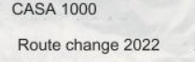
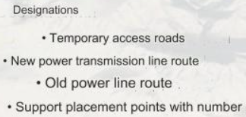

Appendix2. List of equipment and vehicles for construction

Item No. | Name of equipment | Vehicle mdel | Type | Model
1 | Excavator | Hyundai Robex R 210W | Wheel Excavator 21 ton | 2018
2 | Excavator | Hyundai 30 ton | Crawler Excavator 30 ton | 2018
3 | Minibus | Mercedes Benz Sprinter | Minibus | 2008
4 | Minibus | Mercedes Benz Sprinter | Minibus | 2008
5 | Minibus | Mercedes Benz Sprinter | Minibus | 2008
6 | Handler | Kamaz 44260C | Manipulator 6.3 ton 6x6 370 hp | 2010
7 | Handler | Mercedes AXOR | 35 MT Hi-up 6x4 280kw(380hp) | 2006
8 | Autocrane | Terex RT100 | Crane 90 ton/53 m | 2013
9 | Autocrane | Grove GRT8100 | Crane 100 ton | 2021
10 | Loader | JBC 3CX | Backhoe loader | 2007
11 | Loader | SDLG | Loader | -
12 | Fuel tank | Howo Sinotruck | Fuel Tank 20m³ 8x4 300 hp | 2013
13 | Car | Lada Niva Travel | Car (4x4) | 2021
14 | Car | Lada Niva Travel | Car (4x4) | 2021
15 | Car | Lada Niva Travel | Car (4x4) | 2021
16 | Truck | Howo | Truck | 2012
17 | Truck | Howo | Truck | 2007
18 | Automixer | Kamaz 6522 | Mixer 9m³ 6x6 320hp | 2021
19 | Automixer | Howo | Mixer 10m³ 6x4 336 hp | 2021
20 | Automixer | Howo | Mixer 10m³ 6x4 336 hp | 2021

Appendix3. List of Structures required for changes in the bypass section
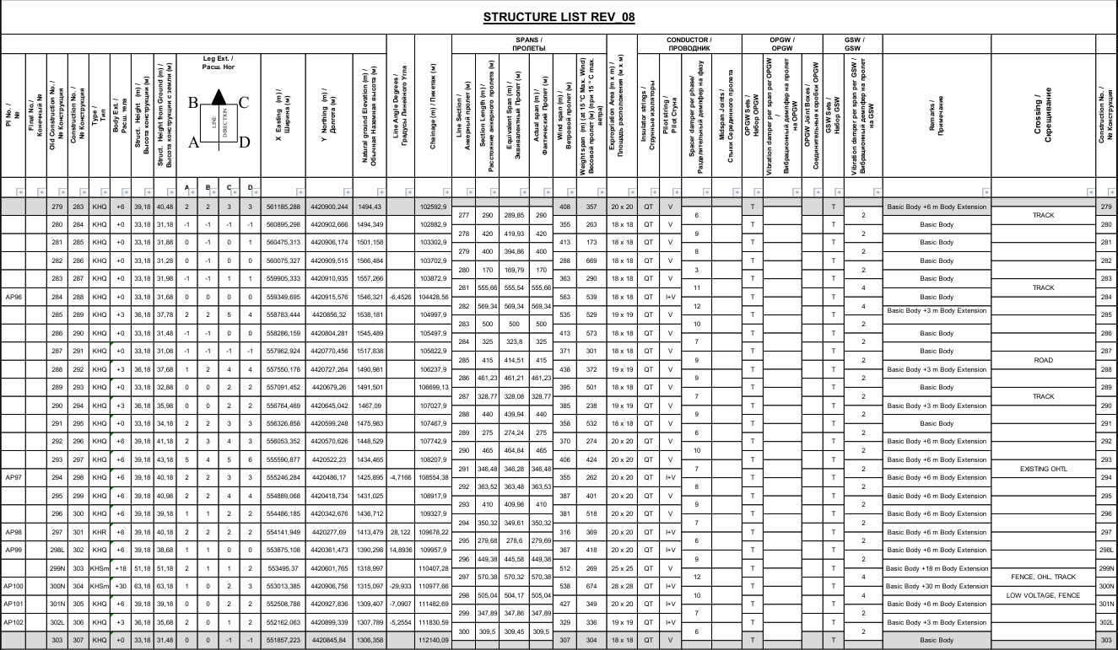
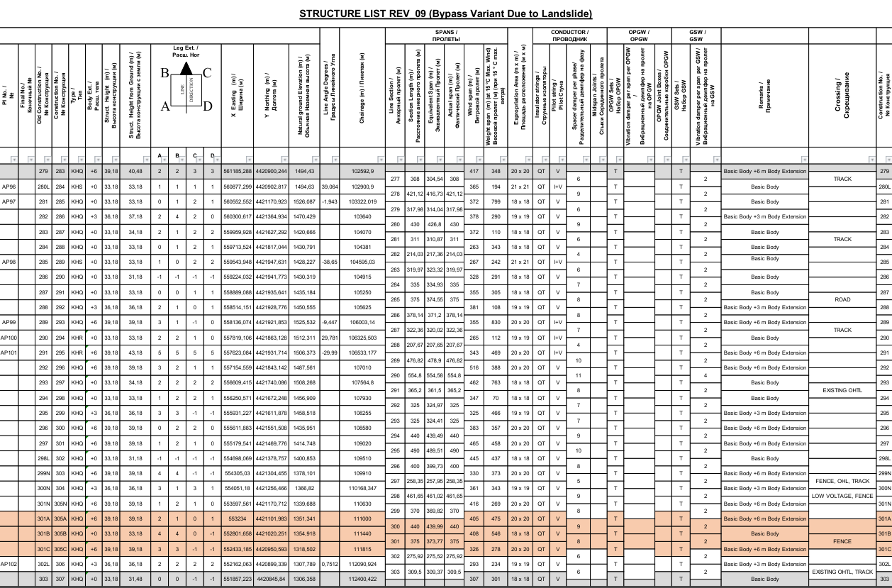

Appendix 4. Plan for the location of access roads
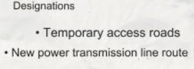
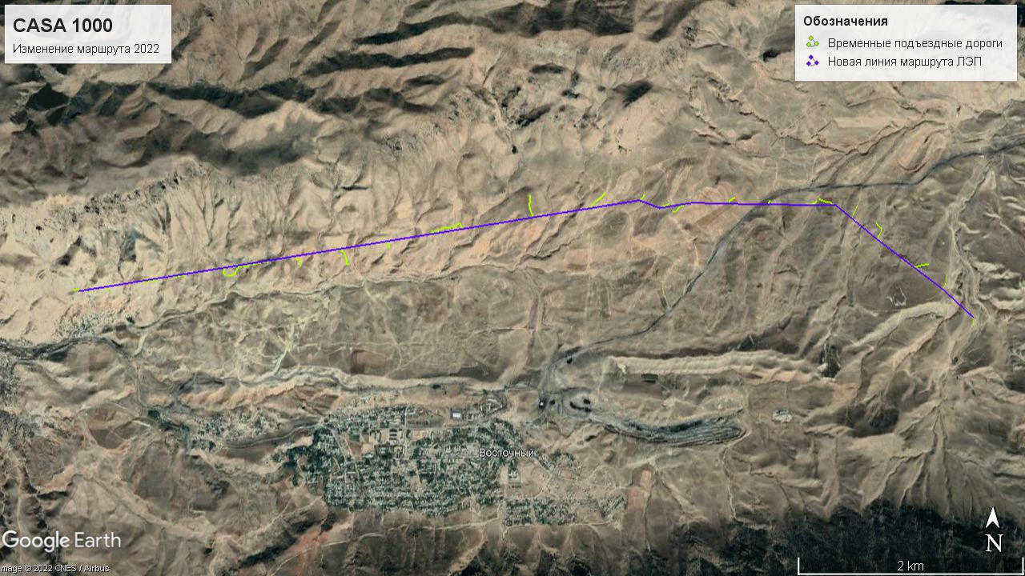

Appendix5. Summary of the number of supports and components
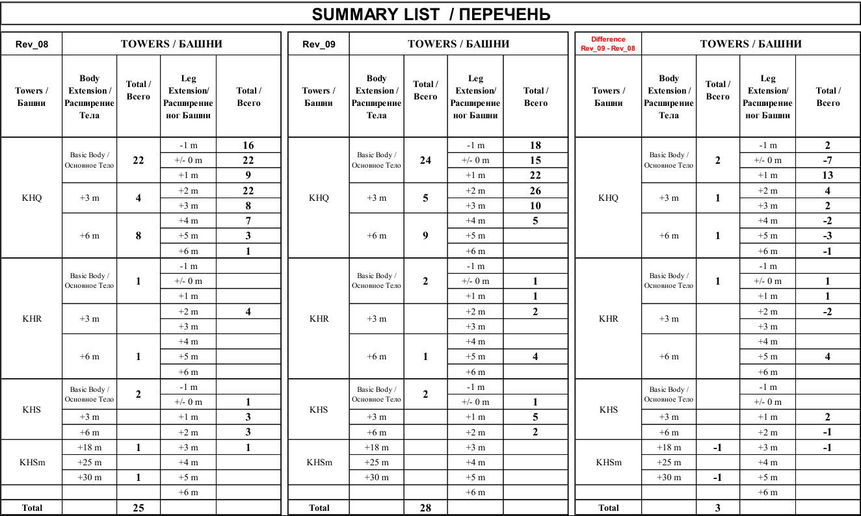
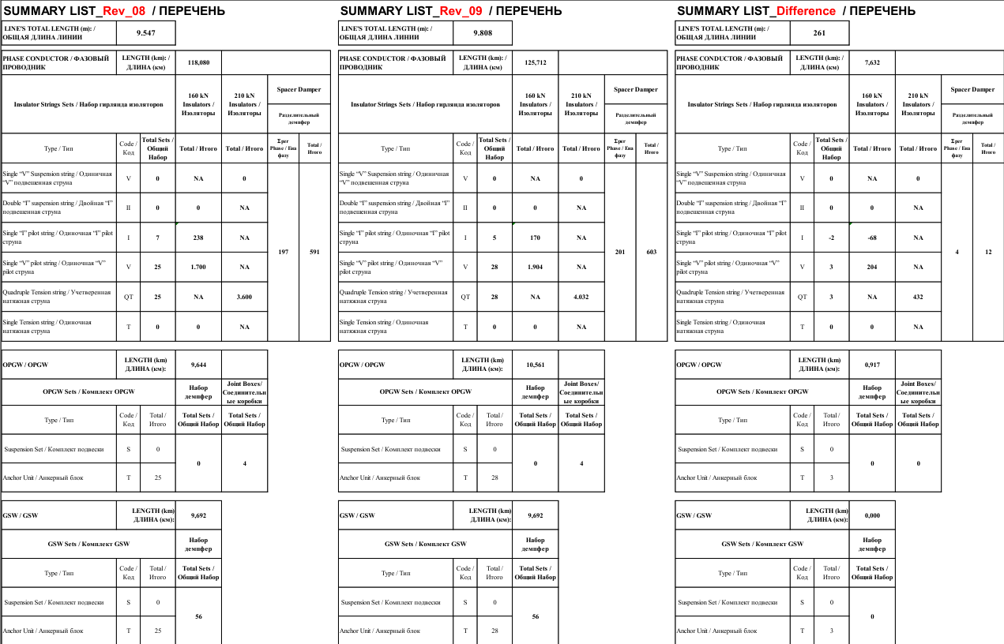

Appendix 6. Characteristics of climatic conditions of the main affected areas
Districts | General characteristics | Temperature regime | Precipitation
Leilek region | The climate of the region is sharply continental, arid, with a pronounced vertical zonality. Significant daily and seasonal temperature fluctuations are noted in the high-mountainous southern part of the area. In the mid-mountain zone, the climate is much milder, temperature fluctuations are not so contrasting, and the snow cover is unstable. The climate of the northern, low-mountainous part of the territory is semi-desert, with long dry summers and short winters with little snow. The latitudinal orientation of the ridges, coinciding with the prevailing direction of the winds that carry the moisture of seasonal cyclones, does not significantly affect the distribution of precipitation.  Winter periods are short and mild.  Summers are hot and dry, occasional short-term rains and thunderstorms, according to the weather forecast, may occur at the beginning of the summer period. Autumn, like summer, is long and mostly dry and sunny. Noticeable changes in the weather can occur from the second half of October, during this period cloudiness may increase, prolonged drizzle may occur. Dense and heavy fogs are an integral part of the autumn period. | Temperatures in January reach -3…-5^{о}С on average, but on some days temperatures can drop to -20 and below.  Average temperatures in July are +34…+36^{о}С, at night the air cools down to +18…+21^{о}С.  There are large daily and seasonal temperature fluctuations. | The great distance from the seas and oceans causes an extremely small amount of precipitation.  The amount of atmospheric precipitation is also determined by altitudinal zonality and ranges from 500-550 mm/year in the highlands to 200-300 mm/year in the zone of low foothills.  Spring is the best season for precipitation. During this period, up to 55% of the entire annual norm may fall.  There is practically no snow cover in the low-mountainous part.  In the high-mountainous southern part, a stable snow cover falls in November and remains until April. The passes in this part are opened from April-May and operate until October-November

Appendix 7. The results of measuring the concentration of pollutants in the air
Sample No. | Instrument readings
 | Dust concentration | Nitrogen dioxide | Sulfur dioxide | Oxides of carbon
MPC | 0,5 | 0,085 | 0,5 | 5
A-C1 | 0,16±0,04 | 0,031±0,006 | 0,014±0,003 | 0,025±0,005
A-C2 | 0,13±0,03 | 0,024±0,005 | 0,016±0,003 | 0,028±0,006
A-C3 | 0,15±0,04 | 0,024±0,005 | 0,03±0,006 | 0,064±0,013

Appendix 8. Protocols of the Kadamzhai Centre for Disease Prevention and State Sanitary and Epidemiological Surveillance - the results of the study of atmospheric air
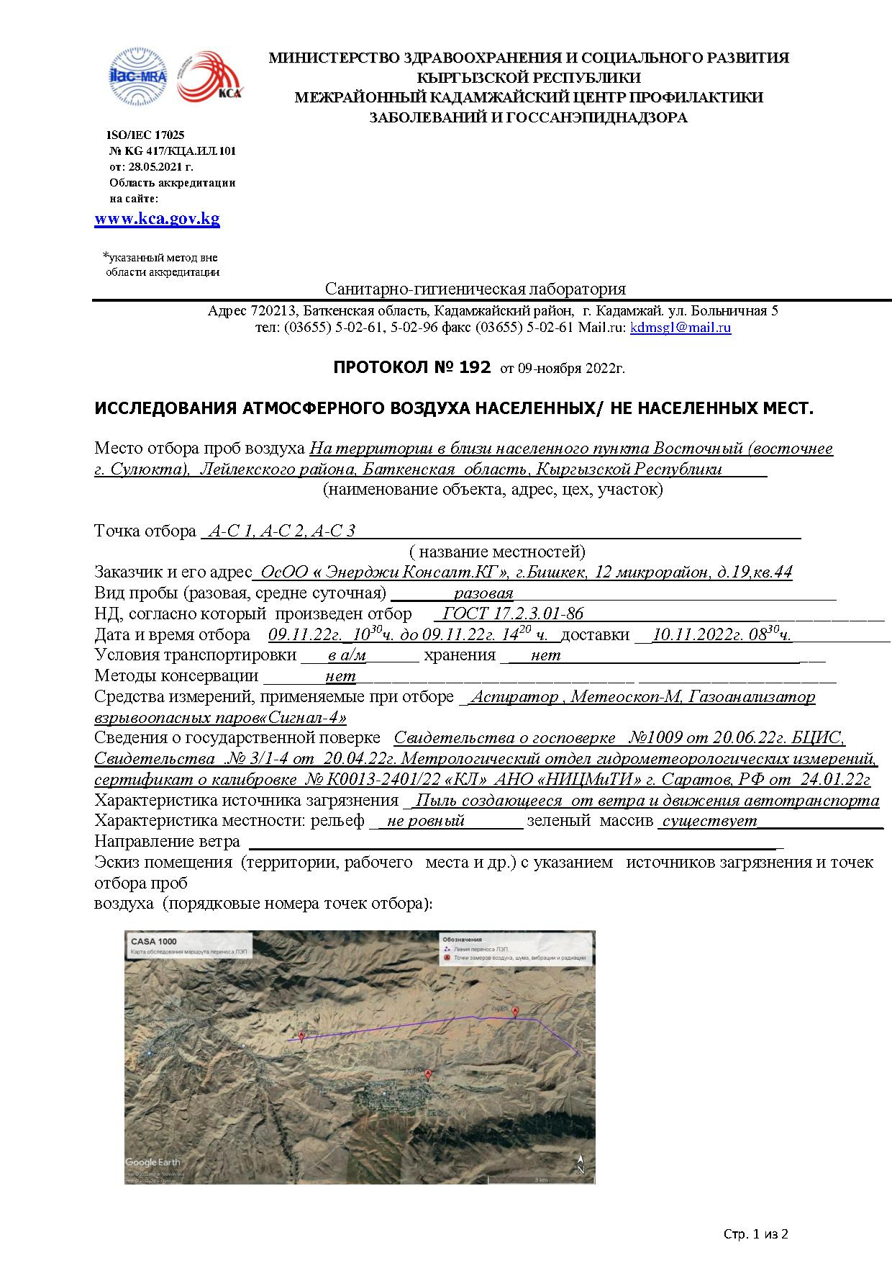
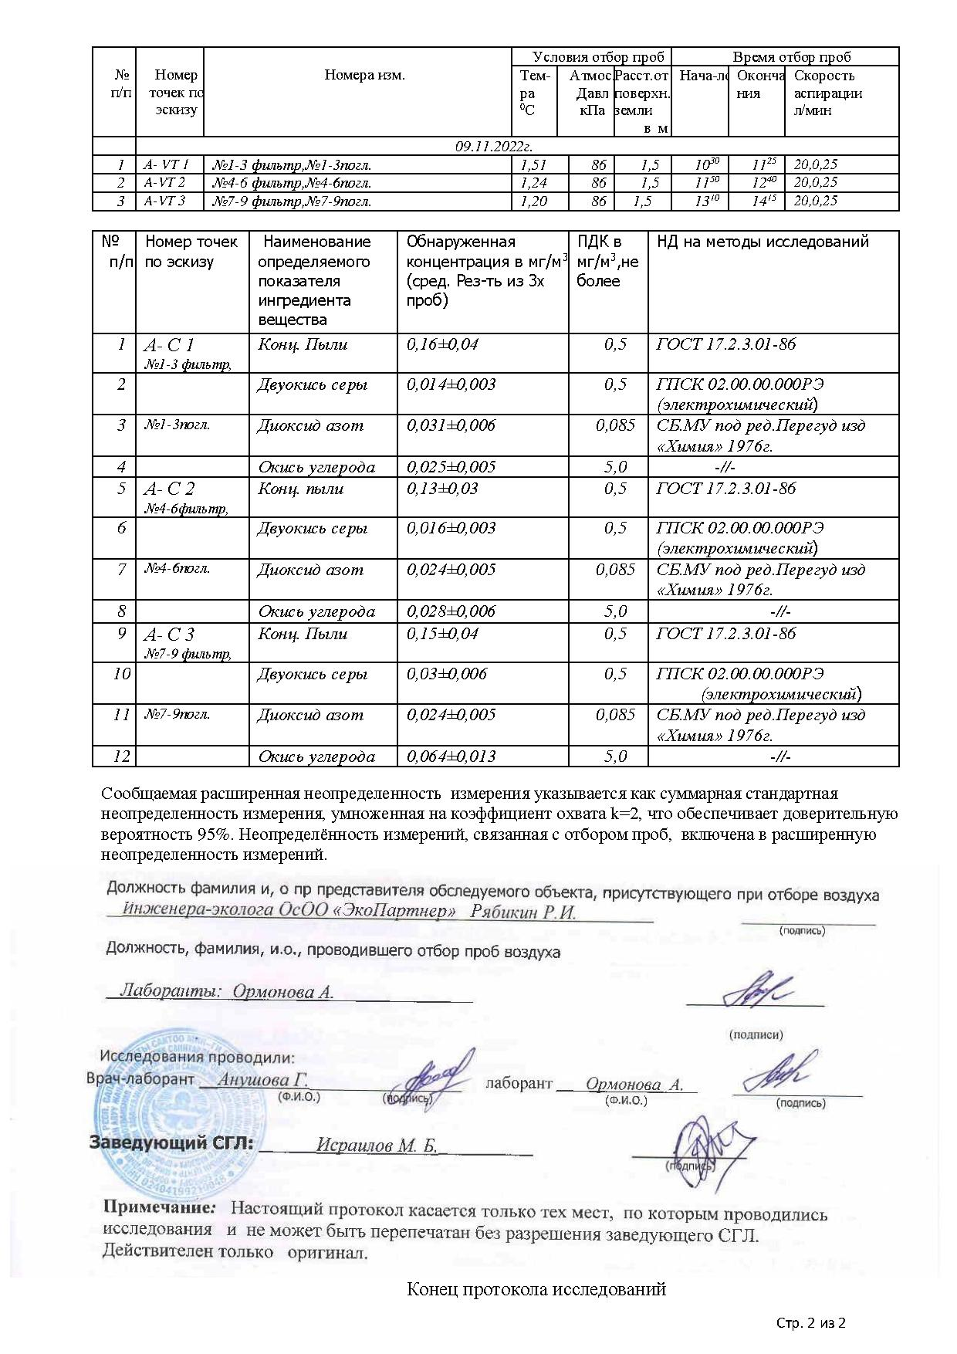

Appendix 9. Results of noise level measurements
Site | Noise level (equivalent sound level in DBA)
MPL | 75
A-C1 | 38,6±5,8
A-C2 | 37,3±5,6
A-C3 | 41,1±6,2

Appendix 10. Noise standards in the Kyrgyz Republic
Description of activity / category | Leqv | Lmax
Areas directly adjacent to hospitals and sanatoriums | Day = 45  Night = 35 | Day = 60  Night = 50
Areas directly adjacent to residential buildings, clinics, dispensaries, rest houses, boarding houses, libraries, schools, etc. | Day = 55  Night = 45 | Day = 70  Night = 60
Areas directly adjacent to hotels and hostels | Day = 60  Night = 50 | Day = 75  Night = 65
Recreation areas, hospitals and sanatorium | 35 | 50
Recreation areas in the territory of microdistricts and the construction of estates, rest houses, sanatoriums, schools, nursing homes, etc. | 45 | 60
Source: GOST 23337-78, SN 2.1.8.562-96, SanPiN 2.1.2.1002-00

Appendix 11. Protocols of the Kadamzhai Centre for Disease Prevention and State Sanitary and Epidemiological Surveillance” – noise study results

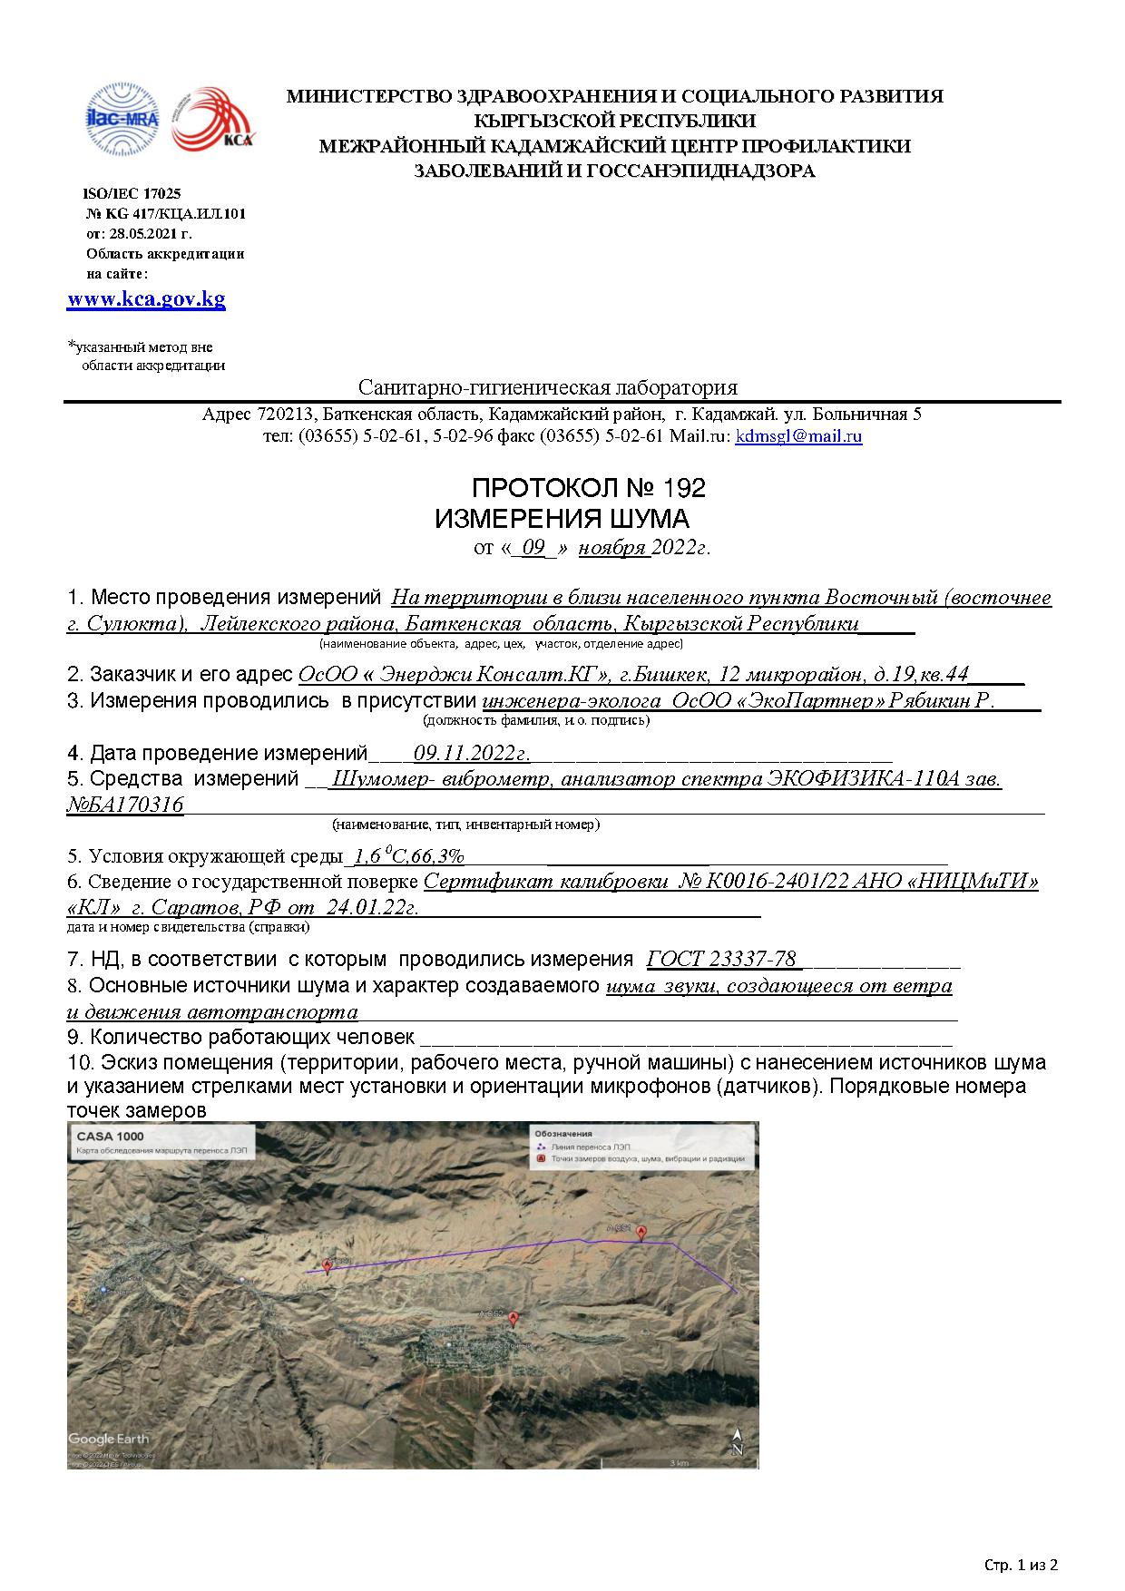

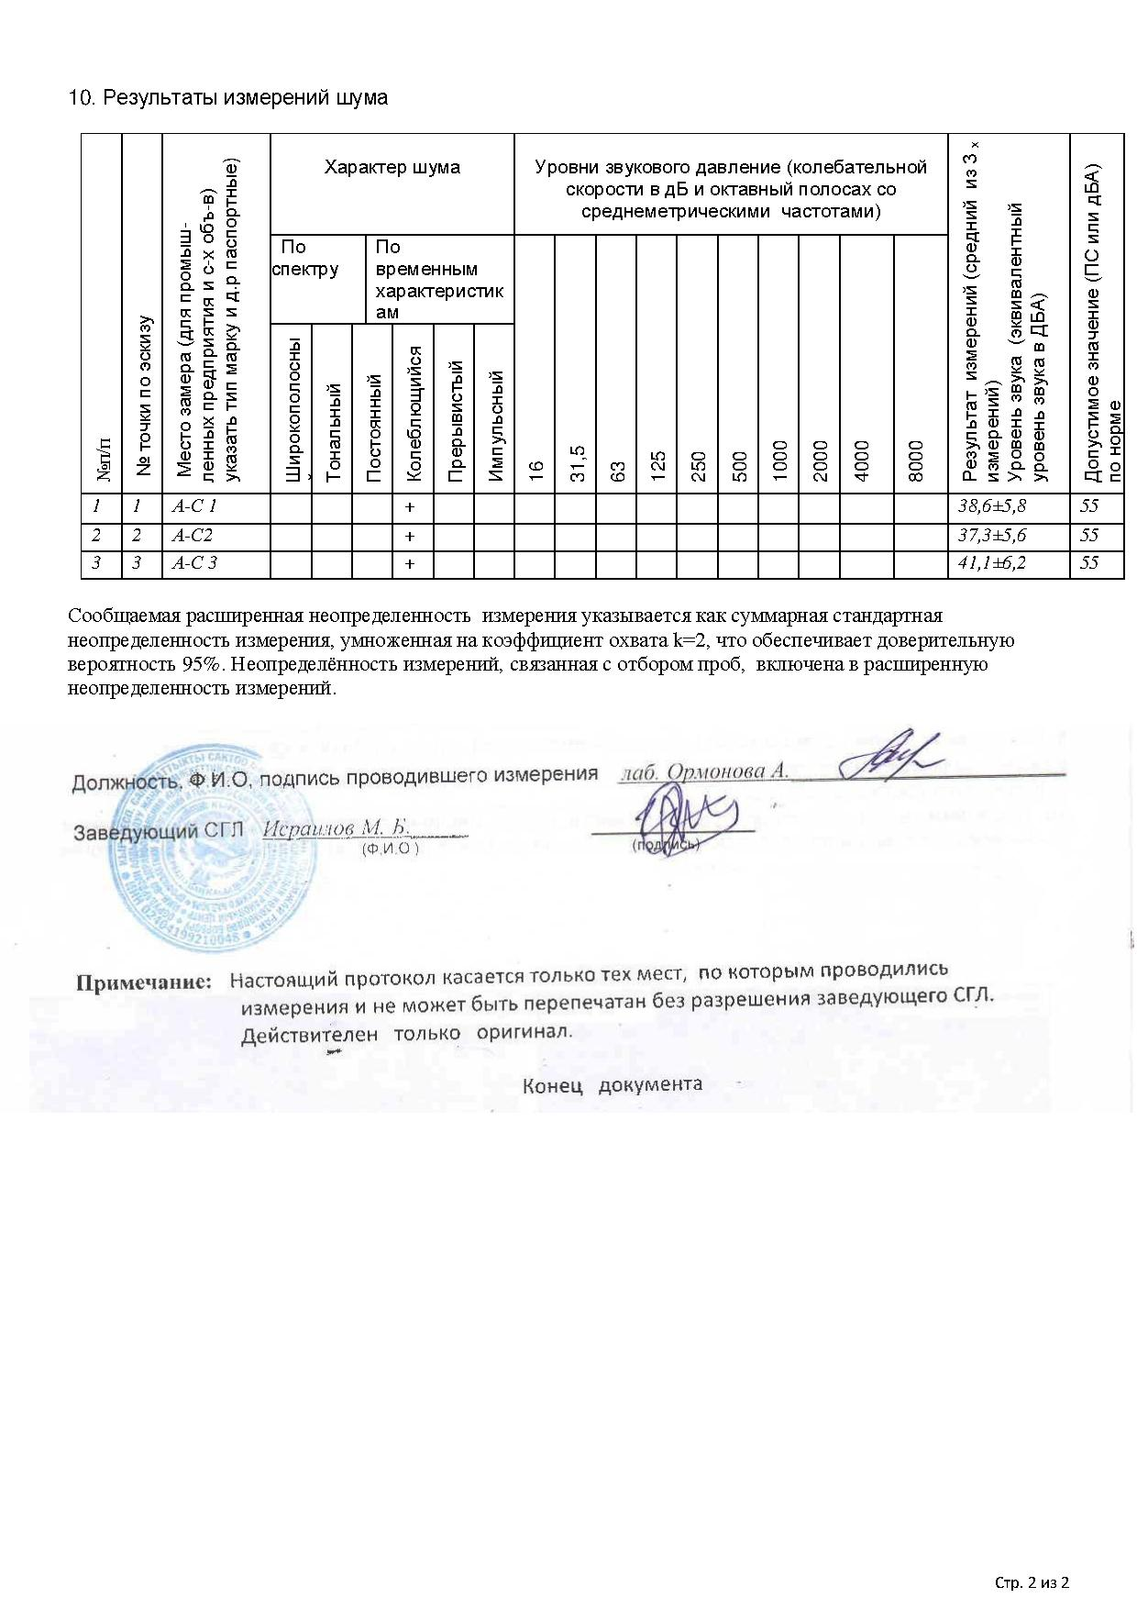

Appendix 12. Vibration measurement results

Site | Vibration level
MPL | 75
A-C1 | 63,6±9,54
A-C2 | 56,4±8,46
A-C3 | 62,7±9,4

Appendix 13. Sanitary standards "Industrial vibration, vibration in the premises of residential and public buildings" SN 2.2.4 / 2.1.8.566-96

Maximum permissible levels of workplace vibration
Category 2 - transport and technological
Geometric average frequencies of bands, Hz | Maximum allowable values along the axes Xo, Yo, Zo
 | Vibration acceleration |  |  |  | Vibration velocity
 | m/s2 |  | dB |  | m/s x 10-2 |  | dB
 | 1/3 oct | 1/1 oct | 1/3 oct | 1/1 oct | 1/3 oct | 1/1 oct | 1/3 oct | 1/1 oct
1.6 | 0.25 |  | 108 |  | 2.50 |  | 114
2.0 | 0.22 | 0.40 | 107 | 112 | 1.80 | 3.50 | 111 | 117
2.5 | 0.20 |  | 106 |  | 1.30 |  | 108
3.15 | 0.18 |  | 105 |  | 0.98 |  | 105
4.0 | 0.16 | 0.28 | 104 | 109 | 0.63 | 1.30 | 102 | 108
5.0 | 0.16 |  | 104 |  | 0.50 |  | 100
6.3 | 0.16 |  | 104 |  | 0.40 |  | 98
8.0 | 0.16 | 0.28 | 104 | 109 | 0.32 | 0.63 | 96 | 102
10.0 | 0.20 |  | 106 |  | 0.32 |  | 96
12.5 | 0.25 |  | 108 |  | 0.32 |  | 96
16.0 | 0.32 | 0.56 | 110 | 115 | 0.32 | 0.56 | 96 | 101
20.0 | 0.40 |  | 112 |  | 0.32 |  | 96
25.0 | 0.50 |  | 114 |  | 0.32 |  | 96
31.5 | 0.63 | 1.10 | 116 | 121 | 0.32 | 0.56 | 96 | 101
40.0 | 0.79 |  | 118 |  | 0.32 |  | 96
50.0 | 1.00 |  | 120 |  | 0.32 |  | 96
63.0 | 1.30 | 2.20 | 122 | 127 | 0.32 | 0.56 | 96 | 101
80.0 | 1.60 |  | 124 |  | 0.32 |  | 96
Adjusted and equivalently adjusted levels and their meanings |  | 0.28 |  | 109 |  | 0.56 |  | 101

Maximum permissible levels of workplace vibration
Category 3 - technological type "B"
Geometric average frequencies of bands, Hz | Maximum allowable values along the axes Xo, Yo, Zo
 | Vibration acceleration |  |  |  | Vibration velocity
 | m/s2 |  | dB |  | m/s x 10-2 |  | dB
 | 1/3  oct | 1/1  oct | 1/3 oct | 1/1 oct | 1/3 oct | 1/1 oct | 1/3 oct | 1/1 oct
1.6 | 0.0130 |  | 82 |  | 0.130 |  | 88
2.0 | 0.0110 | 0.020 | 81 | 86 | 0.089 | 0.180 | 85 | 91
2.5 | 0.0100 |  | 80 |  | 0.063 |  | 82
3.15 | 0.0089 |  | 79 |  | 0.045 |  | 79
4.0 | 0.0079 | 0.014 | 78 | 83 | 0.032 | 0.063 | 76 | 82
5.0 | 0.0079 |  | 78 |  | 0.025 |  | 74
6.3 | 0.0079 |  | 78 |  | 0.020 |  | 72
8.0 | 0.0079 | 0.014 | 78 | 83 | 0.016 | 0.032 | 70 | 76
10.0 | 0.0100 |  | 80 |  | 0.016 |  | 70
12.5 | 0.0130 |  | 82 |  | 0.016 |  | 70
16.0 | 0.0160 | 0.028 | 84 | 89 | 0.016 | 0.028 | 70 | 75
20.0 | 0.0200 |  | 86 |  | 0.016 |  | 70
25.0 | 0.0250 |  | 88 |  | 0.016 |  | 70
31.5 | 0.0320 | 0.056 | 90 | 95 | 0.016 | 0.028 | 70 | 75
40.0 | 0.0400 |  | 92 |  | 0.016 |  | 70
50.0 | 0.0500 |  | 94 |  | 0.016 |  | 70
63.0 | 0.0630 | 0.110 | 96 | 101 | 0.016 | 0.028 | 70 | 75
80.0 | 0.0790 |  | 98 |  | 0.016 |  | 70
Adjusted and equivalently adjusted levels and their meanings |  | 0.014 |  | 83 |  | 0.028 |  | 75

Appendix 14. Protocols of the Kadamzhai Centre for Disease Prevention and State Sanitary and Epidemiological Surveillance –soil pollution study results

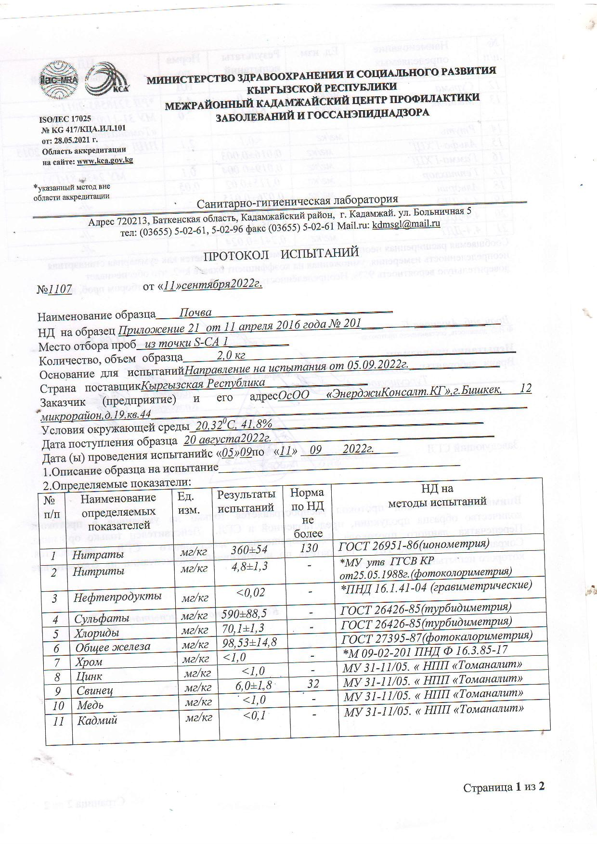

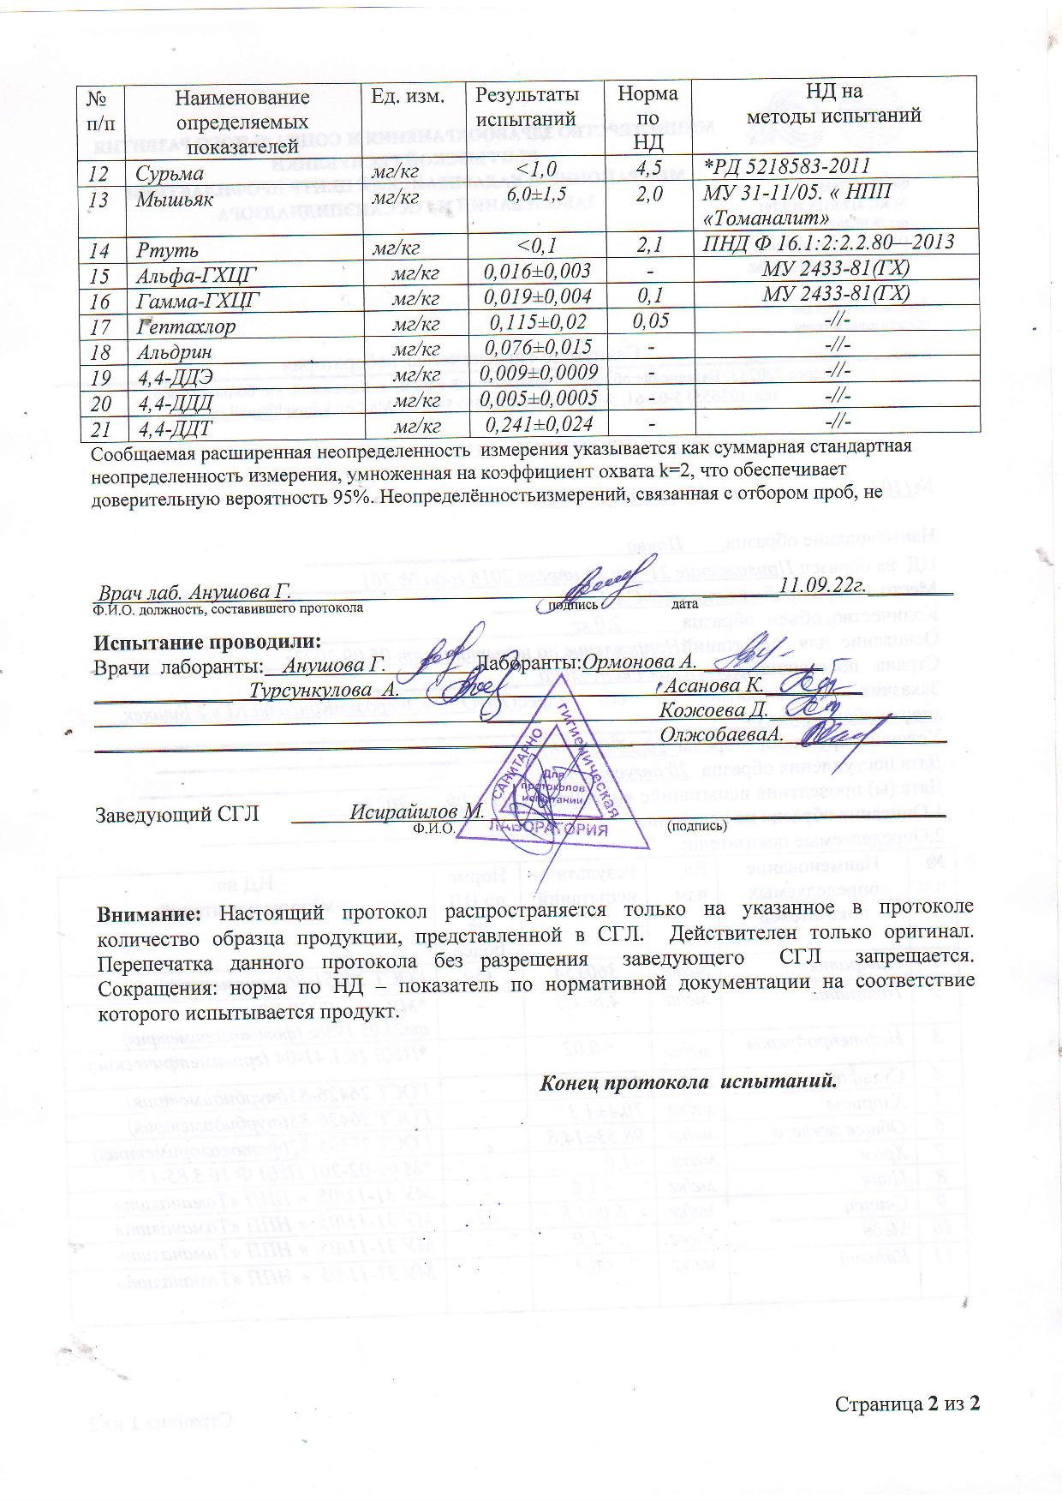

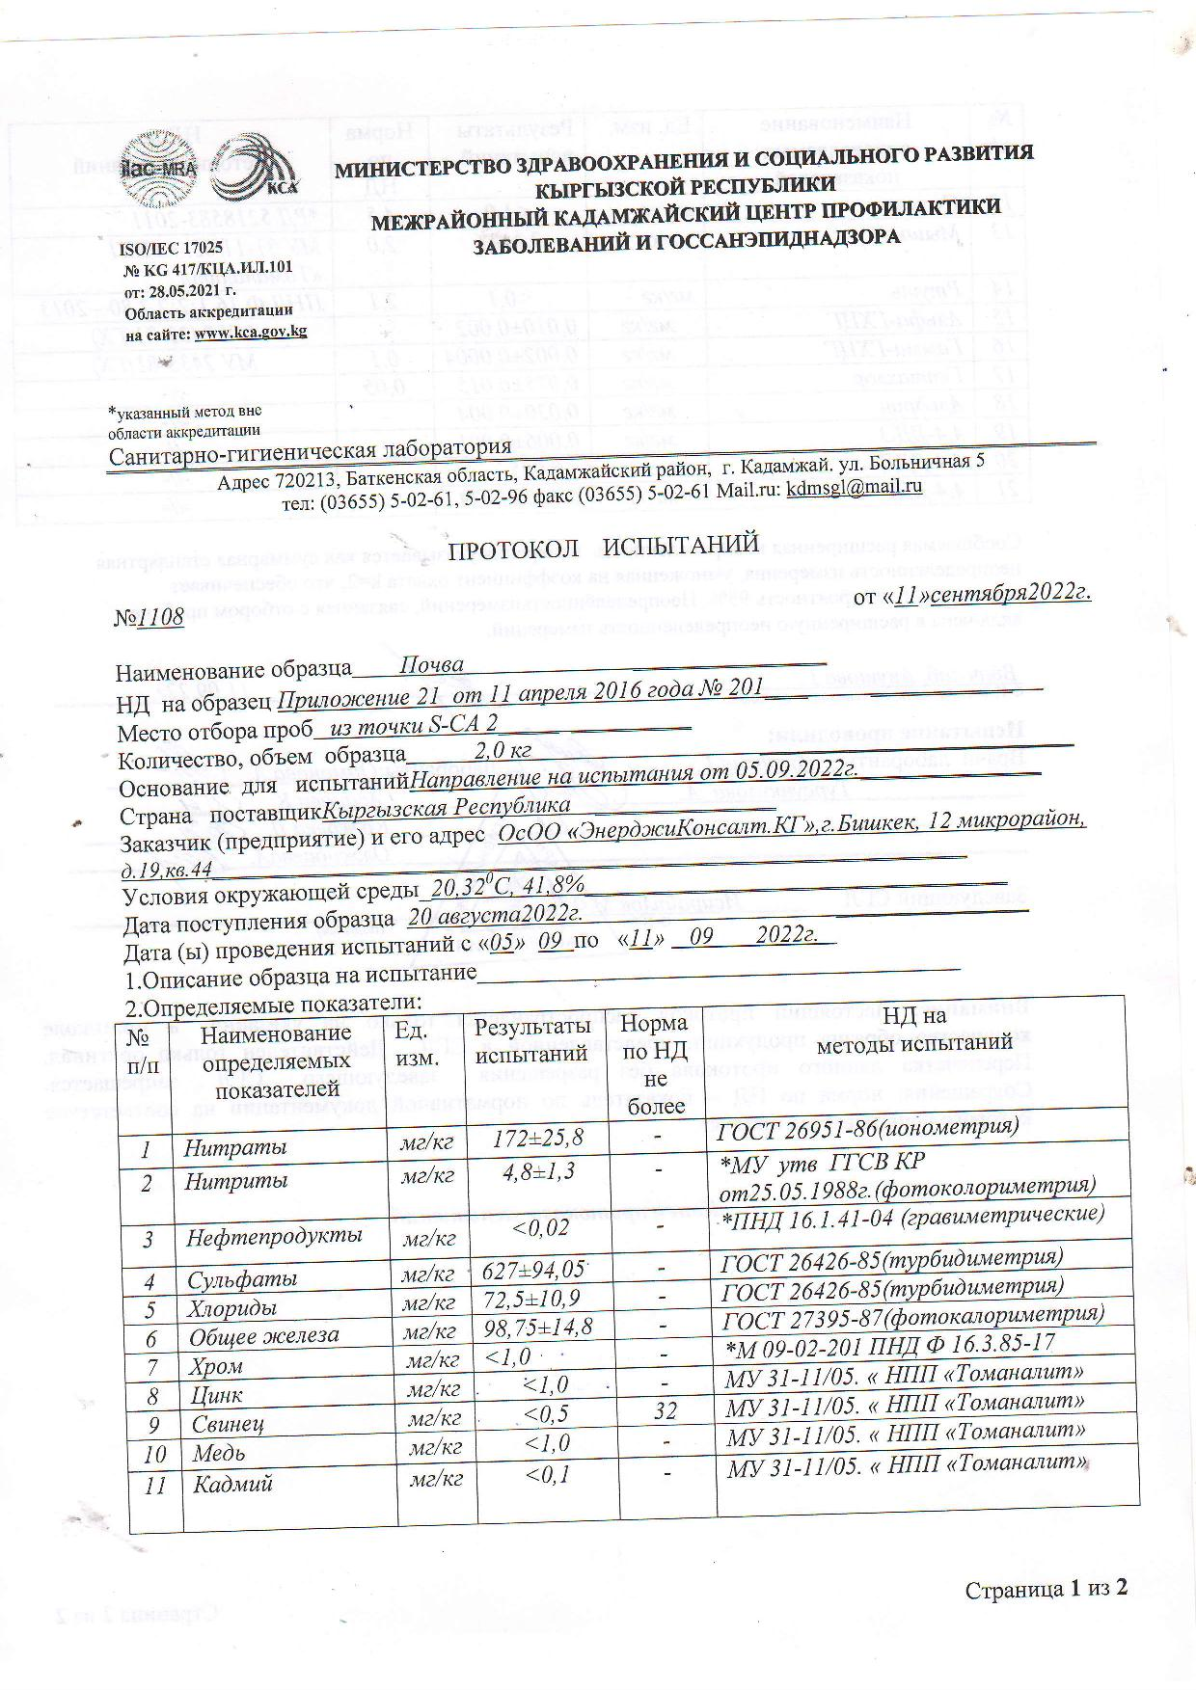

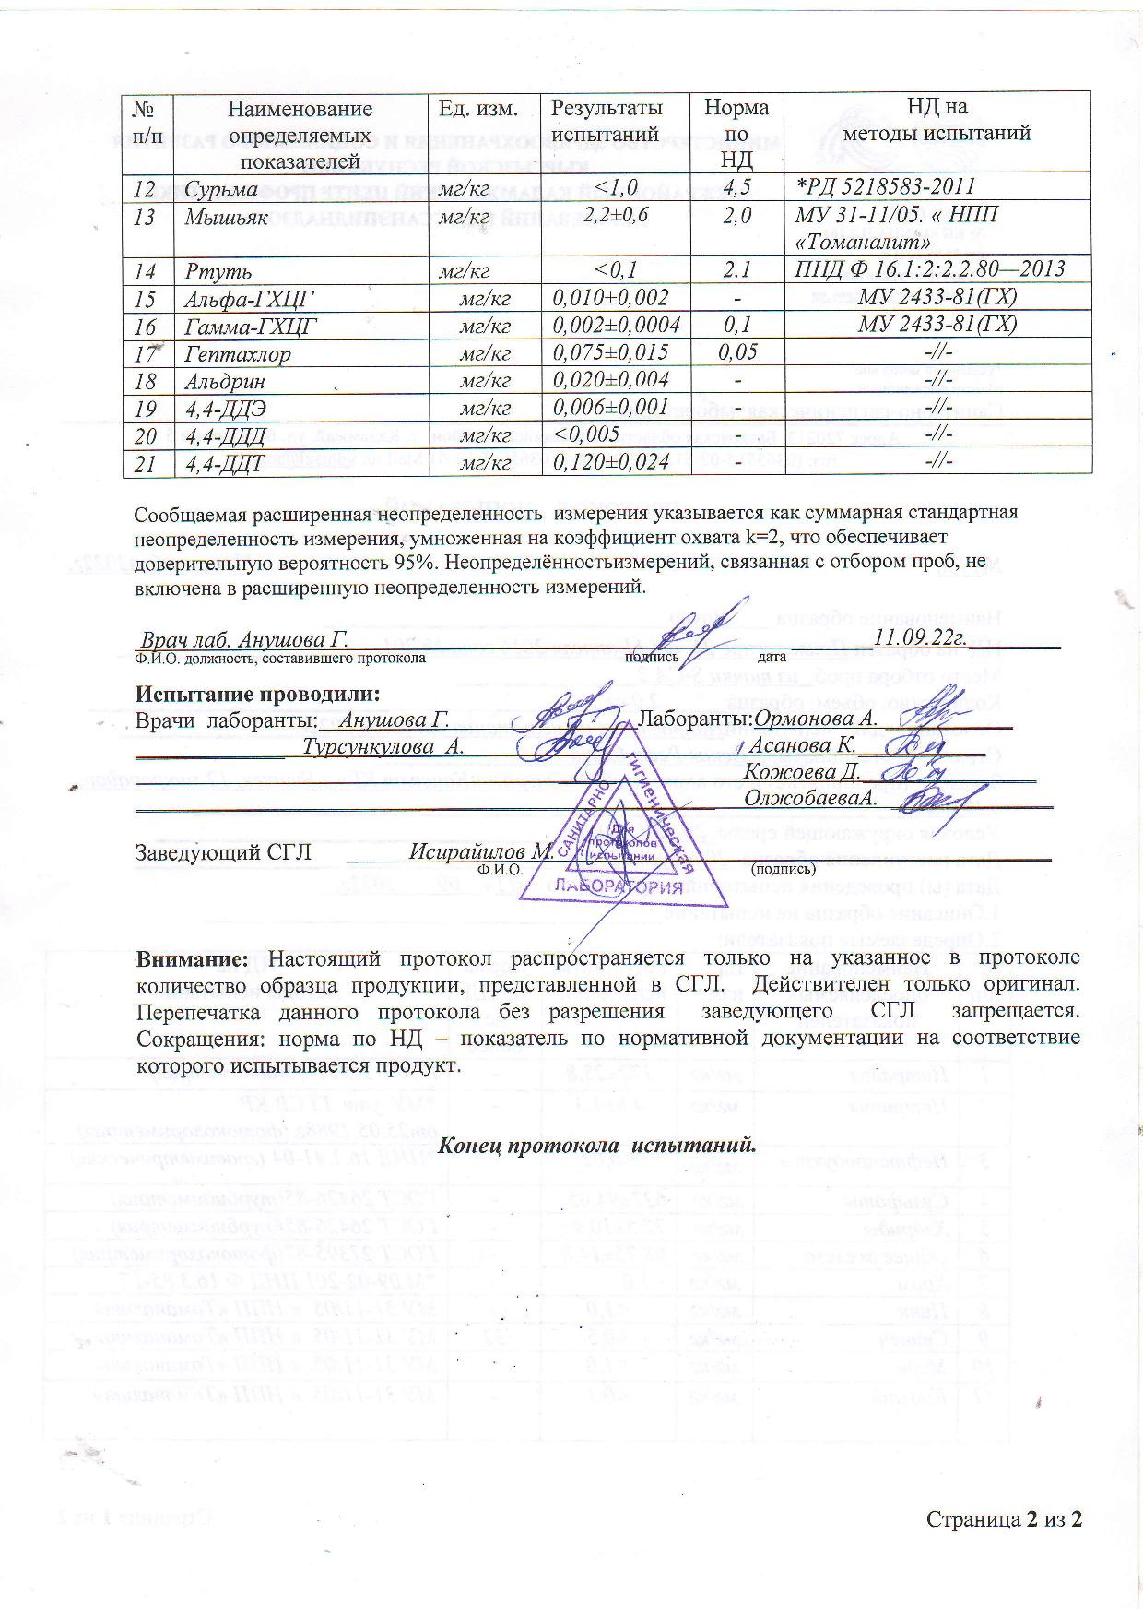

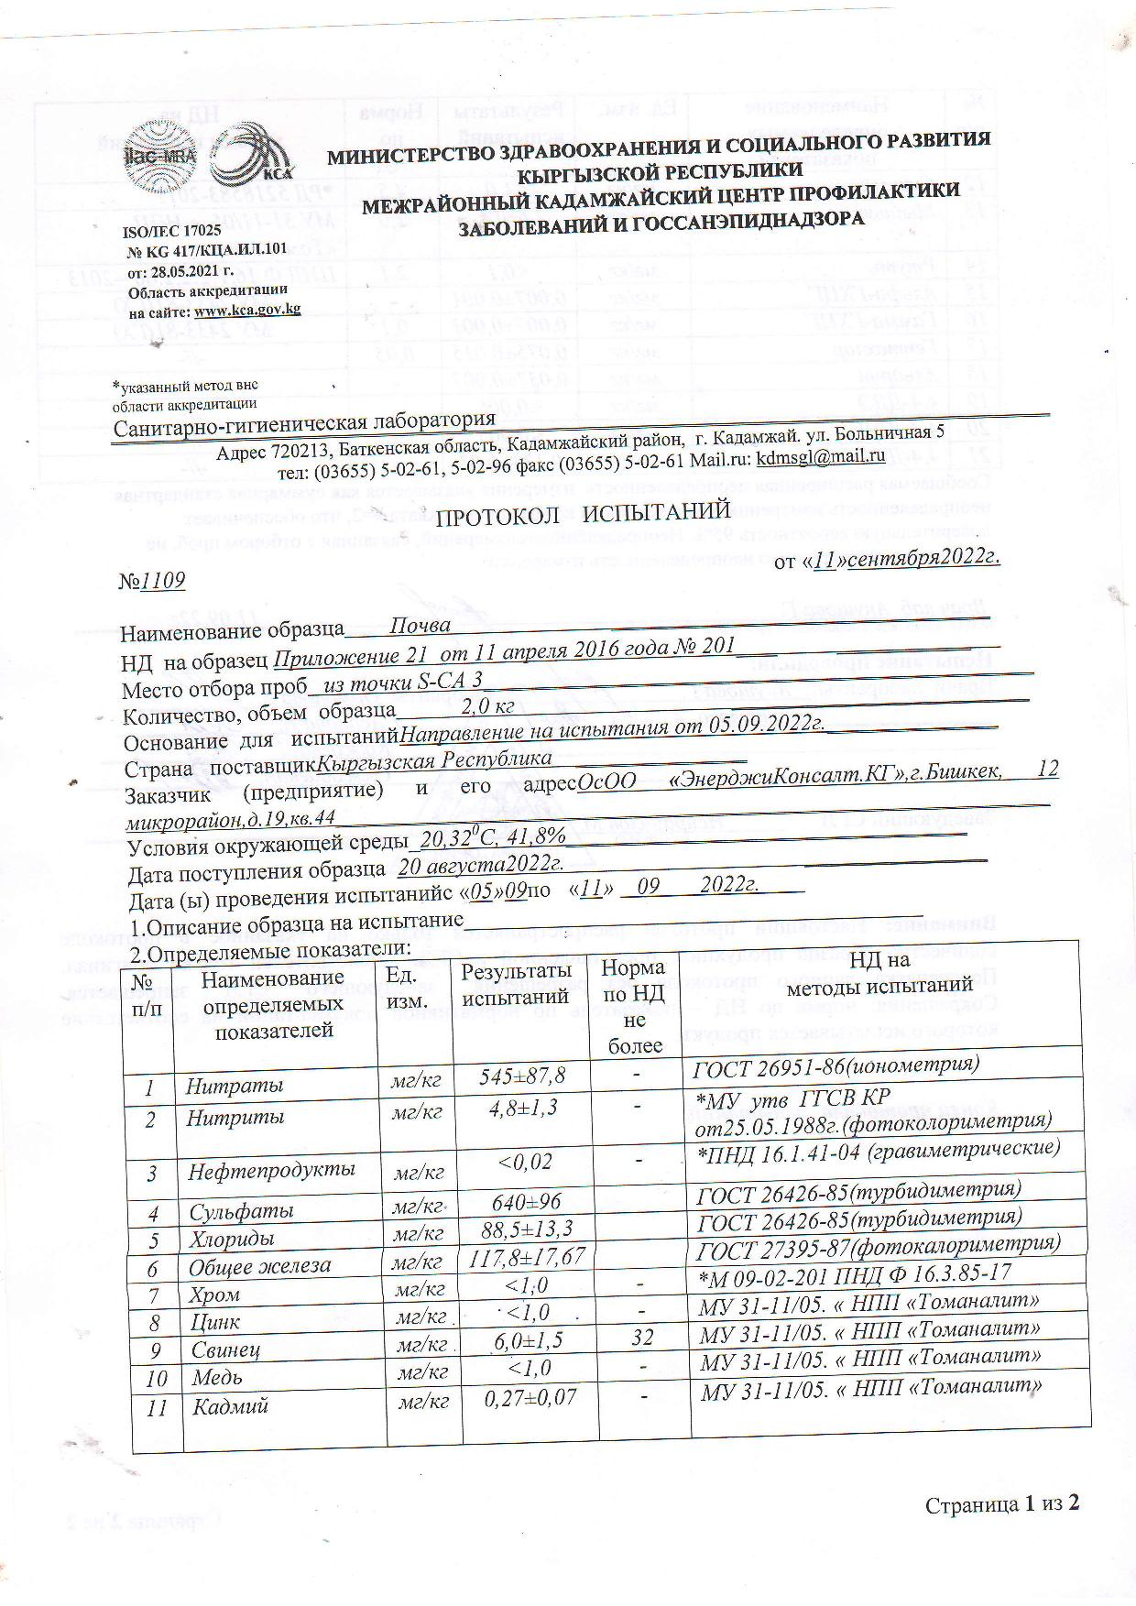

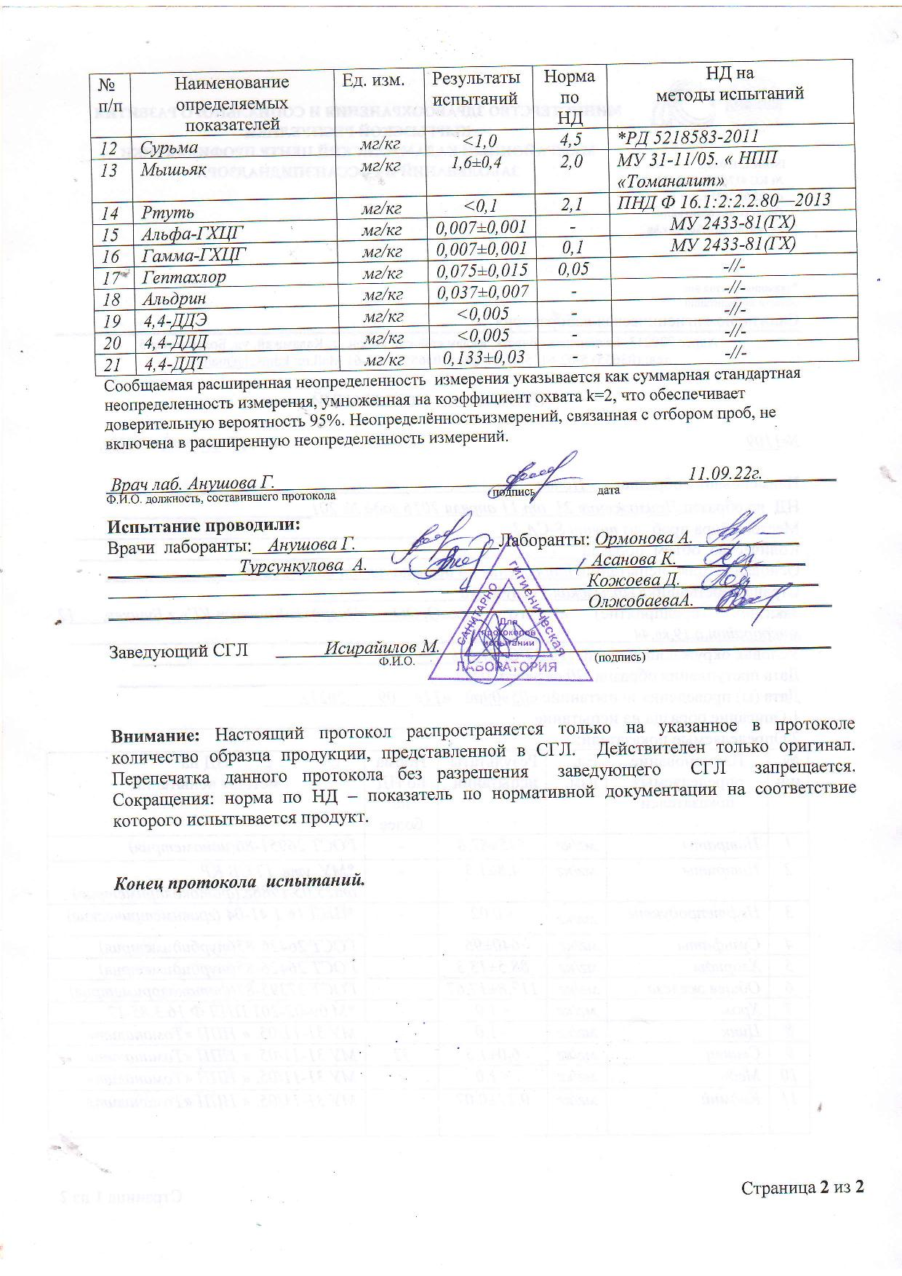

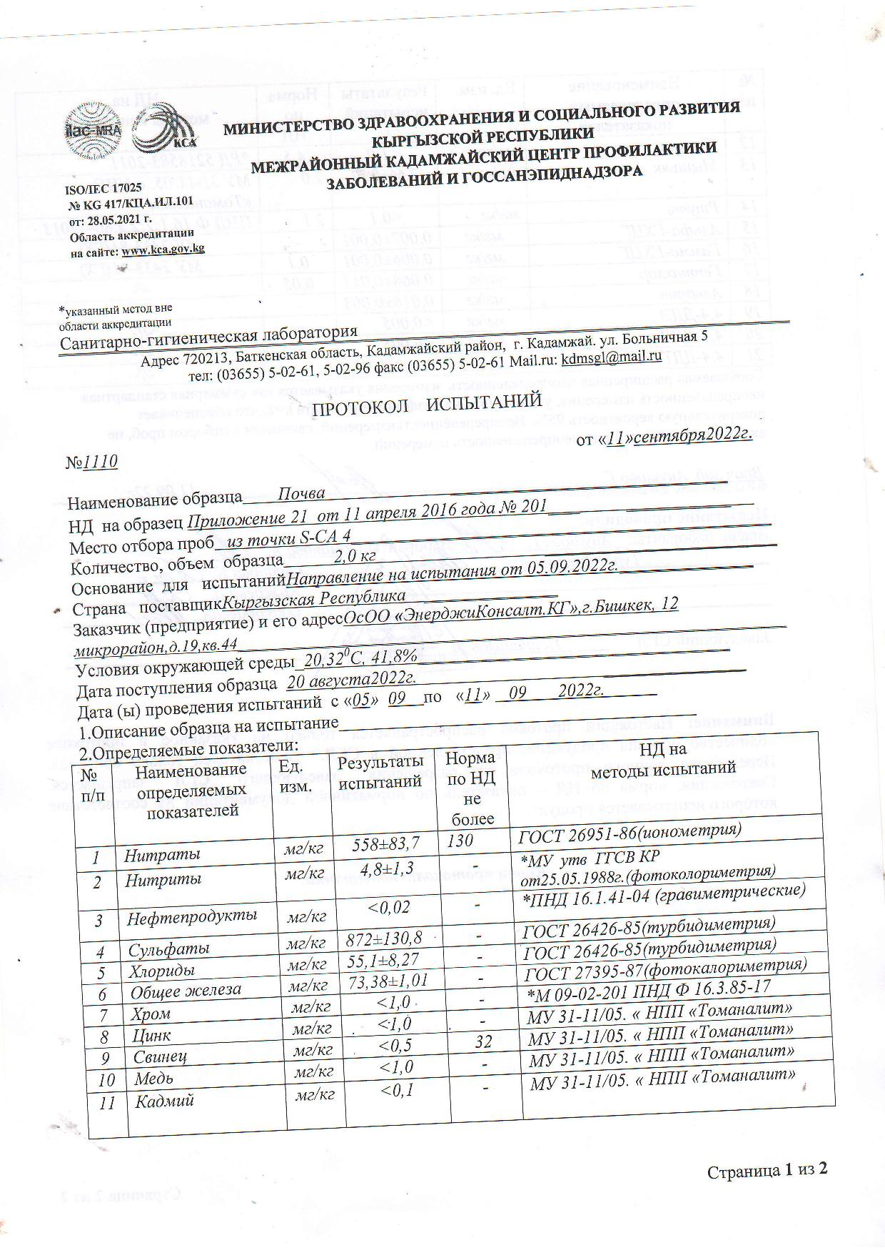

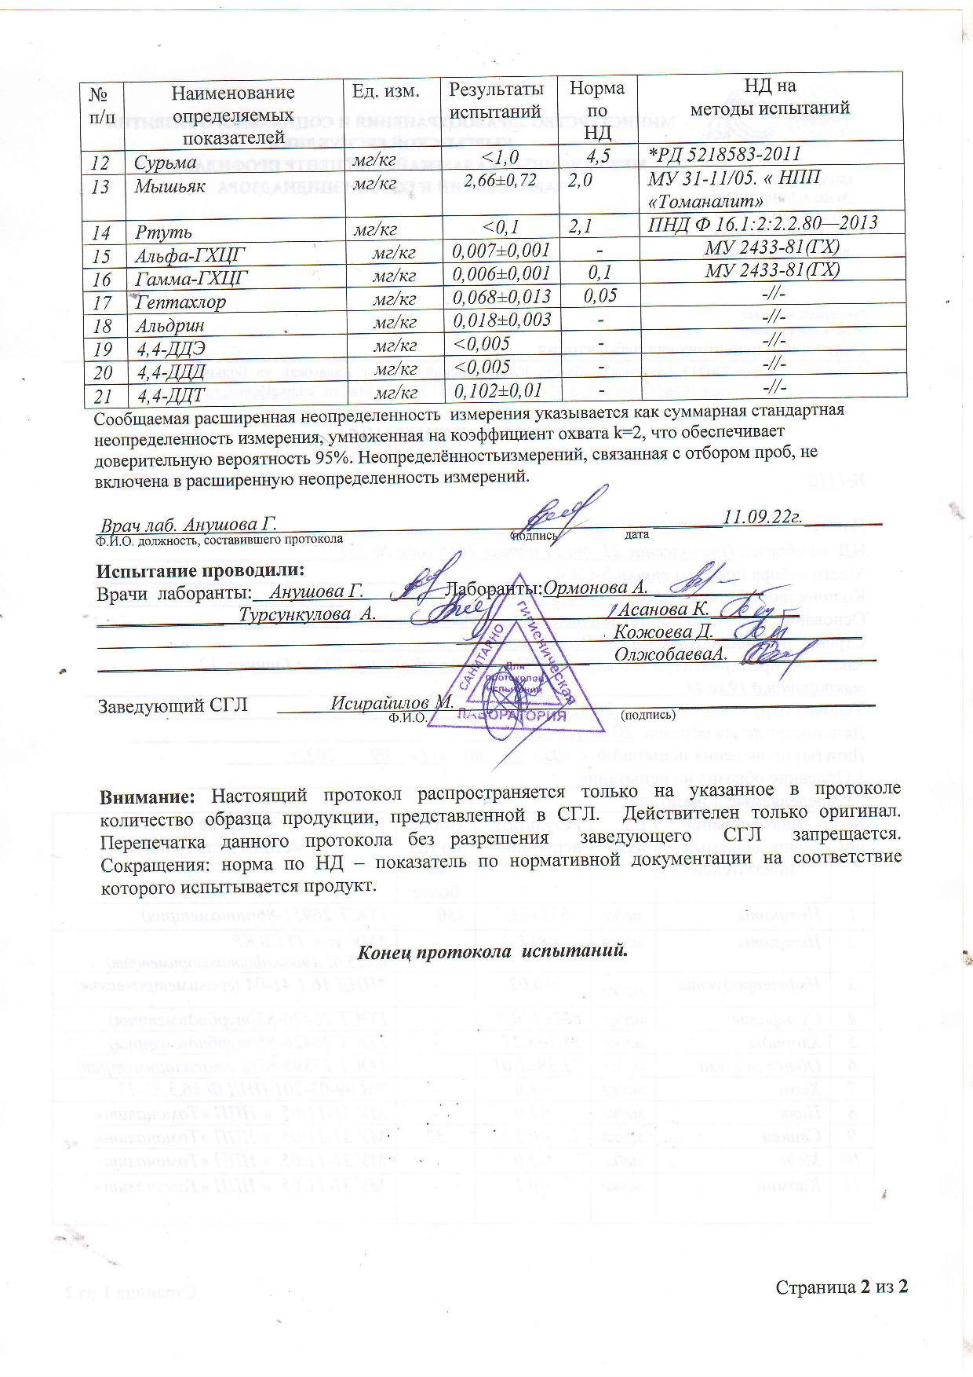

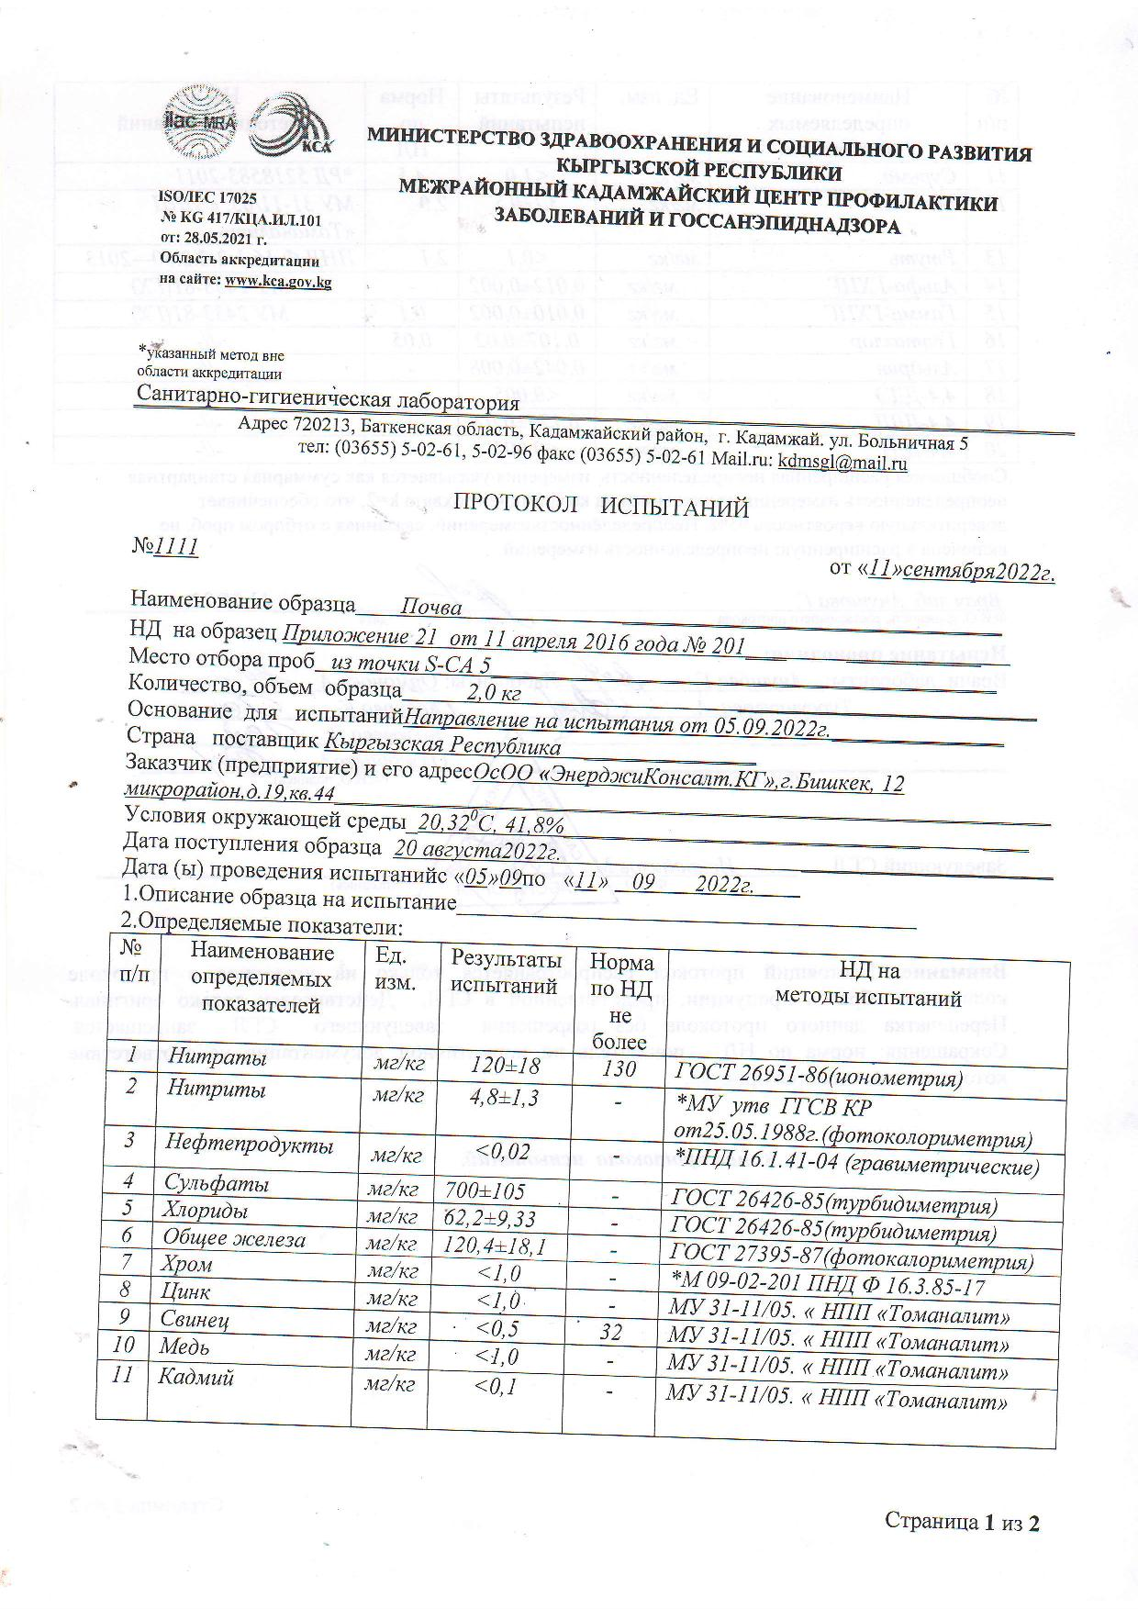

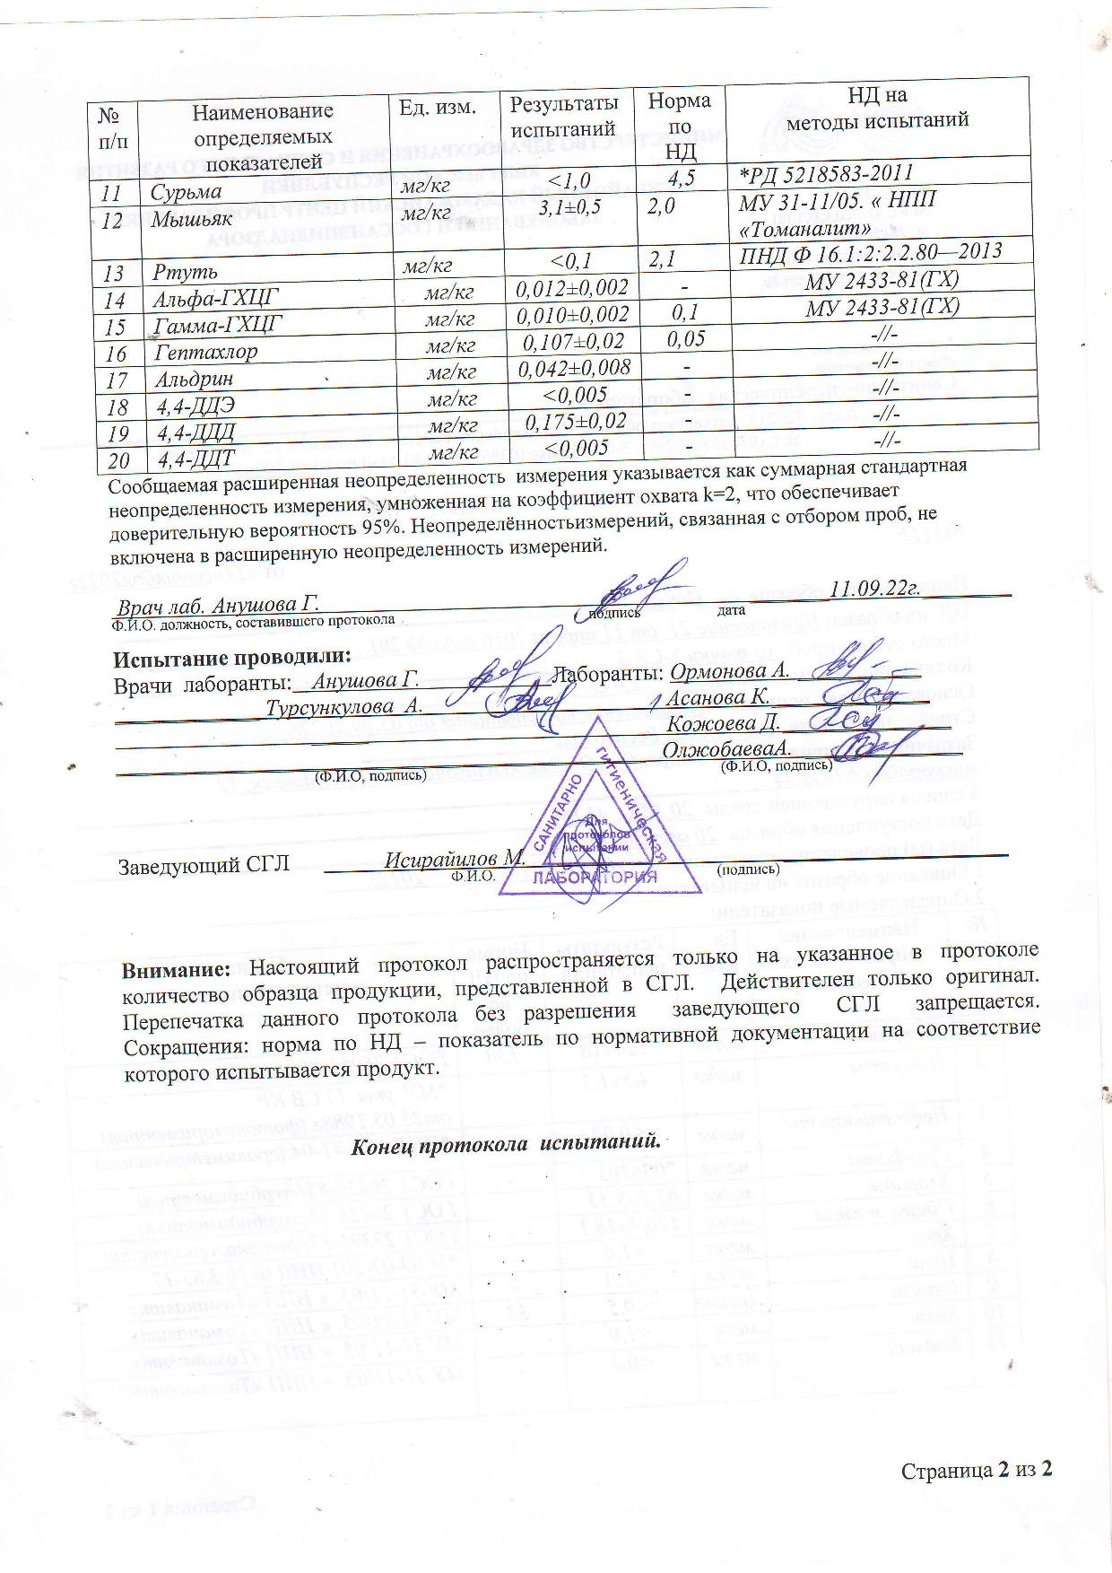

Appendix 15. Protocols of the Kadamzhai Centre for Disease Prevention and State Sanitary and Epidemiological Surveillance – soil pollution study results
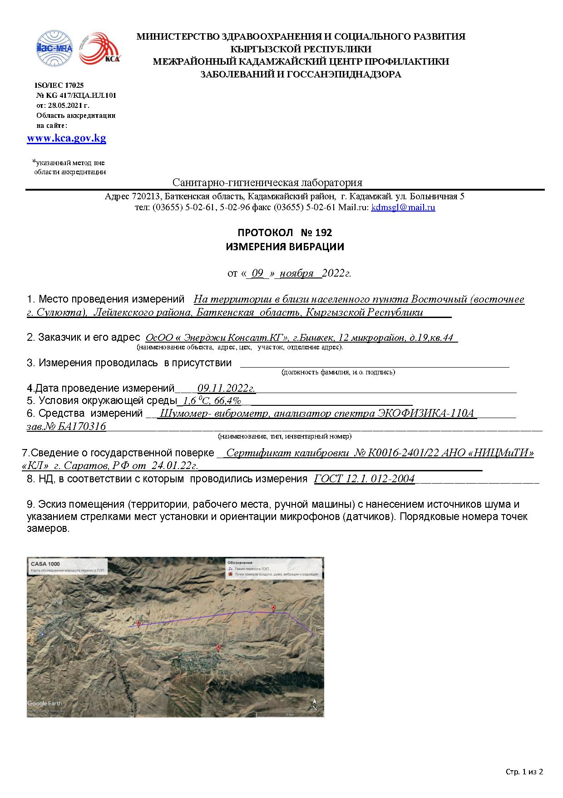

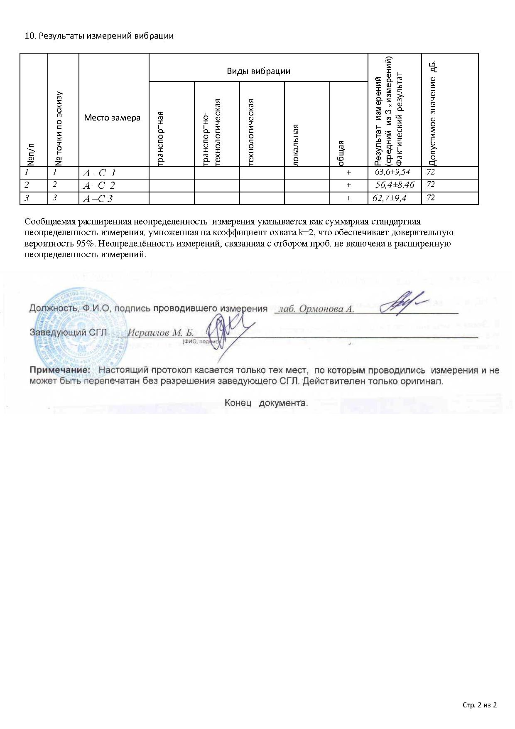

Appendix 16.The results of the analysis of the fertility of soil samples
Element | Dense residue | Humus | СО2 | рН | Absorption capacity | Absorbed sodium | Gross |  | Nitrogen total | Mobile
 |  |  |  |  |  |  | Phosphorus | Potassium |  | Phosphorus | Potassium
Measurement unit | % | % | % |  | mg-eqv. Per 100 gr of soil |  | % | % | % | mg/kg | mg/kg
S-CS 1.1 | 0,083 | 4,58 | 1,1 | 7,75 | 22 | 0,2 | 0,196 | 1,65 | 0,205 | 26 | 440
S-CS 1.2 | 0,063 | 3,64 | 1,2 | 7,9 | 17 | 0,18 | 0,185 | 1,71 | 0,18 | 14 | 360
S-CS 2.1 | 0,068 | 6,55 | 2,1 | 7,8 | 21 | 0,12 | 0,17 | 1,8 | 0,3 | 31 | 568
S-CS 2.2 | 0,064 | 3,74 | 2,2 | 7,8 | 18 | 0,12 | 0,17 | 1,92 | 0,17 | 15 | 400
S-CS 3.1 | 0,086 | 3,48 | 3,1 | 7,9 | 17 | 0,12 | 0,107 | 1,65 | 0,17 | 38 | 600
S-CS 3.2 | 0,057 | 3,38 | 3,2 | 7,8 | 16,8 | 0,18 | 0,112 | 1,86 | 0,16 | 15 | 280
S-CS 4.1 | 0,13 | 2,23 | 4,1 | 7,75 | 14 | 0,18 | 0,108 | 1,41 | 0,11 | 25 | 336
S-CS 4.2 | 0,12 | 1,66 | 4,2 | 7,95 | 13,4 | 0,18 | 0,53 | 1,23 | 0,075 | 7 | 160
S-CS 5 | 0,063 | 1,56 | 3,1 | 7,95 | 18 | 0,12 | 0,53 | 0,66 | 0,07 | 32 | 300

Appendix 17. The results of the obtained data on the mechanical and microaggregate composition
Sample code | Fraction content % (particle size mm) |  |  |  |  |  | Sum of particles <0.01
 | 1.0-0.25 | 0.25-0.05 | 0.05-0.01 | 0.01-0.005 | 0.005-0.001 | <0.001
S-CS 1.1 | 12,84 | 6,76 | 53,2 | 9,88 | 8,2 | 9,12 | 27,2
S-CS 1.2 | 8,19 | 8,69 | 47,56 | 10,24 | 12,92 | 12,4 | 35,56
S-CS 2.1 | 19,11 | 16,45 | 37,68 | 6,72 | 10,76 | 9,28 | 26,76
S-CS 2.2 | 0,76 | 1,24 | 56,12 | 12,12 | 14,24 | 15,52 | 41,88
S-CS 3.1 | 43,19 | 15,92 | 20,72 | 5,24 | 7,05 | 7,88 | 20,17
S-CS 3.2 | 13,78 | 18,22 | 39,32 | 7,88 | 9 | 11,8 | 28,68
S-CS 4.1 | 13,62 | 29,42 | 16,72 | 8,16 | 10,4 | 21,68 | 40,24
S-CS 4.2 | 0,52 | 0,68 | 45,8 | 18,04 | 14,84 | 20,12 | 53
S-CS 5 | 11,87 | 11,09 | 34,56 | 14,2 | 11,24 | 17,04 | 42,48

Appendix 18. Calculation of waste generation volumes
- Production processes

Cleaning material contaminated with oil or oil products (content of oil or oil products is less than 15%); FCCW code: 91920402604
The calculation is carried out in accordance with the "Methodological recommendations for the development of draft standards for the maximum disposal of waste for thermal power plants, combined heat and power plants, industrial and heating boiler houses." St. Petersburg, 1998, according to the formula:
N = Мо× (1+ М/100 + W/100) × 0,001
where: N - mass of rag waste, t/year;
Мо – mass of rags used per year, kg = 80
М – waste oil content, %;
W – waste moisture content, %.
80 * (1+ 13,0/100 + 15,0/100) * 0,001 = 0,102*0,5 = 0,05 t/ 0.5 years

Tyres of pneumatic tires with a metal cord, used; FCCW code: 92113002504
The calculation is carried out in accordance with the Methodological recommendations for assessing the volume of production and consumption waste generation, Moscow, 2003, GU NITsPURO, according to the formula:
Msh = 10⁻³ * ∑ Ni * Ki * Kish * mish * Li / НiL
where: Li – average annual mileage of cars with tires of the i-th brand, thousand km; 35 thousand km
Ni –the number of cars with tires of the i-th brand; Ni = 15 pcs.
Kish - the number of tires installed on the i-th car brand, pcs.; Kish = 5 pcs.
mish - weight of one tire (new), i-th brand, kg; mish = 50 kg
Ki- tire wear coefficient; Ki = 0.80 units.
НiL- standard mileage of the i-th tire model, thousand km; НiL = 200 thousand km
Msh = 10⁻³ * ∑ 15* 0,80 * 5 * 30 * 35/200 = 0,315 * 0,5 = 0,158 t/0,5 year

Undamaged lead-acid batteries, with electrolyte; FCCW code: 92011001532
The calculation is carried out in accordance with the Methodological recommendations for assessing the volume of production and consumption waste generation, Moscow, 2003, GU NITsPURO, according to the formula:
M.b.e. = ∑ Kia.b * Kiu * mi a.b./ Ni a.b * 10⁻³
where: Ma.b. e - mass of spent lead batteries with electrolyte not drained, t / year;
mi a.b.e - mass of lead batteries of the i-th brand with electrolyte, kg = 25;
Kia.b - the number of batteries i - of the brand that are in operation, pcs. = 20;
N ia. B - average battery life i - the same brand, years = 3;
Kiu - coefficient taking into account the partial evaporation of the electrolyte in the process of operation of the battery i - th brand = 0.90.
M.be.= ∑ 20 * 0.90 * 25/3 * 10-3 = 0.150 * 2 = 0.075 t/0.5 year

Waste mineral hydraulic oils that do not contain halogens; code N 130106/P 00/Q 12/WM3/T2/C00/H00/D® 00/AC060 according to FCCW: 40612001313
The calculation is carried out in accordance with the Guidelines for the calculation of waste generation standards for motor transport enterprises, St. Petersburg, 2003, Atmosphere Research Institute, according to the formula:
М = ∑Ni * V * k_{c} * p * 10⁻³, t,
where: Ni - the number of units of excavators of the i-th brand, pieces;
V is the volume of the oil sump of excavators of the i-th brand, l;
Kc - waste oil collection coefficient, Kc = 0.9;
p is the density of used oil, kg/l, p = 0.9 kg/l.
M =∑ 15 * 22 * 0.9 * 0.9 * 10-3 = 0.268 * 2 = 0.134 t / 2 years

Waste concrete mixture in the form of dust; FCCW code: 3 46 120 01 42 4 (Grade 4)
The calculation of the waste generation of the concrete mixture was carried out in accordance with the Methods for calculating the standards for the generation of waste (approved by the Order of the Ministry of Environmental Protection and Natural Resources of the Republic of Tajikistan dated March 6, 1998 N 152), according to the formula:
Мо = 0,01*B * Пyi * К1 * К2 * К3,
where: Mo - the amount of generated waste, t;
B - productivity, m3/year;
Пyi - indicator of the specific amount of generated waste;
K1 - coefficient taking into account the influence of the quality of raw materials, depending on the grade of concrete being prepared;
K2 - coefficient taking into account the level of automation and mechanization of production;
K3 - coefficient taking into account the influence of the applied technology depending on the type of concrete.
Mo =0.01 * 21866.5 * 3.3 * 0.8 * 0.9 * 0.977 = 1269 * 0.5 = 635 (t) / 0.5 years

Aluminum aerosol cans contaminated with paints and varnishes (content of paints and varnishes is less than 5%); FCCW code: 4 68 212 12 51 4 (Grade 4)
The calculation is performed in accordance with MPO-3-99. Methodology for calculating the volume of waste generation. Waste generated during the use of paints and varnishes. St. Petersburg, 1999, according to the formula:
P = Σ (Qi / Mi × mi) × 10-3
where: P - mass of container waste contaminated with paints and varnishes, t/year;
Qi - consumption of paints and varnishes of the i-th type, kg;
Mi is the weight of paints and varnishes of the i-th type in one package, kg;
mi is the weight of the empty packaging from the i-th type of paint and varnish materials, kg.
P = Σ (20 / 1,3 × 0,38) × 10⁻³ = 0,0058*2= 0,0029 t/ 0,5 year

Wooden containers that have lost their consumer properties, uncontaminated; FCCW code: 4 04 140 00 51 5 (grade 5); single material product
The calculation is performed in accordance with MPO-3-99. Methodology for calculating the volume of waste generation. Waste generated during the use of paints and varnishes. St. Petersburg, 1999, according to the formula:
P = Σ (Qi / Mi × mi) × 10-3
where: P - mass of container waste contaminated with materials, t/year;
Qi - annual consumption of raw materials of the i-th type, kg;
Mi is the weight of raw materials of the i-th type in the package, kg;
mi is the weight of the empty packaging from raw materials of the i-th type, kg.
P = Σ (10 591 / 8 × 50) × 10⁻³ = 66,194 t

Scrap of porcelain and glass insulators; FCCW code: 4 59 110 11 71 5 (grade 5)
The amount of this type of waste is calculated based on the average statistical data for three years. This type of waste will be generated during the operation phase during the repair / replacement of structural parts - the volume of waste will be extremely minimal. Can be calculated only after the launch of the power line.

Waste of insulated wires and cables; FCCW code: 4 82 302 01 52 5 (grade 5)
The determination of the volume of waste generation is based on production experience.
The average rate of scraps of insulated wires and cables is 0.1%
The total amount of waste of insulated wires and cables for the period of construction and installation works will be:
Мотх = 30 ×∙1 /1000 = 0,030 (t)/ per 0,5 year

- Waste from construction/dismantling of temporary buildings and structures

Scrap and waste of steel products uncontaminated; FCCW code: 4 61 200 01 51 5
The calculation is carried out in accordance with RDS 82-202-96 Rules for the development and application of standards for intractable losses and waste materials in construction. Moscow, 1996.
The approximate volume of generation of this type of waste is 0.1225 (t) / 0.5 years

Scraps, lumpy waste of chipboard and / or fiberboard; FCCW code: 3 05 313 41 21 4
The calculation is carried out in accordance with RDS 82-202-96 Rules for the development and application of standards for intractable losses and waste materials in construction. Moscow, 1996.
The approximate volume of generation of this type of waste is 0.1531 (t) / 0.5 years

Waste of thermal insulation mineral fiber contaminated; FCCW code: 4 57 120 00 00 0
The calculation is carried out in accordance with RDS 82-202-96 Rules for the development and application of standards for intractable losses and waste materials in construction. Moscow, 1996.
The approximate volume of generation of this type of waste is 0.230 (t) / 0.5 years

- Waste from the vital activity:

Liquid waste; FCCW code: 73210001304
The calculation is carried out in accordance with SP 42.13330.2011 "Urban planning. Planning and development of urban and rural settlements".
The formula for calculating the standard volume of waste generation:
Мrake out= m * Q * ρ
Where, М rake out - mass of waste from the sewage sump, t/year;
m - Number of employees, people;
Q - Specific norm of waste generation, m³/person per year;
ρ - Waste density from cesspools, t/m³;
With an estimated number of employees of 250 people during construction:
М rake out. = 200 * 3,0 * 1,20 = 0,720*0,5=0,360 t / 0,5 year (150 m³/year)

Garbage from office and household premises, unsorted (excluding bulky); 733 100 01 72 4
The calculation of the normative amount of accumulation of municipal solid waste is carried out by the method of "reference tables of specific norms of waste generation".
The formula for calculating the standard mass of solid waste generation:
М= Q*К* N* К n
where, Q – number of units of account (person, places, m² of area)
K - the share of unsorted solid waste, by default, k = 1, or (for calculation with the allocation of large-sized) K = 0.95, according to Appendix 11 to SNiP 2.07.01. -89
N - Standard in kg per unit of account, 40 kg per person per year
The calculation was carried out on the basis of and taking into account the regulatory and methodological documents:
"Collection of specific indicators of production and consumption waste generation" M.1999
With an estimated number of employees of 200 people during construction:
М = 200 * 40 * 0,001 = 8 *0,5 = 4t / 0,5 year

Food waste from kitchens and public catering organizations, unsorted; FCCW code: 73610001305
The calculation is carried out in accordance with the "Temporary guidelines for the calculation of standards for the generation of production and consumption waste", St. Petersburg, 1998, according to the formula:
Мfood= q × N × m × 10⁻³
where: Мfood - mass of food waste, t/year;
m - specific standard for waste generation, kg/dish; m = 0.02 kg/dish
q is the average daily number of dishes, pieces; q = 600 meals per day
N - the number of days of the canteen, days; N = 350 days
М food. = 600 * 450 * 0,02 * 10⁻³ = 5,4 *0,5 = 2,7 t/ 0,5 year
TThe standards for generation of production and consumption waste are presented in the table 7.7.2.1
Table 7.7.2.1
Waste generation standards
Item No. | Name of waste type according to FCCW | FCCW code | Hazard class | Annual norm of waste generation, t | Volume for the entire construction period |  | Waste generating activity, process
1 | 2 | 3 | 4 | 5 | 6 |  | 7
Industrial waste
 | Undamaged lead-acid batteries, with electrolyte | 92011001532 | 2 | 0,135 | 0,0675 |  | Production activities (use of vehicles)
 | Total Hazard Class II |  |  | 0,135 | 0,0675
 | Waste mineral hydraulic oils, halogen-free | 40612001313 | 3 | 0,3207 | 0,16035 |  | Production activities (use of vehicles)
 | Total Hazard Class III |  |  | 0,3207 | 0,16035
 | Used pneumatic tires with metal cord | 92113002504 | 4 | 0,4032 | 0,2016 |  | Production activities (use of vehicles)
 | Cleaning material contaminated with oil or oil products (content of oil or oil products less than 15%) | 91920402604 | 4 | 0,102 | 0,05 |  | Production activity (cleaning)
 | Waste concrete mixture in the form of dust | 3 46 120 01 42 4 | 4 | 1 269 | 634,5 |  | Production of concrete for foundation works
 | Aluminum aerosol cans contaminated with paints and varnishes (content of paints and varnishes less than 5%) | 4 68 212 12 51 4 | 4 | 0,0146 | 0,0073 |  | Galvanizing of structural parts
 | Linoleum waste uncontaminated | 8 27 100 01 51 4 | 4 | 0,153 | 0,0765 |  | Erection and dismantling of temporary structures and buildings
 | Offcuts, lumpy waste of chipboard and/or fibreboard | 3 05 313 41 21 4 | 4 | 0,765 | 0,3825 |  | Erection and dismantling of temporary structures and buildings
 | Waste mineral fiber thermal insulation contaminated | 4 57 120 00 00 0 | 4 | 0,115 | 0,0575 |  | Erection and dismantling of temporary structures and buildings
 | Total Hazard Class IV |  |  | 1270,5 | 635,25
 | Remains and cinders of steel welding electrodes | 919 100 01 20 5 | 5 | 0,1 | 0,05 |  | Welding works
 | Scrap and waste of steel products, uncontaminated | 4 61 200 01 51 5 | 5 | 0,612 | 0,306 |  | Erection and dismantling of temporary structures and buildings
14 | Plant waste during clearing of security zones and right-of-way of engineering infrastructure facilities | 7 33 382 02 20 5 | 5 | - | - |  | Vegetation clearing at construction sites and bypases
16 | Scrap of porcelain and glass insulators | 4 59 110 11 71 5 | 5 | - | - |  | Replacement and repair of structural parts
15 | Waste of insulated wires and cables | 4 82 302 01 52 5 | 5 | 1,472 | 0,736 |  | Suspension of wires / cutting off excess
 | Total Hazard Class V |  |  | 2,184 | 1,092
 | TOTAL waste |  |  | 1273,1397 | 636,56985
 |  | Waste
1 | Waste from a sump for sewerage | 732 221 01 30 4 | 4 | 0,360 | 0,18 |  | Vital activity of workers
2 | Garbage from office and household premises, unsorted, (excluding bulky) | 733 100 01 72 4 | 4 | 8 | 4 |  | Vital activity of workers
 | Total Hazard Class IV |  |  | 10,9 | 4,18
3 | Food waste from kitchens and catering organizations, unsorted | 73610001305 | 5 | 5,4 | 2,7 |  | Vital activity of workers
 | Total Hazard Class V |  |  | 5,4 | 2,7
 | TOTAL waste |  |  | 13,76 | 6,88
 | TOTAL industrial waste/living activities |  |  | 1286,8997 | 643,44985

During the construction of facilities, 17 types of waste will be generated, of which:
- Hazard class II – 1 type of waste
- Hazard class III - 1 type of waste
- Hazard class IV – 9 types of waste;
- Hazard class V – 6 types of waste.

ТTable 7.7.2.2. Composition and physico-chemical properties of waste
Item No. | Name of waste type according to FCCW | FCCW code | Hazard Class | Physical form | State of aggregation | Component composition of waste
 |  |  |  |  |  | Name of components | Content of components, %
1 | 2 | 3 | 4 | 5 | 6 | 7 | 8
Industrial waste
 | Undamaged lead-acid batteries, with electrolyte | 92011001532 | 2 | Products containing liquid | Products containing liquid | Lead | 53
 |  |  |  |  |  | Plastic (polyethylene, polyvinyl chloride, or ebonite) | 27
 |  |  |  |  |  | Electrolyte (sulfuric acid, water, inorganic lead compounds) | 20
 | Waste mineral hydraulic oils, halogen-free | 40612001313 | 3 | Liquid in liquid/emulsion | Liquid in liquid/emulsion | Mineral oil  Water | 94,9  4
 |  |  |  |  |  | Suspended solids | 1,1
 | Used pneumatic tires with metal cord | 92113002504 | 4 | Articles of solid materials other than fibers | Articles of solid materials other than fibers | Rubber | 76
 |  |  |  |  |  | Metall | 17
 |  |  |  |  |  | Textile | 7
 | Cleaning material contaminated with oil or oil products (content of oil or oil products less than 15%) | 91920402604 | 4 | Fiber products | Fiber products | Dirt | 20-30
 |  |  |  |  |  | Textile | 50-60
 |  |  |  |  |  | Oil products | <15%
 | Waste concrete mixture in the form of dust | 3 46 120 01 42 4 | 4 | Dust | Dust | Cement | 14
 |  |  |  |  |  | sand | 28
 |  |  |  |  |  | water | 2
 |  |  |  |  |  | rubble | 56
 | Aluminum aerosol cans contaminated with paints and varnishes (content of paints and varnishes less than 5%) | 4 68 212 12 51 4 | 4 | Single material product | Single material product | Aluminum | 74
 |  |  |  |  |  | Plastic | 24
 |  |  |  |  |  | Paintwork materials | 2
 | Linoleum waste uncontaminated | 8 27 100 01 51 4 | 4 | Single material product | Single material product | PVC | 35,1
 |  |  |  |  |  | Dioctylphthalate | 22,4
 |  |  |  |  |  | Chloroparaffin | 4,0
 |  |  |  |  |  | Chalk | 35,6
 |  |  |  |  |  | Lead | 2
 |  |  |  |  |  | Stearate | 2,9
 | Offcuts, lumpy waste of chipboard and/or fibreboard | 3 05 313 41 21 4 | 4 | Lump form | Lump form | Wood | 80,75
 |  |  |  |  |  | Binder (urea-formaldehyde resin) | 12,50
 |  |  |  |  |  | Hydrophobic additive (paraffin) | 1,00
 |  |  |  |  |  | Hardener (ammonium chloride) | 0,75
 | Waste mineral fiber thermal insulation contaminated | 4 57 120 00 00 0 | 4 | Single material product | Single material product | Silica  Magnesium oxide | 49,06  6,17
 |  |  |  |  |  | Iron trioxide | 5,38
 |  |  |  |  |  | Iron oxide | 6,37
 | Scrap and waste of steel products, uncontaminated | 4 61 200 01 51 5 | 5 | Single material product | Single material product | Carbon steel | 85.08
 |  |  |  |  |  | Manganese | 1,67
 |  |  |  |  |  | Chromium | 0,3
 |  |  |  |  |  | Copper | 0,3
 |  |  |  |  |  | Nickel | 0,15
 |  |  |  |  |  | Tin | 5,0
 | Scrap of porcelain and glass insulators | 4 59 110 11 71 5 | 5 | Mixture of hard materials | Mixture of hard materials | Silica | 73,5
 |  |  |  |  |  | Calcium oxide | 14,07
 |  |  |  |  |  | Aluminium oxide | 3,7
 | Waste of insulated wires and cables | 4 82 302 01 52 5 | 5 | Products from several materials | Products from several materials | PVC polymer | 62
 |  |  |  |  |  | DOP plasticizer | 28
 |  |  |  |  |  | Lead Stabilizer | 2
 |  |  |  |  |  | Filler | 6
 |  |  |  |  |  | Other stabilizers and lubricants | 2
 | Remains and cinders of steel welding electrodes | 919 100 01 20 5 | 5 | Solid | Solid | Iron | 97,00
 |  |  |  |  |  | Coating | 2,00
 |  |  |  |  |  | Other | 1,00
 |  |  |  |  |  | SiO₂ | 20
 |  |  |  |  |  | Al₂ O₃ | 15
 |  |  |  |  |  | H₂ O | 8
 |  |  |  |  |  | Fe₂ O | 5
 |  |  |  |  |  | CaCO₃ | 4,5
 |  |  |  |  |  | C | 2
 |  |  |  |  |  | ZnSiO₃ | 0,5
Waste from vital activity
 | Food waste from kitchens and catering organizations, unsorted | 73610001305 | 5 | Dispersed system | Dispersed system | Waste may include leftovers from cooking and leftover food
 | Waste treatment of septic tanks for sewerage | 732 221 01 30 4 | 4 | Liquid | Dispersed system | Water | 94,16
 |  |  |  |  |  | Ammonium ion | 0,27
 |  |  |  |  |  | Nitrogen nitrate | 1,09
 |  |  |  |  |  | Nitrogen nitrite | 0,03
 |  |  |  |  |  | Chlorides | 1,12
 |  |  |  |  |  | Sulfates | 0,42
 |  |  |  |  |  | Phosphates | 0,19
 |  |  |  |  |  | Iron | 0,68
 |  |  |  |  |  | Surfactant | 0,07
 |  |  |  |  |  | BOD | 0,05
 |  |  |  |  |  | Weighted substances | 1,92
16 | Garbage from office and household premises, unsorted  (excluding oversized) | 733 100 01 72 4 | 4 | Solid | Mixture of solid materials (including fibres) and products | Paper, cardboard | 59,24
 |  |  |  |  |  | Plastic | 31,12
 |  |  |  |  |  | Textile | 2,01
 |  |  |  |  |  | Glass | 3,01
 |  |  |  |  |  | Wood | 2,88
 |  |  |  |  |  | Other | 1,74

Appendix 19. Conclusion of the archaeological survey of the territory
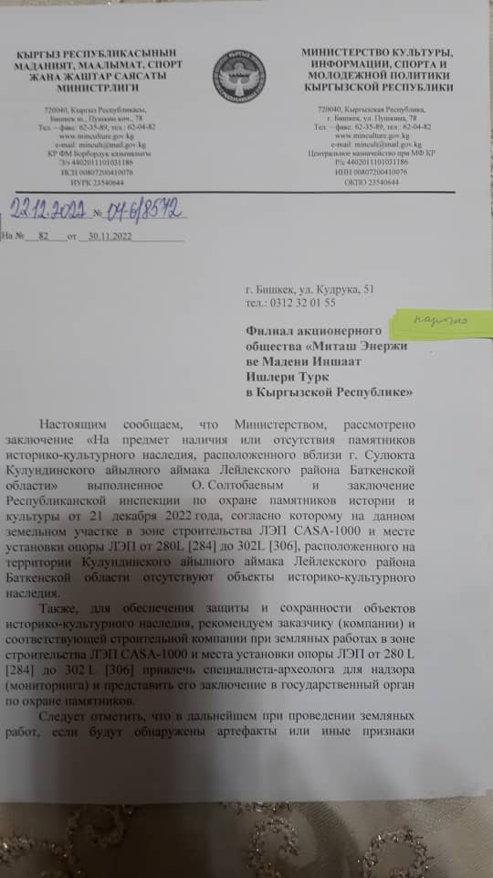

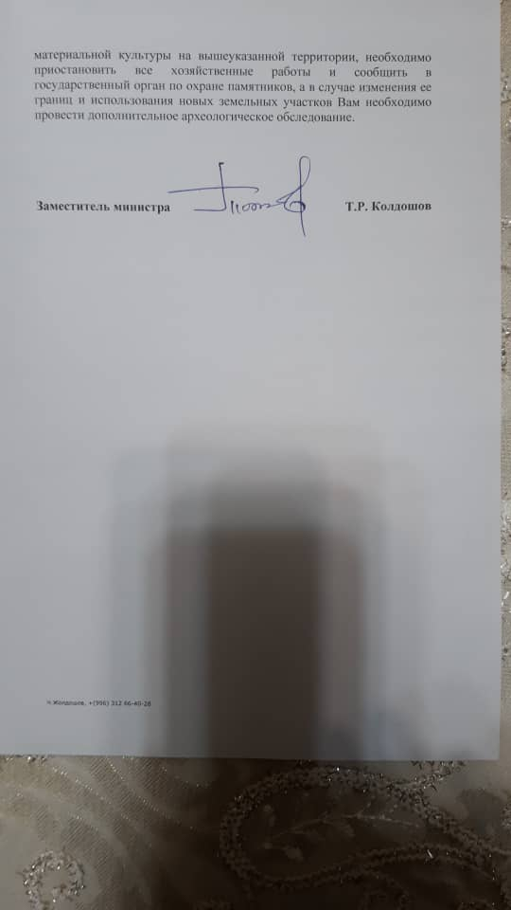

Conclusion:

We hereby inform you that the Ministry has considered the conclusion “On the presence or absence of monuments of historical and cultural heritage located near Sulukta city, Kulunda ayil aimak, Leilek district, Batken region” made by O. Soltobaev and the conclusion of the Republican Inspectorate for the Protection of Historical and Cultural Monuments dated December 21, 2022, according to which there are no objects of historical and cultural heritage on this land plot in the construction zone of the CASA-1000 power transmission line and the installation site of the power transmission towers from 280L [284] to 302L [306], located on the territory of Kulunda ayil aimak of Leilek district of Batken region.

Also, in order to ensure the protection and preservation of objects of historical and cultural heritage, we recommend that the customer (company) and the relevant construction company during earthworks in the construction zone of the CASA-1000 power transmission line and the installation site of the power transmission line towers from 280L [284] to 302L [306] involve a specialist - archaeologist for supervision (monitoring) and submit his conclusion to the state body for the protection of monuments.

It should be noted that in the future, during excavation, if artifacts or other signs of material culture are found in the above-mentioned territory, it is necessary to suspend all works and inform the state authority for the protection of monuments, and in the event of a change in its boundaries and the use of new land plots, you need to conduct further archaeological research.

Deputy Minister T.R. Koldoshev

Appendix 20. Explication of land plots
Name of aiyl aimak | Poles # | X Easting m | Y Northing m | Distance between the towers | length, width of towers | Pole area, in m2 | Type of land under the tower  . | Land user | inventory data and photo tablet" KYRGYZGIPROZEM" Batken
 |  |  |  |  |  |  |  |  | contour number | Type of land
Kulundu | 280L [284] | 560877.299 | 4420902.817 |  | 21 x 21 | 441 m2 | pasture | а/а | 578 | Pasture
 |  |  |  | 421,0
Kulundu | 281 [285] | 560552.552 | 4421170.923 |  | 18 x 18 | 324 m2 | pasture | а/а | 585 | Pasture
 |  |  |  | 318,0
Kulundu | 282 [286] | 560300.617 | 4421364.934 |  | 19 x 19 | 361 m2 | pasture | а/а | 585 | pasture
 |  |  |  | 430,0
Kulundu | 283 [287] | 559959.928 | 4421627.292 |  | 18 x 18 | 324 m2 | pasture | а/а | 585 | pasture
 |  |  |  | 311,0
Kulundu | 284 [288] | 559713.524 | 4420915,576 |  | 18 x 18 | 324 m2 | pasture | а/а | 584 | pasture
 |  |  |  | 214,0
Kulundu | 285 [289] | 559543.948 | 4421947.631 |  | 21 x 21 | 441 m2 | rainfed arable | Bolotbek Mamatovich Mavlyanov | 588 | rainfed arable
 |  |  |  | 320,0
Kulundu | 286 [290] | 559224.032 | 4421941.773 |  | 18 x 18 | 324 m2 | rainfed arable | Bakytbek Temiralievich Borukulov | 590 | rainfed arable
 |  |  |  | 335,0
Kulundu | 287 [291] | 558889.088 | 4421935.641 |  | 18 x 18 | 324 m2 | haying | Akbarali AbdugaparovichAkbotoev | 591 | pasture
 |  |  |  | 375,0
Kulundu | 288 [292] | 558514.151 | 4421928.776 |  | 19 x 19 | 361 m2 | haying (ФПС) | а/а | 631 | rainfed arable
 |  |  |  | 378,1
Kulundu | 289 [293] | 558136.074 | 4421921.853 |  | 20 x 20 | 400 m2 | haying | Asanbek Gulbaevich Satybaldiev | 634 | haying
 |  |  |  | 322,4
Kulundu | 290 [294] | 557819.106 | 4421863.128 |  | 19 x 19 | 361 m2 | haying | Asanbek Gulbaevich Satybaldiev | 634 | haying
 |  |  |  | 207,7
Kulundu | 291 [295] | 557623.084 | 4421931.714 |  | 20 x 20 | 400 m2 | haying | Asanbek Gulbaevich Satybaldiev | 634 | haying
 |  |  |  | 476,8
Kulundu | 292 [296] | 557154.559 | 4421843.142 |  | 20 x 20 | 400 m2 | haying | Конурбаев Ибраим Абибилаевич | 610 | haying
 |  |  |  | 554,8
Kulundu | 293 [297] | 556609.415 | 4421740.086 |  | 18 x 18 | 324 m2 | pasture | а/а | 609 | pasture
 |  |  |  | 365,2
Kulundu | 294 [298] | 556250.571 | 4421672.248 |  | 18 x 18 | 324 m2 | pasture | а/а | 609 | pasture
 |  |  |  | 325,0
Kulundu | 295 [299] | 555931.227 | 4421611.878 |  | 19 x 19 | 361 m2 | pasture | а/а | 606 | pasture
 |  |  |  | 325,0
Kulundu | 296 [300] | 555611.883 | 4421551.508 |  | 20 x 20 | 400 m2 | pasture | а/а | 606 | pasture
 |  |  |  | 440,0
Kulundu | 297 [301] | 555179.541 | 4421469.776 |  | 20 x 20 | 400 m2 | pasture | а/а | 605 | pasture
 |  |  |  | 490,0
Kulundu | 298L [302] | 554698.069 | 4421378.757 |  | 18 x 18 | 324 m2 | pasture | а/а | 605 | pasture
 |  |  |  | 400,0
Kulundu | 299N [303] | 554305.030 | 4421304.455 |  | 20 x 20 | 400 m2 | pasture | а/а | 604 | pasture
 |  |  |  | 258,4
Kulundu | 300N [304] | 554051.180 | 4421256.466 |  | 19 x 19 | 361 m2 | pasture | а/а | 604 | pasture
 |  |  |  | 461,7
Kulundu | 301N [305N] | 553597.561 | 4421170.712 |  | 20 x 20 | 400 m2 | pasture | а/а | 603 | pasture
 |  |  |  | 370,0
Kulundu | 301A [305A] | 553234.000 | 4421101.983 |  | 20 x 20 | 400 m2 | pasture | а/а | 517 | pasture
 |  |  |  | 440,0
Kulundu | 301B [305B] | 552801.658 | 4421020.251 |  | 18 x 18 | 324 m2 | pasture | а/а | 517 | pasture
 |  |  |  | 375,0
Kulundu | 301C [305C] | 552433.185 | 4420950.593 |  | 20 x 20 | 400 m2 | pasture | а/а | 516 | pasture
 |  |  |  | 275,9
Kulundu | 302L [306] | 552162.063 | 4420899.339 |  | 19 x 19 | 361 m2 | pasture | а/а | 516 | pasture
Total:Kulundu |  |  |  | 9189,9 |  | 9564 m2

№ tower | Full name/Name of PAP | Project Impact | Impact area , m2
285 | Mavlyanov  Bolotbek  Mamatović | Removal of land for placement of towers | 441
 |  | Temporary use of land for an access road | 531
286 | Borukulov  Bakytbek  Temiralievich | Removal of land for placement of towers | 324
 |  | Temporary use of land for an access road | 453
287 | Akbotoev  Akbarali  Abdugaparovich | Removal of land for placement of towers | 324
 |  | Temporary use of land for an access road | 462
289 | Satybaldiev  Asanbek  Gulbaevich | Removal of land for placement of towers | 400
 |  | Temporary use of land for an access road | 702
290 |  | Removal of land for placement of towers | 361
 |  | Temporary use of land for an access road | 309
291 |  | Removal of land for placement of towers | 400
 |  | Temporary use of land for an access road | 225
292 | Konurbaev  Ibrahim  Abibilaevich | Removal of land for placement of towers | 400
 |  | Temporary use of land for an access road | 636

Appendix 21. List of participants in the public discussion

1. Head of Kulunda aiyl okmotu Tashtalbaev O.K.
2. Land surveyor of Kulunda aiyl okmotu Murzhalalov Sh.
3.Deputy of the Kulunda aiyl kenesh Abduraimov T.
4. The head of the village named after Razzakov Borukulov B.
5. Tursunkulov Kochkorali
6. Sadykov Akbarali
7. Zhoroev Akmatali
8. Kenzhebaev Zhanibek
9.Abdiev Akhun
10. Kabylov Diamond
11. Kadyrov Elmurat
12. Asralov Bakyt
13. Pazylov Isabay
14. Mavlyanov Kaiym
15. Kamchybekov Zhunus
16. Abdullaev Abdumalik
17. Erkebaev Gapar
As well as employees of NESK and the Contractor - 2 people.

Appendix 22. Coronavirus (COVID-19) Readiness Report Form
THE CORONAVIRUS (COVID-19) READINESS REPORT FORM must follow the format below. A breakdown by various sub-projects, construction sites and/or Contractors should be provided. Discrepancies should be analyzed and their causes assessed, and necessary adjustments considered.
See previously provided guidance to Borrowers and Contractors on considering the spread of coronavirus infection (COVID-19) in construction activities under World Bank financed projects; Contingency planning background memo providing examples of mitigation measures and approaches to prevent/contain the spread of coronavirus infection (COVID-19), etc.

GENERAL INFORMATION
Name of the project/subproject, date of the report
Specify information for identification
Requirements / guidelines for protection against coronavirus infection (COVID-19) issued by government authorities at all levels
Provide information on the regulatory framework on this issue, the date these provisions come into force both at the national and local levels (at the level of settlements)
Brief description of active, suspended or partially active activities/subprojects
Describe the level of activity for each project/subproject (the PIU works at the Owner’s premises; construction works are carried out at the sites, etc.), as well as the types of construction works (if they are ongoing) and the number of employees at each site separately and in total for each subproject / Contractor

(а) ASSESSMENT OF THE CHARACTERISTICS OF THE WORK FORCE
Information about the accommodation of workers
For each subproject/Contractor, provide information on how many workers live in construction camps for workers, how many live in residential premises, hotels, etc.; how many people live in their own private living quarters
Transportation to/from the site and business trips
If employees need to travel to / from the site or get from their place of residence, indicate the type of transport (public transport, own vehicle, transport organized by the Employer, etc.)

PREPAREDNESS/RESPONDING MEASURES FOR CORONAVIRUS INFECTION (COVID-19)
b) Entry/entrance to and exit/departure from the site and pre-work inspections
Describe the measures taken to ensure entry/ entrance security and medical examinations.
(c) General hygiene
Describe what general hygiene requirements are established for personnel involved in the project (both PIU and project workers) and how these requirements are communicated to workers
(d) Cleaning and waste disposal
Provide an overview of cleaning protocols (including disinfection) for all facilities, including offices, residences, canteens, common areas, and key construction equipment.
(е) Adaptation of work practice
Describe what changes have been made to practices and deadlines to reduce or minimize contact between workers
(f) Medical services within the project
Provide an assessment of the adequacy of the existing medical services at the site, taking into account the existing infrastructure (size of the medical center, number of beds, isolation rooms), medical staff, equipment and materials, procedures and training. If these services are not sufficient, describe what steps have been taken to improve them.
(g) Local health and other services
Provide an overview of the resources and capabilities of the local health services, what procedures are in place when a sick worker needs to be referred to a local health facility. Indicate the presence of a medical facility located near the site to which patients can be referred, and agreements between the Contractor and this facility.
(h) Cases of illness or spread of the virus
Describe what is planned to be done to treat an employee who is ill or who is with exhibiting symptoms that may be related to coronavirus infection (COVID-19)
(i) Continuity of supply and work within the project
Assess whether COVID-19 related restrictions will affect supply chains and what mechanisms are in place to ensure business continuity. Specify critical supplies.

(j) OUTBREAK EMERGENCY PLANNING
Measures to address the spread of COVID-19 can be presented in different forms: as a contingency plan, as an annex to an existing emergency response and preparedness plan, or as separate procedures. Describe how such measures are presented in the case of each individual sub-project/Contractor and when such plans/procedures came into effect.

INFORMATION AND COMMUNICATIONS
(k) Training and informing employees
Workers should be aware of the procedures that have been adopted by the project and their responsibility for following them. Provide a description of activities to raise awareness/preparedness of employees (issuance of special work instructions, public announcements about medical examination procedures, access to medical facilities, etc.).
(l) Informing and interacting with the population living in the territory
The population living in the area may be concerned about the risks posed to them as a result of the presence of visiting workers or the employment of local workers at the project site. Describe the risk-based procedures to be followed when informing stakeholders at the local level.
Grievance mechanism
An additional column should be added to the project-related grievance log to control requests/reports/complaints related to COVID-19. Provide up-to-date information on the number of COVID-19-related entries in the complaint log since the last periodic report.

(m) REPORTING ON COVID-19
Number of cases, including: number of confirmed cases of COVID-19 infection and number of suspected cases of coronavirus infection/cases for which the diagnosis is being clarified
Indicate information about employees involved in the project who have confirmed or suspected coronavirus infection (COVID-19): number, date of isolation, severity of the disease. Personal data must not be provided!
Accountability Mechanisms
The ESIRT system has a requirement to report disease outbreaks. The PIU/Contractor shall report disease outbreaks in accordance with the ESIRT guidelines in case of a “major” incident. The Borrower should be kept informed of any questions or concerns related to the care of infected workers at project sites, especially if the infection rate approaches 50% of the workforce.
Confirm that these reporting requirements are accepted by the appropriate and responsible personnel within the PIU/Contractor's organizational structure.

Encyclopedic Dictionary. 2009.
LawoftheKyrgyzRepublicdatedJanuary 14, 1994 No. 1422-XII “OnWater” (amended and supplemented as of April 06, 2017).
SanPiN 2.2.4.010-03
LawoftheKyrgyzRepublicdated June 12, 1999 No.51 “On protection of atmospheric air” (amendedandsupplementedasofJuly 06, 2016)
LawoftheKyrgyzRepublic“On Population Censuses”, dated May 14, 1998 N 63.
LawoftheKyrgyzRepublicdated June 12, 1999 No.51 “On protection of atmospheric air” (amendedandsupplementedasof 06 July 2016).
The Land Code of the Kyrgyz Republic dated June 2, 1999 No. 45 (amendedandsupplementedasof July 25, 2017).
The Land Code of the Kyrgyz Republic dated June 2, 1999 No. 45 (amendedandsupplementedasof 25 July 2017).
LawoftheKyrgyzRepublicdated June 17, 1999 No.59 “On Fauna” (amendedandsupplementedasofMarch 22, 2016)
“Sanitary protection zones and sanitary classification of enterprises, structures and other objects” dated April 11, 2016 No. 201.
Modern Encyclopedia. 2000.
Dictionary-guide of terminology of regulatory technical documentation.
Dictionary of environmental terms and definitions, 2010
Ecological Encyclopedic Dictionary. — Kishinev: Chief editorial board of Moldavian Soviet encyclopedia. I.I. Dediu. 1989.
ResolutionoftheGovernmentoftheKyrgyzRepublicdatedJuly 27, 2001 No.378 “On Approval of Environmental Monitoring Cooperation Agreement signed in Saratov on January 13, 1999”).
Wikipedia, thefreeencyclopedia.
LawoftheKyrgyzRepublicdatedMay 8, 2009 No.151 “GeneraltechnicalguidelineonprovisionofecologicalsafetyintheKyrgyzRepublic” (amendedandsupplementedfrom 01 March 2012)
LawoftheKyrgyzRepublicdatedMarch 31, 2016 No.32 “On inspection procedure of activities of local self-governing bodies”
Chemico-Analytical Encyclopedia
Encyclopedic dictionary. 2009
The Land Code of the Kyrgyz Republic dated June 2, 1999 No. 45 (amended and supplemented as of 25 July 2017).
LawoftheKyrgyzRepublicdatedNovember 13, 2001 No.89 “On Production and Consumption Waste”.
LawoftheKyrgyzRepublicdatedNovember 13, 2001 No.89 “On Production and Consumption Waste”
LawoftheKyrgyzRepublicdated June 16, 1999 No.54 “On Environmental Expertise” (amendedandsupplementedasof 04 May 2015)
World Bank’s Operations Manual, Annex А, Operating Policy (ОР 4.01.) January 1999.
Ecological dictionary, 2001
“The Sanitary and Epidemiological Rules and Regulations. Sanitary Protection Zones and Sanitary Classification of Enterprises, Structures and Other Objects” dated April 11, 2016 No. 201
Ecological Encyclopedic Dictionary. — Kishinev: Chief editorial board of Moldavian Soviet encyclopedia. I.I. Dediu. 1989.
Resolution of the Government of the Kyrgyz Republic dated February 13, 2015 No. 60 “On approval of the Regulation on the procedure for environmental impact assessment in the Kyrgyz Republic”.
Resolution of the Government of the Kyrgyz Republic dated July 12, 1993 No.304 “On recultivation of lands” (amendedfrom 10 September 2013)
SanPiN 2.2.4.010-03
Geological dictionary: in 2 volumes. - M .: Nedra. Edited by K.N. Paffengolts and others. 1978.
Decree of the Government of the Kyrgyz Republic No. 60 dated February 13, 2015 “Regulations on the Order of Environmental Impact Assessment in the Kyrgyz Republic”
Regulations on the procedure for conducting environmental impact assessment in the Kyrgyz Republic, dated February 13, 2015 No. 60
Approved by the Ministry of Energy of the Russian Federation and recommended for use by NEG of Kyrgyzstan.
Experts from the American publication "FocusEconomics" for 2019 identified Kyrgyzstan as one of the ten poorest countries. Source: https://www.focus-economics.com/blog/the-poorest-countries-in-the-world#GDP%20per%20capita%202016-2022
Appendix 17, Decree of the Government of the Kyrgyz Republic of the Kyrgyz Republic as of April 11, 2016 No. 201 "On approval of acts in the field of public health".
PDKmr — maximum permissible single concentration of a substance in the air of populated areas, mg/m3. This concentration when inhaled for 20 minutes should not cause reflex reactions (including subsensory) in the human body.
See Appendix 7 "Results of measurement of the concentration of pollutants in the air"
A.P. Klopotovsky, 1984
Soil fertility - the ability of the soil to meet the needs of plants in nutrients, moisture and air, as well as provide conditions for their normal life. Soil fertility is significantly affected by the content of humus, nitrogen, phosphorus, potassium, soil alkalinity and other characteristics.
Humus is the main organic matter of the soil, containing the nutrients necessary for higher plants. Humus makes up 85-90% of soil organic matter and is an important criterion in assessing soil fertility. It is a complex dynamic complex of organic compounds formed during the decomposition and humification of organic residues. The composition of humus includes specific humic substances, intermediate decay and humification products, and nonspecific organic compounds.
The Resettlement Policy Framework was developed by the Government of the Kyrgyz Republic, November 2013.
Law of the Kyrgyz Republic "General technical regulations for ensuring environmental safety"
Statio (from lat. statio - location) - a certain section of the environmental space, which has a set of conditions (relief, climate, food, shelter, etc.) necessary for the existence and residence of a certain type of animal there. In a narrower sense, a statio is commonly referred to as areas of habitat used by an animal to perform a specific function (nesting, feeding statio) or at certain times of the day or year (day, night, seasonal statio).
Boita (fromclassicalGreek. βιοτή — life) — a historically established set of species of living organisms, united by a common area at the present time or in the past geological epochs.
CIGRE (Conseil International des Grands Réseaux Electriques - International Council on Large High Voltage Electrical Systems) is a non-governmental and non-profit international organization that unites scientists and experts in the field of electrical power systems.
The procedure for handling production and consumption waste in the Kyrgyz Republic
Land easement: a legally binding agreement that allows landowners to voluntarily restrict or limit development that may occur on their land.
Pastures are exclusively owned by the Kyrgyz Republic, the Kyrgyz Republic Law“On Pastures”. Pastures are used by all local residents, according to the territory of residence, including PAP. Pastures are used for grazing on the basis of pasture tickets, or for other purposes under the lease agreements. It is necessary to submit an application to the AA Pasture Committee and, based on the number of available livestock, receive a pasture ticket and an established area for grazing.
KR GR No. 201 dated 11 April 2016
Source: https://znaytovar.ru/gost/2/RD_342050494_Tipovaya_instrukc.html
Ministry of Internal Affairs, State National Security Agency, State Defense Committee, Security Council, Ministry of Foreign Affairs, Ministry of Economy, Ministry of Finance, Ministry of Culture and Tourism, Ministry of Transport and Roads, State Border Service, State Customs Service, Veterinary Service, Phytosanitary Agency and others.
Guidance is provided in Appendix 27
Including requirements presented in Annex 29
See Section 9, Occupational Safety.
The mechanism of land transformation is presented in Section 3.1 (detailed information with support plans will be presented in the RAP)
The final calculation will be presented after the forest management project is completed by the Department of Forestry and Hunting of the SAEPF

